Context-Gated Channel Attention:
Extending Attention U-Net with Top-Down Channel Selection
Medical Images Processing with Deep Learning (336033) — Final Project
Aviv Niemann (ID: __________) · ______________ (ID: __________)
Selected paper: O. Oktay et al., "Attention U-Net: Learning Where to Look for the Pancreas," MIDL 2018 (arXiv:1804.03999)
Proposed extension: a context-gated channel-attention branch added to the attention gate, conditioned on the same coarse-scale gating signal the original spatial gate uses — extending the paper's top-down "where to look" mechanism from spatial locations to feature channels.
1. Introduction
Summary of the paper. The Attention U-Net augments the standard U-Net with attention gates (AGs) on the skip connections. Each gate takes the fine-scale encoder features x that would be concatenated into the decoder together with a coarser-scale gating signal g from the deeper decoder path, and produces a per-pixel spatial attention coefficient α ∈ [0,1]. Multiplying x by α suppresses background responses before they reach the decoder, so the network learns to focus on the target organ without an external localization module. The gates are additive, trained end-to-end, and add few parameters. On abdominal CT the authors show AGs improve pancreas segmentation — notably increasing recall — with the benefit most pronounced when training data is scarce.
Problem and relevance. Automated organ segmentation in CT is clinically valuable but hard for small, low-contrast, shape-variable structures. Prior state of the art relied on multi-stage cascades (localize, then segment), which are redundant and complex. The attention gate folds localization into a single end-to-end model for negligible cost, and its attention maps offer a degree of interpretability.
Motivation. The gate is elegant and widely used, but has a clear limitation: its attention is purely spatial — it decides where to look but applies the same scalar across all feature channels, never deciding which channels are relevant. Channel-attention modules (SE-Net, CBAM) address channel selection, but via pure self-attention over the feature map's own statistics, discarding the paper's core idea of top-down contextual gating. This gap is a natural place to extend the method.
2. Proposed Extension
Description. We add a second gating branch that produces a per-channel weight β ∈ [0,1]^C applied alongside the spatial coefficient, so the gated skip output becomes W(x · α · β). Crucially β is computed from both the local features x and the coarse gating signal g, mirroring the spatial gate: β = σ(W_out · ReLU(W_x·GAP(x) + W_g·GAP(g))), where GAP is global average pooling. The channel gate is thus context-gated: the coarse decoder context helps decide which channels matter, just as it already decides which locations matter. It is initialized to pass all channels (β ≈ 1) so it cannot suppress useful features before learning.
Gap addressed and hypothesis. The original AG collapses channel information into a single spatial scalar. We hypothesize that different channels carry different, location-dependent relevance — especially for small, low-contrast organs — and that letting top-down context modulate channels improves the precision/recall trade-off. We further hypothesize the advantage over both the baseline and a naïve channel-attention bolt-on grows as training data shrinks, the regime the original paper highlights as most favorable to attention.
Alternatives considered. (i) A standard CBAM block on the AG — its channel attention is pure self-attention and ignores g; we retain it as a control to isolate the value of context-conditioning. (ii) Squeeze-and-Excitation in the encoder — same objection, not tied to skip gating. (iii) Residual/highway connections around the gate — the original authors reported no benefit, so we did not pursue it.
3. Methodology
Models. All four variants are built from one configurable 2D U-Net so the only difference is the gating module: U-Net (no gating); Attention U-Net (original spatial gate α(x,g)); AG+CBAM (spatial gate + CBAM channel/spatial self-attention, the control); and Hybrid, ours (spatial gate α(x,g) and context-gated channel gate β(x,g)). Following the paper, the shallowest skip is left ungated; the spatial gate reproduces the authors' reference implementation.
Data and preprocessing. Medical Segmentation Decathlon Task09_Spleen — 41 labeled 3D abdominal CT volumes with binary spleen masks, chosen to stay in the paper's CT small-organ domain while remaining a feasible proof-of-concept. Volumes are windowed to a soft-tissue HU range, normalized, sliced to 2D axial slices and resized to 256×256; all spleen slices plus a sample of background slices are kept. Patients are split train/val/test at the patient level (never per slice) to prevent leakage; the same test set is used for every variant and training size.
Training. Adam (lr 3×10⁻⁴), batch 8, up to 60 epochs with early stopping on validation Dice, gradient clipping, light augmentation, 5 random seeds; we report the mean and a paired Wilcoxon signed-rank test on per-slice Dice. Loss — a stability finding: the paper uses Dice loss for imbalance robustness, but on our small-foreground 2D slices pure Dice training was stochastically unstable, intermittently collapsing to an all-background prediction from which Dice's vanishing gradient could not recover; plain BCE+Dice was worse under heavy imbalance. We adopted a Dice+Focal compound loss — Dice optimizes overlap, focal down-weights easy background and preserves a strong foreground gradient — which eliminated the collapse across all 100 training runs. This instability is an artifact of the small-foreground 2D setting and does not arise in the paper's full-3D regime.
Experiments. (1) main comparison of all four variants at full data; (2) a low-data sweep training each variant at 4, 8, 16 and all patients; (3) interpretability via spatial attention maps and the learned channel weights β. Tools: PyTorch, MONAI, nibabel, scikit-image, SciPy, matplotlib. Full experiments ran on an NVIDIA L40; the submitted Colab notebook reproduces the whole pipeline and defaults to a reduced proof-of-concept configuration.
4. Results and Analysis
Main comparison (full data, 5 seeds; pooled per-slice metrics over 1240 foreground slices). All pairwise differences are statistically significant (paired Wilcoxon, p < 0.0001).
Variant | Dice | Precision | Recall
U-Net (baseline) | 0.844 | 0.865 | 0.876
Attention U-Net (original) | 0.865 | 0.900 | 0.892
AG + CBAM (control) | 0.886 | 0.907 | 0.903
Hybrid — ours | 0.844 | 0.888 | 0.863
Table 1. Full-data segmentation results. AG+CBAM is best; the original Attention U-Net significantly improves over the plain U-Net; our hybrid ties the U-Net on Dice while trading recall for precision.
Channel attention significantly improves the paper's method. Both attention variants beat the plain U-Net, and adding channel attention raises Dice further: the CBAM channel attention lifts the original Attention U-Net from 0.865 to 0.886 (p < 0.0001), the best result overall on every metric. This is the central positive finding — the Attention U-Net leaves channel selection unexploited, and adding it helps.
Our context-gated variant: a precision/recall trade-off. At full data the hybrid ties the plain U-Net on Dice (0.844) and is significantly below the original Attention U-Net and CBAM. However, relative to the U-Net it raises precision (0.865 → 0.888) while lowering recall (0.876 → 0.863): the context-gated channel gate makes the model more conservative — predicting less spleen but more accurately — rather than more sensitive. This differs from the original paper's recall-boosting effect and indicates the extra channel gate is actively reshaping the decision, not merely adding capacity (it adds only 0.6% parameters over the spatial gate).
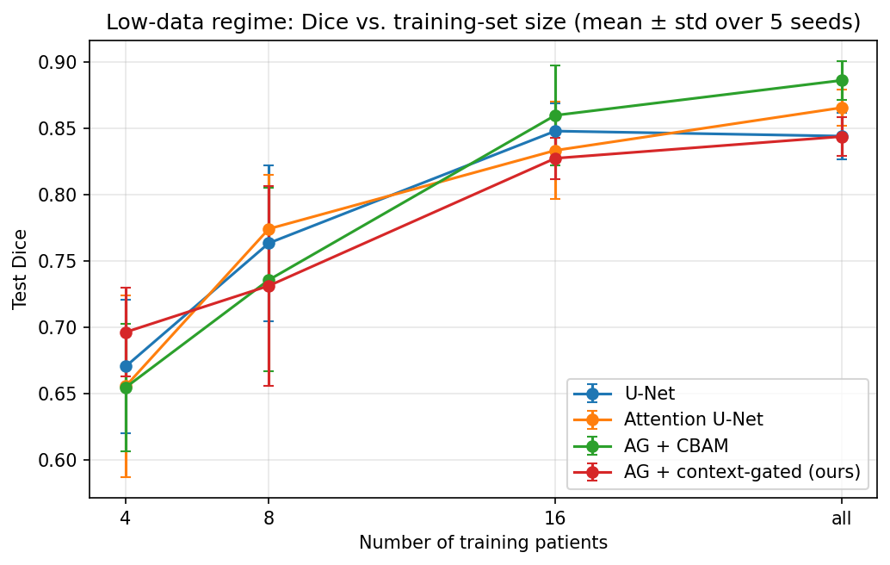
Figure 1. Low-data regime: test Dice vs. training-set size (mean ± std, 5 seeds). Our hybrid (red) is the best variant at the smallest training size (4 patients), consistent with the hypothesis that context-gated channel selection helps most when data is scarce; the advantage does not persist at larger sizes.
Low-data regime. Figure 1 tests our central hypothesis. At the smallest training set (4 patients) the hybrid is the top performer (Dice 0.696 vs. 0.670/0.656/0.655 for U-Net/Attention/CBAM), supporting the idea that a context-conditioned channel gate is most useful when per-image statistics are unreliable. The advantage is not monotonic — at 8 and 16 patients the hybrid is no longer ahead — so the evidence is suggestive of a low-data niche rather than a robust trend.
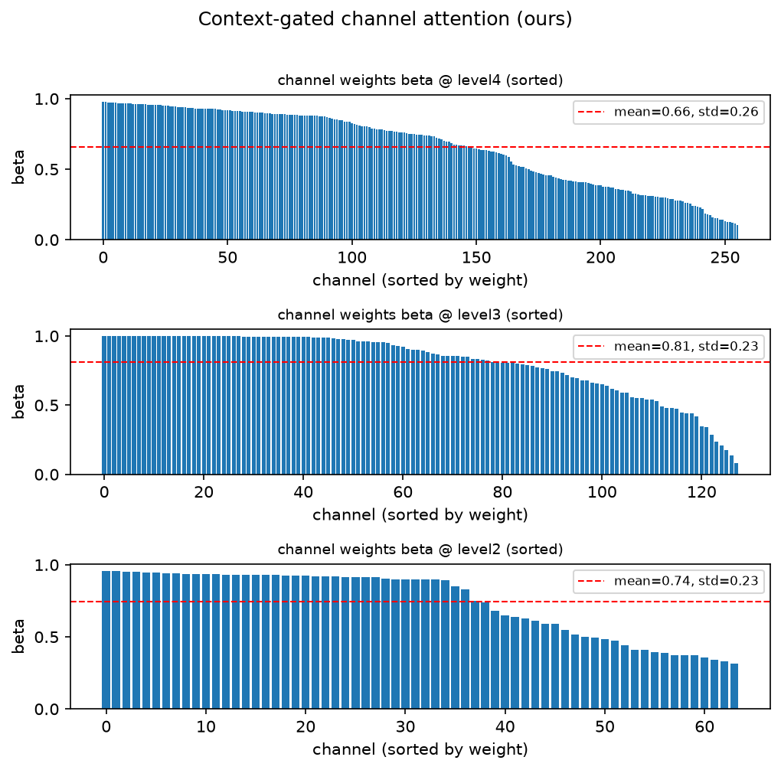
Figure 2. Learned context-gated channel weights β at three gated levels (sorted). β spans ~0.1–1.0 (means 0.66–0.81, std ≈ 0.23), showing the gate performs meaningful, non-uniform channel selection rather than trivial pass-through.
Interpretability. Figure 2 shows the learned channel weights β are far from uniform (they span roughly 0.1–1.0), confirming the gate learns genuine channel selection. Qualitative prediction overlays and spatial attention maps (in the repository) reproduce the paper's observation that gates localize the organ; the failure cases are dominated by thin organ tips and low-contrast boundary slices, where all variants struggle.
5. Conclusion
Findings. Starting from the hypothesis that context-gated channel attention would improve the Attention U-Net, we found a more nuanced result. Adding channel attention to the attention gate significantly improves spleen segmentation — a CBAM-style channel attention raises Dice from 0.865 to 0.886 (p < 0.0001) and is best on every metric. Our specific context-gated variant does not beat the original at full data; instead it shifts the model toward higher precision and lower recall, and its clearest benefit is the extreme low-data regime, where it is the best variant. The learned channel weights confirm the mechanism performs real, non-uniform channel selection.
Limitations. A 2D proof-of-concept on a single organ at downsampled resolution, with a small dataset and high seed-to-seed variance for the gated variants; the required Dice+Focal loss adaptation; and, with 1240 paired samples, statistical significance that reflects small effect sizes. Results should be read as indicative, not definitive.
Future work. Extend to full 3D volumes and multiple organs; add deep supervision (used in the original but omitted here); investigate why context-conditioning underperforms simple channel recalibration at full data while helping at low data; and test on thin, branching structures such as retinal vessels, where channel-specific selection may matter more.

