Medical Images Processing with Deep Learning (336033) -Final Project

Context-Gated Channel Attention:
Extending the Attention U-Net with Channel Selection
Aviv Niemann- 314955873
Nir Mikel- 209060318

Selected paper: O. Oktay et al., "Attention U-Net: Learning Where to Look for the Pancreas," MIDL 2018 (arXiv:1804.03999)
Proposed extension: add channel attention to the attention gate's skip-connection gating - a novel context-gated channel gate (guided by the context signal g from the deeper layers), compared against a CBAM-style channel-attention variant.

1. Introduction
1.1 Summary of the paper- The standard U-Net architecture has become a cornerstone in medical image segmentation due to its symmetric encoder-decoder structure. The encoder progressively extracts high-level features representations by down sampling feature maps, while the decoder restores spatial resolution. To recover high resolution spatial details lost during pooling, U-Net uses skip connections that directly copy high-resolution features from the encoder to the decoder layers. However, standard skip connections carry a notable drawback, they indiscriminately transfer low-level features, including noisy background responses and redundant non-target activations. In complex tasks like abdominal CT segmentation, where target organs (for example: pancreas or spleen) show high inter-patient shape variability and low tissue contrast-this not selective propagation can sometimes lead to false positives and boundary uncertainty.
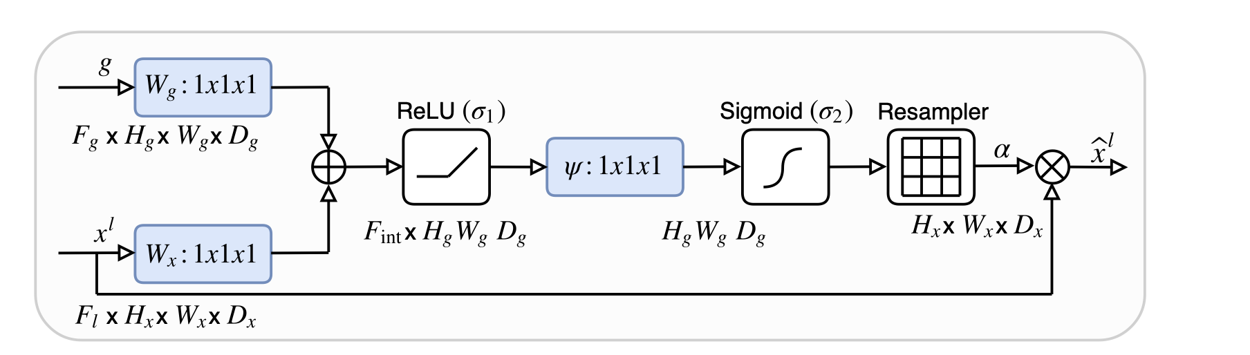
to address these limitations without resorting to computationally expensive multi-stage cascaded networks (which crop explicit Regions of Interest) that were used before attention methods were presented, the writers proposed the Attention U-Net. The core innovation is the integration of Attention Gates (AGs) directly into the skip connections. Instead of passing feature maps raw, the AG acts as an end-to-end differentiable filtering mechanism. It leverages a coarser-scale gating signal g, from the deeper decoder layers to gate the finer spatial features $x^{l}$ coming from the encoder skip connection.
Figure 1- Schematic of the proposed additive attention gate (AG). Input features (xl) are scaled with attention coefficients (α) computed in AG. Spatial regions are selected by analysing both the
activations and contextual information provided by the gating signal ( g) which is collected from a
coarser scale. Grid resampling of attention coefficients is done using trilinear interpolation. (citation from the paper)

The spatial Attention Gate dynamically computes a spatial attention map $α∈ [0,1]$ that scales each spatial location of the input features $x^{l}$before they reach the decoder. As shown in figure1, the AG takes two input tensors: Skip Connection Features ($x^{l})$ and Gating Signal (g).
To combine these signals. $x^{l} and g$ are projected into a common intermediate space by
$1×1$ convolutions and linearly fused to form a spatial attention map $α∈\left[0,1\right]$ using ReLU and Sigmoid activations. By elementwise multiplying the skip connection features with $α$, background activations are suppressed while task-relevant foreground responses are dynamically highlighted during both forward pass and gradient backpropagation.
1.2 Problem and relevance- Automated segmentation of small, soft tissue abdominal organs in CT scans is important for clinical diagnosis and surgical planning, yet remains challenging because to low tissue contrast, high shape variability, and extreme class imbalance. standard CNNs often produce false positives in background regions or require costly multi-stage localization networks, Attention Gates solve this by suppressing nontarget activations end-to-end, improving segmentation accuracy at cheap computational cost.
1.3 Motivation - The attention gate is purely spatial: it decides where to look but applies the same scalar to every feature channel, it never decides which channels are relevant. Since different channels encode different features (edges, texture, semantics), we hypothesized that adding channel selection to the gate could improve it, and we chose this paper because that gap is a clear and high motivated place to extend a used method.

2. Proposed Extension
2.1 Reasoning and hypothesis- The original AG collapses all channel information into one spatial scalar. We hypothesized that a context-conditioned channel gate would improve the precision/recall trade-off, especially for small, low-contrast structures.
2.2 Context-Gated Channel Attention (Hybrid Architecture) -To address the original paper channel gap, we design a novel Hybrid Attention Gate that computes both spatial and channel-wise attention coefficients within each skip connection. Unlike conventional self-attention modules, our channel gating branch extends the paper’s top down principle: it conditions the channel weights $β∈{\left[0,1\right]}^{C}$ (c = number of channels) on both the local encoder features $x^{l}$ and the coarse decoder gating signal $g$. Mathematically, while spatial attention $α$ filters activations per pixel, the channel branch combine spatial responses of fused features $\left(x^{l},g\right)$ to infer a channel modulation vector $β$. The input feature map is scaled sequentially:
$${\overset{ˆ}{x}}^{l}=x^{l}⋅α⋅β$$
To prevent premature suppression of useful representation layers during early optimization epochs, the channel gate is initialized to act as an identity pass-through ($β≈1$).
2.2 Alternatives considered - Second varient: Localized Channel Attention (CBAM) When our context-gated Hybrid did not improve over the paper's model at full data (Section 5), we search the literature and adopted a second, channel-attention design as a comparison: CBAM (Woo et al., ECCV 2018), which applies channel, then spatial self-attention. Unlike our gate, CBAM’s channel attention operates purely by using self-attention- it derives global channel descriptors using average and max pooling directly from $x^{l}$, completely bypassing the deeper decoder signal $g$. Integrating both variants allows us to isolate the specific impact of top-down contextual gating versus localized channel refinement.

2.3 Methodological Evolution: The Low-Data Benchmark
Our experimental process evolved based on empirical findings. When full-dataset evaluations (Section 5) revealed that channel attention variants achieved competitive performance with the original Spatial AG but remained within standard deviation bounds, we re-examined the core assumption of Oktay et al- that attention mechanisms provide their most significant gains when training limited amount of data. Consequently, we trained the models on low-data by restricting the training set size to 8 patients ($≈$ 320 images), we specifically test whether context-gated channel selection provides superior feature selectivity and spatial robustness when the network has limited opportunities to learn background activation from data alone.
3. Methodology
3.1 Models- All four variants are built from one configurable 2D U-Net so the only difference between them is the skip connection gate :U-Net (no gate), Attention U-Net - the paper's model (spatial grid gate, ported from the authors' code), Hybrid – our first varient (spatial gate + context gated channel gate) and AG+CBAM- our second varient (spatial gate + CBAM channel & spatial self attention) .All use deep supervision (auxiliary heads at each decoder scale), following the paper.
3.2 Dataset and preprocessing- Medical Segmentation Decathlon Task09_Spleen (41 labeled 3D abdominal CT volumes). Volumes are windowed to a soft-tissue range, sliced to 2D axial slices, resized to 256×256, and per-slice z-score normalized. Patients are split at the patient level (never per slice) to avoid leakage (if a certain patient’s is used for training there will be no images of this patient at the test).
3.3 Training- Adam (lr 3×10⁻⁴), batch 8, up to 60 epochs with early stopping on validation Dice, gradient clipping, and paper’s methof of augmentation (affine rotation/scale + flips).
Loss Function: While the original 3D paper utilized pure Sorensen-Dice loss, training on 2D slices with small target foregrounds led to numerical instability and all-background collapse under pure Dice. We resolved this by adopting a joint Dice + Focal Loss, this is applied identically to all variants. Evaluation: the full-data study uses 5-fold cross-validation. Low-Data Benchmark: Evaluated on a fixed, held-out test set ($20\%$ of patients) using N=8 training patients across multiple random seeds to assess data efficiency.We report Dice, precision, recall, and paired Wilcoxon signed-rank tests on per-slice Dice.
Loss Function Formulation and Rationale
While the original paper utilized pure Sorensen-Dice loss for 3D volumetric segmentation, training on 2D CT slices with small foreground organs (like the spleen) often leads to numerical instability or convergence to a trivial all-background solution. To ensure robust gradient dynamics, we adopted a composite Dice + Focal Loss, defined as: $L_{\text{total}}=L_{\text{Dice}}+L_{\text{Focal}}$

Sorensen-Dice Loss ($L_{\text{Dice}}$)
The Dice loss directly optimizes the spatial overlap between the predicted binary segmentation mask $p∈\left[0,1\right]$ and the ground truth mask $y∈\left\{0,1\right\}$:
$$L_{\text{Dice}}=1-\frac{2\sum_{i}{p_{i}}y_{i}+ϵ}{\sum_{i}{p_{i}}+\sum_{i}{y_{i}}+ϵ}$$
where $i$ indexes individual pixels and $ϵ={10}^{-6}$ prevents division by zero. In image segmentation, Dice loss focuses directly on the region-level intersection over union, making it naturally resilient to global background size variations compared to standard pixel-wise cross-entropy.

Focal Loss ($L_{\text{Focal}}$)
To address extreme pixel-level class imbalance, where background pixels signnificantly outnumber foreground target pixels we add to Dice loss the Focal Loss:
$$L_{\text{Focal}}=-\sum_{i}{{\left(1-p_{t},i\right)}^{γ}}\log\left(p_{t},i\right)$$
where $p_{t},i=p_{i}$ if $y_{i}=1$ and $p_{t},i=1-p_{i}$ if $y_{i}=0$, and $γ≥0$ is the focusing parameter (set to $γ=2.0$).
3.4 Frameworks & Infrastructure- Implemented in Python using PyTorch, MONAI, SciPy, scikit-image, and nibabel. Model execution and timing benchmarks were conducted on an NVIDIA L40 GPU.

4. Results and Analysis
4.1 Full-Data Benchmark (5 Fold Cross Validation)- Our initial evaluation focused on testing our proposed context-gated Hybrid model (first variant) under 5 fold cross validation. When results showed that the Hybrid model did not outperform the baseline Attention U-Net (0.852 vs. 0.869 Dice), we incorporated AG + CBAM as a secondary benchmark to test whether self-attention channel selection could provide an advantage. Although CBAM achieved a slightly higher mean Dice ($0.872$), paired Wilcoxon testing confirmed the improvement was not statistically significant ($p=0.274$) due to fold to fold varianc.
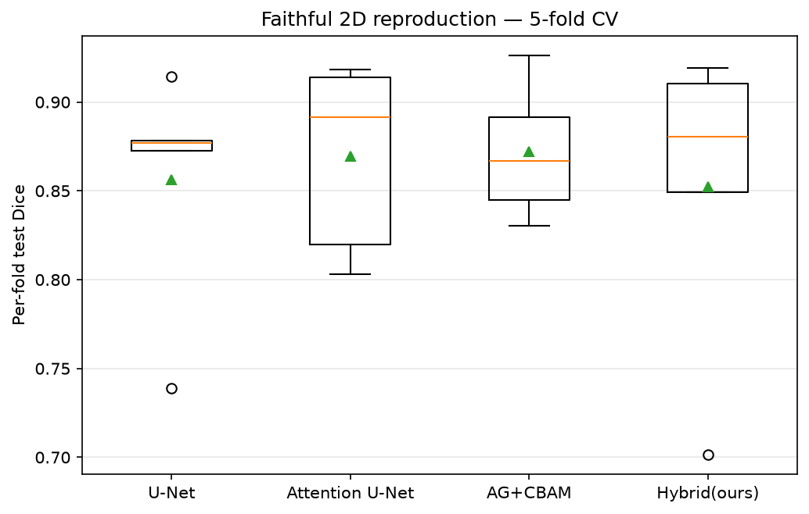
Table 1- Full-data 5 fold cross validation on spleen.
Figure 2- Per fold Dice (full data). The four variants overlap.
Variant | Dice (mean ± std) | Precision | Recall
U-Net | 0.856 ± 0.061 | 0.906 | 0.885
Attention U-Net (paper) | 0.869 ± 0.048 | 0.908 | 0.895
AG + CBAM | 0.872 ± 0.034 | 0.908 | 0.892
Hybrid (ours) | 0.852 ± 0.079 | 0.903 | 0.878

4.2 Transition to Low-Data- Observing that full-data capacity on this dataset yielded performance saturation across all variants, we formulated our low data hypothesis based on the paper's core thesis- that attention mechanisms demonstrate their main value when training data is limited. We evaluated all four models under an $N=8$ training regime across 8 distinct random seeds. Under data scarcity, both channel oriented architectures significantly outperformed the spatial only Attention U-Net (paper’s model). AG + CBAM achieved the highest overall performance (0.877 Dice), representing a substantial +0.084 absolute gain over the paper's model (p<0.0001). Hybrid model achieved $0.824$ Dice, yielding a statistically significant $+0.031$ gain over the paper's Attention U-Net ($p<0.0001$).

Table 2- Low-data results (8 training patients)
Variant | Dice (n=8, 8 seeds) | vs paper's model
U-Net | 0.784 | -
Attention U-Net (paper) | 0.793 | baseline
AG + CBAM | 0.877 | +0.084 (p<0.0001)
Hybrid (ours) | 0.824 | +0.031 (p<0.0001)
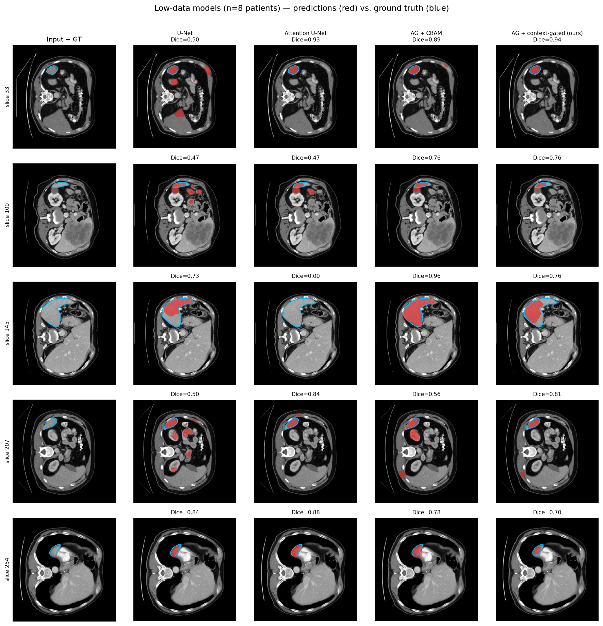
Qualitative comparison- Qualitative prediction overlays (Figure 3) closely align with our quantitative findings. Under low data constraints (N=8)$,$Attention U-Net exhibit false positives in background tissue and complete organ misses on challenging slices. In contrast, both AG + CBAM and Hybrid models segmented clean boundary.
Figure 3- Low-data (n=8) predictions (red) vs. ground truth (blue).
4.3 Failure cases and challenges Initial training faced two main chalnges: a 3D pipeline failed to converge (verified by usung a baseline U-Net), and 2D pure Dice loss collapsed to all background predictions on small foreground slices which we resolved using a joint Dice+Focal. Additionally, our channels oriented models did not significantly outperformed the paper’s model, that led us to test the advantage of attention gate under limited amount of data.
5. Conclusion
5.1 Findings- This project evaluated context gated and self-attention channel extensions to the Attention U-Net. While channel gating offers limited advantage when training on a high amount of data, it provides significant performance gains in data limited environments. Under an N=8 patient training, our proposed Hybrid model (+0.031 Dice) and the CBAM variant (+0.084 Dice) both outperformed the paper's spatial-only Attention U-Net. These findings validate and extend the original paper's thesis: attention mechanisms have value in low data settings, and channel selection provides crucial feature refinement when spatial context alone is insufficient.
5.2 Limitations- 2D Proof of Concept: Evaluation was conducted on 2D axial slices of a single organ (spleen) due to 3D convergence constraints, Channel Attention Trade-offs: The simpler localized channel self-attention (CBAM) outperformed top down context gating (Hybrid) in data limitation settings.
5.3 Future work- Future investigations should extend this framework to full 3D volumetric models and expand from single organ binary tasks to multi class organ segmentation (for example; segmenting the pancreas, spleen, liver, and kidneys simultaneously, as evaluated in the original paper). Multi-class gating would allow testing whether multi dimensional attention coefficients can learn organ-specific spatial and channel feature responses.

