Cloudwatch configuration

1.) Package need to install:

cailtsbaexap1:/tmp # rpm -ivh amazon-cloudwatch-agent.rpm

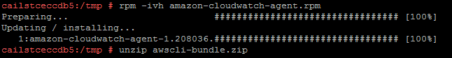

2.) AWS-cli bundle need to install: -

cailtsbaexap1:/tmp # unzip awscli-bundle.zip 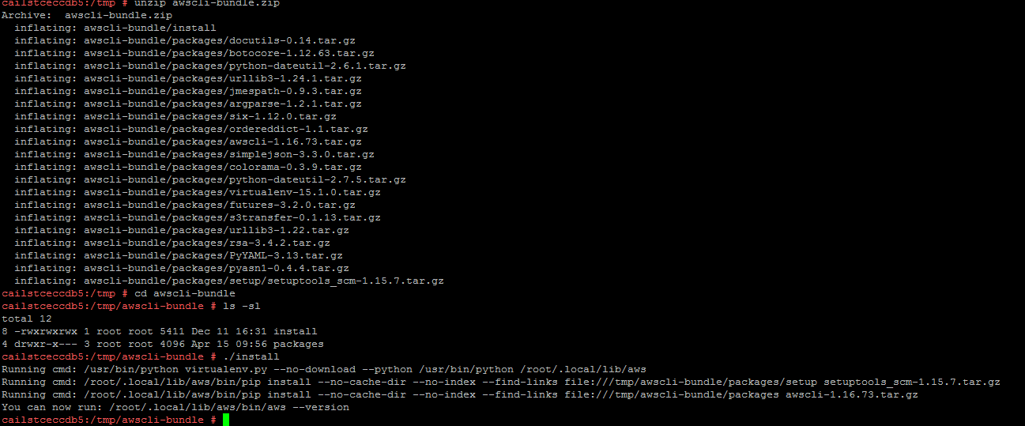



3.) aws configure CLI has been configured:-

AWS configure the aws configure --profile AmazonCloudWatchAgent **(TRANSFER FILE)**

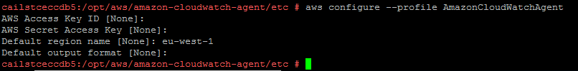

4.) Below file need to be edit with the below details:-

Vi /opt/aws/amazon-cloudwatch-agent/etc/common-config.toml

And uncomment no_proxy = "169.254.169.254" and add the "169.254.169.254" as below: -

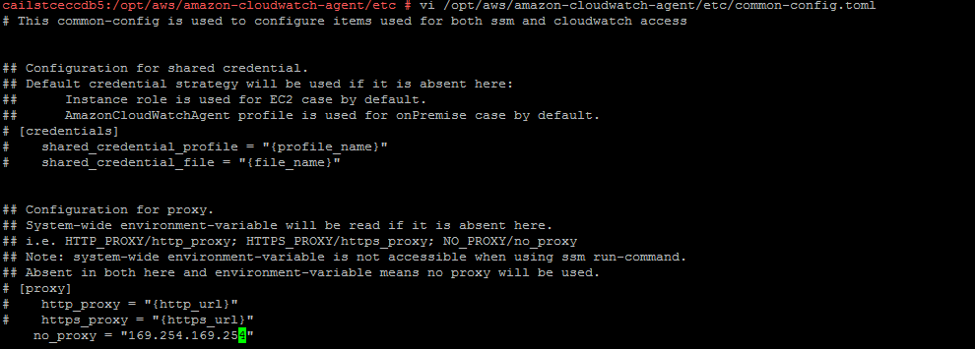

5.) Edit the below file with details given below as per the env type:-

vi /opt/aws/amazon-cloudwatch-agent/bin/config.json

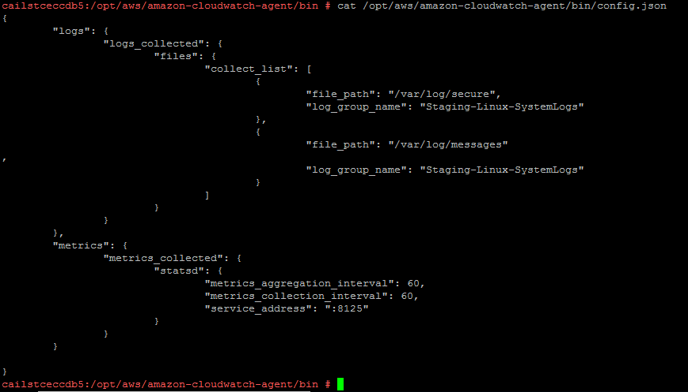

Development VPC:

Log group Name : Development-Linux-SystemLogs

Staging VPC: (NON-PROD)

Log-group Name: Staging-Linux-SystemLogs

Test VPC:

Log-group Name: Test-Linux-SystemLogs

SharedService-Shared:

Log-group Name: SharedService-Linux-SystemLogs

SharedService-Security:

Log-group Name: SecurityService-Linux-SystemLogs

Production VPC:

Log-group Name: Production-Linux-SystemLogs

7.) run the below command after changing the json file output should be like below:-

cd /opt/aws/amazon-cloudwatch-agent/bin/

/opt/aws/amazon-cloudwatch-agent/bin/amazon-cloudwatch-agent-ctl -a fetch-config -m ec2 -c file:./config.json -s

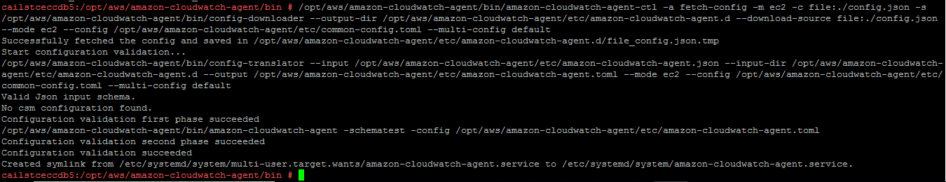

8.) Host file need be edit and add the below entry with the below entry depend on the server is in which availability zone:-



Its depend on the Availability zone: --

SharedServices:

10.204.75.137   logs.eu-west-1.amazonaws.com if server is in AZa

10.204.76.33    logs.eu-west-1.amazonaws.com if server is in AZb

10.204.78.66   logs.eu-west-1.amazonaws.com if server is in AZc

NonProd-Development:

10.204.42.163    logs.eu-west-1.amazonaws.com if server is in AZa

10.204.45.32     logs.eu-west-1.amazonaws.com if server is in AZb

10.204.46.254     logs.eu-west-1.amazonaws.com if server is in AZc

NonProd-Test:

10.204.58.182   logs.eu-west-1.amazonaws.com if server is in AZa

10.204.61.241   logs.eu-west-1.amazonaws.com if server is in AZb

10.204.62.223   logs.eu-west-1.amazonaws.com if server is in AZc

NonProd- Staging:

10.204.27.21   logs.eu-west-1.amazonaws.com if server is in AZa

10.204.29.204   logs.eu-west-1.amazonaws.com if server is in AZb

10.204.30.113   logs.eu-west-1.amazonaws.com if server is in AZc

Production:

10.204.11.142   logs.eu-west-1.amazonaws.com if server is in AZa

10.204.12.98   logs.eu-west-1.amazonaws.com if server is in AZb

10.204.14.184   logs.eu-west-1.amazonaws.com if server is in AZc

9.) Check the status with the below command for the agent: -

/opt/aws/amazon-cloudwatch-agent/bin/amazon-cloudwatch-agent-ctl -m ec2 -a status

