|  |
| --- |
|  |
| Cloudwatch Configuration  Linux |
|  |
|  |

|  |  |
| --- | --- |
| Current Version And Effective Date | Version 0.1 DRAFT |
| Business Area Owner |  |
| Department Responsible |  |
| Document Contact | Aviya Singh |
| Document Author | Aviya Singh |
| Approved By |  |
| Document Initial Implementation Date | 03/06/2019 |
| Next Review Date |  |
| Classification | CADENT |

# Cloudwatch Configuration

## Linux

### What is the purpose?

Amazon CloudWatch is a monitoring and management service. CloudWatch provides you with data and actionable insights to monitor your applications, understand and respond to system-wide performance changes, optimize resource utilization, and get a unified view of operational health. CloudWatch collects monitoring and operational data in the form of logs, metrics, and events, providing you with a unified view of AWS resources, applications and services that run on AWS, and on-premises servers.

### Scope of this document.

To configure cloudwatch on linux servers using ansible in a single click.

# Amazon Cloudwatch Configuration Steps through Ansible:

Ansible control node (10.204.64.130) is executing the playbook on the target nodes to configure amazon cloudwatch.

* Change the directory to the Cloudwatch folder where the playbook is kept.

PATH 🡪 /var/ansible/ANSIBLE_TASKS/CLOUDWATCH



* Add IP or hostname in the inventory file on which Cloudwatch needs to be configured.

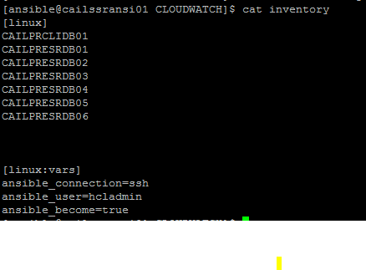

* Execute the playbook and provide the vault password (shared on one-to-one email) with the defined tag depending on the log group it belongs.

**ansible-playbook cloudwatch.yml --ask-vault-pass -i inventory --tags “<tag_name>”**

Tag_names which are being used as below:

shared 🡪 shared service

prod 🡪 production

test 🡪 test

dev 🡪development

stage 🡪 staging



* Ansible task completed, drop a mail to the cloud team to verify.