

**E-Learning Platform**

**Software Requirements Specification**

|  |  |  |  |
| --- | --- | --- | --- |
| **Team Elite** | | | |
| **Name** | **Roll no** | **Work** |  |
| Sudansh Rana | 102217005 | Backend |  |
| Avneesh Jarangal | 102217026 | Frontend |  |
| Saksham Dhiman | 102217029 | Backend |  |
| Prerit Bhagat | 102397030 | Frontend |  |
| **Under Guidance of Ms. Ritu Gothwal** | | | |

**Table of Contents**

Table of Contents 2

1. Introduction 1
   1. Purpose 1
   2. Objective 1
   3. Goals 1
   4. Scope 1
   5. References 1
2. Overall Description 2
   1. Product Perspective 2
   2. Product Functions 2
   3. User Classes and Characteristics 2
   4. Operating Environment 2
   5. Design and Implementation Constraints 2
   6. User Documentation 2
   7. Assumptions and Dependencies 2
3. External Interface Requirements 3
   1. User Interfaces 3
   2. Hardware Interfaces 3
   3. Software Interfaces 3
4. Functional Requirements / Features 4
   1. Real-Time Messaging 4
   2. Community Creation 4
   3. Channel-based Communication 4
   4. Screen Sharing… 4
   5. Member Management 4
   6. Customizable Themes 4
   7. Multimedia Sharing: 4
   8. Notification 4
5. Other Nonfunctional Requirements 5
   1. Performance Requirements 5
   2. Safety Requirements 5
   3. Security Requirements 5

Appendix A: Glossary 5

**SRS - E-Learning Platform PAGE 2**

# Introduction

## Purpose:

The purpose of this SRS document is to provide a detailed overview of our software product E-learning Platform, a web-based E-learning platform. This document describes the project's target audience and its user interface, hardware and software requirements. It defines how our client, team and audience see the product and its functionality

## Scope:

## E-learning platform aims to develop a safe, user-friendly website that offers essential branch-specific materials.The platform will ensure that user receive accurate and consolidated course materials. In this system the user has direct access to all course materials and can download them.

## The software must be able to perform the following operations:

### Authentication:

### It must be able to authenticate the username and password of administrator in order to provide security.

### Download:

User has privilege to access and download the course material.

### Update course details

### Administrator must be able to update the course details in the database & system must not permit the user to alter the course details.

### Comment:

User can dropdown comments as feedback which will be further acknowledged by the administrator

Initially we plan to design a prototype of the software which will be incremented future based on the feedback evaluation.

## Definitions, abbreviations and acronyms:

## Definitions

|  |  |  |
| --- | --- | --- |
| S. No. | Term | Definition |
| 1 | Authentication | physical & behavioural characteristics for authentication purposes |
| 2 | Comment | A user comment is a piece of text input by an individual who interacts with software. |
| 3 | Administrator | A person who has all the authority of database |
| 4 | User | A person who can access course material |

## Abbrevations

|  |  |  |
| --- | --- | --- |
| S. No. | Mnemonic | Full Form |
| 1 | Admin | Administrator |
| 2 |  |  |
| 3 |  |  |

## Goals:

### User-friendly Interface:

### The website should be accessible across different devices (desktops, tablets, and mobile phones) with a responsive design to accommodate various learning preferences.

### Secure and Scalable Platform:

### Ensure the platform adheres to strict security standards to protect user data, personal information, and payment details.

### Scalability:

### Build a scalable infrastructure that can accommodate a growing number of users and courses without compromising performance.

**SRS - E-Learning Platform PAGE 3**

## References:

### Documentation references:

* + - * HTML: https://www.w3schools.com/
      * CSS: https://developer.mozilla.org/en-US/docs/Web/CSS
      * JS: https://developer.mozilla.org/en-US/docs/Web/CSS

### Video References:

* + - * JS: https://www.youtube.com/@Harshitvashisth
      * HTML & CSS : https://www.youtube.com/@CodeHelp

### Books References:

* + - * JavaScript and HTML5 Now by Kyle Simpson
      * MASTERING HTML, CSS by Laura Lemay (Author)

## Overview:

# Overall Description

## Product Perspective

Elearner is a E-learning platform that aims to provide users with a seamless and enjoyable communication experience.

## Product Functions/ Features

### Learning Delivery:

They offer learner self-registration, learners profiles with contact data and information about courses, exams, certificates, online assignments for learners, and learner performance assessment.

### User-friendly Interface:

The website should be accessible across different devices (desktops, tablets, and mobile phones) with a responsive design to accommodate various learning preferences..

### Interactive Learning Content:

Incorporate multimedia elements such as videos(links), to engage learners and make the content more dynamic.

### Secure Platform:

Ensure the platform adheres to strict security standards to protect user data, personal information, and payment details.

### Scalability:

Build a scalable infrastructure that can accommodate a growing number of users and courses without compromising performance.

**SRS - E-Learning Platform PAGE 4**

## User Classes and Characteristics

### Users:

* + - * **Characteristics:** who interact with the platform.
      * **Roles:** primary goal of user is to seek knowledge from course material and can interact through feedback.

### Administrators:

* + - * **Characteristics:** Administrators are individuals responsible for overseeing the overall operations. They often have decision-making authority, technical expertise, and a deep understanding of the platform's goals and objectives.
      * **Roles:** Administrators have the highest level of access and control within E learning website. They are responsible for managing comments and course contents.

## Operating Environment

### Platform Compatibility:

Chat-byte is designed to operate as a web-based application accessible through modern web browsers. This includes popular browsers such as Google Chrome, Mozilla Firefox, Safari, and Microsoft Edge. The platform is optimized for compatibility with the latest versions of these browsers to ensure a seamless user experience across devices and operating systems.

### Device Compatibility:

Chat-byte is compatible with a wide range of devices, including desktop computers, laptops, tablets, and smartphones. The platform's responsive design and adaptive layout ensure optimal performance and usability on different screen sizes and resolutions.

## Design and Implementation

* + - **Technology Stack:** Chat-byte will be developed using a specific technology stack, including *TypeScript, React.js, Next.js, and MySQL*. These technologies have been chosen based on their compatibility, performance, scalability, and community support. Constraints related to the availability of skilled developers, licensing costs, and compatibility with existing systems may influence the selection of the technology stack.
    - **User Interface Design:** The design of Chat-byte's user interface (UI) should adhere to specific design guidelines, branding requirements, and usability principles. Constraints such as platform

### SRS - E-Learning Platform PAGE 5

limitations, device capabilities, and user preferences may impact the UI design decisions. Additionally, the UI design should prioritize *accessibility, responsiveness, and compatibility* with different screen sizes and resolutions.

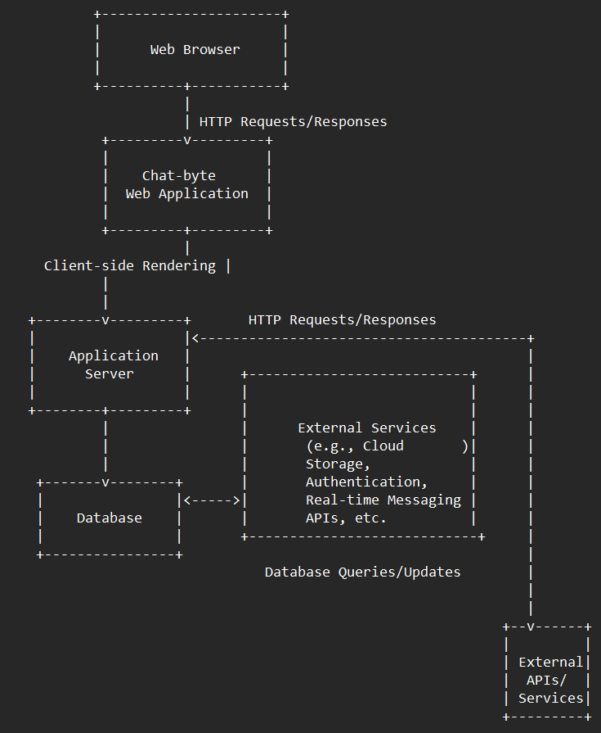

* + - **Development Team:** Skilled developers, *UI/UX designers, Frontend and Backend developers, Database administrators*. The successful implementation of Chat-byte depends on the expertise and skills of the development team. Constraints related to the availability of skilled developers, resource allocation, and team dynamics may impact the project's timeline and success. Collaboration tools, training programs, and ongoing support can help mitigate these constraints and ensure effective teamwork.

### Block Diagram/ DFD:

**SRS - E-Learning Platform PAGE 6**

## User Documentation

* + - Comprehensive user documentation will be provided to guide users on how to use the platform effectively.

## Assumptions and Dependencies

* + - **Assumptions:** Assumptions about user behavior, technology trends, and market dynamics will be validated through user research and feedback.
    - **Dependencies:** Dependencies on third-party services, libraries, frameworks, and APIs will be identified and managed to ensure smooth integration and functionality.
      * **LiveKit** is an open source WebRTC stack that gives you everything needed to build scalable and real-time video, audio, and data experiences in your applications.
      * **Prisma** is an open-source ORM (Object-Relational Mapping) tool that provides a type- safe and intuitive way of accessing databases.
      * **Clerk's** integration gives Supabase developers another incredible option for handling authentication

# External Interface Requirements

## User Interfaces

### Login Page:

The login page serves as the entry point for users to access Chat-byte's features and functionalities. It should provide a secure and user-friendly authentication experience, enforcing strong authentication mechanisms to protect user credentials and prevent unauthorized access. Performance requirements dictate that the login process is fast and responsive, with minimal latency. Safety and security measures, such as encryption of authentication data and protection against brute force attacks, ensure the confidentiality and integrity of user login information. Moreover, software quality attributes such as reliability and usability contribute to the overall quality of the login page by ensuring its robustness and ease of use.

### Dashboard

The dashboard is a central hub where users can access key information and navigate to various sections of Chat-byte. It should provide a clear and organized overview of the user's activities, including recent conversations, notifications, and community updates. Performance requirements ensure that the dashboard loads quickly and updates in real-time to reflect the latest information. Safety and security measures protect sensitive data displayed on the dashboard, such as user profiles and chat history. Software quality attributes such as usability and maintainability contribute to the overall quality of the dashboard by ensuring its ease of navigation and adaptability to user preferences.

### Chat Channels

Chat channels are dedicated spaces within Chat-byte where users can engage in real-time communication with each other. They should provide a seamless and interactive chat experience, supporting text, voice, and video messages. Performance requirements dictate that messages is

### SRS - E-Learning Platform PAGE 7

delivered instantly, with minimal latency, even in channels with a large number of participants. Safety and security measures protect user privacy and prevent unauthorized access to chat content. Software quality attributes such as reliability and scalability ensure that chat channels remain accessible and responsive under varying user loads and usage patterns.

### Community Creation Page:

The community creation page allows users to create new communities within Chat-byte, fostering collaboration and engagement among like-minded individuals. It should provide an intuitive and streamlined interface for defining community settings, including the community name, description, and membership rules. Performance requirements ensure that the community creation process is fast and responsive, with minimal latency. Safety and security measures protect community data and prevent unauthorized access to community settings. Software quality attributes such as usability and maintainability contribute to the overall quality of the community creation page by ensuring its ease of use and adaptability to user needs.

### Settings Page

The settings page enables users to customize and configure their Chat-byte experience according to their preferences and requirements. It should provide a comprehensive set of options for managing account settings, notification preferences, privacy controls, and theme customization. Performance requirements ensure that the settings page loads quickly and responds to user inputs without delay. Safety and security measures protect sensitive user data stored in settings, such as account credentials and privacy settings. Software quality attributes such as usability and accessibility ensure that the settings page is easy to navigate and understand for users of all skill levels.

## Hardware Interfaces

* + - **Computer/Laptop:** 1.6 GHz or faster processor, 2 GB of RAM
    - **Stable Internet Connection**

## Software Interfaces

### Visual Studio Code:

VS Code, is a source-code editor developed by Microsoft

### Node.js:

Node.js is a cross-platform, open-source JavaScript runtime environment

### Next.js:

Next.js is an open-source web development framework created by the private company Vercel providing React-based web applications with server-side rendering and static website generation

### React.js:

React is a free and open-source front-end JavaScript library for building user interfaces based on components.

### MySQL:

MySQL is an open-source relational database management system.

**SRS - E-Learning Platform PAGE 8**

# System Features

## Real-Time Messaging

Chat-byte will support real-time messaging functionality, allowing users to send and receive text, voice, and video messages instantly. This feature ensures seamless communication and enables users to engage in conversations with individuals and groups in real time.

## Community Creation and Management

Users will have the ability to create and manage communities within Chat-byte. This feature enables users to connect with like-minded individuals based on shared interests, hobbies, or professional affiliations. Community creators can define community rules, invite members, and moderate discussions to foster a positive and engaging community environment.

## Channel-based Communication

Chat-byte will support channel-based communication, allowing users to create and participate in chat channels dedicated to specific topics, projects, or interests. This feature enables organized and focused discussions within communities, making it easier for users to find relevant content and engage with others who share their interests.

## Screen Sharing

Chat-byte will include a screen-sharing feature that allows users to share their screens during video calls or collaborative sessions. This feature is particularly valuable for virtual meetings, presentations, or helping others troubleshoot technical issues seamlessly within the app.

## Member Management

Community moderators and administrators will have access to member management features, allowing them to manage community membership, roles, and permissions. This includes the ability to kick members, change roles from guest to moderator, and ensure a streamlined and organized community environment.

## Customizable Themes:

Chat-byte will offer customizable themes, including light and dark mode options, to cater to user preferences and enhance the visual appeal of the platform. Users can choose their preferred theme for personalized comfort and reduced eye strain, providing a customizable and enjoyable user experience.

## Multimedia Sharing:

Chat-byte will enable users to share multimedia content such as images, videos, documents, and links within chat channels and conversations. This feature enhances communication and collaboration by providing users with the ability to share rich media content relevant to their discussions

## Notification:

This feature enables users to stay informed without being overwhelmed by excessive notifications

**SRS - E-Learning Platform PAGE 9**

# Other Non-functional Requirements

## Performance Requirements

* + - **Scalability:** The system should be able to handle a large number of concurrent users without significant performance degradation.
    - **Response Time:** The website should load within an acceptable time frame,

## Safety Requirements

* + - **Authentication and Authorization:** The platform enforce strong authentication mechanisms, to verify the identity of admin and prevent unauthorized access to alter the resources. usernames and password is only provided to admin to change accordingly

## Software Quality Attributes

* + - **Reliability The system should be** reliable and resilient, with minimal downtime and service disruptions. This includes robust error handling, fault tolerance, and graceful degradation mechanisms to ensure continuous operation and availability, even in the event of failures or unexpected conditions.
    - **Usability:** This system is user-friendly and intuitive, with a clean and consistent user interface that promotes ease of use. This includes browse material, user feedback mechanisms, and user comment mechanism features to accommodate diverse user needs and preferences and ensure an inclusive user experience.
    - **Performance Efficiency:** The platform is efficient in terms of resource utilization, response times, and scalability to meet user demands and performance expectations. This includes performance profiling, optimization techniques, and load testing to identify and address bottlenecks and performance issues proactively.

**SRS - E-Learning Platform PAGE 10**

## Appendix A: Glossary

Table 1 explains the most commonly used terms in this SRS document.

|  |  |  |
| --- | --- | --- |
| **S.no** | **TERM** | **DEFINITION** |
| **1)** | Server | Servers are the different spaces made on chat-byte either by community or friend groups for some interest |
| **2)** | Channel | A channel is a group made inside a server that has 3 types: text, audio, and video. |
| **3)** | Admin | Admin is the person who creates the server/channel |
| **4)** | Moderator | The moderator is the person assigned by the admin who has the same powers as the admin |

### SRS - E-Learning Platform PAGE 11

**Chat Byte Software Requirement**

**Specification**

|  |  |  |  |
| --- | --- | --- | --- |
| **Regards Team Elite** | | | |
| **Name** | **Roll no** | **Work** |  |
| Sudansh Rana | 102217005 | Backend |  |
| Avneesh Jarangal | 102217026 | Frontend |  |
| Saksham Dhiman | 102217029 | Backend |  |
| Prerit Bhagat | 102397030 | Frontend |  |
| **Under Guidance of Ritu Gothwal**  **07/ 02/ 24** | | | |

**SRS - E-Learning Platform PAGE 12**