Team: FinTech Coders

Team members: Avneet (Lead), Yamini, Uttkarsh, Sharnveer

Contribution:

Avneet: Project Setup on Git, Footer HTML CSS

Uttkarsh: Main section- Widgets HTML CSS

Yamini: UI-UX( Research on images, background selection ) Header HTML CSS

Sharnveer: Header HTML

**SCREENSHOTS –**

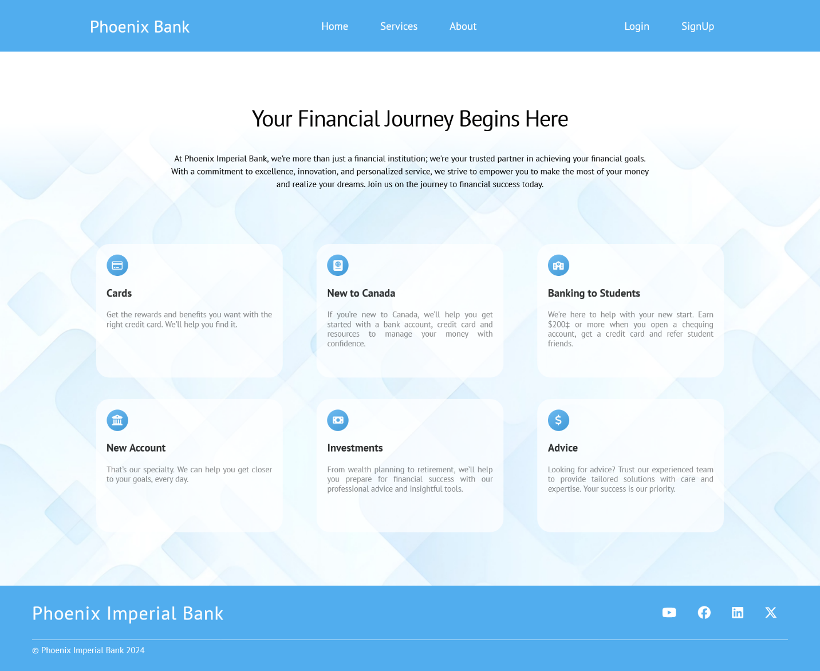

Github Link - https://github.com/Avneet26/phoenix-bank-project