UCS420: Cognitive Computing
Assignment 4 – A Cognitive FAQ System Using Pandas (Nova 2.0)

Pre-requisites: Pandas DataFrame
Q1: Build Your Personalized Knowledge Base: Take your college roll number. Extract its digits. Build a pandas DataFrame with exactly 6 FAQ entries: 4 fixed entries (given in table below) and other 2 entries constructed from your own roll number digits as follows:
- Take the LAST TWO DIGITS of your roll number. For each digit d, compute category = ["billing", "account", "general"][d % 3]. Invent one realistic question+answer+3 keywords per entry that fits the assigned category (e.g.
if d%3 gives "account", write a question like “how do I update my registered mobile number”).
- # Example roll number ...23 -> digits 2, 3
- # digit 2 -> category[2 % 3] = general
- # digit 3 -> category[3 % 3] = billing

Output: Print your final 6-row DataFrame.
import pandas as pd

fixed_entries = [
{"question": "what is the annual fee", "answer": "The annual fee is Rs 500.",
"keywords": "fee cost price charge", "category": "billing"},
{"question": "how to reset password", "answer": "Go to Settings > Reset Password.",
"keywords": "password reset login", "category": "account"},
{"question": "what are your working hours", "answer": "We are open 9 AM to 5 PM.",
"keywords": "hours timing open time", "category": "general"},
{"question": "how can i pay the fee", "answer": "You can pay via UPI, card, or net banking.",
"keywords": "pay payment upi fee", "category": "billing"},
]
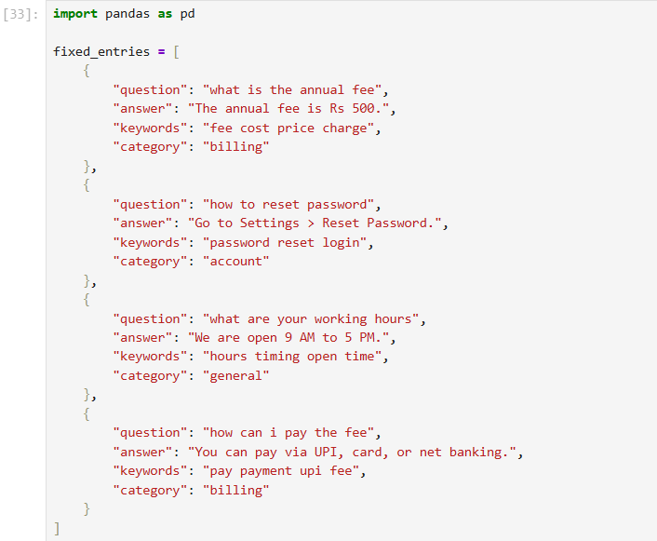
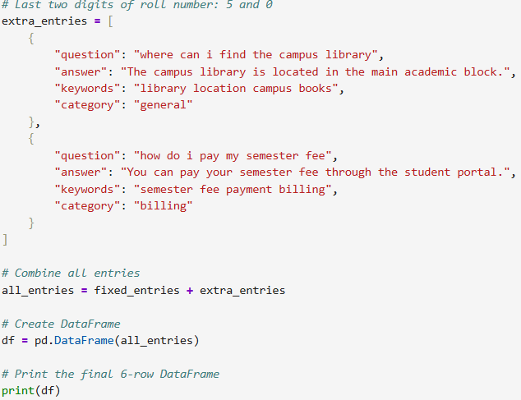
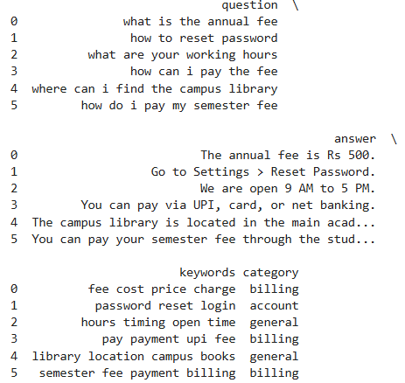
Q2: Generate and Score a Hypothesis - Implement a scoring function that takes a query string and returns all matching entries ranked by confidence
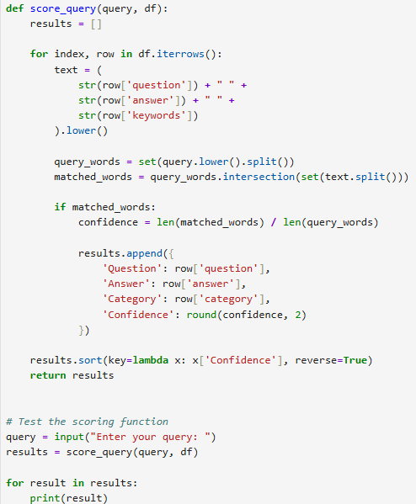
Q3: Write a function same_category(category_name, df) that returns all questions belonging to a given category. Call it using the category of one of the personalized entries from Q1, and print the result.
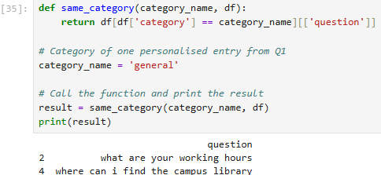
Q4: Pick any one entry in your knowledge base. Ask the user to input a new keyword, add it to that entry's keywords, and save your entire updated DataFrame to a CSV file named <your_roll_number>_faq_data.csv.
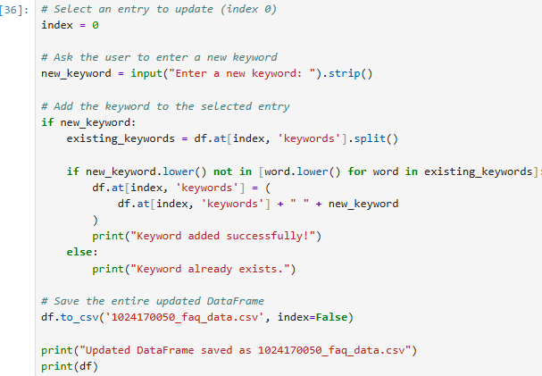
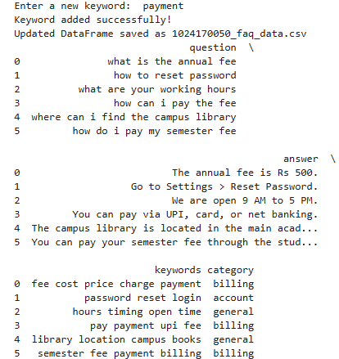
Q5: Using groupby, print how many FAQ entries you have per category.
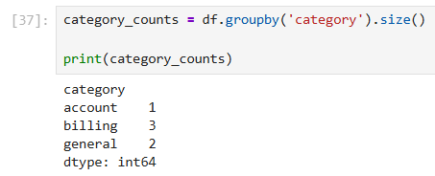
Q6: Modify your Q2 scoring function so that if two or more entries tie for the highest score, it does not silently pick one — it prints all matching entries instead, so the user can see every equally good match. Demonstrate with one query that produces a tie (e.g. a query matching both "fee" entries) and one that doesn't.
