UCS420: Cognitive Computing
Assignment 2 — Python Data Structures (Lists, Tuples, Sets, Dictionaries)

- Take your roll number. Extract its individual digits, and multiply each digit by 10 to form your list L (10 numbers in list now).
- Print L
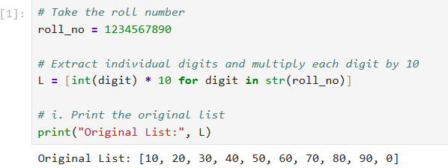

- Add two numbers of your choice to L — one using append() and one using insert() at a specific position. Print L after each and explain in a comment what changed.

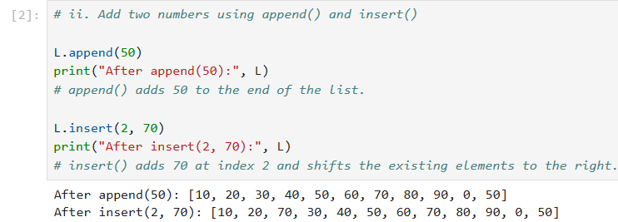

- Remove two elements from L — one using remove() and one using pop(). Print L after each.

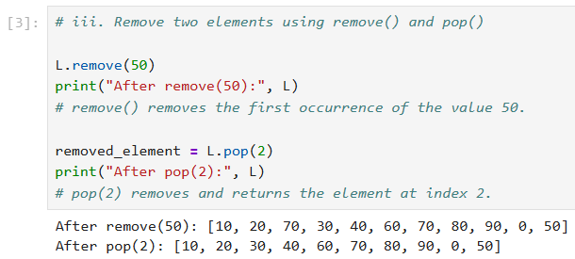

- Sort L in ascending order using sort(), then descending order using sort(reverse=True). Print both.
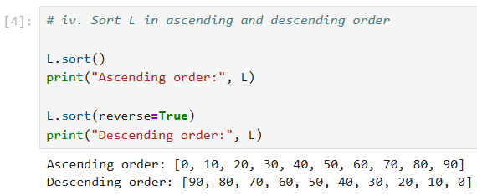

- Use slicing to print the first three elements and the last three elements of L in a single line each.
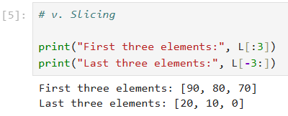

- Use list comprehension to create a new list containing only the elements of L that are greater than the average of L.
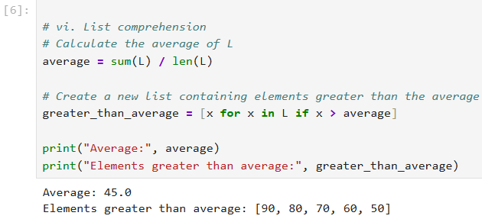

- Create a tuple named scores containing 8 marks: use the first 8 values from your list L in Q1.

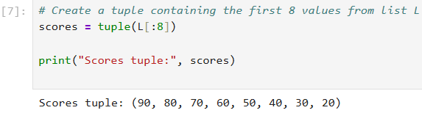

- Find the highest score and its index in the tuple, and the lowest score and how many times it appears.
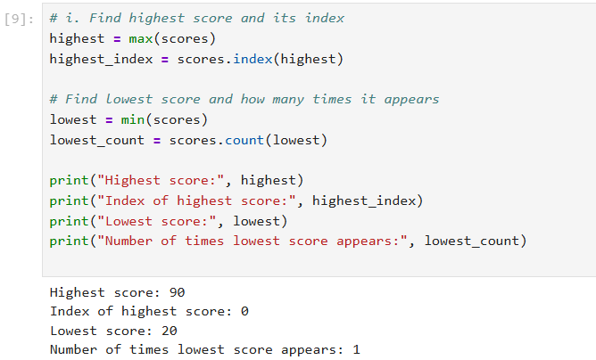
- Reverse the tuple and return the result as a list (tuples themselves cannot be reversed in place — explain why in a one-line comment, referring to tuple immutability).
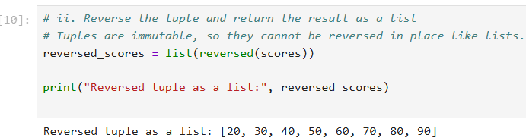
- Ask the user to input a score. Print its first occurrence index if present in the tuple, or a not present message if not.
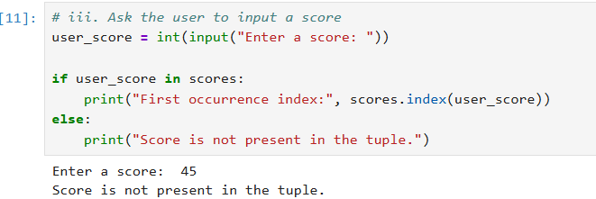
- Attempt to change one element of the tuple directly (e.g., scores[0] = 100). Run it, capture the error Python raises, and explain in one line why this happens and how it differs from a list.
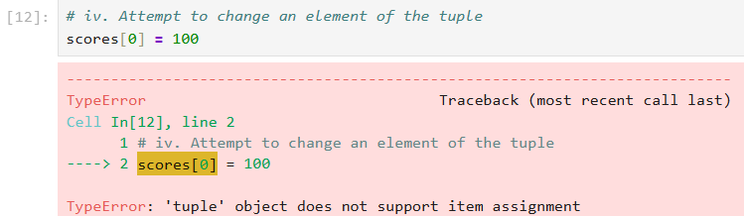
- Unpack the tuple into a first score, a second score, and all remaining scores using the * operator in a single line of unpacking.
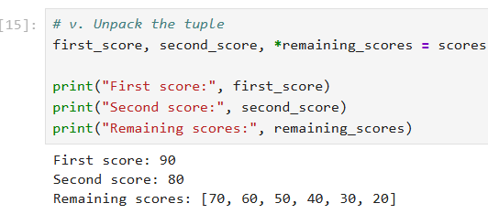

- Set the random seed to your own roll number using random.seed(your_roll_number) before generating your numbers — this keeps your list random-looking but reproducible and unique to you (a different seed produces a different list, so this cannot be copied from a classmate).
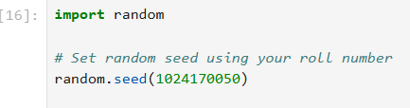
  - Generate a list of 100 random numbers between 100 and 900 (inclusive).
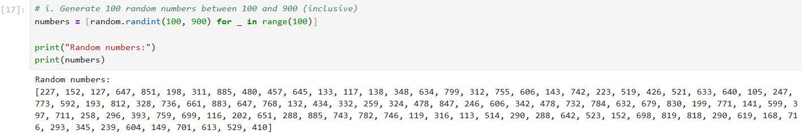
  - Count and print all odd numbers in the list.
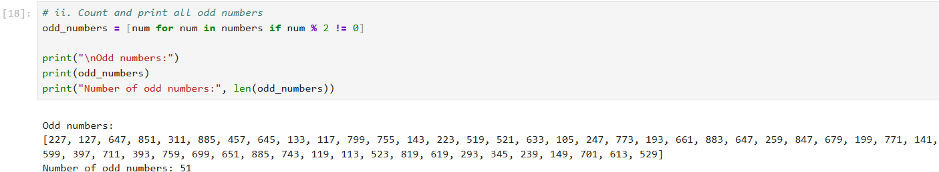
  - Count and print all even numbers in the list.
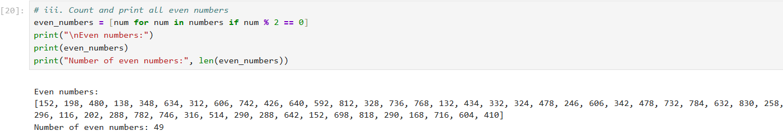
  - Count and print all prime numbers in the list, and additionally build the actual list of prime numbers found using list comprehension.
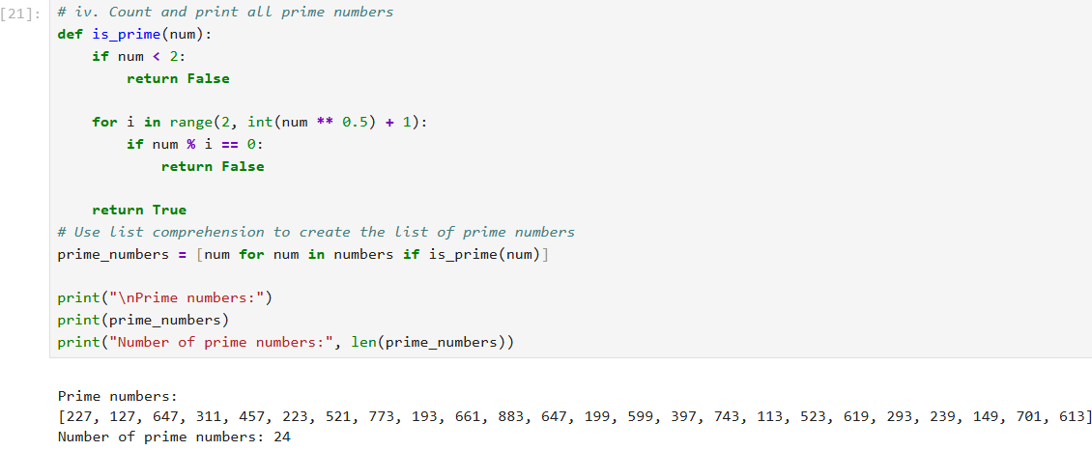
  - Print the number that occurs most frequently in your list, and how many times it occurs.
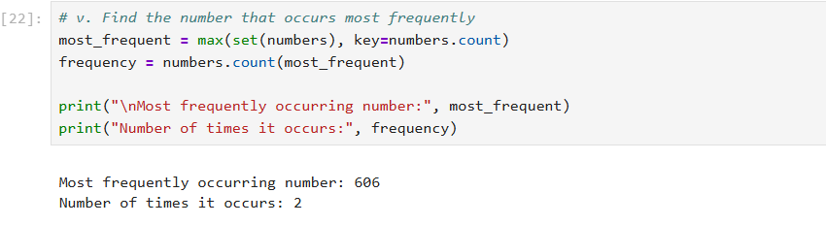
- Using the same 8 digits of your roll number from Q1 (before multiplying by 10), create set A = {digit × 7 for each digit} and set B = {digit × 9 for each digit}. Print both sets.
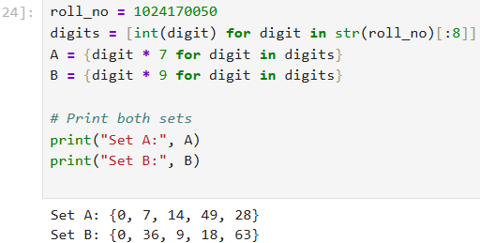
  - Find the union of A and B — all unique values across both sets.
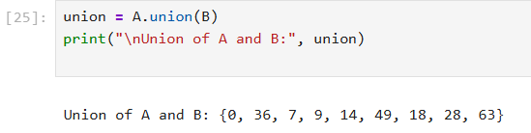

  - Find the intersection of A and B — values common to both.
  - Find A − B and B − A separately (not combined) using difference(), and explain in one line how this differs from symmetric_difference().
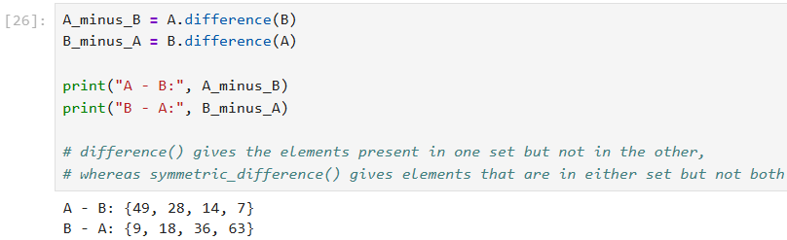
  - Find the symmetric difference of A and B.
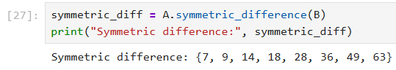
  - Check whether A is a subset of B, and whether B is a superset of A, using issubset() and issuperset().
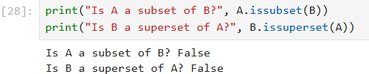
  - Ask the user to input a value X. Remove X from set A if present using discard() (not remove()) — explain in one line why discard() is safer than remove() when you're not sure the value exists.
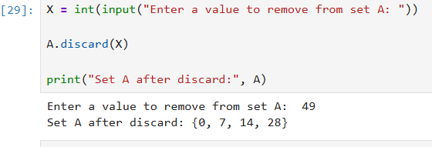
- Consider the following dictionary:
my_dict = {
"name": "<your name>",
"roll_no": "<your roll number>",
"branch": "<your branch>",
"age": <your age>,
"city": "<your home city>"
} 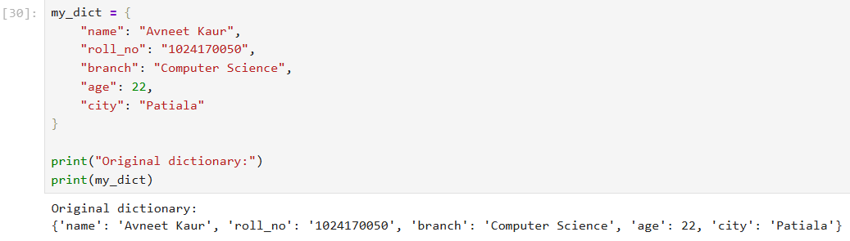
  - Rename the key “city” to “location” without changing its value (do not just recreate the dictionary by hand — use pop() or dictionary comprehension so the code would work for any dictionary).
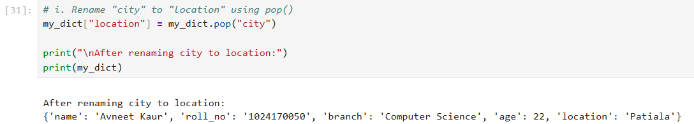
  - Add a new key “cgpa” with your CGPA as its value.
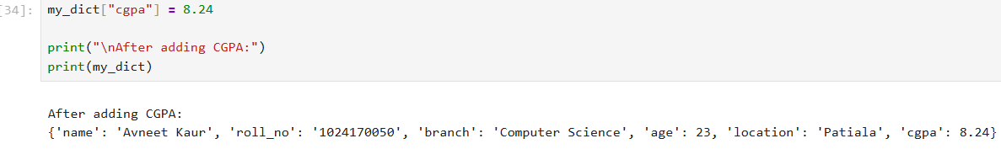
iii. Update the value of “age” by increasing it by 1.
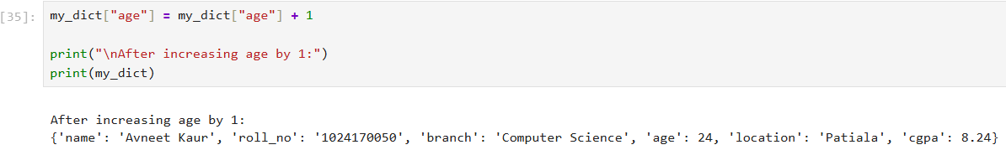
  - Delete the “branch” key using two different methods in two separate copies of the dictionary: once with pop() and once with the del keyword. Explain in one line how pop() differs from del (hint: what does each return?).
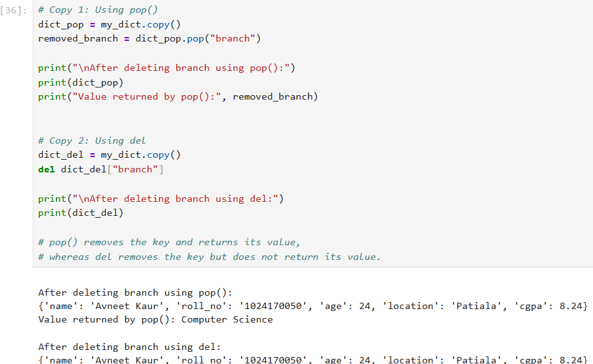
  - Iterate over your dictionary using .items() and print each key-value pair as “key → value”.
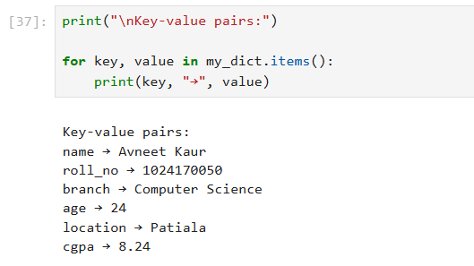
  - Before accessing a key called “email” (which doesn't exist in your dictionary), check for its existence using the in keyword and print a safe fallback message instead of letting the program crash.

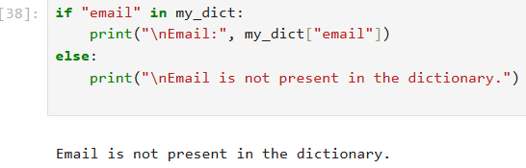
  - Create a second dictionary friend_dict with the same 5 original keys but a friend's (fictional) details. Merge it with your own using the {**dict1, **dict2} syntax, and explain in one line which values “win” when both dictionaries share a key.

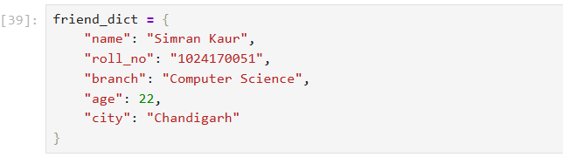

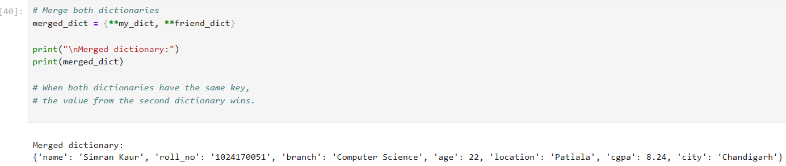
  - Use dictionary comprehension to create a new dictionary containing only the key-value pairs from your original dictionary where the value is a string.
