Avneet kaur
1024170050
Assignment-3 UCS420 “Cognitive Computing”
Q.1 Create a dataset as follow in the table.
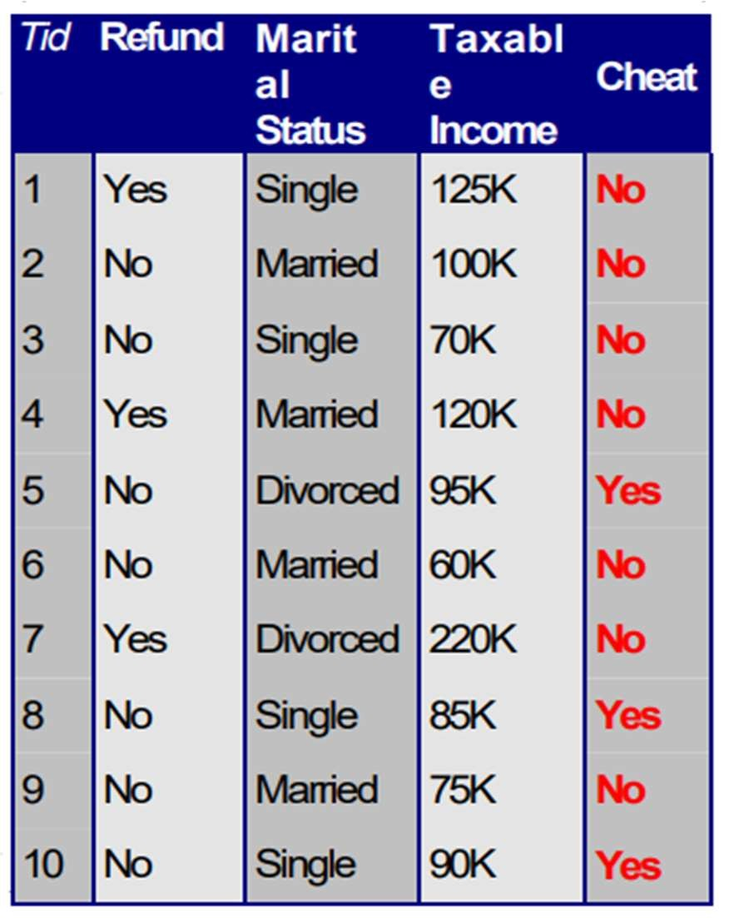
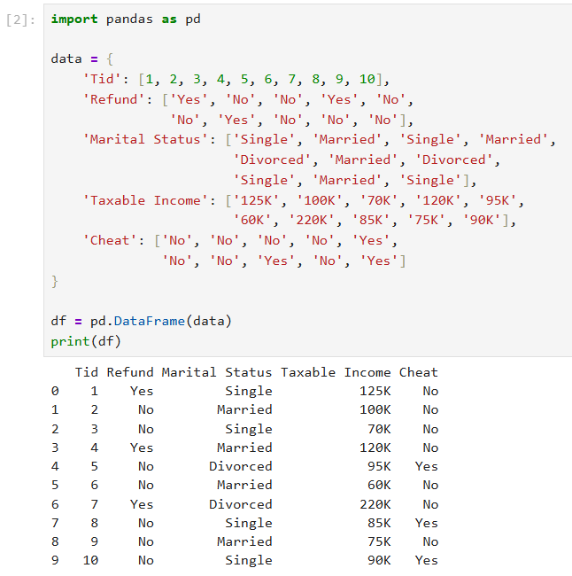
Q.2 From the above table that you have created, locate row 0, 4, 7 and 8 using DataFrame.
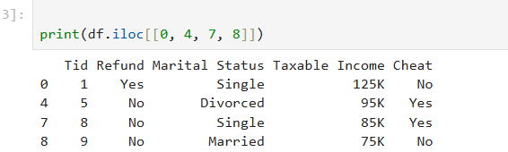
Q.3 Navigate the DataFrame and do the following task for the table created in question 1:
- Select row from index 3 to 7.
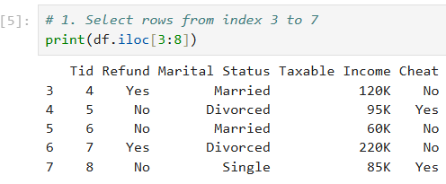
- Select row from index 4 to 8, and column 2 to 4.
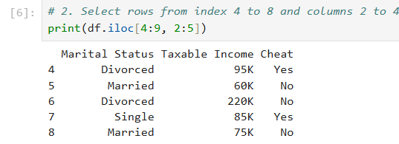
- Select all rows with column index 1 to 3 (include index 3 during selection).
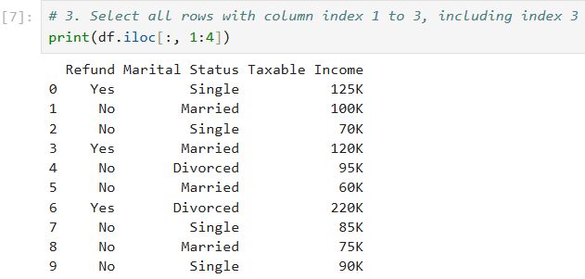
  - Read a csv file and display its first five rows.
Note-: Download dataset from https://www.kaggle.com/datasets/uciml/iris)
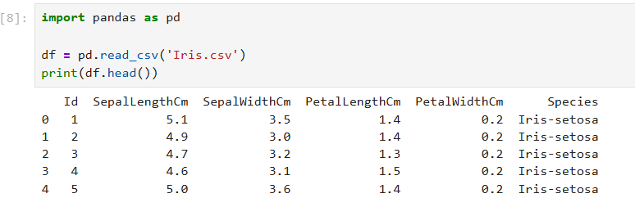
  - From the csv file (uploaded in the Q.4) delete row 4, and delete column 3. Display the result.
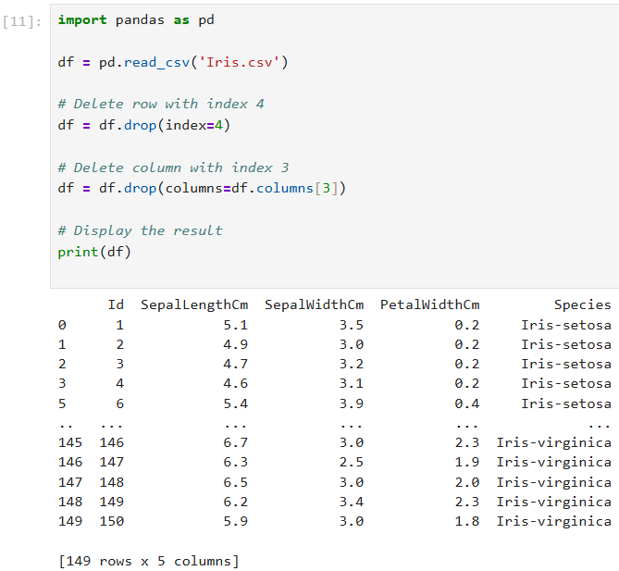

  - Create a sample dataset (employees.csv) containing information about employees in a company.
Employee_ID | Name | Department | Age | Salary | Years_of_Experience | Joining_Date | Gender | Bonus | Rating
101 | Alice | HR | 29 | 50000 | 4 | 2020-03-15 | Female | 5000 | 4.5
102 | Bob | IT | 34 | 70000 | 8 | 2017-07-19 | Male | 7000 | 4.0
103 | Charlie | IT | 41 | 65000 | 10 | 2013-06-01 | Male | 6000 | 3.8
104 | Diana | Marketing | 28 | 55000 | 3 | 2021-02-10 | Female | 4500 | 4.7
105 | Edward | Sales | 38 | 60000 | 12 | 2010-11-25 | Male | 5000 | 3.5
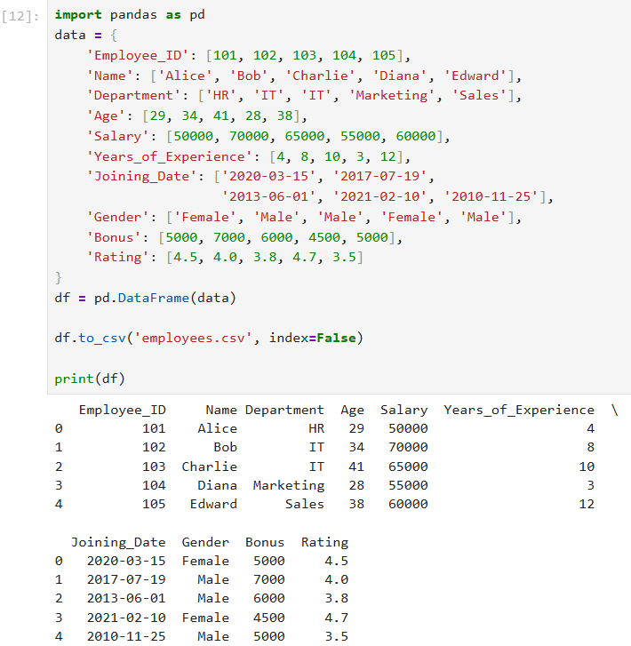
WAP to determine the following using dataset in Q6:

- Shape (number of rows and columns) of the DataFrame.
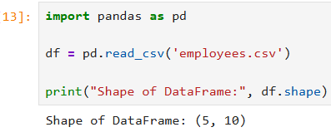
- Summary of the DataFrame that includes the data types and non-null counts for each column.
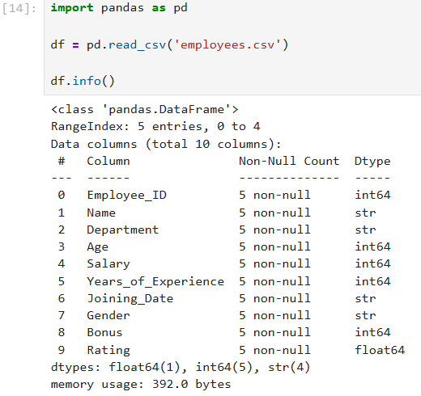
- Generate descriptive statistics.
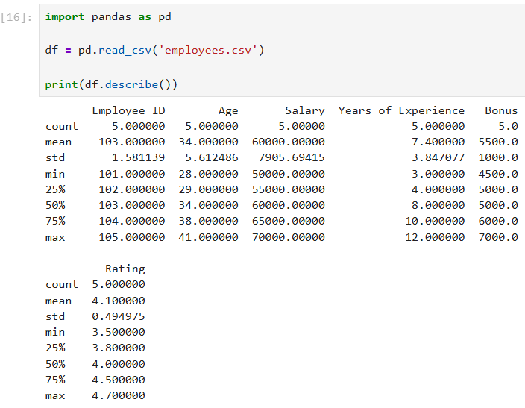
- Display the first 5 rows and last 3 rows of the dataset.
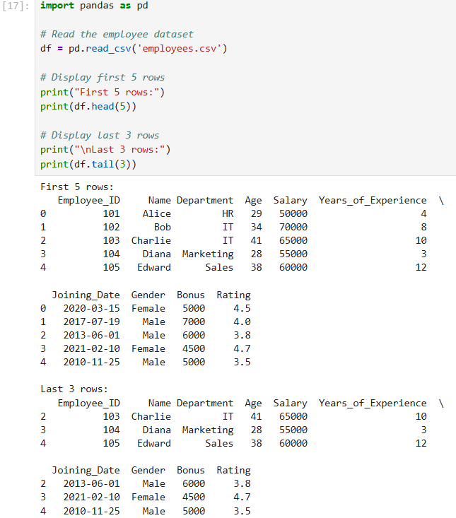
- Calculate the following statistics from the dataset:
  - The average salary of employees.
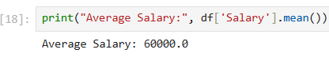
  - The total bonus paid to all employees.
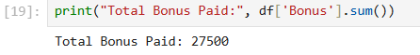

  - The youngest employee's age.
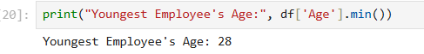
  - The highest performance rating.
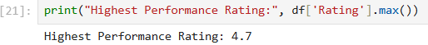
- Sort the DataFrame by the Salary column in descending order.
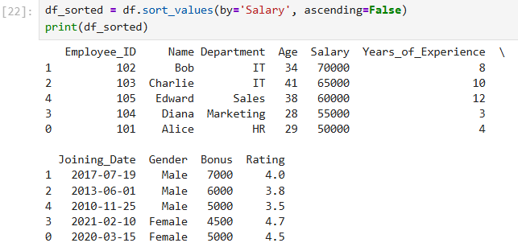
- Add a new column that categorizes employees based on their performance rating:
  - Excellent for ratings >= 4.5
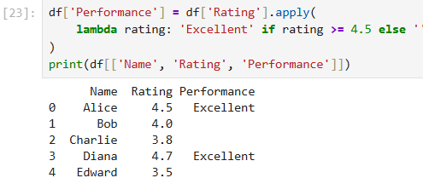
  - Good for ratings >= 4.0 but < 4.5
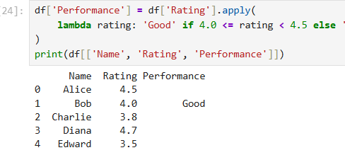
  - Average for ratings < 4.0
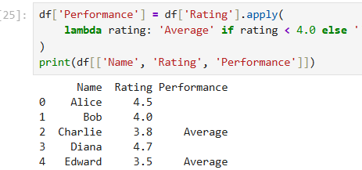
- Identify missing values in the DataFrame.
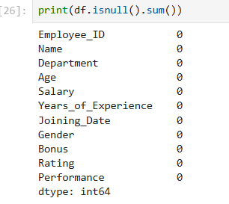
- Rename the Employee_ID column to ID.
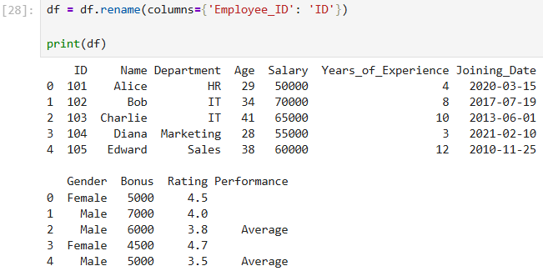

- Find all employees who:
  - Have more than 5 years of experience.
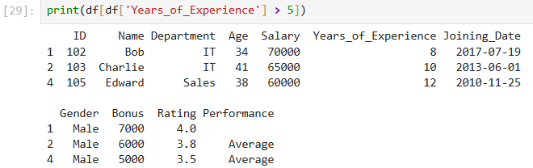
  - Belong to the IT department.
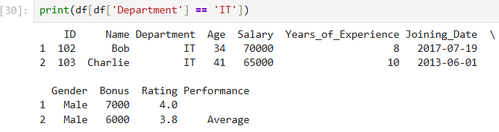
- Modify the dataset by adding a new column, Tax, which deducts 10% of the Salary.
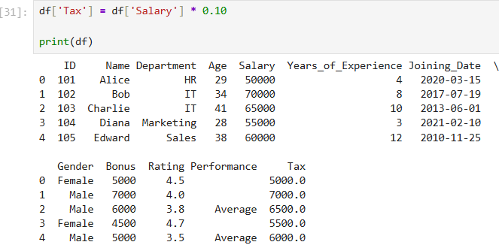
- Save the modified DataFrame (with added columns) to a new CSV file.
