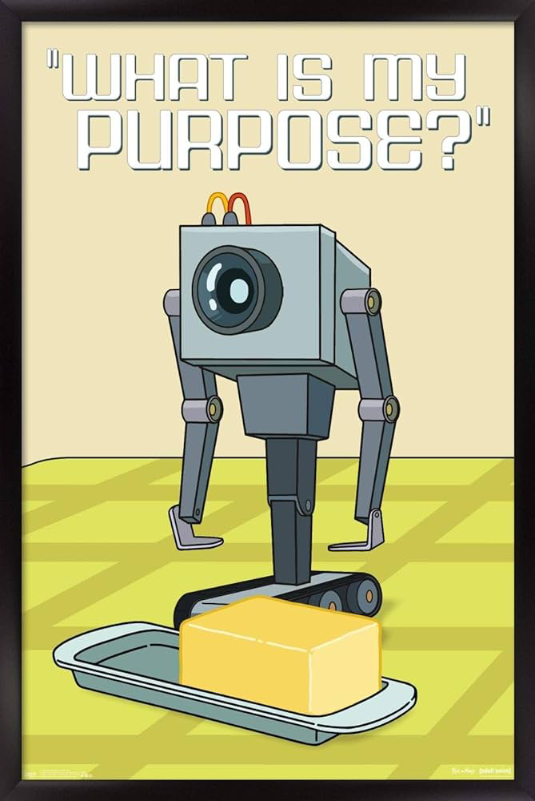
Portraitron
Components:
- UR5e? (robotic arm)
- 2D Camera (one for the person and one for the page?)
- Clipboard
Functionality:
Draw person standing in a specific spot. Drawing is done on paper, then stamped with commemorative stamp and (optionally) handed to person.
Algorithms:
- Create drawing in the program:
  - Take high definition picture of the subject
  - Convert camera input to strokes
  - Strokes order choosing algorithm?
- Drawing:
  - Pick up the pen contraption
  - Draw strokes on page
  - Let go of the pen contraption
  - Pick up stamp
  - Stamping motion
  - Let go of the stamp
- Handing the drawing:
  - Take the page
  - Hand the page to a designated location
Useful sources:
https://swiftsketch.github.io/

