“Independent Study” Paper for Prof. Sakurai Hiroshi
Creation of Meaning – From our Brain to Society
Avner Peled
(Waseda student ID: 97105077-1)

1. Introduction
When I was first exposed to the theories of self-organization and morphogenesis (Sakurai, 2011), it was as if a gap has been closed in my mind. I was always baffled by the apparent contrast between the sense of order and organization in the world, and the infinitely complex and dynamical theory of its underlying mechanisms. Everything in this world interacts – from molecules, to individuals in society and neurons in our brain. The “Butterfly effect” (Lorenz, 1963.) exists in each and every level of interaction, and it appears as if the world should be an ever lasting chaos of wild and random changes. But instead, we have a unified and seemingly organized experience of the world. Slowly changing organized patterns are being formed everywhere, from the shapes of mountains to the unified streams of ideas in society. Evolution provides a partial answer to the mechanisms of improvement and functionality. But still, it does not explain what is the driving force behind the creation of patterns.
It seems that self-organization (Bak et al, 1983) might be the answer to this confusion. The laws of the universe simply do not allow totally random chaos to occur. Instead, as a result of these interactions, patterns are literally forced on the underlying particles and “unknowingly”, they cooperate together in order to emerge a new form of macro-behavior.
I was first introduced to this phenomena through Professor Sakurai's theory of morphogenesis in the mind and in society. While this theory refers to the “mind” as the field of operation with the most basic autonomous unit being the “omoi” (A sort of thought), I would like to try and bring it down to earth and reconstruct it using the biological neuron as the basic unit of operation. This field is already known in the neurobiology world as “Neurodynamics”. While performing this reconstruction I would like to put an emphasis on the matters regarding the problems of consciousness. I believe that neurodynamics is a key element towards trying to solve the “Hard” problem of consciousness (Chalmers, 1995).
Borrowing from the work of neurodynamics pioneer – Walter J. Freeman (Freeman, 2001), I will refer to the creation of pattern in the mind as the creation of “meaning”. Meaning for me is a useful term, because I see it as the basic building block of the world that we are constructing for ourselves in our minds and in our society. From the mash of sensory input which we receive from the world, we self-organize our own meaningful world, which we consciously experience, and according to which we decide and act. The active manifestation of meaning could be called “Intentionality”, since it's our goal directed behavior which we construct in co-ordinance with the environment.
I will start by describing the biological basis of how meaning is created in each of our brains as a result of the dynamic interaction of neurons. In my opinion, creation of meaning is not only a descriptive explanation of the mind, but also has a causal aspect. It is a driving force of our behavior, a source of reward and pleasure and the basis for consciousness. I will try to describe these processes from a dynamical point of view, applying them on various psychological processes. Then, going up the hierarchy levels, I will try to describe the creation of meaning in society and how it can be used to explain social phenomenon.

2. Self-organized criticality in the brain.
Our basic autonomous unit of operation is the neuron cell. Our brain is consisted of billions of neurons, utilizing chemical and electrical signaling to interconnect with one another. I will try to avoid a complex biological explanation as much as possible and explain this matter in a more abstract and conceptual fashion. Having said that, I believe it is essential to describe this phenomenon in detail so I can provide a substantial base for the more complex ideas later on.
The main idea is that dynamic, non linear interactions between neurons, which at first seem completely chaotic, actually emerge discrete and organized patterns in the level of neuron populations (a group of interconnected neurons). It is as if neuron populations magically sync with one another to create ordered electrical oscillations of activity. This phenomenon has been wildly observed all over the scientific community but has been given different interpretations. Walter J. Freeman, in his book “How brains make up their minds” (Freeman, 2001) , provides a good explanation. Below is a diagram of a neuron from his book:
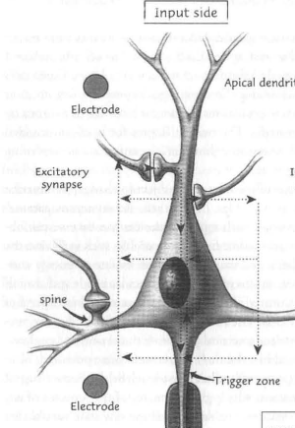

A neuron receives its input from other neurons using multiple branches, called dendrites. It sends output to other neurons using a single pipe called the axon which branches far away to form connections with its destinations . A connection between two neurons is called a synapse. It is important to note that:
- There is a difference between the dendrites and the axon - The sum of the inputs from all of the neuron's dendrites determines whether the neuron will fire its axon pulse or not. On the other hand, the pulse fired on the axon is always exactly the same for each neuron. The dendrites can have an inhibitory affect or an excitatory affect on the neuron. They can either increase or decrease the chance for firing the axon's pulse. Prof. Freeman calls this distinction Wave-Pulse Conversion. The dendritic input changes the amplitude of an electro-magnetic wave in the neuron's “Trigger zone”, and once it passes a certain threshold, the pulse is fired.
- Once a neuron fires its axon pulse, it takes a small period of time to recover before it can fire another pulse. This is called the refractory period.

In neuron populations, several kinds of feedback interactions can occur, as described in this diagram:
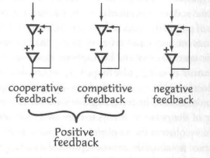
The state of a neuron population can be measured using the sum of wave amplitudes and the collective pulse density. This is called a mesoscopic state, as apposed to the microscopic state of one neuron. Although the Wave-Pulse conversion function of one neuron is linear, between thresholds of the refractory period, because of these feedback interactions, the Wave-Pulse conversion of neuron populations is non linear and creates a sigmoid curve:
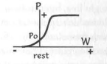
The higher limit of the curve is imposed by the refractory periods and and the lower limit is imposed by the background activity of neurons in the population caused by cooperative feedback interactions. It is important to note that these states are whole population states which emerge out of the micro interactions of the population. The sigmoid curve means that the interactions are non linear (they can increase slowly and suddenly accelerate even under the same stimuli), and that they have a property of stabilization (at some point they stop changing in response to stimuli). Above some level of synaptic connection density, neurons cease to act as individuals and start to act as part of a group. This is called a state transition. The point in which the state transition occurs is called the point of criticality. A mesoscopic state is stable, so when it is excited or inhibited from the outside, it demonstrates a fluctuation but eventually returns to its stable state. In the language of dynamics this is called an attractor. The attractor is self-organized because it is dynamically created as a result of the interactions of a neuron population.
The first type of attractor in a population is called a point attractor. This is the stable state of activity achieved by continuous and circulated positive feedback of excitatory interactions. This is what we measure as spontaneous background activity. When a fluctuation occurs, the population eventually returns to its point attractor. The other type of attractor is of utmost importance and is called the limit cycle attractor of oscillations:

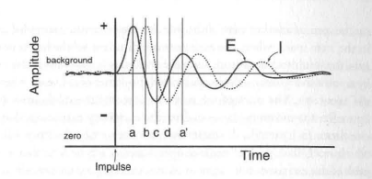
In each population, excitatory neuron are connected to inhibitory neurons in a negative feedback loop. When stimuli occurs, the excitatory neurons excite the inhibitory neurons which in turn inhibit their original exciters (The amplitude rises and then drops). Because of the delay, the excitatory neurons are inhibited beyond their basal level (The amplitude drops beyond the initial level). Then, because of the refractory period of the inhibitors, background activity excites the excitatory neurons and they bounce back (amplitude rises again). This process than repeats itself. If the gain of the oscillation, which is determined by the gain of the synaptic connections, is smaller than 1.0, the state loops while decreasing the amplitude, until it eventually returns to the point attractor (as in the figure). But if it is 1.0 or higher , the oscillation persists. and a thus criticality is reached and a state change occurs. The same oscillation will occur in any gain higher than 1.0 because of the previous discussed non linear limitations. This is in fact the basis of self-organized criticality in the brain.
This self-organization becomes even more interesting when the mesoscopic effect is tested over an entire sensory system in response to stimuli. Prof. Freeman had tested this on the rabbit's olfactory bulb (sense of smell) in response to various odorants (Freeman, 2001). The result is that a global spatial oscillation pattern appears in which the frequency of the oscillation is the same all over the olfactory bulb, but the amplitude differs between different spatial locations. This is called the “AM Pattern” (Amplitude modulation). The frequency always seems to be between 20-100Hz, also called the “gamma” range and can be recorded by an EEG device.
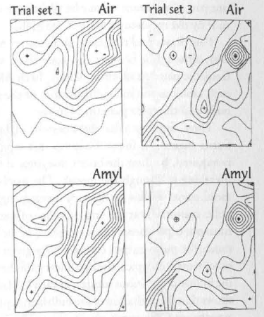
The spatial AM pattern in fact represents an “attractor landscape”.
Between inhalations of an odorant, a single large basal point attractor operates, consisting of many “attractor wings”, representing different mesoscopic neuron populations. When air is inhaled, an AM pattern is displayed, after which the basal attractor reappears. When a familiar or reinforced odorant is presented , the AM pattern changes into a new pattern. If the new odor is irrelevant, an AM pattern fails to form. Here are some important characteristics of AM patterns:
- AM patterns are not constant for a stimuli. In fact, a different AM pattern is shown for each “sniff” of the same odorant. This implies that an AM pattern is related to the entire history of an organism and not just a specific stimuli. Every AM pattern is freshly created and is never like its previous. There is no store of AM patterns in the brain, there are only various spatially organized, ever-changing attractors which shape the upcoming pattern.

- In order for a specific AM pattern attractor to form, certain synaptic connections have to be strengthened in order to enable the oscillation dynamics of negative feedback interactions. According to research, there are two main mechanisms for this:
  - Neuromodulators – these are specific chemicals such as Dopamine and Epinephrine which are released by reinforcement, reward and various other systems. They are said to be controlled by the brain's limbic system which is involved in emotional processing and are a key elements in learning. (Freeman, 2001)
  - Hebbian learning – The Hebb rule (Hebb, 1949) basically states that neuron cells which fire at the same time, strengthen their synaptic connection and will tend to activate each other in the future.
The combination of these 2 mechanisms allow for AM patterns to be formed and “learned” in response to various stimuli. The patterns are first created with the help of neuromodulators, and are then associated to other stimuli using Hebbian learning. This allows for abstraction and generalization. For example, if two sensory receptor cells fired in response to a stimuli, and with the help of neuromodulators, an AM pattern was formed, a similar receptor which only fires one of the two cells, may create the same AM pattern due to Hebbian learning.

- AM patterns are flexible and sensitive - every new AM pattern modifies existing AM pattern in various attractor wings. Any slight change may cause an emergence of a whole new pattern. The non-linear, sigmoid, nature of the neuron population is what gives AM patterns its complex and dynamical nature.
- AM patterns can appear one after another in a sequence. In the language of dynamics this is called a “chaotic trajectory”.

A very unique property of AM patterns in the brain, is that they can also be carried throughout the cortex as a sort of signal. When an AM pattern is formed (for example in a sensory cortex), the fact that all of the waves have the same frequency means that it can be spatially aggregated by the other parts of the cortex and abstracted into a new input, which in turn could form new AM patterns along the cortex. In this way a hierarchy of patterns can be formed in the cortex, adding a whole new dimension of complexity.

These biological characteristics lead us to the assumption that the dynamic creation of new stable AM patterns is in fact the creation of meaning in the brain.

- Creation of meaning
The self-organization of AM patterns in the brain implies a sort of unidirectionality. As opposed to common theories in cognitive neuroscience, there is no direct connection between the stimuli received by our sensory receptors and its processing in the brain. We do not perceive the world, we create it. This is reminiscent of an idealistic view of the world. Although the sensory input provides a driving force for the creation of AM patterns, it does not translate to them. Our conscious experience, our behavior – they are all patterns which we self-organize in our brain. This also presents a solipsistic view of the world - as if each member of society is enclosed in his own world which he created for himself. Yet, as I will further discuss later, we manage to overcome this solipsism through communication.
The mechanism of self-organization sets imagination as the basis of our experience. From the moment we are born, we start creating our world, forming attractors in correspondence with the input we receive from the environment. Through life, we maintain a set of very strong and stable attractors for patterns which we may call “habits”. Every decision that we make has imagination in its base.On every occasion, we create a new AM pattern. Our experience is like a travel through an attractor landscape. High level creativity emerges when we escape from strong attractors. I will expand this discussion in the part about flow and creativity.
AM patterns represent a sort of “code” by which we construct our world. When we create a new AM pattern, it is as if we assign another block of code to this world. It represents our understanding of sensory stimulus, our intention of acting, our awareness and our conscious experience. If an AM pattern is not created in response to a stimuli, we consider that stimuli irrelevant for our intentions. In short, AM patterns are meaning. To quote Freeman (Freeman, 2001):
“AM patterns result from what Aquinas called imagination and what I call the non-linear dynamics of neuron populations, and they result to the meaning of stimuli”
Freeman refers to Thomas Aquinas numerous times in his book, as his theory of imagination resembles the unidirectional creation of meaning from stimuli.
AM patterns of meaning are not a direct result of a stimuli. They emerge from within ourselves. In fact, AM patterns are not to be seen as a reflection of the past. Instead - we create AM patterns as a sort of projection into the future , representing our intended course of action. That said, every AM pattern has a reflection of our past inside it, because it was continuously molded by each experience.
As described in the previous chapter, AM patterns can run in sequence or in parallel, and can be used by higher hierarchical levels to form new AM patterns. This allows us to create complex meaning structures of space and time. Without going to much into the biological explanation, the brain's limbic system (including the Entorhinal cortex, amygdala and hippocampus) is said to be in charge of coordinating the brain's AM patterns into one macroscopic meaning structure (Freeman, 2001). The limbic system maintains a global AM pattern composed of local AM patterns and regulates the mesoscopic state transitions using neuromodulators. For example, in order to navigate our way through a street, it may recognize each portion of the street as a macro AM pattern, and then fire the necessary chemicals that will create the next pattern that will advance through that street.
An AM pattern should eventually reflect our future goal – our intended behavior. But that doesn't imply that all of the meaning which our imagination creates is directly related to some goal. Keeping the analogy to a code, it is like our goals and behaviors are determined by a combination of codes. When we create an AM pattern, we assign a code by which we operate. This code could be a part of something as direct as “I will now pick up this cookie and eat it”, or it could be a part of a more complex goal such as “One day I will start my own company”. It can also be something very deep and indirect such as understanding the meaning of a painting - what some symbol in the painting represents or what the painter is trying to say. It is the significance something has on our lives.
We are repeatedly making predictions throughout life using this code. With the modulation and monitoring of our limbic system, we shape our attractor landscape patterns so that they will fit the environment. When we knock on the table, we expect to hear a certain sound. When we pick up something heavy, we expect to feel its heaviness. When we perform an an action that is a part of some work, we anticipate its consequence. When we make a prediction, we test it using the input from the environment by trying to form an AM pattern. If the environment matches, the pattern is created and further processing begins using the limbic system. If it doesn't match, there is an instability and we reshape our landscape trying to match a new pattern, assign a new code.
Although AM patterns form the code of our memory, an AM pattern is never the same. But then again – none of our actions are ever the same and none of our experiences are ever the same. Our life is a continuous stream of patterns, dynamically changing from one to the other. Prof. Sakurai describes the mind as constantly being in the “edge of chaos”. Ranging between the stable attractors and the unstable, dynamic chaos. In the same way, I think that our trajectory of AM pattern attractors is constantly fluctuating and moving between stability and instability.
Under the laws of Hebbian learning and neuromodulation, the attraction landscape is created. Some attractor basins are deeper than others. The deepest ones are what we call habits. But fluctuations can occur, habits can change and the dynamics of creativity can create new patterns out of the blue. Are we aware of the creation of every AM pattern? Certainly some of our habits and behaviors happen without our awareness. This requires diving into the nature of consciousness.

4. Self Organization of Consciousness
The problem of consciousness is one of the toughest philosophical and scientific problems of this century. Countless of articles have been written and yet no clear answer exists which explains the nature of consciousness. Before approaching the problem, I would like to try and define consciousness as clear as I can. I would refer to two forms of consciousness:
- Qualitative awareness - As written in David Chalmers' influential article “Facing up to the problem of consciousness (Chalmers, 1995), the real “Hard” problem of consciousness is the problem of subjective experience. How does the chemical and electrical operation of neurons emerge our “Qualia”? The redness of red, the feeling of pain, the phenomenological aspect of our experience. Consciousness can be defined as our qualitative awareness to sensory data, but this awareness does not rely on the external world in order to emerge. When we are dreaming, we have qualitative experiences of sounds and colors without any reference to the external world. Being unconscious to something in that sense, would mean to not be aware of its qualitative experience. When someone is talking to us but we cannot hear him because our attention is concentrated somewhere else, it means that we are unconscious of his voice.
- Self awareness – This is our conscious sense of self as a being separated from the rest of the universe. We experience ourselves as an agent making decisions. When we walk home from the bus station out of habit, we are unconscious of our decision to take a right turn in a familiar street. Psychoanalysis may refer to our actions as motivated by the unconscious when they lack this kind of self awareness. Self awareness is also associated with free will. When we are aware of our decisions, we feel as if they are an expression of our free will.

I will try to tackle these two aspects from a dynamical systems perspective, using the biological info which I have provided so far. Jun Tani had investigated the topic of self-awarenesss from a dynamical point of view using robot simulations (Tani, 1998). His conclusion makes sense in a phenomenological point of view – The time in which we are aware of ourselves is when our prediction fails and we enter into an unstable chaotic state. When we are most absorbed in our actions, in a way in which everything goes smoothly and as predicted, we lose self consciousness. The process becomes habitual and our body works automatically switching from one AM pattern to the next. But when our prediction fails, we fail to create a pattern and neurons start firing in an unsynchronized way, generating periodic chaotic behavior. That's the time when we're trying to make the next decision. The emotional systems start to act and modify our attractor landscape so that we can once again fall smoothly into an AM pattern. It is at that point of instability that we feel our free will. The dynamic and unpredictable nature of the brain really implies that anything could happen and our actions are non deterministic. But why and how is it that we feel ourselves at that moment? The feeling of free will is also a 'qualia' which cannot be described. Much like the redness of an apple.
Qualitative consciousness is very hard to explain due to its subjective nature, and also its arguable lack of functionality – even if we did not experience the redness of red, would we still be able to behave the same? No one knows the answer. But one characteristic of qualitative consciousness is easy to notice and that is its unity. While we have sensory neurons responding to micro bits of information regarding sights, sounds, touches etc. we have one unified conscious experience of the world. Since there is no central authority in the brain which can perform this sort of binding, the mechanism for this unity is unknown and creates the problem known as “The binding problem”. For this problem, self-organizing dynamics may come to our rescue. In our brain, there is only one big macro AM pattern of oscillation at any time. This pattern is a sort of aggregation for all of the 'meanings' in the brain and that makes it a perfect candidate for the basis of our conscious experience. But even if a macro AM pattern represents our emergent conscious experience, we still don't know how it is done.
I agree with David Chalmer's opinion (Chalmers, 1995) that the main reason for this “explanatory gap“ is the lack of appropriate definitions in physics. Without adding some reference to qualia in our physical entities, we cannot explain the qualitative conscious experience. Even if we map it into a macro AM pattern in the brain, we are still left only with electromagnetic oscillations which we cannot assign to the nature of our subjective experience.
In my view, the only field in physics which somehow relates directly to our subjective consciousness is quantum mechanics. Experiments such as the double-slit experiment (Jönsson, 1961) and proofs of Bell's inequality (Bell, 1964) show the quantum phenomenas of superposition and entanglement. In short, until we measure the properties of a particle – such as position and magnetic spin, they are undetermined and only reflected in a function of probability. Schrodinger's equation describes all matter in the universe as waves. Not only sound and light but also wood and stone. Only when we measure the properties of a particle, it stops “behaving” like a wave in superposition (in all possible positions) and we see its concrete properties. Entanglement means that if two particles are in some way entangled, a measurement of one particle effects the state of the other, with no relation to their distance. Two entangled electrons or photons can be miles away and only once we measure one of them the other changes accordingly.
A point of conflict which gave birth to many interpretations to quantum mechanics is the definition of “measurement”. What exactly causes the collapsing of a particle wave into concrete properties? Some would say it's the measurement device which disrupts the particle and causes its wave to collapse, but actually there is no proof of that. According to the equations of quantum mechanics, if a particle in a superposition state hits a measurement device – before we look at the result, the measurement device is also in superposition state along with the particle. Thus, only our conscious observance of the measurement device causes the wave function to collapse.
In that case, perhaps there is some connection between our qualitative conscious experience and the quantum nature of the universe. Specifically, perhaps there is some quantum interaction going on between the macro AM pattern and the universe, which emerges properties of qualia. Unfortunately, I am not experienced enough in quantum theories to address this problem. However, some attempts have already been made, notably by Gustav Bernroider (2003), Roger Penrose (1994) and Chris King (2003). To me it seems that as in Chris King's article, the solution might relate to the transactional interpretation of quantum mechanics which involves wave interactions which go backwards in time. Perhaps, in some way, the chaotic system which forms AM patterns – which are a sort of lookout into the future, perform quantum interactions with the material around us and our experience is a manifestation of this process. Of course, this only adds a functional dimension to the problem but the actual properties of the subjective experience still need to be devised inside of this process. There is still a long way to go.
Next I would like to explore how the creation of meaning affects our daily life as a driving force.

4. Creation of meaning as a driving force

A lot of research has been done on what drives us towards some decision. A popular distinction is between rationality and emotion. Supposedly, some decisions are more rational,relying on logical inference, while some are driven by our hormones and emotional system, bypassing logic. As apposed to Kant's description of “pure reason” (Kant, 1781), it is now accepted that human beings are not rational. We always take shortcuts as we are not computers. Even computers aren't able to make the optimal rational decision in a short time.
According to the theory of the creation of meaning through AM patterns, the mechanism for decision making relies on the attractor landscape that we are constantly shaping in accordance with the environment. Our behavior is not predictable because of its complex nature but it is attracted to the attractors which were previously formed by learning and reinforcement.
We also know that the modulators of our attractor landscape are chemical substances released by the limbic system, which is also in charge of our emotional experience. But then, we have to ask the question, when are these neuromodulators released? When do we shape our attractor landscape toward some goal? This dates back to the research done by B.F Skinner on animals, regarding positive and negative reinforcement (Skinner, 1974). Skinner describes several primary or unconditioned reinforcers . These are reinforcers that are not dependent on anything which we have learned from the environment. They are embedded in us through evolution. These reinforcers are directly related to the survival and reproduction of the individual such as consumption of food and water, air and sex. The human mind is more complex than that of skinner's dogs, but it is safe to say that we are still driven by these primary reinforcers.
Now-days, a distinction is made between the modulators which are released during reward seeking and during the consummation of the reward. Dopamine is the primary chemical released during reward-seeking, while during the consummatory act various other reward and pleasure chemicals are released (Baldo and Kelley, 2007).
Hypothesizing on the mechanism of learning through consummatory reward seems rather simple. When performing biological actions which are crucial for our survival and reproduction (such as eating, or having an orgasm), our body releases neuromodulators that modify our attractor landscape and in that way we are learning and to repeat these actions.
But why do we release dopamine during reward-seeking? How do we achieve motivation towards a goal, without actually seeing it yet? I would like to insert a new ingredient into the theory and hypothesize that we always strive to create AM patterns. That is, create meaning for ourselves in accordance with the environment. AM patterns provide us an escape from instability and random behavior into a more flowing motion towards some goal. I would like to even further hypothesize that the act of escaping a momentary chaos of instability, and smoothing it into an AM pattern gives us great pleasure and we strive for that moment. The simple emergence of a an AM pattern which is already set to emerge because of an attractor is not a challenge. In this case, our attractor landscape is already modified correctly. What we sought after is the changing of our landscape in response to instability in order to emerge a new AM pattern out of the chaos.
The biological and physical mechanism which seems most probable to me for seeking the creation of AM patterns is that it is much more energetically efficient. Especially over random chaotic behavior which may or may not eventually land on some primary reinforcer. The more our neurons are synchronized, and we have assigned meaning for every sensory input, the more we are set towards our goals. Then, we are more energetically efficient (Buzaski et al, 2004). Meaning patterns create order in our brains, and allow us to stay focused and to not be distracted by any fluctuation. It would make sense that evolution would favor the creation of such patterns. And how are they created? As I've mentioned before, simply by applying neuromodulators on various synaptic connections (for example using dopamine) such that we increase the negative feedback gain and create the everlasting oscillations. When we create them, we feel pleasure and thus we are motivated to keep creating more patterns. Perhaps a global AM pattern exists, which is in charge of releasing neuromodulators in order create more AM patterns.
While creating AM patterns is favorable, our brain can still tell when we are trying to reach a goal which is negative or dangerous to us. Probably through macro AM patterns of the limbic system. If releasing dopamine to shape the attractor landscape is identified with “wanting”, there should also be a mechanism for “not wanting”. The human amygdala (part of the limbic system) is often associated with human fear and anxiety (Davis, 1992). Perhaps the limbic system is inhibiting the creation of new goal/meaning patterns when it recognizes danger, which is embedded by evolution. Failure to create a pattern can result in instability, over-self-awareness, anxiety and fear.
One prominent theory of pleasure is Mihály Csíkszentmihály's theory of “flow” (Csíkszentmihályi , 1990). According to professor Csíkszentmihály, “flow” is a state of optimal experience, in which one has a sense of balance between one's skill and the challenge presented. It is characterized by a clear view of the goals, immediate success/failure feedback, a high degree of concentration, a distorted sense of time and loss of self awareness. A holistic state which merges action and awareness. In my opinion, this describes a state in which one is highly focused in repeatedly creating AM patterns of meaning out of instability.
I would like to try to describe different variations of the challenge-skill balance:
- High level of skill, low level challenge:
When we have a high level skill and a low level challenge it is as if our attractor landscape is modeled exactly in perfect expectancy for the environment. The AM patterns are created easily, with no instability on the way. This is the state of habit – for example, riding a bicycle. In this state we tend to lose self-awareness of the act and perform it unconsciously. As I have described earlier, I believe that our self-awareness arises during the phases of chaotic instability. When our attractor landscape is an exact match to the environment – such instability does not occur. Although this state doesn't consume energy, it is also not favored. One may say that it is boring. We need creativity in order to advance in life. If we only rely on habits, without creating new meanings, we will not expand.

- Low level of skill, high level challenge:
When he have a low level of skill and a high level challenge, we spend most of our time in instability, trying random things, constantly shaping our attractor landscape until we finally manage to create the correct pattern. This is a state of over-self-awareness, or anxiety. This state is consuming a lot of energy and is definitely not pleasurable.

- Balance between level and skill –
This is the ultimate combination of creation and self-awareness. We jump back and forth between instability and stability, only smoothly. When our skill is in balance with the challenge, it means that our attractor landscape is always almost at a perfect match with the environment. We only need to make slight modifications every time. I hypothesize that the act of smoothing instability to stability is the most pleasurable act, and indeed it is beneficial for the organism. That is why this may be called the optimal experience.

As an analogy, I would ask – why do we like to be surprised? And when? I think that we like to be surprised, but only when we quickly figure out the meaning of the surprise. If we are surprised by something and then puzzled by the meaning, it could lead to a form of stress. But if we immediately understand the meaning, we feel pleasure. That is because we experienced the transition between instability and stability.
I believe that aside from “Flow” the pleasure in the transition from instability to patterns of meaning also plays a crucial role in arts and aesthetics, especially in music. Imagine looking at an abstract art piece. At first, all of the different colors and shapes create a sort of confusion in your head, and you are not able to make much of the meaning. But then, you start seeing all kinds of meanings in the pictures elements. Each meaning, or code, that you gather, gives you pleasure. That is precisely the transition from instability to pattern. Then, imagine you pick up some meaning which is even more complex and which you can relate to your own life experience. Perhaps this is the creation of an even more complex macro-pattern, out of mesoscopic instability.
The relation of music to AM patterns seems to be far more direct than other types of art. According to Edward W. Large (2010) -
“certain kinds of musical structures tap into fundamental modes of brain dynamics at precisely the right time scales to cause the nervous system to resonate to musical patterns”.
I believe that music may put our brain in a more 'harmonic' mode, in which neurons are more synched and exhibit oscillations, which makes it easier to create new AM patterns. Music also causes the release of dopamine (Sutoo and Akiyama, 2004) which as we know, modulates the creation of new patterns.
What exactly is creativity? In my opinion, creativity is the ability to change our attractor landscape. We do this by modulating the synaptic connections which cause neuron populations to oscillate. This process could probably be done intrinsically, using thought and emotion alone, but it is much easier to perform when receiving stimuli from our senses. Once an attractor is escaped, whether it is of a more complex, macro AM pattern, or a simple one – we enter a state of instability, in which the neurons fire irregularly and the chaotic non linear system may go in any direction. Then, using help from emotion and neuromodulators such as dopamine, we increase the synaptic gain of other neurons in an attempt to create a new oscillation. Interestingly, studies have shown a connection between dopamine and creativity (Kulisevsky, 2009). When criticality is reached, the new meaning is formed and we feel pleasure. In the same way, I believe that meaning is created in an entire society and I will try to investigate it in the next chapter.

- Criticality and meaning in society
Because of the unidirectionality of AM patterns, it may seem like every individual is enclosed in his own world of AM patterns, and in a sense this is true. But this doesn't mean that individuals cannot synchronize with each other. For that purpose we have language and communication. By stimulating each other's senses, in response to actions, we shape each other's attractor landscape so that they match our common environment. We have the power to induce AM pattern creation in other members of the society. Through Hebbian learning, these patterns get associated with the sense data, although they do not represent it. I show my friend an apple and say “Apple”, according to the attractor landscape which I had formed earlier. My friend repeats what he heard and says “Apple”. I provide him positive feedback (for example, a smile) and his own attractors gets shaped by emotions. We now agree that this is called “Apple”.
The neuronal interactions which emerge AM patterns are non-linear, because of the nature of neurons and are complex because of the multiple connections between each and every neuron. Society interactions are also complex because every person can interact with every person through the use of language. Especially in the age of the internet and social networks. The ideas of society are also non-linear, because the emergence of communication itself is dependent on the non linear emergence of AM patterns. Thus, we can treat society as just another level beyond the macro level of AM pattern it it can form patterns of its own. Just like neurons are synchronized in the creation of AM patterns, society individuals are synchronized as a result of communication and emerge a global social behavior. I've tried to describe the relations in the following chart :

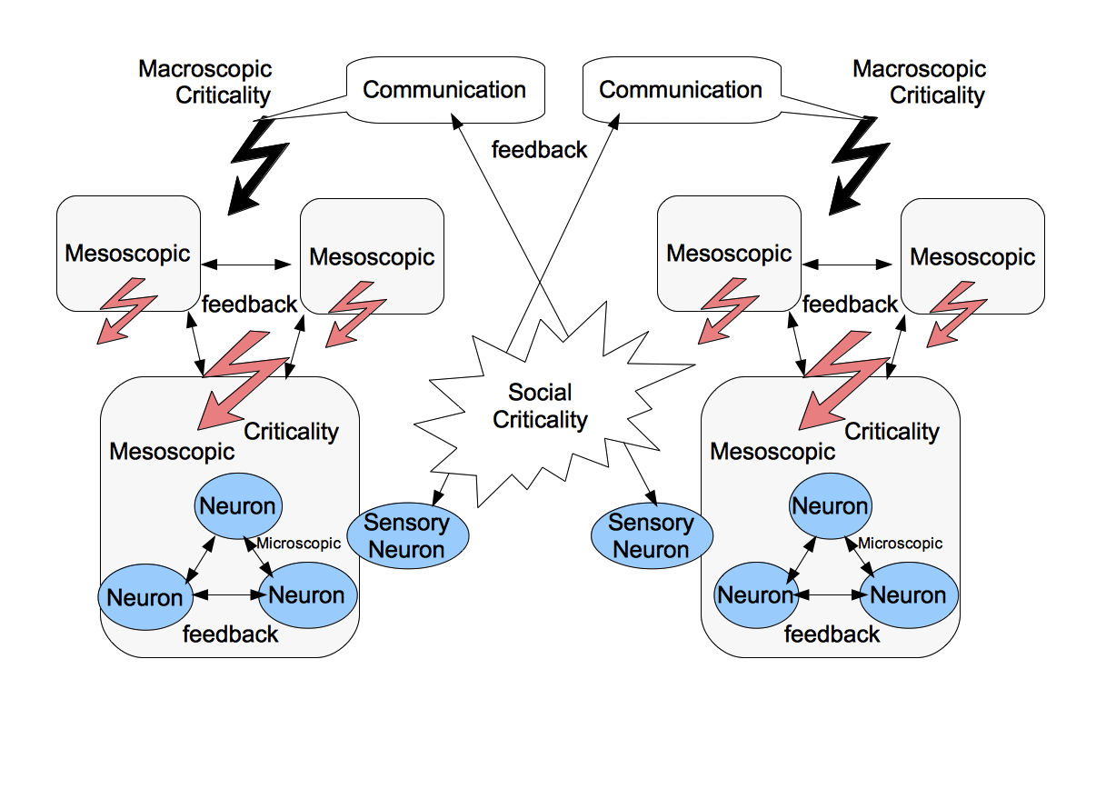
We can treat the emergence of meaning in society as just another level of complexity. The bottom-most level is the neuron. The mesoscopic levels are the AM patterns of neuron populations. The macro levels are AM patterns which aggregate local mesoscopic populations. Above that we have the patterns of society which aggregate the macro patterns of the individuals in the society.
The same operators which affect our decisions in daily life, work during society interactions. We are still looking to create meaningful patterns and are still motivated by the basic elements of survival. Through society, we find ourselves as “meaningful” - both when someone else affects our lives, but notably also when we affect someone else's life. Professor Sakurai calls this “Symbiogenesis” - the collaborative generation of omois. Everyone always searches for the meaning of their life. In the language of neurodynamics, I would say that we are simply trying to arrange our attractor landscape towards some goals. Society enables us to get feedback on our actions, and in that way realize if our goal is correct. For example, if I decide that my meaning in life is to bake cookies – the happy expressions on the customers who eat my cookies, cause my emotional system to act and strengthen the AM patterns that form the code of my behavior towards the goal of making cookies. I feel happy because I have a clearer goal in life, or in dynamic terms, my attractor landscape is more smoothly fit into my actions.
When society reaches criticality, a new goal emerges for the whole society. How does that happen? Society doesn't have a brain of its own, but instead, its ideas are reflected in the brain of each member of the society. When a person has a pattern of meaning formed inside of him, he expresses it through communication. The feedback of society, being positive or negative, releases emotional neuromodulators which allow him to modify his pattern accordingly. Each interaction has consequences on everybody's patterns of meanings. What I say to my friend, can eventually come back to me in a circular feedback fashion, just like with neurons. Thus, at some point which we cannot predict, the communication “gain” is high enough so that the idea persists within the entire society. At this point trends emerge, or even social revolutions.
I agree with professor Sakurai about the role of music in the emergence of social phenomenon. Musicians act as prophets, expressing the meaning patterns which they have formed through social interactions. I would like to add that according to the findings on the neurodynamics of music and the way our brain resonates to music, music may have a biological basis for shaping the attractor landscape of society. The oscillating like structure of music makes it easier for our brain to create new patterns and destabilize old attractors. Professor Freeman also refers to the role of music in social interaction (Freeman, 2001) through the tradition of tribal dance and the phenomenon of trance. He believes that intense experiences like these enable new assimilation of meaning over old ones, through a process he calls “unlearning”. In my opinion, this may be due to the resonating nature of music. He also mentions the ability of physically stressing situations such as in the army's boot camp, to induce new meaning into the individual. This may be related to the release of chemicals under life threatening situations which causes attractor landscape shaping. Just as like we feel we owe our life to someone who has saved us from a life threatening accident.
Another interesting social phenomenon is the apparent lose of the sense of responsibility in individuals like in the case of the holocaust, where atrocities were performed by ordinary men. We have seen that the more we have a clear view of our goals and our place in the world – that is, our attractor landscape is very strong and stabilized,, the more we lose our self awareness and our ability to consciously examine our actions. Therefore, when through society, we create our code and patterns of meaning, receive positive feedback and participate in the global emergence of the social goal, we tend to lose perception of ourselves and view ourselves as just another screw in a large machine. I think this has the same basis such as driving the car out of habit, only in a much more complex pattern of meaning. That may be the origin of the common term “I was only doing my job” . We all want to be meaningful in this world, but sometimes we get lost in our meaningfulness and lose the ability to step out and see the collective pattern of meaning which was formed in society. In the same way, the synchronized microscopic neurons are unaware of the emergence of a pattern in the mesoscopic level. And the mesoscopic oscillating populations, are are unaware of their role in creating a macro pattern throughout the cortex.

- Conclusion
The field of neurodynamics is only beginning. Large parts of this theory are mainly logical speculations with hardly any empirical basis. But the rules of the universe work at each and every level – from the tiniest particles to the patterns of an entire society. It is often said that the Mandelbrot pattern, which exhibits pattern formation from a non-linear complex system, is the thumbprint of god. I tend to believe so.
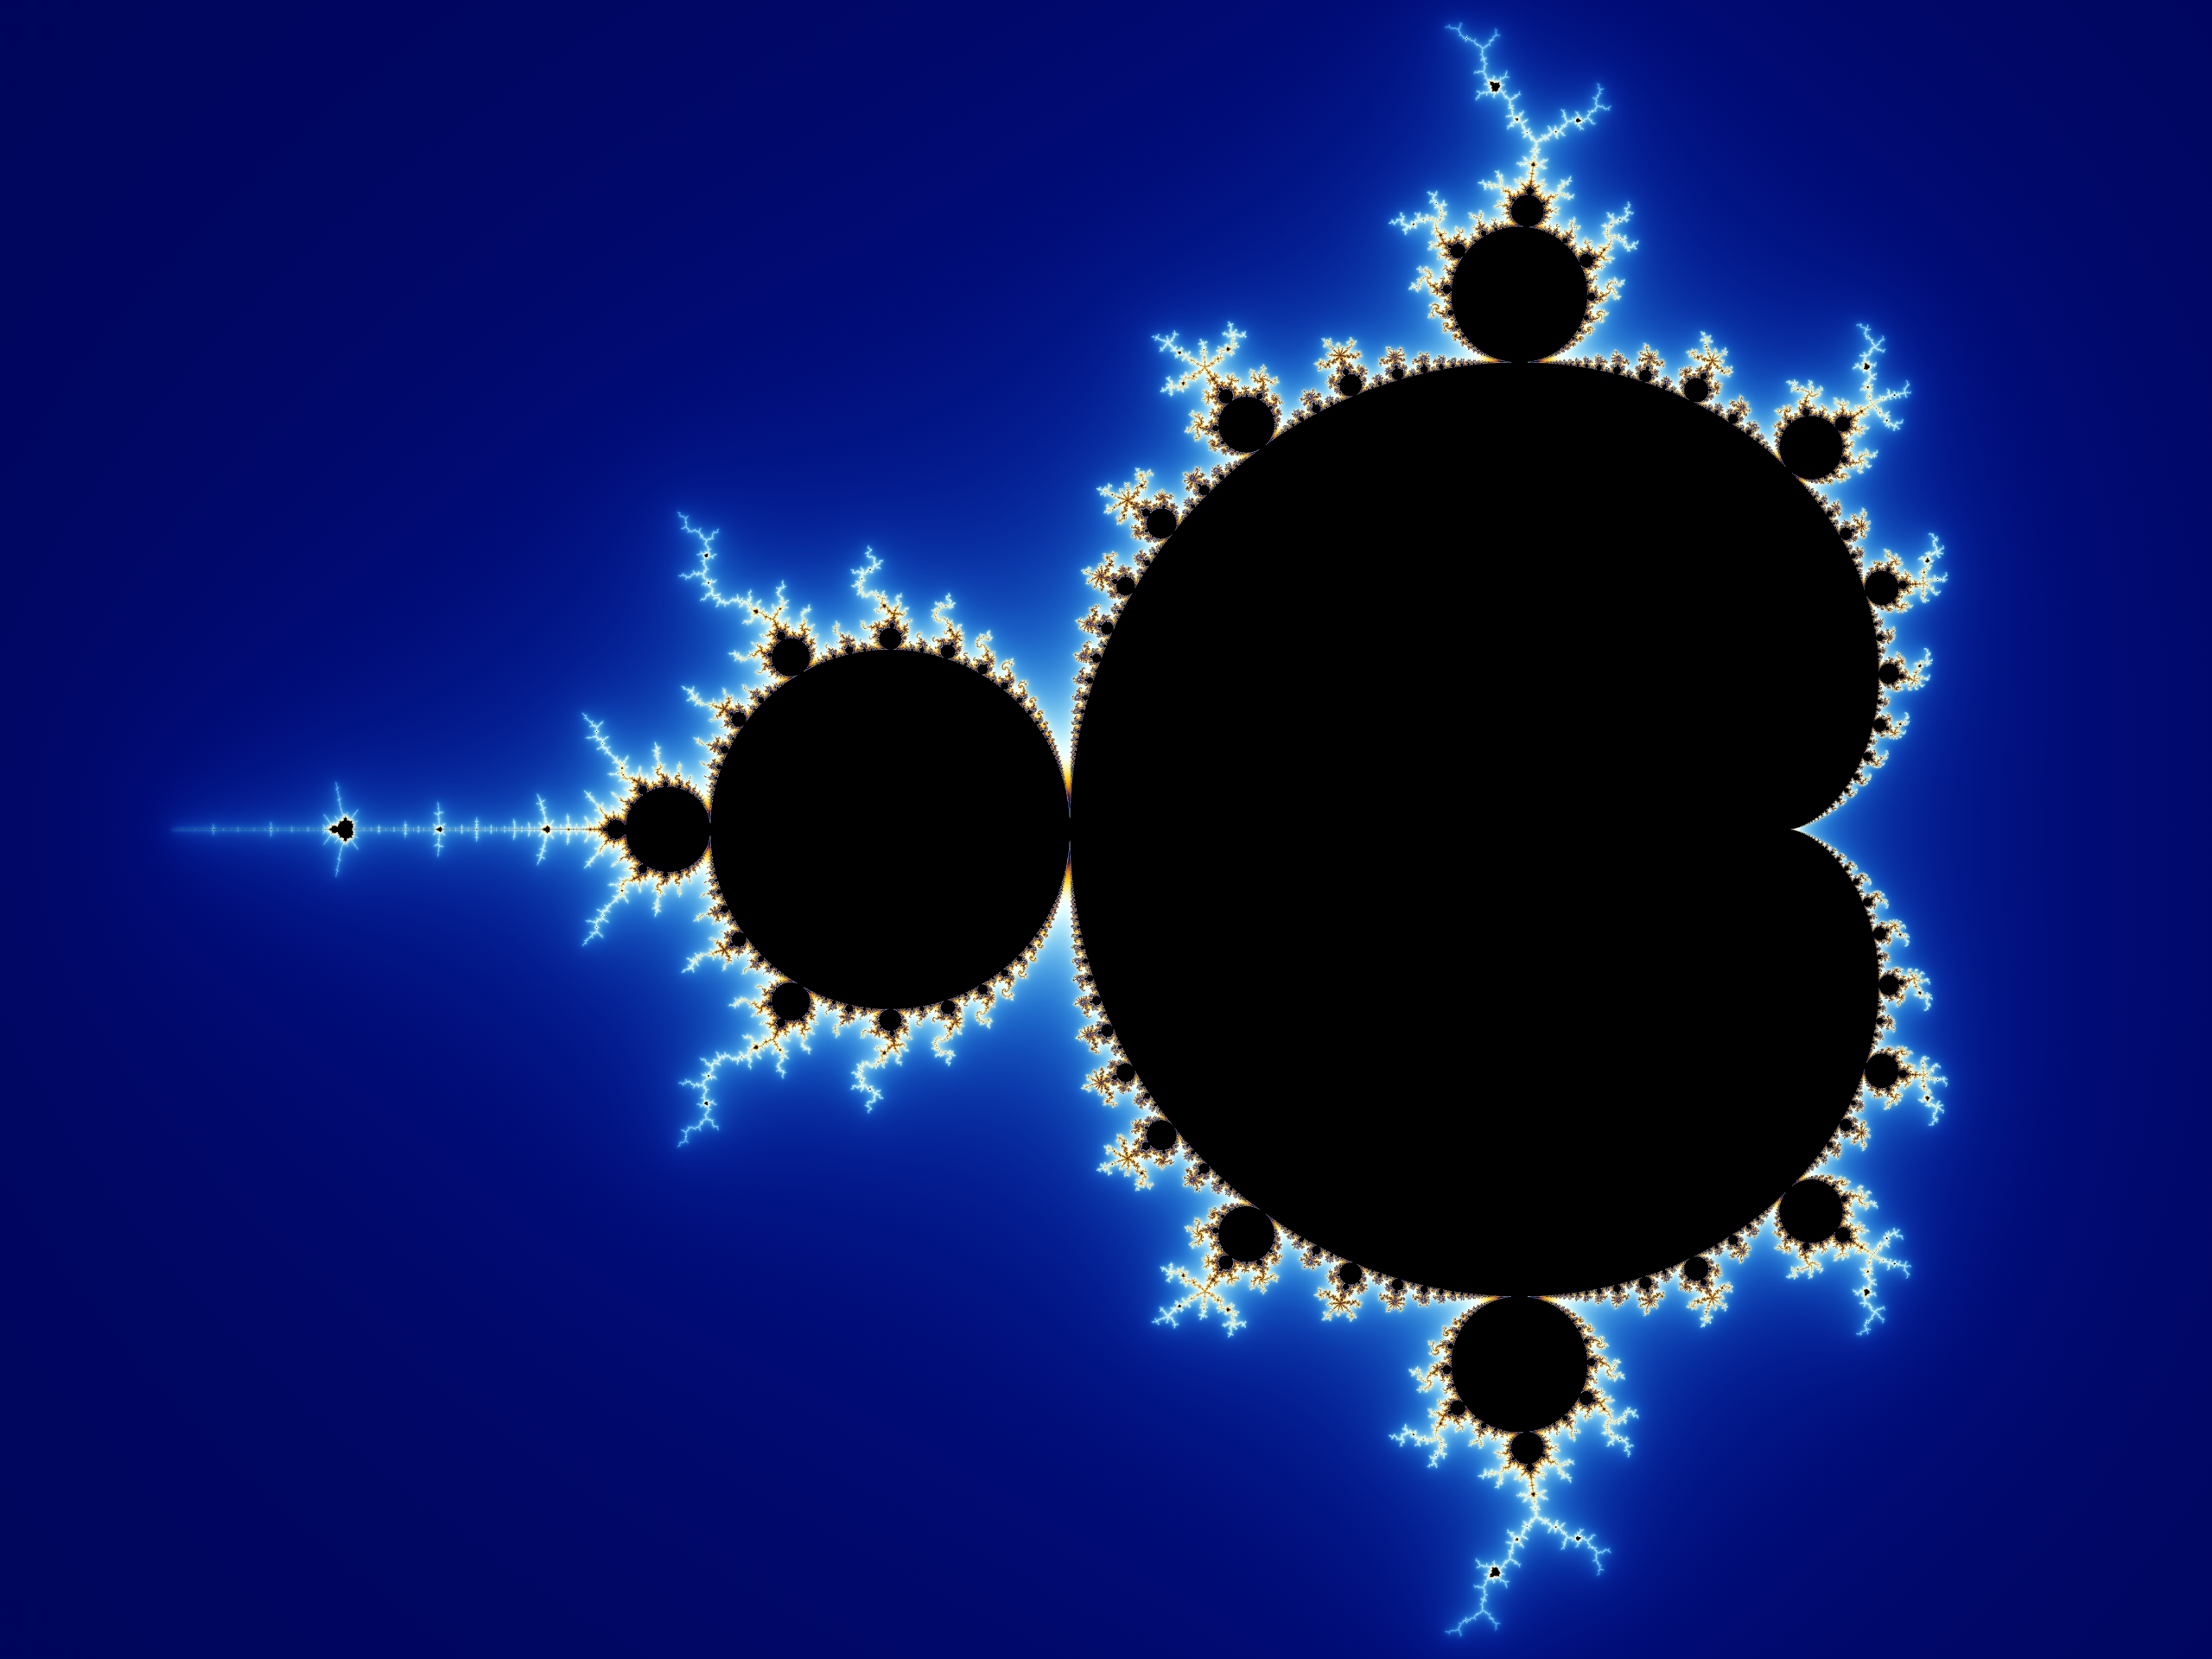

- Bibliography

Bak, P., C. Tang, and K. Wiesenfeld. 1987: Self-organized criticality: an explanation of 1/f noise. Phys. Rev. Lett. 59, 381-384.
Baldo, B. A., & Kelley, A. E. 2007. Discrete neurochemical coding of distinguishable motivational processes: Insights from nucleus accumbens control of feeding.
Bell J.S. 1964: "On the Einstein Podolsky Rosen paradox". Physics 1 #3, 195
Bernroider, G. 2003: Quantum-neurodynamics and the relation to conscious experience. ISSN 1303 5150
Buzsaki G, Draguhn A 2004. "Neuronal oscillations in cortical networks". Science 304 (5679): 1926–1929. doi:10.1126/science.1099745
Csíkszentmihályi M. 1990: Flow: The Psychology of Optimal Experience, New York: Harper and Row, ISBN 0-06-092043-2
Chalmers, D. 1995: "Facing Up to the Problem of Consciousness" Journal of Consciousness Studies, 2 pp. 200-219
Davis M. 1992: The role of the amygdala in fear and anxiety. Annu Rev. Neurosci 15:353–375.
Freeman, W.J. 2001: 'How Brains Make Up Their Minds.' Columbia University Press, New York
Hebb, D. O. 1949: The Organization of Behavior: A neuropsychological theory. New York: Wiley.
Jönsson C. 1961: Zeitschrift für Physik, 161:454–474
Kant, I. 1781: , Critique of Pure Reason, trans. P. Guyer and A. Wood (Cambridge: Cambridge. Univ. Press, 1998).
King C.C. 2003: Chaos, Quantum-transactions and Consciousness, NeuroQuantology, Vol. 1(1): 129-162;
Kulisevsky J. 2009: Changes in artistic style and behaviour in Parkinson's disease: dopamine and creativity. J Neurol 256:816
Large, E. W. 2010 -. Neurodynamics of music. In M. R. Jones, A. N. Popper & R. R. Fay (Eds.), Springer Handbook on Music Perception. New York: Springer‐ Verlag.
Lorenz, E.N. 1963: Deterministic nonperiodic flow. Journal of the Atmospheric Sciences 20, 130–41.1
Penrose, R. 1994: Shadows of the mind. Oxford: Oxford University Press.
Sakurai, H. 2011: ‘Selected Topics in Sociology (SILS) 2011'
Skinner, B. 1974: About Behaviorism, New York: Random House.
Sutoo D, Akiyama K 2004: Music improves dopaminergic neurotransmission : demonstration based on the effect of music on blood pressure regulation. Brain Res 2004;1016:255-262.
Tani, J. 1998: "An interpretation of the `Self' from the dynamical systems perspective: A constructivist approach", Journal of Consciousness Studies, Vol.5, No.5/6, pp.516-542

