Doctoral Candidate in Digital Learning

Applicant statement

Avner Peled

11/2019

# Statement

With great determination and humility I am applying for the position of Doctoral Candidate in Digital Learning in the Learning Environments research group at the Aalto Media Lab. Following the completion of my Master’s thesis at the media lab: *Soft Robotic Incarnation* (Peled, 2019), I wish to carry on the same research path that brought me to my current state, but to expand on it, and induce bifurcations that would lead me to unexplored territories of soft robot mediation. I intend to persist with an active and exploratory approach that adjoins scientific research with philosophy, and philosophy with design and artistic practices, not forgetting the initial motivation that brought me to the media lab, the dire need for creative and technological solutions in the Israeli-Palestinian conflict.

During my doctoral studies, I aim to design and produce the next generation of my soft robotic telepresence: HITODAMA, as well as deploy it in public spaces both in Israel and in Palestine. At the same time, I will perform local case studies in various fields in Finland, focusing on public spaces and educational systems. I hope to initiate international research collaborations, not only in Japan as I have already done in my Master’s thesis, but also in Israel where cutting edge research in the psychology of conflict and in expressive robotics is taking place. The work on HITODAMA in my Master’s thesis has taught me a great deal of valuable lessons which will serve my greatly as I proceed toward the next steps. I have devised the following draft for a research plan based on the conclusions and evaluations of my Master’s thesis, as well as my future aspirations for the field.

# Research overview

## From reification to incarnation through user experience

In my Master’s thesis, I investigated and categorized various ways in which a remote, re-embodied individual is experienced by the local interlocutor who is interacting with the mediating robot. I am primarily interested in the depth, authenticity and presence of the remote individual’s inner, irreducible qualities, as they are expressed through the robot. I began to materialize these notions nominally through phenomenological terms such a flesh (Merleau-Ponty, Lefort, & Lingis, 1968) and logos (Edgar, 2012; Rancière, 1999). A spectrum could be thought-of (see fig. 1), describing the range of of phenomena as the figure of the stranger is incorporated into the mind of the individual. On one end: re

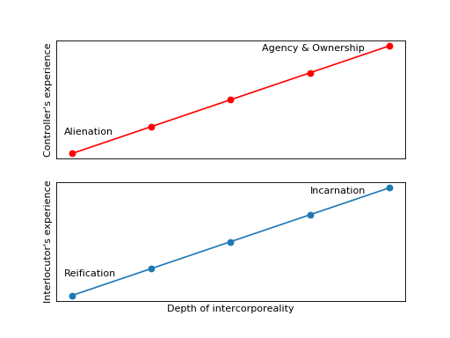

Figure 1: Interaction through robot mediatoin ([Source code](generated/1745353795726075950.txt), [high res.](generated/1745353795726075950.hires.png))

# Time-line

# Summary

# References

Edgar, O. (2012). *“Things seen and unseen”: the logic of incarnation in Merleau-Ponty’s ontology of flesh*. The University of Nottingham.

Merleau-Ponty, M., Lefort, C., & Lingis, A. (1968). *The visible and the invisible : followed by working notes*. Retrieved from <https://aalto.finna.fi/Record/alli.761571>

Peled, A. (2019). *Soft Robotic Incarnation*. Aalto University.

Rancière, J. (1999). *Disagreement: politics and philosophy*. Minneapolis: University of Minnesota Press.