Telerobotic intergroup contact: acceptance and preferences in Israel and Palestine.
Avner Peledª*, Teemu Leinonenª, and Béatrice Hasler^{b}
ªDepartment of Media, Aalto University, Espoo, Finland; ^{b}Sammy Ofer School of Communication, Reichman University, Herzliya, Israel
*avner.peled@aalto.fi
Provide short biographical notes on all contributors here if the journal requires them.
Telerobotic intergroup contact: acceptance and preferences in Israel and Palestine.
Type or paste your abstract here as prescribed by the journal’s instructions for authors. Type or paste your abstract here as prescribed by the journal’s instructions for authors. Type or paste your abstract here as prescribed by the journal’s instructions for authors. Type or paste your abstract here.
Keywords: word; another word; lower case except names
Subject classification codes: include these here if the journal requires them

1. Introduction

3. Method

3.1. Survey
On March 22nd, 2021, an online, anonymous survey was launched simultaneously in Israel (targeting only Jews) and Palestine (West Bank and Gaza). We reached out to participants in Israel through a surveying company and in Palestine through a paid research assistant. The survey included both binary/scale questions as well as open-ended questions divided into four main parts:
- Demographic information.
- General attitude toward robots and the outgroup.
- Opinions and preferences on casually meeting people via telerobotics.
- Opinions and preferences on the use of telerobots for intergroup contact.
The survey was published in Hebrew and Arabic and answers to all open-ended questions were all translated into English for analysis. The survey allowed participants to express no interest in intergroup contact or telerobot operation, therefore skipping over the corresponding questions, without asking further details on the preferences of the participant. The survey was open for nearly one month, until April 19th 2021.

3.2. Sociopolitical context
The survey took place in the midst of the ongoing struggle against the global COVID-19 pandemic. At the time, partial restrictions were taken place in both Israel and Palestine. According to atOur World in Data (Mathieu et al., 2021) in March 2021 Israel had higher rate of daily cases than Palestine (about 60 per 1 million compared to 2 in Palestine), but was also significantly ahead of Palestine in its vaccination campaign. More than half of the population in Israel already received their second dose of the vaccine in March 2021, while in Palestine, vaccine coverage was virtually nonexistent, with less than 0.2 percent of the population being fully vaccinated. This was, in part, due to Israel’s control over the passage and authorization of medical goods in Palestine, and in part due to the overall gap in the nations’ capacity to obtain vaccines (Dahdal et al., 2021). At the same time, the COVID-19 pandemic pushed telerobotics (and remote presence in general) to the center-stage, as many were seeking for solutions to remote operation in healthcare, work, and education (Shen et al., 2021).
In the political sphere, the elections in Israel had just ended for the fourth time without a clear winner. However, the possibility for a new administration under Naftali Bennett, which continued to form in the coming months, was beginning to surface. In the United States, the Trump administration was replaced a few months earlier by that of Joe Biden. The Trump administration has carried a distinctive Pro-Israeli tone, largely dismissing the national aspirations of the Palestinian People (Teran, 2021; Viveash, 2021). The position of the Biden administration was a more neutral one, but still committed to Israel, as were previous administrations throughout the history of Israel (Chomsky, 1999). It is important to note that the survey took place roughly one month before tensions between Israelis and Palestinians in Jerusalem reached another boiling point, leading to extensive military conflict with Hamas in Gaza (dubbed operation _Guardian of the Walls_), sparking a severe level of violence and raising once again claims for war crimes and human rights violations.

3.3. Participants
A total of 624 participants partially completed the survey (328 in Israel and 296 in Palestine), out of which a total of 556 respondents completed the entire survey (291 from Israel and 265 from Palestine).
Out of the total 624 respondents, 310 were male (167 in Israel and 143 in Palestine), 312 female (159 in Israel and 153 in Palestine); 2 did not disclose their gender (both from Israel). Total respondents aged between 13 and 71 (M=35.31, SD=13.48), between 13 and 71 in Israel (M=36.09, SD=14.23) and between 15 and 71 in Palestine (M=34.45, SD=12.57). No statistically significant age difference was found between the groups (p=0.127).
Participants were also asked to rate their level of tech confidence as a value between 1 and 5. Israelis had a significantly higher level of tech confidence (p<0.01) with a mean value of 3.8 (SD=1.04) compared to 2.87 within Palestinians (SD=1.32). Israelis were also significantly more likely to own a smartphone (p<0.01) or a laptop (p<0.01)

3.4. Measurements
This section details the parameters that were measured in each of the four parts mentioned above. The complete set of questions is available in Appendix A.

Demographic information
The survey was anonymous but the participants were asked to specify their age, gender, and spoken languages. The nationality of the participants was hard-coded into the survey depending on whether it was distributed via the Israeli survey company or the Palestinian research assistant.
In addition to basic information, we asked participants to estimate their level of tech confidence on a 1-5 scale. We also queried whether participants owned a smartphone, laptop, and whether they have previously interacted with a robot. Finally, we asked the participants regarding their intergroup contact experience: if they have friends from the other group and whether they have previously participated in organized meetings with the other group.

General attitude toward robots and the outgroup.
General attitude toward robots was measured using the NARS ranking (Negative Attitude toward Robots Scale) that includes a collection of statements that the participants rank between 1 (Strongly disagree) and 5 (Strongly agree). We used a trimmed-down version of the ranking which included the S1 and S3 (inverse) subscales from the work of Tsui et al (2010) on attitude toward telepresence robots. A higher ranking on the scale meant a more negative attitude toward robots. Therefore, the standard S1 scale included statements such as I would feel nervous operating a robot in
front of other people, while the S3 scale included statements such as I feel that I could
make friends with robots. Overall the ranking included 11 questions, 6 from S1 and 5 from S3.

The attitude toward the outgroup was measured using a feeling thermometer. Feeling thermometers are a common measurement of explicit prejudice toward social groups (Lavrakas, 2008; McConnell & Leibold, 2001; Miller et al., 2004). Participants rate their general feeling toward the group using a scale from zero (not favorable) to a hundred (most favorable). Additionally, we asked the participants to rate their general feeling toward robots using a feeling thermometer. The method was not previously used with robots except with some inconclusive reports by Crawford and Brent (2019), but we wanted to test its efficacy in correlation with the NARS scale and other results.

Opinions and preferences on casually meeting people via telerobotics.
To assess the general interest of participants in telerobotics, they were first presented with an illustration depicting the scenario of operating a telerobot situated in a remote location via a mobile phone. Participants ranked their level willingness to a number of subjunctive statements between 1 and 5 (Definitely not to Definitely yes): would they approach a telerobot at a public space, would they use one in their home, or would they be interested in operating a telerobot in a remote location. They also answered open questions about the difference between a robot-mediated conversation and face-to-face, what kind places would they like to visit with a telerobot, and what would they have the robot perform.
The next set of question had to do with preferences on the appearance of the teleoperated robot. Those questions were skipped in case the participants expressed no interest (marked either 1 or 2) in operating a telerobot. Participants had to choose one of several categories of appearance: human, animal or plant, machine, or an abstract shape. Following their selection, they were queried on how their robotic avatar would reflect their identity. We offered multiple aspects in which the robot could appear similar to its operator: nationality, age, gender, voice, religion, or other physical accessories that reflect ones identity. Participants were also able to select whether they would not reveal anything about themselves, or try to be someone else through the robot.
Following, we asked participants about what features they would like to have in their telerobot. Participants rated a list of features from 1 (not at all important) to 5 (very important). The list included features that we identified in our theoretical review (Peled et al., 2020) as ones that may benefit intergroup contact scenarios. Those included: Speech translation, moving around the space, making hand gestures, providing touch feedback, showing emotions, showing online content (such as videos and images), showing personal content (such as a private photo file), playing games, and suggesting conversation topics. Additionally, we presented three options of anonymity during the conversation: anonymity only for the operator (the face of the operator is not visible but they can see the interlocutor), for both, or for none. The last question in this section allowed participants to type freely what other features they would like.
Finally, we asked a yes/no question on whether participants would be interested in learning how to build their own robotic avatar.

Opinions and preferences on the use of telerobots for intergroup contact.
Once the participants completed the sections on telerobot and avatar design preferences, they were presented for the first time with the notion of using a telerobot to communicate with members of the outgroup. We first asked to about the general attitude toward the outgroup using the feeling thermometer mentioned above, and then about the level of interest from 1 (Definitely not) to 5 (Definitely yes) in meeting a member of the outgroup via four scenarios: a telerobot operated remotely via a smartphone, a puppet robot performing remotely in public location (see next section), a face-to-face meeting, and an online video chat.
Participants who marked either 1 or 2 in both of the telerobot-based forms skipped to the end of the survey. Those who expressed at least some interest in meeting an outgroup member using a telerobot were then presented with a similar set of questions regarding the preferred identity of their avatar and the preferred feature-set of the telerobot. Finally they were presented with two open questions regarding their hopes and their concerns about meeting a member of the outgroup through a robot.

Interest in telerobotic puppets
The scenario of telerobotic puppets was first presented following the questions on casual telerobotic preferences. An illustration and description of the idea presented the participants with the opportunity to remotely perform in front of an audience. This was followed by a questioning the level of interest in performing a robotic puppet show from1 (definitely not) to 5 (definitely yes). To those that answered 3 (undecided) and above, we presented an additional open question asking the participants where they would perform and what kind of performance it would be.
When presenting the possibility of using telerobots to interact with the outgroup, we listed performing a remote puppet theater as one of the options to meet the outgroup. Finally, we presented the option of performing the robotic puppet theater together with a partner for the outgroup so that it is performed simultaneously in both locations. We presented an illustration of the scenario and once again queried nuestioning the level of from1 (definitely not) to 5 (definitely yes). To those that answered 3 (undecided) and above, we presented two additional questions, one for selecting the type of performance: political satire, children’s theater, adult drama, situational comedy, or other, and an open question asking the participants to describe the performance in detail.

4. Results

4.1. General attitude toward robots and the outgroup

Correlation between the feeling thermometer and the NARS scale
The feeling thermometer and NARS scale were found to be negatively correlated (R=-0.67, p < 0.01) – A lower (less favorable) value on the feeling thermometer correlated with a higher (more negative) score on the NARS scale.

Correlation between technological confidence and experience with attitude toward robots.
The level of tech confidence predicted the result on both the NARS scale and feeling thermometer. A higher level of confidence predicted a lower result on the NARS scale and a higher value on the feeling thermometer, meaning a more favorable view of robots (R=-0.16,p<0.01). The variables of having a smartphone, a laptop, or previous interactions with robots did not..?

General attitudes toward robots
In general, Palestinians had a more favorable attitude toward robots, both when using the NARS scale F(1,614) = 46.9, p < 0.0, η_{p}² = .07 and the feeling thermometer F(1,609) = 25.45, p < 0.1, η_{p}² = 0.04. This effect remains also when controlling for technological confidence. Additionally, while Palestinian men and women did not have a significant difference between them, Israeli women had a significantly more negative attitude than Israeli men in both NARS: t(326) = 3.3, p<0.01, and the feeling thermometer: t(314)=-4, p<0.01. In terms of previous experience, Israeli participants had significantly more prior interaction with robots (χ2(1) = 38.35, p < 0.01).

General attitudes toward the outgroup
Both groups scored low values in the feeling thermometer toward the other group. Nevertheless, the attitude of the Palestinian participants toward Israelis was significantly lower than that of the Israeli participants toward Palestinians: F(1,561) = 210.29, p < 0.1, ηp2 = 2.73 (see figure 1). The mean thermometer score of Palestinians toward Israelis was 12.92 (SD=17.28) while the mean the score is Israelis toward Palestinians was 38.48 (SD=24.25). In terms of demographics, gender did not have an effect, but age was a predictor only for Palestinians (p < 0.013). An older age of a Palestinian participant predicted a lower results on the feeling thermometer.
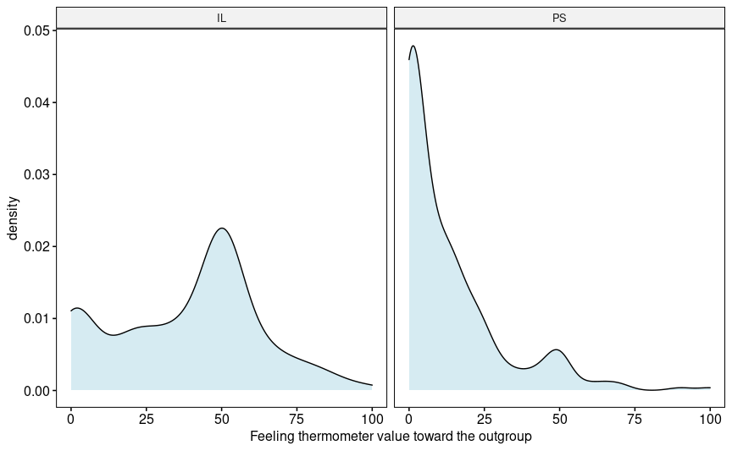
Figure 1. Feeling thermometer toward the outgroup: density chart.

4.2 General opinions on meeting people via telerobotics.

Interest in telerobot interaction and operation
When asked about their interest to approach a remotely operated robot, Palestinians were significantly more interested: F(1,586) = 21.654, p < 0.1, ηp2 = 0.04. The effect resided primarily between females. The mean response from Palestinian females was a slightly positive 3.55 (3 being undecided) while the mean response for Israeli females was a slightly negative 2.91. While age did not have an effect on the response of Palestinian participants, the response from Israeli was more positive as the age increased (R = 0.2, p < 0.01). A positive result on the NARS also predicted more willingness interact with a telerobot (R = -0.57, p < 0.01).
When asked about the willingness of the participants to have a robot in their home which they would use to communicate with others, the response from all of the participants was slightly negative (IL mean 2.72, PS mean 2.7) with no significant difference between the age and gender demographics . Nevertheless, a positive result on the NARS scale did predict more willingness to have a robot at home (R = -0.47, p < 0.01).
When asked regarding their interest to operate a robot in a remote location, Israelis participants were generally more interested F(1, 586) = 9.316, p < 0.01, η_{p}² = 0.016. This effect manifested primarily within Israeli males who had a slightly positive mean response of 3.39 (3 being undecided) as apposed to the rest of the participants who averaged at a slightly negative 2.85. While age did not have an effect on the response of Israeli participants, the response from Palestinians was more positive as the age decreased (R = -0.14, p = 0.02). A positive result on the NARS predicted more willingness to operate a robot from all participants (R = -0.46, p < 0.01).
To summarize the results of these scenarios, approaching a telerobot is more appealing to Palestinian women and older Israelis, while operating a telerobot is more appealing to Israeli men and younger Palestinians. Furthermore, a generally positive attitude toward robots entails more willingness to both interact, and operate a telerobot.

Comparing telerobot communication to a face-to-face meeting
When asked about the experience of meeting a person through a robot rather than face-to-face, the by far most common word for Israeli participants was “strange” (n=76/197: 38.57% of the responses). For Palestinians participants there was a more balanced response of positive and negative words. Figure 1 shows a comparison of word clouds.
Zooming further into the responses of the participants reveals few patterns. Out of the 76 occurrences of strange in Israeli participants, 18 had the form of strange but.. Adding something positive to the opinion. Out of those, nine responses were in the form of Strange at first, but can get used to it later. All of the above nine cases came from Israeli women. Out of the 14 occurrences of strange in Palestinian participants, two had abated the claim with an additional positive comment.

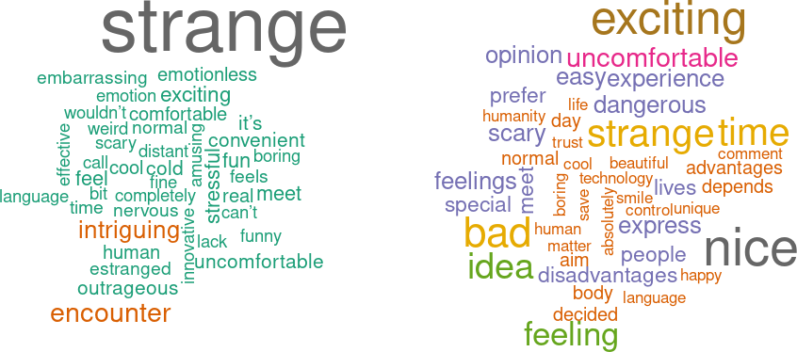
Figure 1. word clouds for the open question comparing telerobot-based communication to face-to-face communication. Left: Israeli participants, right: Palestinian participants.

Where would you go and what would you do with a telerobot
Among those who expressed some interest in operating a telerobot, several prominent themes of usage emerged. The main themes include: touring abroad, performing house chores or errands, visiting family, and traveling to hard to reach places. The distribution of the themes was largely the same between Israeli and Palestinian participants. Israeli participants, however, mentioned shopping significantly more than their Palestinian counterparts (χ2(1) = 5.1367, p = 0.02). Of all responses, only one Palestinian participant mentioned the outgroup in this question, writing:
I would like to visit all the places in Palestine and Israel with their different communities in which I cannot be present.

4.3. Interest in meeting the outgroup via telerobotics
We asked participants whether they are willing to meet members of the outgroup via four different mediums: A telerobotic avatar, a telerobotic puppet show, a face-to-face meeting, or a video call. The mean results from all participants on all scenarios were slightly negative (less than 3 – undecided). The mean results from Israeli participants (2.67, 2.16, 2.96, 3.0 correspondingly) were all significantly higher than the mean results from Palestinian participants (1.53, 1.44, 1.40, 1.40), p < 0.01.
Overall within the two populations, Palestinians were less negative about meeting Israelis via a telerobotic scenario (wilcox sigbned rank V=3320.5, p = 0.02) compared to face-to-face, while Israelis were less negative about the non-robotic scenarios (wilcox signed rank V=1911.5, p < 0.01). Both Israeli and Palestinian participants also significantly preferred the standard telerobotic scenario over the telepuppet performance (wilcox signed rank IL: V = 7734.5, p < 0.01, PS: V=1250, p < 0.01). Gender demographics did not effect the preference of all participants. While for Israeli participants age did not matter, for Palestinians a younger age predicted more willingness to meet Israelis in the video call (R = -0.22, p < 0.01), face-to-face (R = -0.26, p < 0.01), and telerobotic puppet scenarios (R = -0.2, p < 0.01), but was not a significant predictor in the telerobotic avatar scenario. A more positive attitude toward robots on the NARS scale did not predict the willingness of Palestinians to meet the outgroup via the telerobotic scenarios, but did increase the willingness of Israelis in both the telerobotic avatar scenario (R = -0.26, p < 0.01) and the telerobotic puppet theater scenario (R = -0.15, p = 0.01).
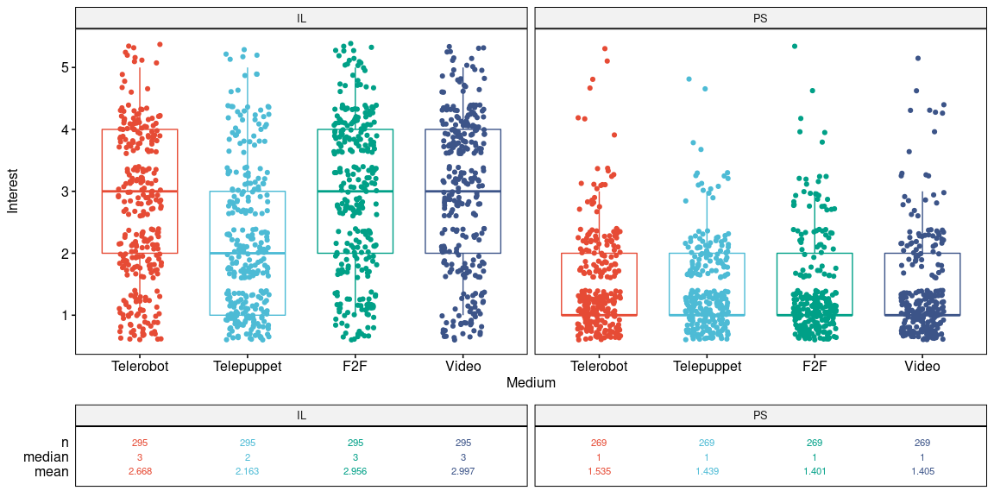
Figure 2: Interest in meeting the outgroup via different mediums.

4.4 Preferences for telerobotics in normal and outgroup communication.
Due to the large number the number of participants who were not interested in intergroup telerobotic contact, the number of participants who answered the preference questions that followed is substantially lower than the total number of participants. 163 Israeli participants and 28 Palestinians participants submitted their preference for telerobotic intergroup contact. From those, 116 Israel participants and 21 Palestinian participants were also interested in casual telerobotic operation, so their answers could be compared between the two scenarios.

Telerobot appearance
For a casual encounter there was no statistically significant difference between the choices of the two groups. Human was the most favorable form, chosen by 52% of the Israeli participants and 42.75% of the Palestinian participants. Machine was the second-best in both groups, chosen by 22.77% of the Israeli participants and 32.82% of the Palestinian participants.
For an encounter with the outgroup, the preferences were more polarized, with Israeli participants increasing their inclination toward a human appearance over that of Palestinian participants (χ²(1) = 16.43, p < 0.01) and Palestinian participants largely stuck with their original choice distribution. Out of 27 Israeli participants who chose a machine appearance for a casual telerobotic encounter, 11 (40%) have changed their appearance to human for meeting the outgroup.
We have also tested whether the choice of appearance in the casual scenario could predict the willingness of the participants to meet with the outgroup via telerobotics. We found no correlations between the two choices.

Identity representation in the telerobotic avatar
In the casual scenario, Israeli participants were overall more interested in embedding their identity into the robotic avatar than the Palestinian participants. Israeli participants had a statistically significant preference over their Palestinian counterparts for preserving their nationality (χ²(1) = 17.14, p < 0.01), their gender (χ²(1) = 39.78, p < 0.01), and their voice (χ²(1) = 18.38, p < 0.01) when operating a telerobotic avatar. On the other hand, Palestinian participants had a statistically significant preference to not reveal anything about themselves via the robot (χ²(1) = 11.26, p < 0.01), or to try out an entirely new identity (χ²(1) = 6.51, p = 0.01).
When designing the identity of the telerobot for meeting the outgroup, most notably the desire for the robot to represent the participants’ nationality has increased (see figure 2). 43% of the Israeli participants (n = 116) opted to preserve the nationality compared to 25% within the same group in the casual scenario (a statistically significant increase χ²(1) = 7.68, p < 0.01). In addition to nationality, the outgroup scenario also decreased the wish of the Israeli participants to be someone else through the robot ( χ²(1) = 8.93, p = 0.03).
Within the Palestinian participants (n = 21), 57% chose to represent their nationality via the telerobot compared to 19% within the same group in the casual scenario ( χ²(1) = 4.95, p = 0.02). Similarly to the Israeli participants, the outgroup scenario also decreased the wish of the Palestinian participants to be someone else through the robot ( χ²(1) = 4.95, p = 0.03).
To summarize, Israelis had a higher preference than Palestinians to use their own identity features when operating a telerobotic avatar, but in the outgroup scenarios the differences diminished. When meeting the outgroup both groups increased their desire to represent their nationality in the telerobot and preferred to avoid being someone else through the telerobot.
We have also tested whether the choice of participants in identity representation in the casual scenario could predict their willingness to meet with the outgroup via telerobotics. Within the group of Israeli participants, only the preference of using your own voice predicted a higher level of interest in meeting the outgroup (R=0.15, p=0.04). Within the group of Palestinian participants only the preference of representing your nationality predicted a higher level of interest in meeting the outgroup (R=0.18, p=0.04).
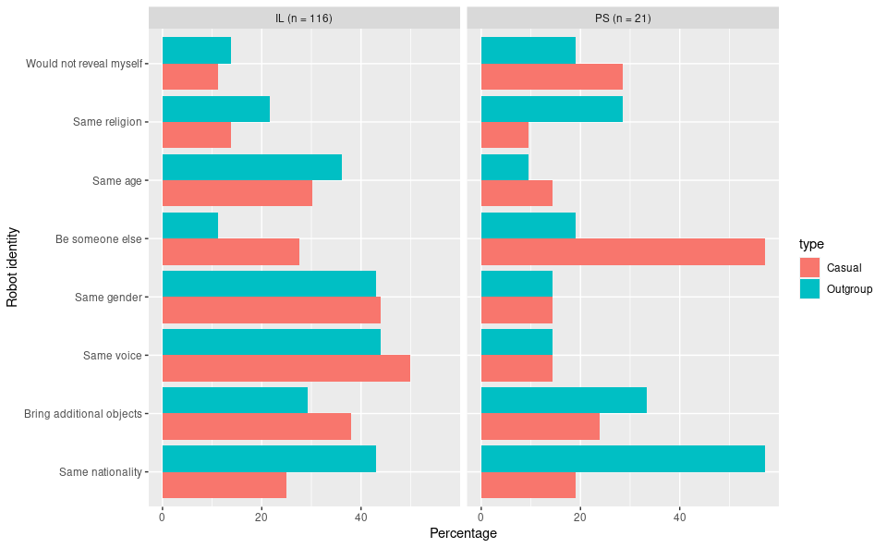
Figure 2. Identity representation in the telerobot, casual VS outgroup.

Visibility or anonymity
We asked the participants whether they would like to see and be seen by their interlocutor when operating the robot, or whether their and/or their partner’s anonymity should be preserved. In the casual scenario both groups had nearly identical results with the overwhelming majority preferring to both see and be seen by their conversation partner (IL 76.5% n=200, PS 76.4% n=127). This was followed by the option to see the partner but be seen (IL, PS 20%) and the option for both to remain anonymous received the least number of choices (IL 3.5% PS 3.1%).
Comparing the casual and outgroup scenario within participants who answered both questions, we see an increase in the number of choices to maintain anonymity on both sides (IL from 1.7% to 8.7% n=115, PS from 4.8% to 23.8% n=21), but only the increase from Israeli participants was statistically significant (Wilcox signed rank V = 0, p < 0.01). We also see a decrease on both sides in the number of choices to see and be seen (IL from 80.9% to 74% n=115, PS from 71.4% to 52.4% n=21), yet it remains the most popular choice. Also in this case, only the decrease from Israeli participants is statistically significant (Wilcox signed rank V = 102, p = 0.05).

Features preferences for the telerobot
Participants were able to freely rank every proposed feature from 1 (not at all important) to 5 (very important) without any limit on the total point pool. Therefore, for the casual scenario, in order to avoid a bias caused by participants who consider any feature important, we chose to analyze each participant’s relative feature rank – the score of a feature in relation to that participant’s mean score of all features.
In the casual scenario, “speech translation” was the most requested feature by both groups. It was ranked a relative mean of +0.6 points by Israeli participants and +0.4 points by Palestinian participants. This was followed by the ability to detect touch feedback, and the ability to travel around the space which was also more distinctive with Israeli participants (F(1, 325) = 15.7, p < 0.01, η_{p}² = 0.046). Israeli participants also more preference to show personal content via the robot than their Palestinian counterparts (F(1, 325) = 7.76, p < 0.01, η_{p}² = 0.023). The Palestinian participants had a statistically significant preference for a feature that uses hand gestures (relative mean +0.17 vs -0.07 ,F(1, 325) = 7.62, p < 0.01, η_{p}² = 0.023) , and for the telerobot to be able to suggest conversation topics (relative mean +0.1 vs -0.56 , F(1, 325) = 45.38, p < 0.01, η_{p}² = 0.123).
For the majority of responses there was no significant change between the casual and the outgroup scenario. If measuring the mean difference between an individual’s response in both scenarios, none of the changes was significant within Israeli or Palestinian participants. If we measure in the mean rank of every feature within all of the participants of each groups (those who answered both scenarios), we detect within Israeli participants a decrease in the rank of enabling traveling in space (p=0.01) and an increase in the rank of the ability for the telerobot to suggest conversation topics (p=0.01).

Features: open question
Participants were also asked to speculate on what kind of abilities they would endow their telerobot with. Themes for the casual scenario were varied in both groups, including different kind of features from flying and cleaning to emotional expression and heavy-lifting. In the outgroup scenario answers consolidated to several main themes, including: abilities related to war such as fighting, self-defense and damage control, abilities related to translation and knowledge of the other’s culture and dialect, and abilities related to mediation, helping with the conversation and representing the operator.
Within the more optimistic theme, Israeli participants focused more on portraying good intentions, asking the telerobot to “show that we are good and we are all ultimately people”, to have a “sensation of good will” or that it could “make peace”. On the Palestinian side, a more optimistic, concrete response was:
Ability to speak the Hebrew language and to have information about the Palestinian people and the suffering they suffered from the Israelis.
Within the negative theme, 7 out of the 53 Israeli participants (13.2%) who answered on both the causal and outgroup scenarios have changed their response from something benign to something related to war and fighting. 1 out of 12 (8.3%) has done the same within the group of Palestinian participants.

4.5. Hopes and concerns: open questions
We asked participants to describe in two questions what would be their hopes and their concerns from meeting the outgroup via a telerobot (see figure 3). Due to the general lower interest of Palestinians to meet with Israelis, only 25 Palestinian participants did not skip this part and answered both questions in comparison to 155 Israeli participants. Out of the 25 Palestinians who did answer, only 6 used the “hopes” question to disclose actual hopes rather than express pessimism or reluctance about the proposed the scenario. Hopes from Palestinian included “breaking mental borders”, “ability to communicate”, that “they [Israelis] can negotiate with him, not ignore him or violate him”, and to “show that the Palestinians are resistant people”.
Out of the 25 responses, nearly a third (8 responses) cited “normalization” as their main concern with the phrase “normalization is betrayal” repeating two times (once with a hashtag sign: #التطبيع خيانة). Other concerns were primarily a general disapproval of the scenario or a having no opinion on the matter.
Hopeful responses from Israeli participants contained general aspirations for peace, understanding, and reconciliation, but also specific references to how communication via telerobtics may aid in conflict resolution. Those included: Getting help from the telerobot in translation, mediation, and explanation, having less prejudice toward the robot than face-to-face, and the general possibility of having communication that otherwise wouldn’t have happened. One participant also noted that conversing in the Palestinian’s own territory may pose less risk of the encounter being intervened by the military. Another participant hoped that “that something in this encounter would be different than a physical encounter between people that usually lack empathy”.
The two most common concerns from Israeli participants had to do with fear that the outgroup would destroy, damage, or hack the robot or that the encounter with the telerobot would be superficial compared to a face-to-face meeting. More specifically participants raised concern over the lack of intimacy, lack of human gestures, that the use of a robot would appear cynical or patronizing, or that there would be too much focus over the technology rather than the humans behind it. One participant also expressed concern that the robot “would remind them [the Palestinians] of weapons that are used against them”. To the contrary, some Israeli participants noted that the gap created by the telerobot would make it easier for them to meet and relieve them of any fear.
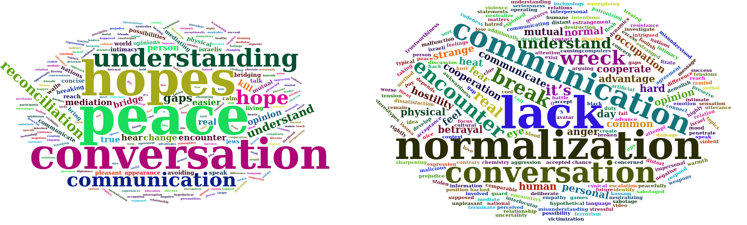
Figure 3. Hopes and concerns for meeting the outgroup via a Telerobot: Israelis and Palestinians.

4.6. Interest in telerobotic puppetry

General interest in telerobotic puppetry
In the casual scenario, the interest of participants in both groups to perform a telerobotic puppet show was lower than the interest in other casual telerobotic scenarios such as approaching a telerobot, owning a telerobot, and operating a telerobot (combined mean=2.37,SD=1 compared to means of 3.22, 2.7, and 2.95). Age had no effect on the level of interest in both groups. Gender had an effect only within the group of Palestinian participants, predicting a stronger interest in the puppet show for females (p=0.05, R=-012). While the general attitude toward robots in the NARS scale did not effect the interest of Israeli participants in the puppet scenario , it had a strong effect for Palestinian participants. For them, a lower result in the NARS scale (a more favorable attitude toward robots) predicted more interest in the telerobotic puppet show scenario (R=-0.34, p < 0.01). When considering both groups combined, previous experience with a glove puppet predicted a higher interest in telerobotic puppets (R=0.092, p=0.03).
In 14 cases out of 254 cases (5.5%) of participants who expressed no interest (probably not or definitely not) in operating a robot, chose probably yes for the puppet show, 13 of them were Israeli participants. The majority of those participants described meeting a telerobot as strange, cold, and non-intimate encounter.
From those participants who had an interest and described their telerobotic puppet show in the open question, several themes emerged. Within the Israeli participants (n=41), the predominant theme was theater for children (n=10, 24%). Six participants described the puppet as human-like, and two of those participants described that the puppet would look the same as them. Three gave the puppet an appearance of a nonhuman. One Israeli participant wrote (before the outgroup scenario was presented):
A performance of public diplomacy for Israel in places that are hostile/not exposed to Israel.
Within the Palestinian participants (n = 26) the main theme was a performance at a public place, with some mentions of famous places including: Camp nou, the Olympics, Paris, or just “all the famous places”. Four participants have mentioned a robot show, technology show, or scientific exhibit, and five have mentioned theaters, cinemas, or art places. Only one participant mentioned a human-like appearance.

Telerobotic puppetry when meeting the outgroup
As mentioned in section 4.3, both groups had a statistically significant preference to the standard telerobotic operation over a telerobotic puppet performance for the outgroup , but the difference was more accentuated on the Israeli side. Only 3 out of 383 participants who chose probably not or definitely not for meeting the outgroup via telerobot, chose definitely yes or probably yes for performing with a robotic puppet in the location of the outgroup, all were Israeli.
For those who expressed some interest in meeting the outgroup via a telerobot (or telepuppet), we also presented the scenario of performing together with a Palestinian partner in a symmetric telerobotic scenario, compared to the asymmetric scenario in which one operator performs at the remote location. Within the people who answered both questions (IL n=160, PS n=27), the mean interest in the collaborative puppet show was less in both groups than the mean interest in the asymmetric telerobotic scenario (IL 2.74 SD=1.07 compared to 2.82 SD=1.1, PS 2.3 SD=1.07 compared to 2.74 SD=0.98), however the difference was not statistically significant. Nevertheless, as in previous cases of willingness to meet the outgroup, the interest of Israeli participants in the symmetric performance was significantly higher than that of Palestinian participants (F(1, 185) = 3.95, p = 0.05, η_{p}² = 0.021). All in all, 39 Israeli participants and only 2 Palestinian participants selected Probably yes or Definitely yes for performing cooperatively and were then asked to describe the show they would perform.
When describing the collaborative puppet show, participants could select one or more genres that they are interested to perform. The top three choices were children’s theater, Situational comedy, and political satire. Participants were also asked to describe in an open question what kind of show would be performed. Responses could be categorized by the level of directness in which they refer to the Israeli Palestinian conflict. 12 out of 38 responses by Israeli participants (31.6%) refer to the conflict directly in their concept. Out of those, 6 describe a political satire type of performance with characters that are emblematic to the conflict such as politicians and soldiers. Two participants refer to the popular Israeli satire TV show Eretz Nehederet as an inspiration. Two responses describe a children’s show about an Israeli and Palestinian kid making peace, one response describes a more antagonistic concept of a “A jew against a Palestinian”, and the other two provide a more descriptive and abstract concept relating to the conflict and peacemaking. Then, 11 out of 38 (28.2%) describe a generic play or children’s theater about conflict resolution and bridging cultural differences without specifically mentioning the Israeli and Palestinian conflict. One of those uses a more antagonistic “three little piggies” parable in which one side is presented as inferior. Finally, 11 out of 38 (28.2%) refer to regular stories with familiar characters and day-to-day life, or fairy tales, without any mention of conflict. Participants described reasons such as “I think I would like to do a show for kids that is not related to the conflict and is funny”, “Something that makes the kids laugh and would allow the performers to shake up the awkwardness”, and “characters of kids, that it [the story] would come from the most innocent and true place.
Of the two Palestinian participants who had interest and provided more detail the performance, one chose to avoid a reference to the conflict, describing “Characters from ordinary life”, while the other described a direct and antagonistic concept:

The story is about a religious idea and how they occupied our land by force, robbing our religious places, and many beliefs

4.6 Individual stories
Based on the results above, we sampled a few cases to zoom in on the results and get a better idea of individual opinions. From each case, we extracted an informative summary. The complete analysis is shown in Appendix A.

Participant A: Israeli male, 47 year old
Favorable and playful toward robots. Would agree to meet with Palestinians via a telerobot, but for that, he prefers to use a non-reviling, machine-like avatar that does not show emotions, yet is still likable.

Participant B: Israeli female, 44 year old
Negative attitude toward telerobots, but would use them to meet Palestinians to express her worldview and personality. Hoping to avoid prejudice.

Participant C: Israeli female, 59 year old
Similar to Participant B, but would use a machine that portrays nationality and gender.

Participant D: Israeli male, 60 year old.
Would meet Palestinians with a puppet but would not perform collaboratively.

Participant E: Israeli male, 17 year old.
Participated in previous organized encounters and sees the advantage of speaking in the Palestinian’s territory. Worried about lack of expression but would use only a machine with national and religious symbols. No collaborative show

Participant F: Israeli male, 40 year old.
Pessimistic about telerobotic encounter but enthusiastic about a collaborative kids show.

Discussion
It is reasonable to assume that the vaccination gap amplified the sensation of inequality and frustration around Palestinians could have effects on the result of the survey.

Reliability and validity.

.1 Participants
The survey was conducted

Heading 1: use this style for level one headings
Paragraph: use this for the first paragraph in a section, or to continue after an extract.
New paragraph: use this style when you need to begin a new paragraph.
Display quotations of over 40 words, or as needed.
- For bulleted lists
- For numbered lists
Displayed equation ( )

Heading 2: use this style for level two headings

Heading 3: use this style for level three headings
Heading 4: create the heading in italics. Run the text on after a punctuation mark.
Acknowledgments, avoiding identifying any of the authors prior to peer review
1. This is a note. The style name is Footnotes, but it can also be applied to endnotes.

References: see the journal’s instructions for authors for details on style

Appendix A

Participant A: Israeli male, 47 year old
Speaks Hebrew and English, extremely tech confident and rather favorable toward robots. Meeting a person through a robot could be fun and he would operate one himself. Would use telerobot to see the pyramids, surf in Sidney, speak Chinese, and summit the Alps. His telerobot would appear as an animal or plant, but portray his nationality, age, gender, and voice. All of the proposed features are very important and he should be able to see and be seen by the interlocutors. The telerobot should also be able to take and send photographs, do house chores, receive emails and drive. Would use a telepuppet to perform with a funny character to kids in his neighborhood and to create his own avatar. He has a negative feeling toward Palestinians, but would probably meet with them using either a video call or a telerobot (undecided about face-to-face). When meeting Palestinians the robot would appears as a machine which reviles nothing about the operator’s identity, but they should still be able to see him. Features which are less important when meeting a Palestinian compared to a casual meeting are: showing emotions, playing games, and suggesting discussion topics. Still, he hopes the robot’s appearance would be likable and not thwart the encounter. Would probably not participate in a collaborative performance.

Participant B: Israeli female, 44 year old.
Speaks Hebrew and English, fairly tech-confident. Highly negative toward robots and finds meeting person via a telerobot to be horrifying. Would probably not use or approach a telerobot in any way, except she’s yet undecided about using them to meet Palestinians. Her attitude toward Palestinians is neutral (50/100) and would probably interact with them using a video call or face-to-face. If she would meet a Palestinian via a telerobot, she would use a human figure that portrays her nationality, age, gender, voice, and religion, while allowing visibility of herself and the interlocutor. The most important telerobot features in that encounter would be language translation, hand gestures, telling when it’s being touched, and showing emotions. She hopes Palestinians would understand her opinions through the robot and that it would not increase prejudice toward her. She is yet undecided about performing a collaborative show.

Participant D: Israeli male, 60 year old.
Speaks Hebrew and English. Favorable attitude and curious about telerobots, but undecided about operating one, yet would probably perform a remote telepuppet show. Slightly positive about Palestinians (67/100) and would probably meet them in any medium. He also has Palestinian friends. When meeting Palestinians he would use a human shape with his voice and visibility of both interlocutors. Important features are translation and showing emotion. He hopes for the encounter to break mental barriers but concerned about communication issues. Undecided about performing a collaborative show.

Participant E: Israeli male, 17 year old.
Speaks English, extremely tech confident. Very favorable toward robots but a meeting via a telerobot would be very annoying because it’s not the other person. Would definitely not operate a telerobot and probably not a telepuppet, but could have a telerobot at home. Very favorable toward Palestinians and would meet in video or face-to-face, but undecided about using a robot. Had participated in organized meetings with Palestinians and has Palestinian friends. If he were to meet a Palestinian via a robot, it would be a machine portraying nationality, voice, and religion and with seeing the operator and interlocutor. Most important features are translation, traveling, and hand gestures. Hopes that the military will not intervene and concerned they would feel looked down upon with no self-expression. Definitely not a collaborative show.

Participant F: Israeli male, 40 year old.
Speaks Hebrew. Fairly negative toward robots, but would probably operate one, traveling the world using an abstract shape and additional objects. All features are equally important and visibility should be of both sides. Would be interested in making own telerobot and performing a telepuppet to kids. Neutral+ (55/100) toward Palestinians and would probably meet with a telerobot/telepuppet but undecided about video and face-to-face. When meeting a Palestinian, would us a human shape representing nationality, same all features are equally important. No hopes for the meeting but would definitely have a collaborative puppet show as a children’s theater about peace and fellowship.
Table 1. Type your title here. Obtain permission and include the acknowledgement required by the copyright holder if a table is being reproduced from another source.
Figure 1. Type your caption here. Obtain permission and include the acknowledgement required by the copyright holder if a figure is being reproduced from another source.

References

https://www.hrw.org/news/2021/07/27/gaza-apparent-war-crimes-during-may-fighting
https://en.wikipedia.org/wiki/Eretz_Nehederet

