The telepresence contact hypothesis

Avner Peled

04/2020

Abstract goes here Abstract goes here Abstract goes here Abstract goes here Abstract goes here Abstract goes here Abstract goes here Abstract goes here Abstract goes here Abstract goes here Abstract goes here Abstract goes here Abstract goes here Abstract goes here Abstract goes here Abstract goes here Abstract goes here

[type=editor, auid=000,bioid=1, prefix=Sir, role=Researcher, orcid=0000-0001-7511-2910, facebook=, twitter=, linkedin=, gplus=]

General introduction paragraph  
Recognizing other uses for robots in contact, such as FtF mediator and simulated contact. Defining the scope of the work:

* Intergroup contact with emphasis on prejudice in asymmetric, conflicted groups.
* At least one group member is physically interacting with a robot in a shared space, which is operated by a member of the opposing group.

# 1. Intergroup contact hypothesis

## 1.1 Contact hypothesis

Review, leading into the need and rise of mediated contact, of which online is most prominent

## 1.2 Online contact

Review, leading into the issues with current online contact:

## 1.3 Issues with online contact

1. Lack of self-accountability

“individuals may feel less accountable for the content they post online or underestimate the social sanctioning of their behavior” (White, Harvey, and Abu-Rayya 2015)

1. Lack of engagement with a reduced social presence

“Out-group members’ reduced social presence was further associated with negative out-group attitudes, notably because the intergroup interaction itself was considered as less interesting, satisfying, cheerful, and involving” (Schumann et al. 2017)

1. Lack of physical turn taking cues.

“a delayed response in an interaction can also work to incite tension in the intergroup relationship…This is particularly pertinent point for online interactions where there can be a lack of physical cues” (White, Harvey, and Abu-Rayya 2015)

1. Lack of opportunity for contact Not much opportunities for online contact, especially in the age of filter bubbles and echo chambers.

Leading into proposing telepresence robot contact as a midway between online and face to face which could solve a lot of the issues with online contact but preserve some of its benefits.

# 2. Telepresence robots

History and terminology:

* telerobot, telepresence, tele-operation, avatar, re-embodiment.
* fully operated / semi-autonomous functions

# 3. A path model for telepresence contact

Previous research on intergroup contact provides us with conceptual and computational tools which we can use to model the path from initial contact to the eventual reduction of prejudice toward the generalized out-group. The stages model suggested by Pettigrew (Pettigrew 1998) outlines the path to prejudice reduction: contact initially *decategorizes* the individual out-group member from its group, then reduces prejudice from the general out-group, and finally dissolves the border between in-group and out-group. Researches have also shown empirically verifiable models for various mediators and moderators involved in prejudice reduction (Voci and Hewstone 2003; Brown and Hewstone 2005; Pagotto, Voci, and Maculan 2010).

Inspired by those findings, we suggest a conceptual model for telepresence conact. Due to the presence of the telerobot, we add another stage on the path to prejudice reduction fig. 1. We hypothesize that an in-group member first develops an attitude toward the robot itself before projecting it on operator, the out-group member. Attitude toward the robot could be influenced by previous bias on robots or by characteristics of the particular robot which we will address in this article. We estimate that the projection of the robot on the operator will be moderated by the degree of how much the robot is perceived as an avatar of the operator, or as a simple medium of communication. Finally, a generalized attitude toward the out-group will be moderated by the level of group salience apparent in the conversation with the telepresence robot.

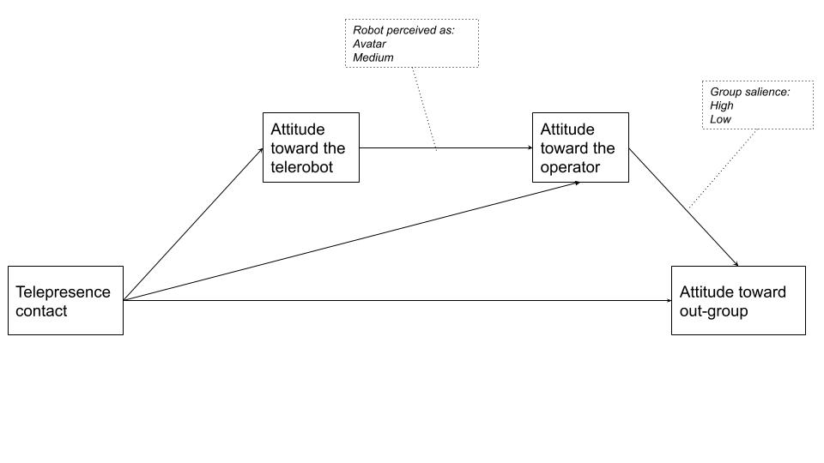

Figure 1: Telepresence Contact: Conceptual path model

# 4. Telepresence systems

A communication event that is mediated by telepresence robots could manifest in one of many different architectures. A single architecture could be defined as a *telepresence system*.

## 4.1 Signal and physical interactions

Before presenting the systems in focus for intergroup contact, we define two types of interactions that can exist within such system. Utilizing concepts from Paynter’s generalized systems theory (Paynter 1961), Hannaford has distinguished between the two types of interaction that occur in telepresence, *information* and *energetic* (Hannaford 2000). We will refer to them simply as *signal* and *physical* interactions. *Physical* interactions refer to real word interactions between elements sharing a physical environment, such as a hand-shake or holding an object. In physical terms, a bidirectional *energy bond* is formed between the interacting elements. *Signal* interactions, on the other hand, occur on an abstract level. They represent a unidirectional logical flow of cause and effect; for example, text that is typed on one end of an online communication and appears on the other end. Intuitively, a physical interaction appears closer and more significant than a flow of signals because it involves our body. The tight bond between our cognition and our physicality is shown in a variety of conceptual frameworks (Dewey 1986; Gallagher 2006, [@malafourisHowThingsShape2013]) that reject the old cartesian dualism of a mind that is separated from the body.

In online communication, a signal would always be a reduction and an abstraction of the physical action that caused it. When operating a telerobot through a remote control interface, the flow consists of three stages: 1. Beginning with an intent for action, a physical interaction occurs between the operator and a local control interface. 2. Control signals are sent through a communication medium to the robot. 3. The robot receives the signal, processes it and performs an physical interaction with its own environment.

According to Minsky, when the control interaction is so seamless and synchronous with the robot in terms of responsiveness and feedback, the operator may feel as if they are physically present in the remote environment, i.e *telepresence*.

## 4.2 Types of systems

If we consider solely the condition of *telepresence*, that is, having a telerobot operated remotely and used for communication, we identify three different systems of communication see 2:

1. *Asymmetric*: The most commonly used system for telepresence communication. One participant is represented by a telerobot and is operating it from a remote location, typically their home, using a computer or mobile device. The other participant is interacting with the robot in a shared physical space. The system is asymmetric because the interaction experience is qualitatively different for the operator and the interlocutor. Common implementations include industry robots, surgical robots, office-based telepresence and social service robots.
2. *Symmetric bidirectional*: In this system both participants are operating a telerobot, which serves both as an avatar for their conversation partner as well a control interface for their telerobot. The interface, in that case, is completely transparent to the operator and typically uses body tracking. No control feedback is available to the operator and operation may commence without any knowledge of the remote telerobot by the participants. This type of system is more resource-heavy than the asymmetric type, and currently only a few implementations exist as prototypes and proofs-of-concept (Nagendran et al. 2015). The lack of feedback in this system also heavily restricts the ability of the operator to travel around the space, as they are unable to see the remote environment.
3. *Symmetric unidirectional*: In this system both participants are operating a telerobot via a control interface, without physically interacting with an avatar. The two robots share the same space, while the participants are separated. Common implementations of this system include cooperative multi-robot tasks (Sirouspour and Setoodeh 2005) and *Robot combat* competitions (Clarkson and Foreword By-Dwyer 2002).As in the asymmetric system, operation is usually performed from a computer or mobile device.

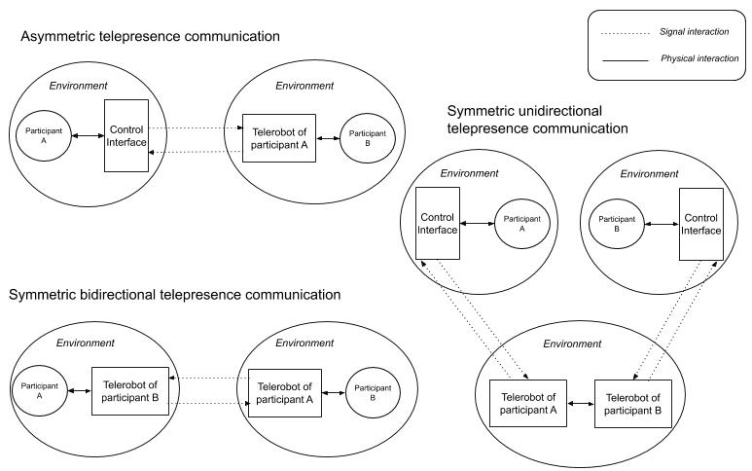

Figure 2: Systems of telepresence communication

While the *symmetric unidirectional* system may facilitate contact in cooperative or confrontational events in front of an audience, since the scope of this article involves at least one person physically interacting with a robot, we would turn the focus toward the first two systems.

## 4.3 The handshake paradigm

To further illustrate the mechanics of the two systems, we will use the common example of the handshake. The handshake is an important and common social gesture in most parts of the world (Schiffrin 1974). It is a reciprocal action, beginning with one person reaching out in an open request and then reciprocated by the partner. It is also a haptic gesture in which subtle forms of touch can have a great social significance (Hillewaert 2016).

In an asymmetric system, the telerobot is usually equipped with a camera that streams the robot’s vision back to the operator. When the interaction partner reaches out their hand, the operator will see this via the interface. The operator uses the control interface to reciprocate and have the robot reach out its hand. Movement is initiated with the push of a button in the most basic interface, or by moving a motion tracking device in a more advanced one. Once the interaction partner touches the robot, the handshake is picked up via a pressure sensor on the robot’s palm and is transmitted back to the control interface. The touch could manifest as a screen flicker or a sound effect on the operator’s computer, or as a vibration in a motion tracking device.

In a symmetric system, both of the participants interact only with the telerobot in front of them. The handshake is initiated when one participant reaches their hand toward the robot. The gesture is picked up by a body tracker and causes the opposing robot to mirror the behavior of its operator and reach out its hand to the interaction partner on the other side. The partner reciprocates and now both robots have their hands reached out. When touch sensors on the robots detect that both participants are now shaking their respective robot’s hand, a squeezing actuation commences in both robots to generate the feeling of the handshake for both partners.

# 4.4 A CMC component in asymmetric systems

Whether participant is interacting with a telerobot, or with a control interface in a symmetric or asymmetric system, telepresence communication is always mediated by a computer (CMC: *Computer Mediated Communication*). Interactions can be therefore anonymous, visibility and identity can be manipulated and conversation content can be augmented. There is still, however, a qualitative difference between an experience of physically interacting with a robot and that of operating one via an interface. When interacting with a telerobot, the perception of it as an avatar could suspend the participant’s disbelief and regard the avatar as a present social agent (Banks and Bowman 2016). In that moment, interaction with the avatar becomes directly embodied and the robot’s function as a medium is nearly transparent. One may argue that a similar suspension could be achieved in an immersive virtual reality environment, but the depth and richness of sensory feedback when operating in a real environment is still measures beyond what can be provided by a virtual one (Borgmann 2000).

Taking this difference into account implies that some social psychology models that apply to CMC, would apply to one side of an asymmetric telepresence system, the side that is operating the robot via a control interface. The participants that are interacting with the robot (both sides in case of a symmetric system), are experiencing an interaction that resembles more of an FtF encounter than a mediated one. Insofar as the robot is perceived as an avatar rather than a medium, we hypothesize that the experience would drift further away from CMC and closer to FtF. Factors that may moderate this effect are discussed in following sections.

A number of CMC models that affect the outcome of contact and the reduction of prejudice in conversation have been identified by researchers(Walther et al. 2015). The *deindividuation* model warns that anonymity may release a person from social regulation and norms, leading to a negative effect on the conversation. The SIDE theory (Spears et al. 2002) provides a contrasting view in which a depersonalized encounter increases group salience, as it motivates individuals to act under a group context while pronouncing enhanced norms and tropes. Models such as SIP and *hyperpersonal* communication (Walther 1996) advocate that more intimate interpersonal relations may form in online contact because of the need for the participants to make up for the lack of non-verbal cues. Having a strong CMC component only on one end of an asymmetric system could create a mix of behaviors in which one side experiences stronger senses of *agency* in *ownership* in the conversation than the other (Gallagher 2000). Ideally, this could evolve into a positive outcome in which an out-group member on the side of the operator enjoys the benefits of anonymity and distance, while the in-group member is fully engaged in physical contact, assimilating new meanings and dissolves existing bias. Realistically however, the asymmetric nature of the conversation alone can have implications on contact, as we hypothesize in the following section.

# 4.5 Equality in telepresence systems

One of Allport’s basic conditions for positive intergroup contact is having an equal status between group members, such as an equal position in a workplace context (Allport 1954, 274). While the general idea was verified in multiple studies (Pettigrew and Tropp 2006), the condition can be further differentiated to equality in status or in *situation*, i.e in contact only; a more realistic condition when group members carry persistent power differences and are in long-lasting and deep-rooted conflicts (Maoz 2011).

It was shown that having symmetry and equality in communication, such as equal turn-taking and mutual respect, is beneficial for contact in groups that are in asymmetric conflict such as Israelis and Palestinians (Maoz 2005). However, this does not mean that existing power relations should be ignored during contact. In fact, it was found that a communication model that “emphasizes the conflict and power relations between the sides”, although more risky, produces a higher equality within the contact (Maoz 2011). Furthermore, equality emerges when the interaction focuses on fulfilling the different needs of the group members. While an advantaged group member needs to feel morally acceptance, a disadvantaged group requires a feeling of empowerment (Shnabel and Nadler 2008). A failure to address inequality in status during contact may even hinder ensuing motivation for social change (Saguy et al. 2009).

Symmetric telepresence systems provide the hardware foundation for equal contact. As will be shown in the proceeding sections, it is up to the software and organizational implementation to make sure that the conversation is handled in an equal manner. An asymmetric system, however, tilts the balance toward one end, and may have implications for contact.

Consider the situation in which a disadvantaged-group member is operating a telerobot anonymously from their home, while the advantaged-group member is interacting with it in a public space. The operator may feel free of social anxiety in their comfort zone, and empowered by the ability to see through the robot’s camera and not be seen. This in turn may encourage bringing up more difficult topics related to conflict during the conversation. Alternatively, the asymmetry in the participant’s visibility may also bring up anxiety and discomfort. In our initial test for intergroup telepresence contact, participants of both sides expressed discomfort regarding the unequal asymmetric setting. One member of a minority group noted that they felt as if they are a government official investigating their exposed partners (Peled 2019, 132).

Conversely, in an an asymmetric system inequality may surface due to a difference in freedom of movement and in appearance between the robotic avatar and the human interlocutor. While some have raised concerns of social robots restricting the freedom of humans (Whitby 2011; Hoorn 2018), the opposite is also possible, as humans are in many cases more free and resilient than their robotic counterparts. Moreover, in the case of oppressed group members that are experiencing day-to-day restrictions on movement, an asymmetric system may highlight the power relations and reduce the sense of equality in the conversation. To summarize, the easier to implement asymmetric telepresence system may create both negative and positive perturbances in contact, and therefore should be designed with great consideration.

# 4. The use of a 2D display and the dual-ecologies problem

The telepresence robot market is rapidly growing, and is predicted to accelerate even more in the upcoming years with increase needs for remote working and social services.[1] Telerobot forms are continuously branching into new directions, but as of 2020 the dominant form remains to be that of a tablet device attached to a motoric vehicle (Kristoffersson, Coradeschi, and Loutfi 2013) (See fig. 3). The tablet typically displays the operators head, as in a Skype call. Examples from market leaders include *Double Robotics*,[2] *Mantaro*[3] and Revolve Robotics.[4] Such telepresence robots are oriented for remote offices and public service environments such as hospitals or schools.

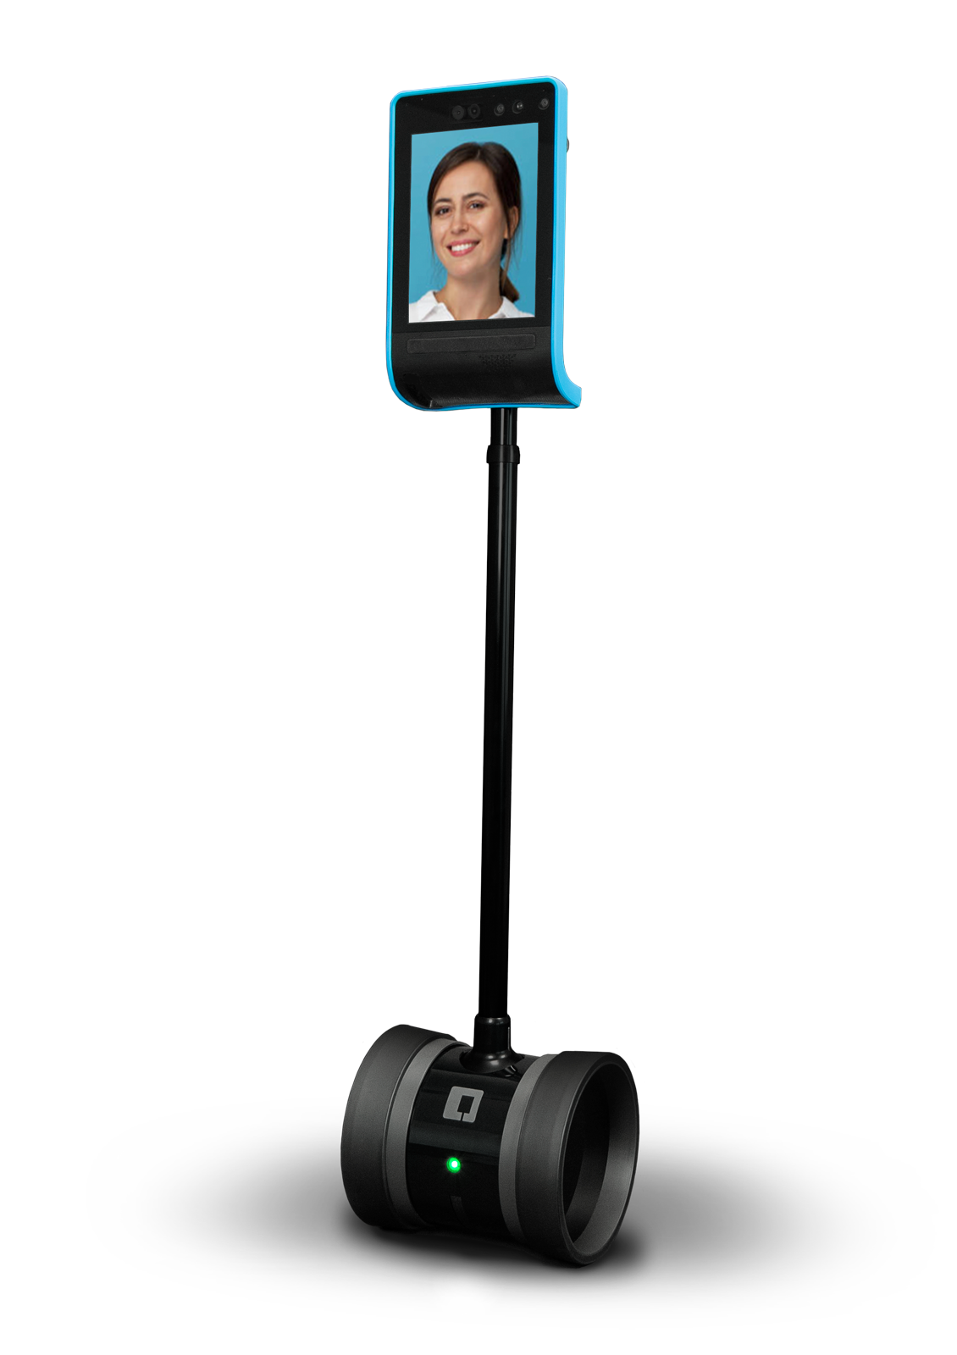

Figure 3: The *Double Robotics* Double 3 telerobot

In a contact situation, it is likely that the telerobot operator would want to remain anonymous, or at least present themselves differently than their actual form. In this case, it is best if the exposure of the face would be optional, or that the operator could manipulate the image. However, there is a more fundamental, ontological issue with using a 2D display on a telepresence robot. The problem was described as the “dual ecologies” problem, and was investigated in a case-study by Choi and Kwak (Choi and Kwak 2016). In their study, a remote partner’s presence in a tablet-based video call was found to be stronger when it is disembodied (tablet only) than when it was attached to wheeled robotic body. The authors explain this by referring to the different ecologies present on the same robot: One is a 2D projection of the operator’s remote location and another is the physical presence of the robotic body in a shared space. They suggest that the receiver of communication experiences confusion, having to interact simultaneously with the immediate environment and with he depiction of the remote environment.

The dual ecologies problem could be extended further, as our initial test shows that even utilitarian use of a display on the telerobot’s body to perform a task, has disrupted the participants’ view of the robot as a uniform avatar. Instead, participants reported reverting to the experience of using a phone-like device while they were interacting with the display, despite having to touch the robot to initiate actions in the virtual interface (Peled 2019, 127). Back projection solutions such as those of *Furhat Robotics*[5] attempt to solve this incongruence by projecting 3d-mapped virtual information directly on the robot’s surface. While this may moderate the negative effects of the display, it does address entirely the dual ecologies problem of having two different spaces combined into one.

An interference with the experience interacting with the avatar may negate the positive benefits of physical interaction such as non verbal cues and direct engagement, and disrupt the flow of attitude forming toward the out-group member. Therefore, the use of a display should be planned carefully for intergroup contact. Alternatively, the robot’s appearance could be designed with an emphasis on uniformity and consistency. Considerations for appearance are discussed in the following section.

# 5. Telerobot design for contact

## 5.1 An extended uncanny valley

The affect of a robot’s design on a human’s attitude toward it has been studied extensively in literature, predominantly in studies of Human-Robot Interaction (HRI) and social robotics (Hancock et al. 2011). A pivotal discussion revolves around the question of *anthropomorphism*: the degree in which a robot’s appearance and behavior resembles that of a human. Current literature paints a picture that is manifold (Fink 2012); while anthropomorphic features may increase a human’s empathy and acceptance of the robot, the effect is context-dependent, culture-dependent, and works only to some extent. In some cases, people have preferred pet-shaped over human-like robots, and in other cases a human shape generated a negative attitude toward the robot. One over-reaching theory on robot-human-likeness has been largely ratified in literature - Mori’s theory of the *Uncanny valley* (Mori, MacDorman, and Kageki 2012). The theory suggest that a human’s affinity toward a robot grows as it displays more human-like features, but at some point falls into a valley of uncanniness when the robot is *too human* yet noticeably *inhuman*. The affinity rises back up only when theoretically no difference between the robot and a human can be discerned.

The theories above assume that the robot in question is fully autonomous, with no human controller in the loop. The context of telepresence naturally adds another element of complexity to the matter at hand and research specific to this question is more scant. A review by Lee et al (Lee et al. 2015) set to find an optimal design for a telepresence robot, recommended a mid-point between human and nonhuman with a caricatured nature. While keeping the uncanny valley in mind, adding some human-like aspects is justified by common research of affinity to anthropomorphic features. The argument for using a nonhuman form was based on research by Groom et al (Groom et al. 2009). The authors showed that robot operators have a greater sense of *self extension* on their avatar when it is nonhuman. They explain this finding by the fact that a humanoid robot assumes its own identity, making it harder for the operators to project themselves on the robot. However, the study by Groom et al did not measure the effect of the non-humanoid form on the conversation from the side of the interlocutor, the person interacting with the robot. Research by Kuwamura et al (Kuwamura et al. 2012) found that the interlocutors experience a distortion of their partner’s personality when it is conveyed through a nonhuman. Compared to a humanoid telerobot, participants interacting with a stuffed-bear felt confused, and had difficulty imagining that they are talking to a human.

Taking us back to the context of intergroup contact, the findings above have great significance. First, the uncanny, as it was originally described by Freud (Freud 1919), invokes emotions as *morbid anxiety*; anxiety being a known mediator for the outcome of contact (Pettigrew and Tropp 2006, 767). Furthermore, the findings in regards to self extension and personality distortion also hold a potential to mediate the result. Nevertheless, as discussed previously, it is not a given that an attitude formed toward the telerobot would naturally project onto the operator. We therefore suggest to extend the model of the uncanny to support telepresence by adding another dimension to the equation. As noted, the level of Avatar WSOD moderates the transference of affect from the avatar to the inhabiter. Adding another multiplier to the uncanny valley equation would then reflect the estimated positive effect of avatar WSOD (see fig. 4). Assuming a high avatar WSDO also implies that the problems of personality distortion presented by Kuwamara et al are mitigated. It should be noted, however, that even with WSOD in place, not all nonhuman forms may fit the context of intergroup contact, especially in the context of conflict. Some caricatured forms may undermine the statue of the participant or even invoke a sense of disrespect.

## 5.2 Designing with group salience in mind

Naturally, the process toward forming a generalized opinion toward the out-group does not end at the interpersonal level. The most widely agreed-upon moderator for generalizing a positive attitude to the intergroup level is *group salience*, the degree in which the participants’ group identity is salient during contact. Earlier research on contact found a bipolar, antagonistic correlation between group identity salience and interpersonal relationship (Brown and Turner 1981): When the group identity is so present, it is harder for the participants to find their commonalities and create new bonds and friendships. Later research, however, suggests that there is now a sufficient evidence that group and interpersonal salience can remain high simultaneously (Brown and Hewstone 2005). One approach,suggested by Pettigrew (Pettigrew 1998), is to expose group identities gradually, starting with a low salience, allowing initial contact to form, and increasing it over time.

Group identity can be transmitted through a variety of channels in telepresence, beginning with the design of the avatar itself and its surroundings, and proceeding into the content of the interaction. Although the physical medium is not as easily manipulated as a virtual environment (Hasler and Amichai-Hamburger 2013), there is still room for creativity in the way group identity is revealed during contact. For example, an avatar may have a non-humanoid appearance, but still maintain group identity through group symbols, cues, language, and so forth. It may speak in an accent, wear typical accessories or flaunt national colors. The freedom to use material objects brings up new design possibilities that are not available in an online encounter. Group cues could be positioned in subtle ways, so that they are gradually revealed by the interlocutor. If the initial appearance and behavior of the robot is engaging enough, an interpersonal bond may be formed despite the presence of group-related cues.

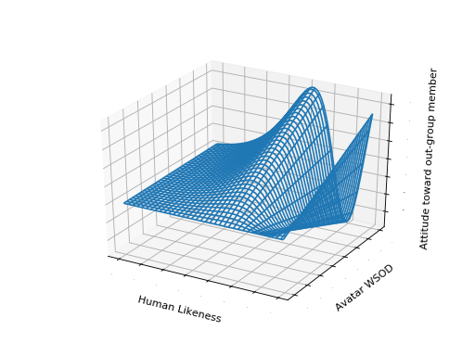

Figure 4: Extended uncanny valley model for intergroup contact

aad

next step is group salience

## 5.1 An extended uncanny valley

Robot’s Height

Mention telenoid

Uncanny -> anxiety -> negative attitude

Using non-human embodied imagery for the the operator affects group identity and anxiety (Kim 2011)

A non-humanoid would have to work harder for emotional expression and empathy, if there are no human facial expressions, but using animalistic expressive movement or semi-anthropomorphic gestures is possible

## 5.2 A combined approach: Group markers on a non-humanoid form

We are not limited to forms that exist in real life. It is possible to include various identifying markers on the non-humanoid avatar to increase group salience during contact. Markers such as:

* Group symbols
* Typical name/nickname
* Native language
* Other conversation content

# 6. Embodied interaction

## 4.2 Using the operator’s voice VS an artificial voice

Using the operator’s voice might have similar effects on individuation as using the face, but adding an artificial voice also provides the ability to speak in many languages The operator’s voice can even be cloned. However, mistakes in translation my increase anxiety in both sides.

## 6.1 Non-verbal cues in tele-operation

A robot can show non verbal cues such as: body attitude, gaze, head nods, and facial expression (as the model allows it). They could smoothen the turn taking in the conversation and increase empathy.

However, such tacit queues are not actively initiated by the operator and would require a certain autonomous algorithm to generate them. This depends on the interface being used and is liable for glitches, abstractions and loss of information.

In asymmetrical form that involves a camera, gaze can be operated by controlling the camera and changing where the robot looks.

## 6.2 Bodily expressions

An operator could have the robot show bodily expressions. Depending on the operating interface, these could be actively initiated or captured by a gesture sensor. The active method is less prone to mistakes which could reduce anxiety.

Active bodily expressions could be triggered for example by a simple click on an emoji, or using more sophisticated forms such as body tracking, or using the phone’s accelerometer.

## 6.3 Interaction with the robot

A robot could have sensors that pick up the interaction of the partner with the robot and sends it back to the operator. In the symmetric form this is the only type of interaction possible, but in asymmetric form it is possible to use a camera to capture interaction.

# 6.4 Feedback in operation

When operating a robot it is helpful to get feedback on actions chosen. It increases the smoothness of operation and reduces anxiety of appearing wrong.

In asymmetric form the operation can have visual feedback. It is possible to use mirrors, or a camera set in space (or on another robot if they are in group). Can use haptic feedback if possible.

In symmetric form there is no feedback, but there is also no real sensation of operating a robot as it is completely transparent.

# 7. Materiality and movement

Have great effect on expression, anxiety, empathy. We suggest the use of soft robotics for telepresence.

# 8. Interaction scenarios

## 8.1 Public space intervention

The operator can ‘intervene’ in a public space and confront passersby. In the asymmetric form would require an interface to ‘call’ a stranger, such as playing a sound or performing a gesture. In the symmetric form it would be a station that can be occupied by a participant, and when to participants are sitting they would start interaction.

Without interrupting the perception of avatar, the robot or the interface design could contain cues that encourage talk about the conflict and promote self-disclosure. It is also possible to place instructions for a cooperative action near the site of the robot, which would require participants to ‘play’ some scenario together, in which conflict-related content could be inserted.

The use of a display for showing relevant content is also possible, but could evoke disbelief in the avatar

## 8.3 Private/structured communication

In an organized contact, that is suitable both for the symmetric and asymmetric forms, the moderators can direct the conversation.

# 9. Real-world conflict considerations

## 9.1 Empowerment via education in robotics

Art therapy, theater of the oppressed.

## 9.2 Legal and ethical considerations

Border crossing, normalization, social pressure.

## 9.3 Israel-Palestine test case

# References

Banks, Jaime, and Nicholas David Bowman. 2016. “Avatars Are (Sometimes) People Too: Linguistic Indicators of Parasocial and Social Ties in PlayerAvatar Relationships.” *New Media & Society* 18 (7): 1257–76. <https://doi.org/10.1177/1461444814554898>.

Borgmann, Albert. 2000. “Information, Nearness, and Farness.” In *The Robot in the Garden*, edited by Ken Goldberg, Hubert Dreyfus, Alvin Goldman, Oliver Grau, Marina Gr&#382;ini&#263; Blake Hannaford, Michael Idinopulos, Martin Jay, Eduardo Kac, and Machiko Kusahara, 90–107. MIT Press.

Brown, Rupert, and Miles Hewstone. 2005. “An Integrative Theory of Intergroup Contact.” *Advances in Experimental Social Psychology* 37 (37): 255–343.

Brown, Rupert J., and John C. Turner. 1981. “Interpersonal and Intergroup Behaviour.” *Intergroup Behavior*, 33–65.

Choi, Jung Ju, and Sonya S. Kwak. 2016. “Can You Feel Me?: How Embodiment Levels of Telepresence Systems Affect Presence.” In *2016 25th IEEE International Symposium on Robot and Human Interactive Communication (RO-MAN)*, 606–11. New York, NY, USA: IEEE. <https://doi.org/10.1109/ROMAN.2016.7745180>.

Clarkson, Mark, and Bill Foreword By-Dwyer. 2002. *BattleBots: The Official Guide*. McGraw-Hill, Inc.

Dewey, John. 1986. “Experience and Education.” In *The Educational Forum*, 50:241–52. Taylor & Francis.

Fink, Julia. 2012. “Anthropomorphism and Human Likeness in the Design of Robots and Human-Robot Interaction.” In *International Conference on Social Robotics*, 199–208. Springer.

Freud, Sigmund. 1919. “The Uncanny.” *Imago* 1: 1–21.

Gallagher, S. 2000. “Philosophical Conceptions of the Self: Implications for Cognitive Science.” *Trends in Cognitive Sciences* 4 (1): 14–21.

Gallagher, Shaun. 2006. *How the Body Shapes the Mind*. Clarendon Press.

Groom, Victoria, Leila Takayama, Paloma Ochi, and Clifford Nass. 2009. “I Am My Robot: The Impact of Robot-Building and Robot Form on Operators.” In *Proceedings of the 4th ACM/IEEE International Conference on Human Robot Interaction - HRI ’09*, 31. La Jolla, California, USA: ACM Press. <https://doi.org/10.1145/1514095.1514104>.

Hancock, Peter A., Deborah R. Billings, Kristin E. Schaefer, Jessie Y. C. Chen, Ewart J. de Visser, and Raja Parasuraman. 2011. “A Meta-Analysis of Factors Affecting Trust in Human-Robot Interaction.” *Human Factors: The Journal of the Human Factors and Ergonomics Society* 53 (5): 517–27. <https://doi.org/10.1177/0018720811417254>.

Hannaford, B. 2000. *Feeling Is Believing: A History of Telerobotics. The Robot in the Garden: Telerobotics and Telepistemology in the Age of the Internet. Edited by Ken Goldberg*. The MIT Press.

Hasler, Béatrice S., and Yair Amichai-Hamburger. 2013. “Online Intergroup Contact.” In *The Social Net*, edited by Yair Amichai-Hamburger, 220–52. Oxford University Press. <https://doi.org/10.1093/acprof:oso/9780199639540.003.0012>.

Hillewaert, Sarah. 2016. “Tactics and Tactility: A Sensory Semiotics of Handshakes in Coastal Kenya.” *American Anthropologist* 118 (1): 49–66.

Hoorn, Johan F. 2018. “Theory of Robot Communication: I. The Medium Is the Communication Partner,” 21.

Kim, Junghyun. 2011. “Two Routes Leading to Conformity Intention in Computer-Mediated Groups: Matching Versus Mismatching Virtual Representations.” *Journal of Computer-Mediated Communication* 16 (2): 271–87. <https://doi.org/10.1111/j.1083-6101.2011.01539.x>.

Kristoffersson, Annica, Silvia Coradeschi, and Amy Loutfi. 2013. “A Review of Mobile Robotic Telepresence.” *Advances in Human-Computer Interaction* 2013: 1–17. <https://doi.org/10.1155/2013/902316>.

Kuwamura, Kaiko, Takashi Minato, Shuichi Nishio, and Hiroshi Ishiguro. 2012. “Personality Distortion in Communication Through Teleoperated Robots.” In *2012 IEEE RO-MAN: The 21st IEEE International Symposium on Robot and Human Interactive Communication*, 49–54. Paris, France: IEEE. <https://doi.org/10.1109/ROMAN.2012.6343730>.

Lee, Hyelip, Yeon-Ho Kim, Kwang-ku Lee, Dae-Keun Yoon, and Bum-Jae You. 2015. “Designing the Appearance of a Telepresence Robot, M4K: A Case Study.” In *International Workshop on Cultural Robotics*, 33–43. Springer.

Malafouris, Lambros. 2013. *How Things Shape the Mind*. MIT Press.

Maoz, Ifat. 2005. “Evaluating the Communication Between Groups in Dispute: Equality in Contact Interventions Between Jews and Arabs in Israel.” *Negotiation Journal* 21 (1): 131–46. <https://doi.org/10.1111/j.1571-9979.2005.00050.x>.

———. 2011. “Does Contact Work in Protracted Asymmetrical Conflict? Appraising 20 Years of Reconciliation-Aimed Encounters Between Israeli Jews and Palestinians.” *Journal of Peace Research* 48 (1): 115–25. <https://doi.org/10.1177/0022343310389506>.

Mori, M., K. F. MacDorman, and N. Kageki. 2012. “The Uncanny Valley [from the Field].” *IEEE Robotics Automation Magazine* 19 (2): 98–100. <https://doi.org/10.1109/MRA.2012.2192811>.

Nagendran, Arjun, Anthony Steed, Brian Kelly, and Ye Pan. 2015. “Symmetric Telepresence Using Robotic Humanoid Surrogates: Robotic Symmetric Telepresence.” *Computer Animation and Virtual Worlds* 26 (3-4): 271–80. <https://doi.org/10.1002/cav.1638>.

Pagotto, Lisa, Alberto Voci, and Valentina Maculan. 2010. “The Effectiveness of Intergroup Contact at Work: Mediators and Moderators of Hospital Workers’ Prejudice Towards Immigrants.” *Journal of Community & Applied Social Psychology* 20 (4): 317–30. <https://doi.org/10.1002/casp.1038>.

Paynter, Henry M. 1961. *Analysis and Design of Engineering Systems*. MIT press.

Peled, Avner. 2019. “Soft Robotic Incarnation.” PhD thesis, Aalto University.

Pettigrew, Thomas F. 1998. “Intergroup Contact Theory.” *Annual Review of Psychology* 49 (1): 65–85.

Pettigrew, Thomas F., and Linda R. Tropp. 2006. “A Meta-Analytic Test of Intergroup Contact Theory.” *Journal of Personality and Social Psychology* 90 (5): 751–83. <https://doi.org/10.1037/0022-3514.90.5.751>.

Saguy, Tamar, Nicole Tausch, John F. Dovidio, and Felicia Pratto. 2009. “The Irony of Harmony: Intergroup Contact Can Produce False Expectations for Equality.” *Psychological Science* 20 (1): 114–21. <https://doi.org/10.1111/j.1467-9280.2008.02261.x>.

Schiffrin, Deborah. 1974. “Handwork as Ceremony: The Case of the Handshake.” *Semiotica* 12 (3): 189–202.

Schumann, Sandy, Olivier Klein, Karen Douglas, and Miles Hewstone. 2017. “When Is Computer-Mediated Intergroup Contact Most Promising? Examining the Effect of Out-Group Members’ Anonymity on Prejudice.” *Computers in Human Behavior* 77 (December): 198–210. <https://doi.org/10.1016/j.chb.2017.08.006>.

Shnabel, Nurit, and Arie Nadler. 2008. “A Needs-Based Model of Reconciliation: Satisfying the Differential Emotional Needs of Victim and Perpetrator as a Key to Promoting Reconciliation.” *Journal of Personality and Social Psychology* 94 (1): 116–32. <https://doi.org/10.1037/0022-3514.94.1.116>.

Sirouspour, Shahin, and Peyman Setoodeh. 2005. “Multi-Operator/Multi-Robot Teleoperation: An Adaptive Nonlinear Control Approach.” In *2005 IEEE/RSJ International Conference on Intelligent Robots and Systems*, 1576–81. IEEE.

Spears, Russell, Tom Postmes, Martin Lea, and Anka Wolbert. 2002. “When Are Net Effects Gross Products? Communication.” *Journal of Social Issues* 58 (1): 91–107.

Voci, Alberto, and Miles Hewstone. 2003. “Intergroup Contact and Prejudice Toward Immigrants in Italy: The Mediational Role of Anxiety and the Moderational Role of Group Salience.” *Group Processes & Intergroup Relations* 6 (1): 37–54. <https://doi.org/10.1177/1368430203006001011>.

Walther, Joseph B. 1996. “Computer-Mediated Communication: Impersonal, Interpersonal, and Hyperpersonal Interaction.” *Communication Research* 23 (1): 3–43.

Walther, Joseph B., Elaine Hoter, Asmaa Ganayem, and Miri Shonfeld. 2015. “Computer-Mediated Communication and the Reduction of Prejudice: A Controlled Longitudinal Field Experiment Among Jews and Arabs in Israel.” *Computers in Human Behavior* 52 (November): 550–58. <https://doi.org/10.1016/j.chb.2014.08.004>.

Whitby, Blay. 2011. “15 Do You Want a Robot Lover? The Ethics of Caring Technologies.” *Robot Ethics: The Ethical and Social Implications of Robotics*, 233.

White, Fiona A., Lauren J. Harvey, and Hisham M. Abu-Rayya. 2015. “Improving Intergroup Relations in the Internet Age: A Critical Review.” *Review of General Psychology* 19 (2): 129–39. <https://doi.org/10.1037/gpr0000036>.

1. https://www.marketwatch.com/press-release/telepresence-robots-market-size-2020-to-showing-impressive-growth-by-2024-industry-trends-share-size-top-key-players-analysis-and-forecast-research-2020-04-20
2. https://www.doublerobotics.com/
3. http://www.mantarobot.com/products/teleme-2/index.htm
4. https://telepresencerobots.com/robots/kubi
5. https://furhatrobotics.com/