Intergroup Contact via Telepresence Robots

Avner Peled

04/2020

Abstract goes here Abstract goes here Abstract goes here Abstract goes here Abstract goes here Abstract goes here Abstract goes here Abstract goes here Abstract goes here Abstract goes here Abstract goes here Abstract goes here Abstract goes here Abstract goes here Abstract goes here Abstract goes here Abstract goes here

[type=editor, auid=000,bioid=1, prefix=Sir, role=Researcher, orcid=0000-0001-7511-2910, facebook=, twitter=, linkedin=, gplus=]

General introduction paragraph  
Recognizing other uses for robots in contact, such as FtF mediator and simulated contact. Defining the scope of the work:

* Intergroup contact with emphasis on prejudice in asymmetric, conflicted groups.
* At least one group member is physically interacting with a robot in a shared space, which is operated by a member of the opposing group.

# 1. Intergroup contact hypothesis

## 1.1 Contact hypothesis

Review, leading into the need and rise of mediated contact, of which online is most prominent

## 1.2 Online contact

Review, leading into the issues with current online contact:

## 1.3 Issues with online contact

1. Lack of self-accountability

“individuals may feel less accountable for the content they post online or underestimate the social sanctioning of their behavior” (White, Harvey, and Abu-Rayya 2015)

1. Lack of engagement with a reduced social presence

“Out-group members’ reduced social presence was further associated with negative out-group attitudes, notably because the intergroup interaction itself was considered as less interesting, satisfying, cheerful, and involving” (Schumann et al. 2017)

1. Lack of physical turn taking cues.

“a delayed response in an interaction can also work to incite tension in the intergroup relationship…This is particularly pertinent point for online interactions where there can be a lack of physical cues” (White, Harvey, and Abu-Rayya 2015)

1. Lack of opportunity for contact Not much opportunities for online contact, especially in the age of filter bubbles and echo chambers.

Leading into proposing telepresence robot contact as a midway between online and face to face which could solve a lot of the issues with online contact but preserve some of its benefits.

# 2. Telepresence robot

History and terminology:

* telerobot, telepresence, tele-operation, avatar, re-embodiment.
* fully operated / semi-autonomous functions

# 3. General forms of interaction

## 3.1 Two types of interaction flows:

From systems theory:

1. Signal / information flow: abstract, virtual, logical.
2. Energy bond: Physical, flowing, corporeal, nonlinear.

## 3.2 Symmetric and asymmetric telepresence

We detail two general forms in which a telepresence dialog could be implemented:

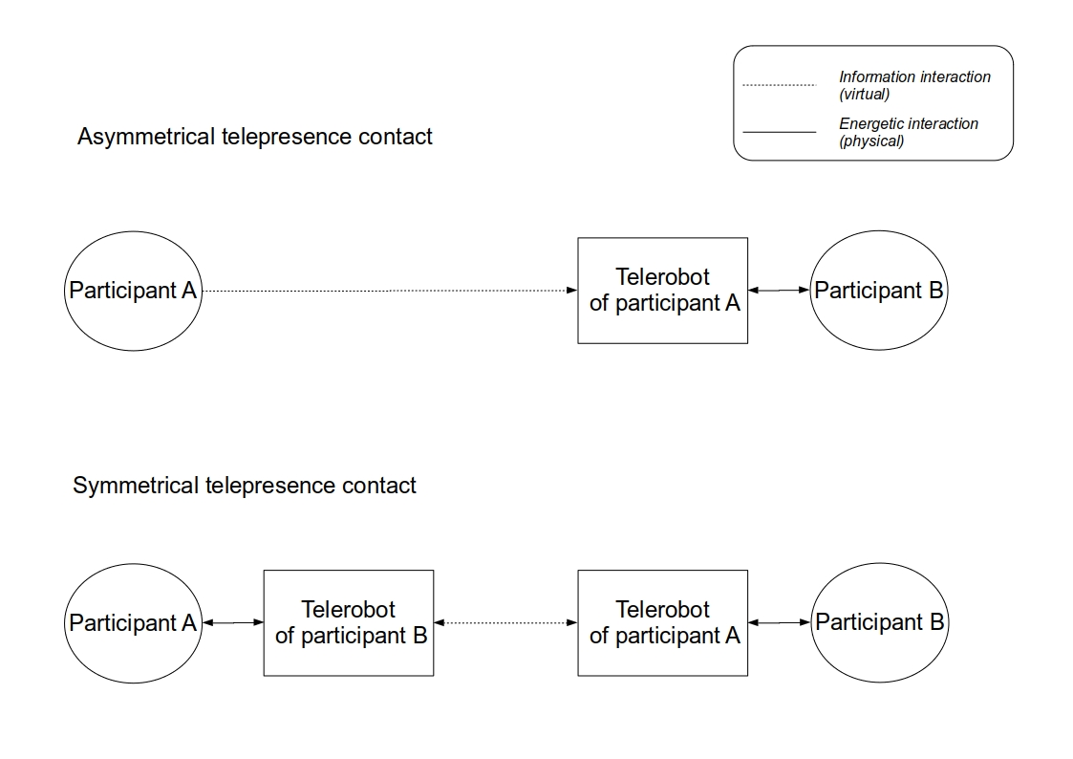

Figure 1: Symmetric and asymmetric telepresence contact

* Suggestions for implementation.
* The handshake scenario

A symmetric form is more equal, but asymmetry may fulfill different needs.

A symmetric form has to use a completely *transparent* operation interface embedded in the robot (otherwise there would be major attention problems) (Nagendran et al. 2015). The robot is both an input interface and and output body. It uses all round body tracking and is more complicated to implement.

# 3. Multiple dimensions of bias

Because participants have bias toward robots, we are adding another dimension of bias.

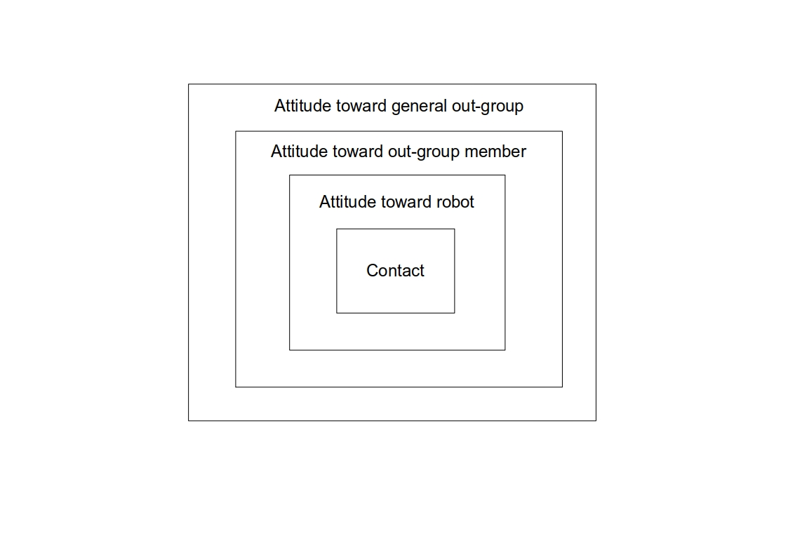

Figure 2: Multiple dimensions of bias

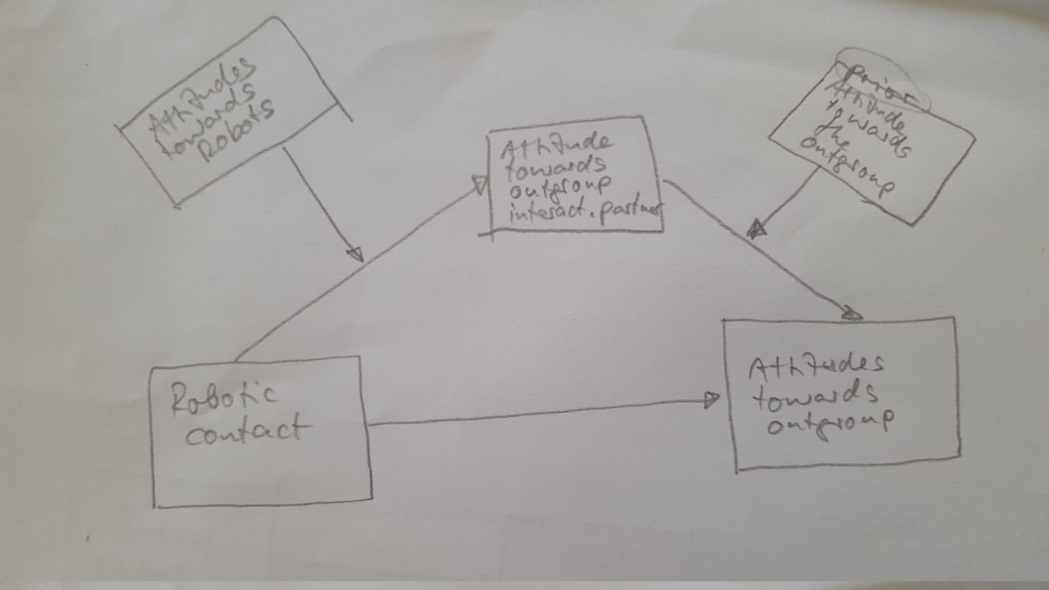

Figure 3: Moderated mediation

# 4. The use of the operator’s face and voice

## 4.1 Showing the operator’s face VS a uniform avatar

Defining avatar

The ‘ipad on segway’ form is now the most common form of telepresence. It’s not really an avatar incarnated. There is no suspension of disbelief that the robot *is* the operator.

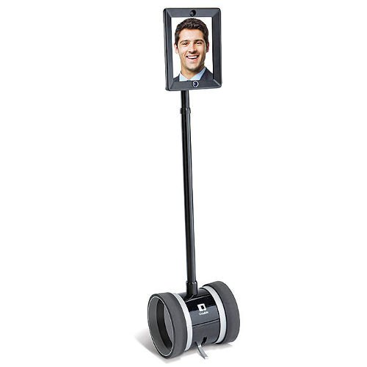

Figure 4: Telepresence ipad

From the operator’s side, exposing of the face could increase anxiety and reduce hyperpersonal behavior, but may increase accountability.

From the partner side, seeing the operator’s face could create a more personal connection with the operator, but because it challenges the belief of the robot being an avatar, the partner perceives the robot as a communication device. This reduces the efficacy of embodied interaction. In fact, using any type of display can subvert the perception of the avatar [Can I reference the qualitative research of my own MA?]

## 4.2 Using the operator’s voice VS an artificial voice

Using the operator’s voice might have similar effects on individuation as using the face, but adding an artificial voice also provides the ability to speak in many languages The operator’s voice can even be cloned. However, mistakes in translation my increase anxiety in both sides.

# 5. Appearance of the telepresence robot

## 5.1 Humanoid vs non-humanoid

Using a humanoid telerobot could increase the connection between the participant and the telerobot and could help in increasing group salience.

It could however evoke the uncanny effect.

Using non-human embodied imagery for the the operator affects group identity and anxiety (Kim 2011)

A non-humanoid would have to work harder for emotional expression and empathy, if there are no human facial expressions, but using animalistic expressive movement or semi-anthropomorphic gestures is possible

## 5.2 A combined approach: Group markers on a non-humanoid form

We are not limited to forms that exist in real life. It is possible to include various identifying markers on the non-humanoid avatar to increase group salience during contact. Markers such as:

* Group symbols
* Typical name/nickname
* Native language
* Other conversation content

# 6. Embodied interaction

## 6.1 Non-verbal cues in tele-operation

A robot can show non verbal cues such as: body attitude, gaze, head nods, and facial expression (as the model allows it). They could smoothen the turn taking in the conversation and increase empathy.

However, such tacit queues are not actively initiated by the operator and would require a certain autonomous algorithm to generate them. This depends on the interface being used and is liable for glitches, abstractions and loss of information.

In asymmetrical form that involves a camera, gaze can be operated by controlling the camera and changing where the robot looks.

## 6.2 Bodily expressions

An operator could have the robot show bodily expressions. Depending on the operating interface, these could be actively initiated or captured by a gesture sensor. The active method is less prone to mistakes which could reduce anxiety.

Active bodily expressions could be triggered for example by a simple click on an emoji, or using more sophisticated forms such as body tracking, or using the phone’s accelerometer.

## 6.3 Interaction with the robot

A robot could have sensors that pick up the interaction of the partner with the robot and sends it back to the operator. In the symmetric form this is the only type of interaction possible, but in asymmetric form it is possible to use a camera to capture interaction.

# 6.4 Feedback in operation

When operating a robot it is helpful to get feedback on actions chosen. It increases the smoothness of operation and reduces anxiety of appearing wrong.

In asymmetric form the operation can have visual feedback. It is possible to use mirrors, or a camera set in space (or on another robot if they are in group). Can use haptic feedback if possible.

In symmetric form there is no feedback, but there is also no real sensation of operating a robot as it is completely transparent.

# 7. Materiality and movement

Have great effect on expression, anxiety, empathy. We suggest the use of soft robotics for telepresence.

# 8. Interaction scenarios

## 8.1 Public space intervention

The operator can ‘intervene’ in a public space and confront passersby. In the asymmetric form would require an interface to ‘call’ a stranger, such as playing a sound or performing a gesture. In the symmetric form it would be a station that can be occupied by a participant, and when to participants are sitting they would start interaction.

Without interrupting the perception of avatar, the robot or the interface design could contain cues that encourage talk about the conflict and promote self-disclosure. It is also possible to place instructions for a cooperative action near the site of the robot, which would require participants to ‘play’ some scenario together, in which conflict-related content could be inserted.

The use of a display for showing relevant content is also possible, but could evoke disbelief in the avatar

## 8.3 Private/structured communication

In an organized contact, that is suitable both for the symmetric and asymmetric forms, the moderators can direct the conversation.

# 9. Real-world conflict considerations

## 9.1 Empowerment via education in robotics

Art therapy, theater of the oppressed.

## 9.2 Legal and ethical considerations

Border crossing, normalization, social pressure.

## 9.3 Israel-Palestine test case

# References

Kim, Junghyun. 2011. “Two Routes Leading to Conformity Intention in Computer-Mediated Groups: Matching Versus Mismatching Virtual Representations.” *Journal of Computer-Mediated Communication* 16 (2): 271–87. <https://doi.org/10.1111/j.1083-6101.2011.01539.x>.

Nagendran, Arjun, Anthony Steed, Brian Kelly, and Ye Pan. 2015. “Symmetric Telepresence Using Robotic Humanoid Surrogates: Robotic Symmetric Telepresence.” *Computer Animation and Virtual Worlds* 26 (3-4): 271–80. <https://doi.org/10.1002/cav.1638>.

Schumann, Sandy, Olivier Klein, Karen Douglas, and Miles Hewstone. 2017. “When Is Computer-Mediated Intergroup Contact Most Promising? Examining the Effect of Out-Group Members’ Anonymity on Prejudice.” *Computers in Human Behavior* 77 (December): 198–210. <https://doi.org/10.1016/j.chb.2017.08.006>.

White, Fiona A., Lauren J. Harvey, and Hisham M. Abu-Rayya. 2015. “Improving Intergroup Relations in the Internet Age: A Critical Review.” *Review of General Psychology* 19 (2): 129–39. <https://doi.org/10.1037/gpr0000036>.