Mathematical Modeling of Social Dynamics
Final Assignment:
Dynamics of the Israeli-Palestinian Separation Barrier – Security Or Greed?
Avner Peled

History:

In 1949, following Israel's successful war for independence, and the Armistice agreements with the neighboring Arab countries, a demarcation line was drawn that splits the territory of the land of Palestine. It is known as the “Green Line”. It was not meant to set any future civil borders, but rather to impose a separation between hostile nationalities and populations living on the same slice of land.

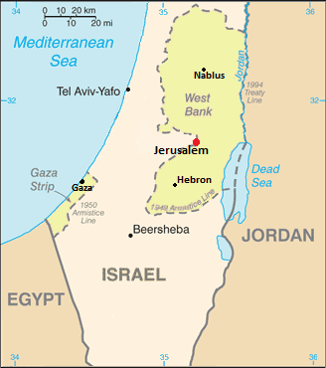Illustration 1: The Green Line
The Jewish and Palestinian populations were already quite intertwined at that point, so it was impossible to draw a complete separation. The established reality meant that the Palestinians who lived to the left of the line became citizens of the newly founded country 'Israel', while the Palestinians to the right of the line (The West Bank) and in Gaza remained in landlocked stateless regions. Some were even separated by their families or land across the line. That was the beginning of the Palestinian struggle for independence.

In 1967, the next landmark in the history of this territory occurred. During the 6-day war, Israel seized control over the entire West Bank and Gaza strip. The demarcation line became much less relevant. This time, however, citizenship was not granted to the inhabitants of Gaza and the West Bank. Instead it remained under military occupation and in the case of the West Bank, it is still so to this day. The following years have been an ongoing struggle for land and existence between Israelis and Palestinians in both sides of the Green Line. While the UN still recognizes Israel as spanning only up until the pre-1967 green line, there have been Israeli attempts to colonize the West Bank and Gaza areas by what is known as settlements. The settlement movement is a stream of colonization that aims to occupy areas (sometimes forcefully) of the West Bank and Gaza and is backed by several governmental plans and an increasing budget [2]. It can be thought to be driven by two main forces:

- Security – Colonization of key areas across horizontal and vertical lines of Palestine provides a strategic military advantage to Israel.

- Religious Radicalism [3] - Many settlers believe that colonization of this land is fulfilling God's will, and that the bible grants a historical right for the Jewish people's ownership of the land.

Additionally, when these forces affect the government's decision makers, new plans for colonization are formulated that grant social benefits to settlers, thus creating yet a third motive for settlement – comfort.

The Separation Barrier:

After dozens of years of struggle and violence, culminating in what is known as the Al-Aqsa Intifada that started in September 2000, Israel initiated the construction of the separation barrier – Also known as the separation wall or the security fence.

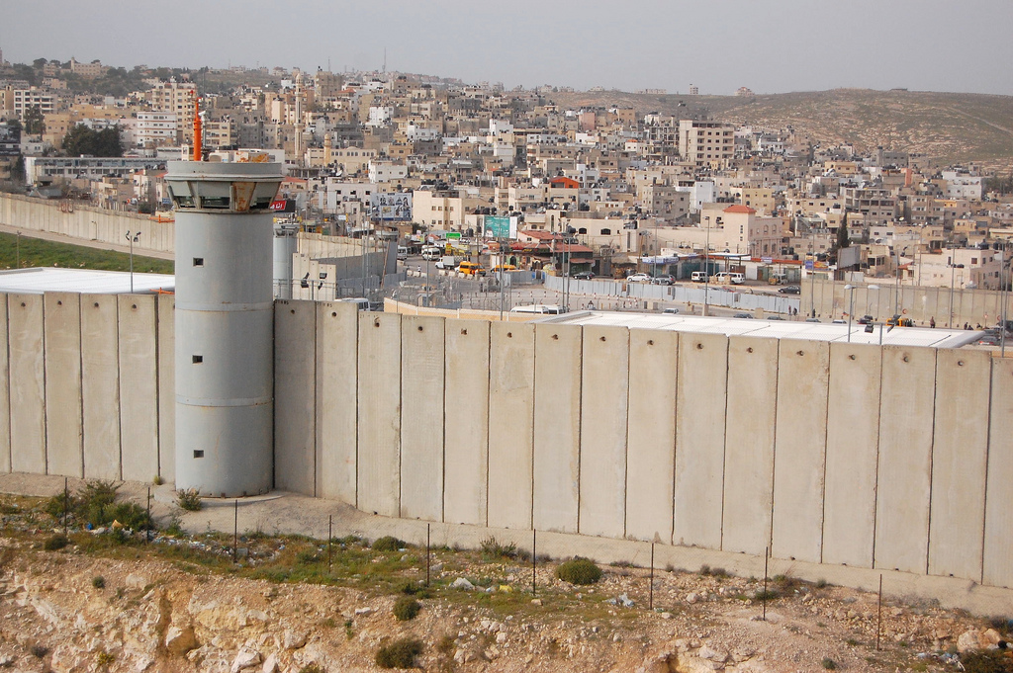
Indeed the proclaimed goal of the barrier by the Israeli government is strictly for security reasons [4] – That is, preventing potential terror attacks in Israel that are originating in Palestinian territory. However, the barrier's proclaimed goal is to also achieve “Minimum Disruption” to the residing population in the area of the green line. This effectively moves the route of the barrier away from the Green Line and toward the settlements. Although the official description states:
“The Security Fence does not annex territories to the State of Israel, nor will it change the status of the residents of these areas”
In effect it does this by setting a barrier between settlement population beyond the green line and the rest of the West Bank.
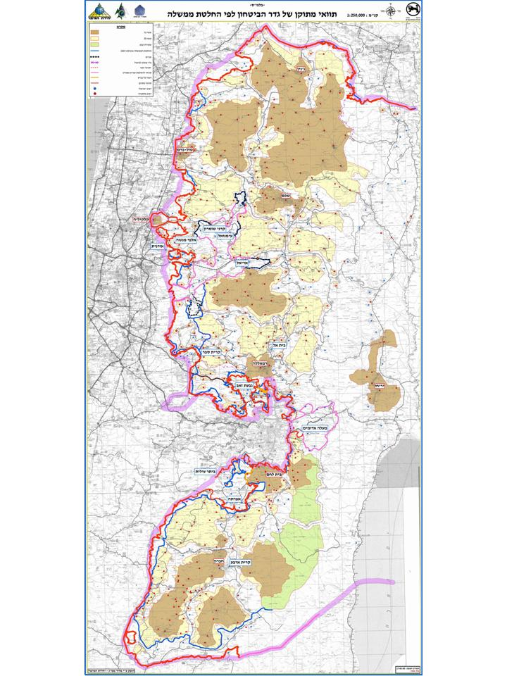Illustration 2: Official route of the fence

In fact, 85% of the fence lies beyond the Green line [5]. Another effect of the barrier was the disruption of agriculture in Palestinian villages, since a lot of the farming land ended up on the Israeli side of the fence. According the world bank, the land to the west of the separation barrier produces around 8% of the total Palestinian agriculture production. This was particularly prevalent in the village of Bil'in, where the planned route of the fence was to include 50% of the village's land to the west of the barrier [6]. After continuous struggle and demonstrations, the people were able to convince Israel's high court of justice to change the route of the barrier. However the demonstrations continue to this day since the route still leaves 370 acres of land to the west of the barrier.
Even after the rectifications, the proposed route (Still not entirely constructed) effectively annexes 9.5% of the west bank [8] [9]. A percentage that is far off from any discussed agreement between Israel and Palestine. These usually amount to about 2-4% of the west bank [10].

Greed

Bil'in was not the only case in which the supreme court intervened and rectified the route of the barrier. In some cases, the proposed route for the fence not only surrounded the settlements beyond the green line, but also “reserved” thousands of acres beyond the current border of the settlements, as if it was planning for further colonization in the upcoming years [7].

Shaul Arieli, a most prominent activist and publicist in the field of the separation barrier [11] wrote in Haaretz newspaper (2011, Rough translation) [12]:

“The amendments that Israel's security council are completing these days are the highlight of the greed parade - A waste of the tax payer's money, security promiscuity, misleading of the supreme court of justice and hindering of IDF's credibility”.

Regarding one of the cases, after 7 years of discussions, the supreme court concluded that the state has hidden crucial material from the justices, and this material proves that the planned route is indeed meant for illegal expansion of the settlement and not for security reasons. Then, only after 3 years of delays by the state, the route was amended. The cost of the amendment for the tax payer: 180 million Shekels (roughly 45 million USD).

Research Question

The greed that is employed by Israel in planning of the fence's route not only endangers the security of both Israel's citizens and the settlers, but it also disrupts the flow of land in the west bank. Does greed have further implications on the conflict than those that are in immediate sight?
I wish to model and simulate the construction dynamics of the separation barrier with various degrees of greed, and use agent based modeling to measure the amount of violence that emerged in response to each level. This way we can obtain better understanding of the implications to Israel's greed in the construction of the separation barrier.

Model

The model is inspired by Epstein's model if civil violence (2002) [13] as well as by a more recent model of segregation and urban violence in east Jerusalem by Bhavnani, Ravi et al. (2014) [14]
I have chosen to use the “Mesa” Python agent based modeling framework [15] for the implementation.

The model's area of coverage starts just after the green line, where any Jewish colony would be called a settlement. The settlers amount to 2% of the total population in the west bank.
The model is based on a 40x40 2D lattice.

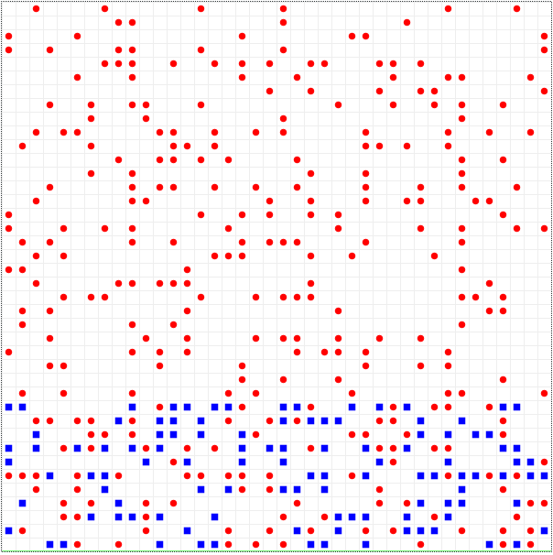Illustration 3: Starting point

At each step the settlers (blue) and Palestinians (red) exhibit the following behavior:

Settlers:

- At a set exogenous rate Vs. the settlers perform an attack on a Palestinian neighbor (if any exist in the Moore neighborhood). Since the settlers largely enjoy favorable living conditions compared to the Palestinians, I have chosen to set an exogenous violence rate. While I am sure that the behaviors of settlers are affected by interaction with the Palestinians, studies show settlers violence is largely due to religious fanaticism or pure harassment [16].
- At an exogenous rate of expansion Es, a settler with a free neighboring spot may expand to that spot. This corresponds to the natural growing of settlements to the favorable conditions as mentioned above.

Palestinians:

The behavior of a Palestinian is more complex and intrinsic to the model.
A Palestinian may attack a neighboring settler (if any exist in the Moore neighborhood) with the probability:

π – Level of Freedom : =

Ψ – Anger: = When a Palestinian receives violence – anger rises by 0.1 . Each step the anger decays by reducing 0.01

λ – Blockage: = Number of barrier neighbors.

Thus the probability for attack increases exponentially with increasing anger and lack of freedom. On the other hand it is decreased by the barrier's ability to block incoming attacks.

Additionally, the Palestinian may perform a larger bombing attack deep in Israel's territory. The probability is exogenous Pb * Pv with Pb being set at 0.001.

Barrier construction

Once a settler becomes a victim to violence, one block of the barrier is constructed.

- The location for the barrier is the random furthest empty spot within radius r, being:
- Gr := A level of greed that is ranging between 0 and 10 in the simulation sets.
- In case the chosen spot for the barrier contains a Palestinian, he is relocated to a random nearest empty spot.

Each iteration includes 100 steps for all agents.
After every iteration, the average violence level is calculated.

Vp – Standard violence by a Palestinian to a neighboring settler.
Vs – Standard violence by a settler to a neighboring Palestinian.
Vb – Bomb violence by a Palestinian (Considered more acute).

The simulation stops when
For each simulation two values are collected:
- Total level of violence until the end of the simulation.
- Settler occupation rate of the west bank in the end of simulation.

For each greed level, 100 simulations were run and the resulting averages were calculated.

Results
The following results were obtained:

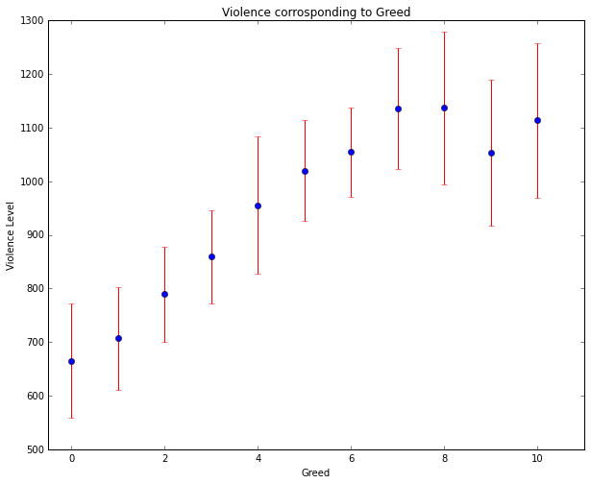

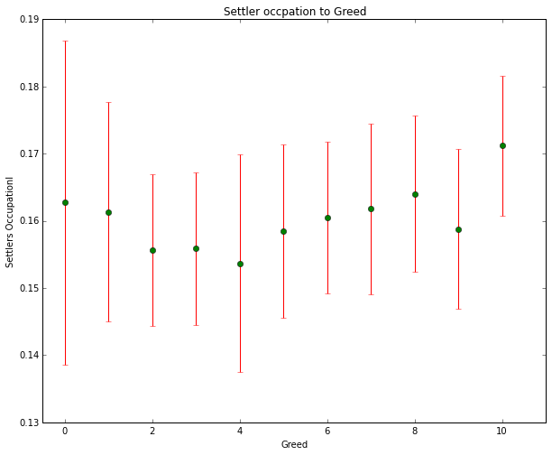
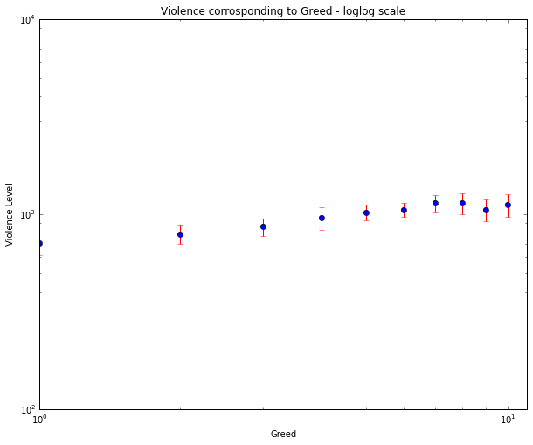

Below are random samples from each greed level:
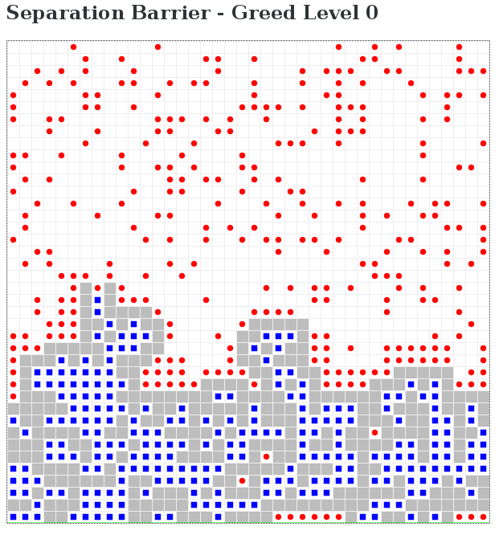
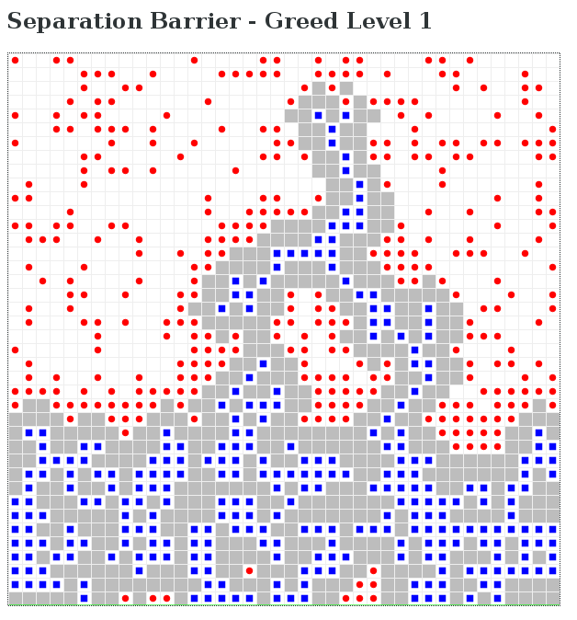
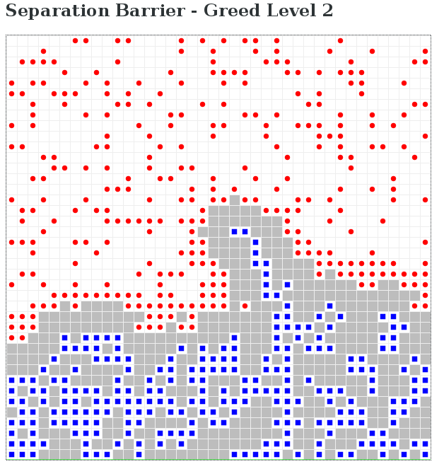
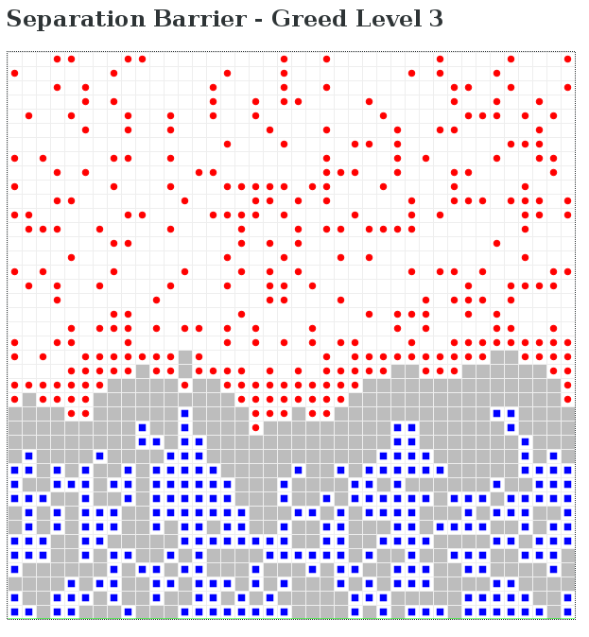
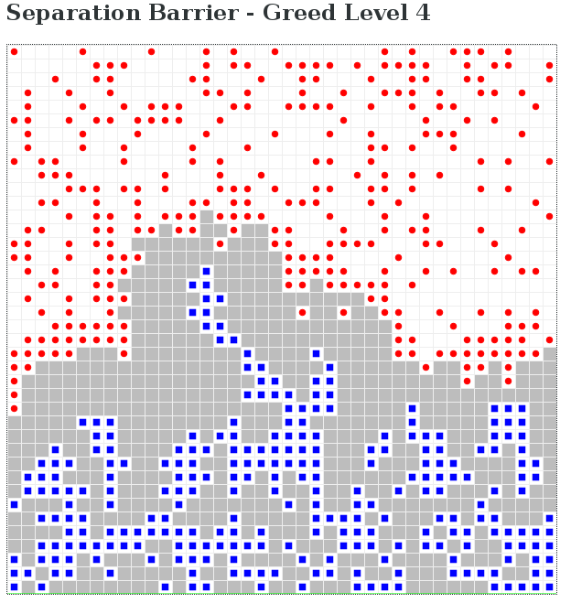
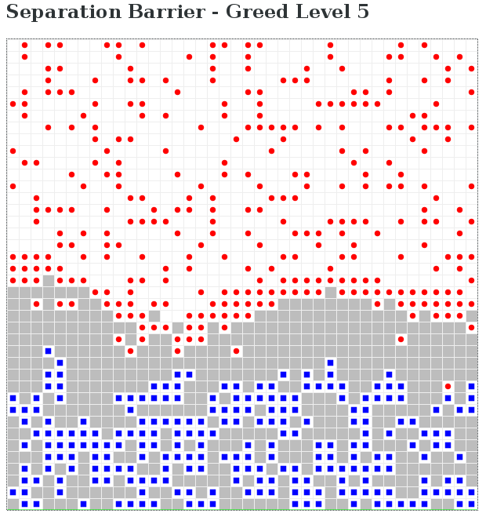
`
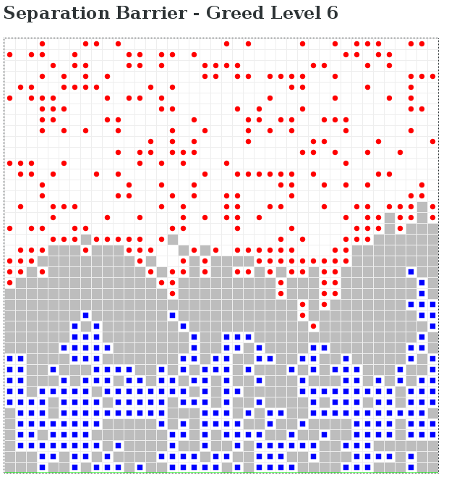
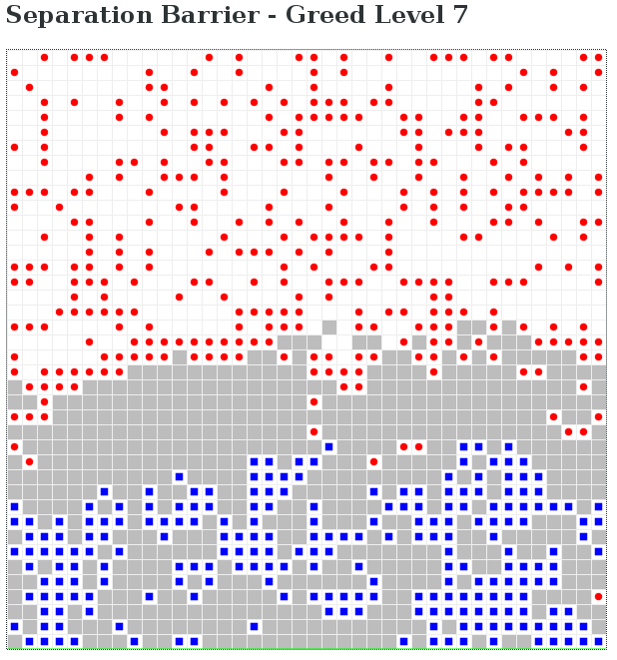
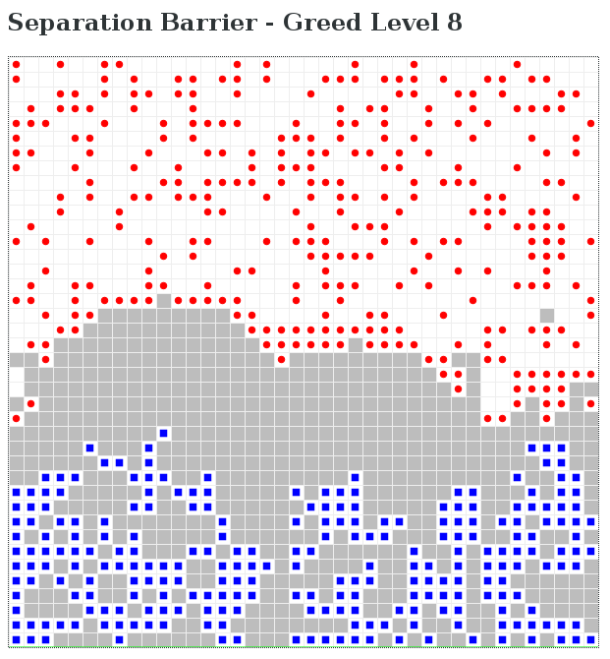
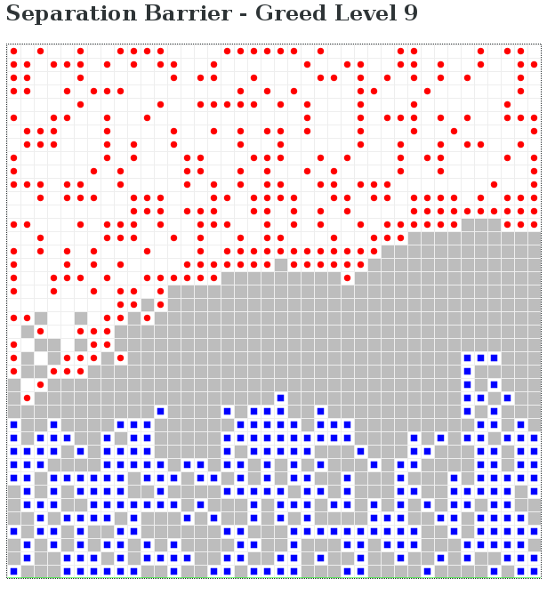
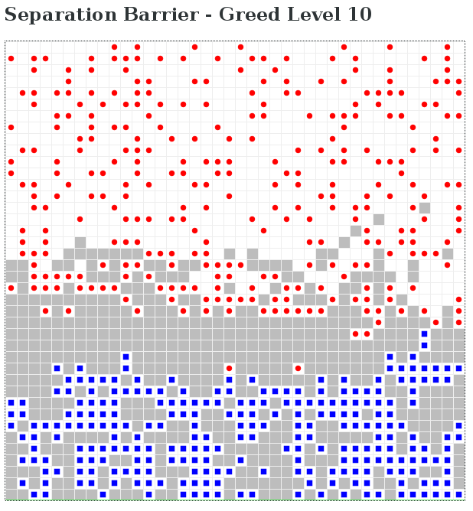

The amount of violence seems to be positively (mathematically speaking) correlated with the level of greed and exhibits a logistic growth model, with a slight disturbance at greed level 9, perhaps due to a statistical margin.
One might say that a phase transition occurs at Gr = 8, which is N / 5.
The magnitude of settler occupation on the bank however is not strongly correlated to the level of greed.

Conclusions

The results confirm my suspicions that the greed employed by the government of Israel in the construction of the separation barrier is not only a waste of tax money and a damage to the state's reputation, but it is also a major driving force of violence in an area that is already saturated with conflict.
Another interesting observation is that in this model, although the settler growth rate remains the same, the level of greed was not truly able to increase the magnitude of settler occupation on the land. That is due to the fact that an increased level of violence encouraged a richer and more complex wall that also limited the settlers' growth, so effectively it created more segregation than growth.
However it does seem that in the highest level of greed tested, there is a marginal rise in settler occupation. This probably relates to the balance between greed and violence that allows enough room for expansion without blocking the path by the barrier.
This requires further study to examine, but is is definitely something to consider when devising the route of the barrier.
When looking at the simulation in real time, it is notable that the increase in violence occurs because of the miss-correlation between the true areas of conflict and the areas in which the barrier is constructed. Building a barrier deep into the land creates a condensed area of conflict behind it. Additionally, because more barriers need to be built to account for greed requirements, more frustration is created among the Palestinians and that leads to more violence.
The study does not begin to address the metaphorical, social and psychological values that such a wall presents on the Israeli and Palestinian society, but it is widely arguable whether the net amount contribution of the barrier to the conflict is positive or negative. I hope that this study can show at least one area in which policy change, assuming that it can withstand lobbying pressure, can actively contribute to the achievement of a more peaceful environment.

References:
[1] Bernard Lewis (1993). Islam in history: ideas, people, and events in the Middle East. Open Court Publishing. p.164. ISBN0-8126-9518-6.
[2] Robin Bidwell, Dictionary Of Modern Arab History, Routledge, 2012 p.442
[3] Gorenberg,The Accidental empire, 4.
[4] http://www.securityfence.mod.gov.il/Pages/ENG/purpose.htm
[5] http://www.btselem.org/separation_barrier/map
[6] http://www.btselem.org/demonstrations/bilin
[7] http://www.haaretz.com/security-or-greed-1.185641
[8] http://www.openstreetmap.org/relation/1410327#map=9/31.9440/35.2744
[10] http://posham.co.il/%D7%94%D7%90%D7%9E%D7%AA-%D7%94%D7%9E%D7%95%D7%A8%D7%9B%D7%91%D7%AA-%D7%A2%D7%9C-%D7%97%D7%99%D7%9C%D7%95%D7%A4%D7%99-%D7%A9%D7%98%D7%97%D7%99%D7%9D/
[11] http://www.shaularieli.com/site/index.asp?depart_id=77951&lat=en
[12] http://www.haaretz.co.il/opinions/1.1180940
[13] Epstein, Joshua M. "Modeling civil violence: An agent-based computational approach." Proceedings of the National Academy of Sciences 99.suppl 3 (2002): 7243-7250.
[14] Bhavnani, Ravi, et al. "Group segregation and urban violence." American Journal of Political Science 58.1 (2014): 226-245.
[15] https://github.com/projectmesa/mesa
[16] https://en.wikipedia.org/wiki/Israeli_settler_violence#Causes_of_violence

