OVERVIEW

This document describes the Smartedge IIOT Gateway Hardware. This should be used in conjunction with the similar documentation available with each sensor or ioexpander.

# **Smartedge-iiot-gateway Hardware Reference**

There are several native hardware interfaces supported by the gateway. Optionally you may need an IO Expander to support the actual sensor used. This section describes the gateway hardware. Other additional reference material will be provided with each SDK model you select.

Here is what you get out of the box.

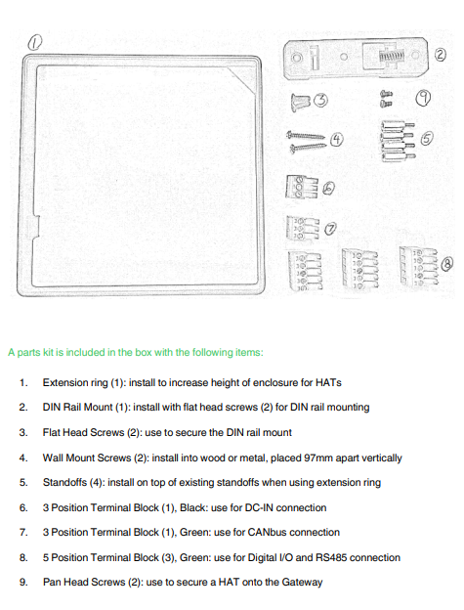

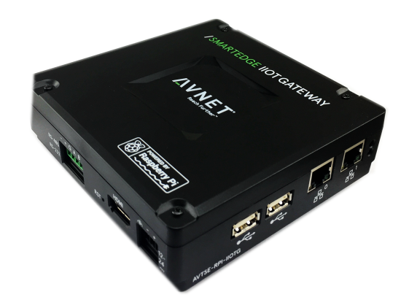

POWER INPUT An external power supply is required. Rating: 12VDC to 24VDC (+/- 10%), 18W minimum, 24W recommended, LPS (Limited Power Source). Use 16-22AWG power supply wiring, stripped back 4-5mm, twisted & optionally tinned. Find the black, 3 position terminal plug in the included hardware kit (under the foam in the box). Insert the prepared wires into the terminal plug, observing proper location. The wire polarities are indicated on the enclosure and shown below. An Earth GND wire is recommended (not included). Signal DC Input Earth GND - 0V (GND) + 12-24VDC CAUTION: Verify terminal block wiring is correct, tight, and with no bare wiring exposed. CAUTION: Please use the BLACK connector on the gateway, using ANY GREEN terminal will void your warrantee.

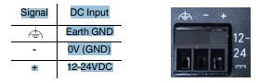

I NTERNAL VIEW

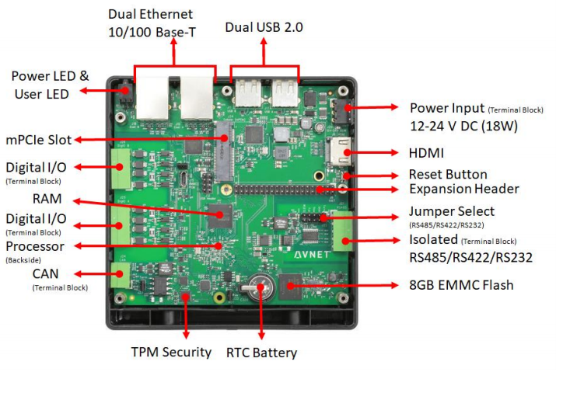

USB 2.0 Two USB 2.0 High-Speed ports are available to accept devices and can provide 0.5A per port.

ETHERNET Two 10/100 Ethernet peripherals are available. By default, both are configured the same and can accept connection to the customers network. Some advanced topologies could be configured by the customer (bridged, router, etc).

RESET BUTTON A pin hole reset button (labeled RST) is located next to the HDMI port. A paperclip can be used to activate it. − Short press (less than 5 seconds) initiates a reboot − Long press (between 5 and 30 seconds) re-enters Configuration state for IoTConnect Cloud Enrollment (section 3.4) − Very long press (greater than 30 seconds) performs a Factory Reset

HDMI An HDMI monitor can be used for console display. It should be connected at boot to enable the proper output.

ONBOARD DIGITAL I/O The digital inputs and outputs are available as /sys/class/gpio/gpio200 thru gpio207. GPIO200/202/204/206 are inputs and GPIO201/203/205/207 are outputs. See the schematic in the appendix for detailed connections. GPIOs must be exported in your application to use them. If they are used in the SDK (IoTConnectSDK.conf) then they are exported automatically. SmartEdge Industrial IoT Gateway User Guide [http://www.element14.com/gateway Page 17](http://www.element14.com/gateway%20Page%2017)

ONBOARD RS232/485 You can use the onboard RS232/485 interface as a serial console, Modbus RTU interface, or other serial usages. The RS-232/RS-485 port is configured by default for 2-wire RS-485 operation with termination enabled. On board jumpers can reconfigure the port for full duplex or RS-232 signaling. See section 3.3 for jumper configuration and connections. The port is /dev/ttySC0. Refer to the schematics in the appendix for detailed connections.

CANBUS The internal CANbus is available but not fully enabled by default in the image. It can be enabled by removing the comments dealing with the can0 section in /etc/network/interfaces. Be sure to set the proper bitrate for your bus. Utilities cansend and candump are included and the can0 device can be used by the network stacks. A CAN termination jumper is enabled by default. Refer to section 3.3 for more information and refer to the schematics in the Appendix.

INTERNAL MPCIE SLOT This full size mPCIe slot is plug-n-play with USB based cards. PCIe cards are not supported. As with any USB device, additional drivers may need to be installed. INTERNAL RASPBERRY PI HAT EXPANSION SLOT A standard Raspberry Pi HAT expansion slot of available, and can support most off-the-shelf HAT cards. The I2C1 bus is enabled for onboard devices, so the HAT card(s) must not conflict with that usage

FRONT PANEL LEDS − Power / Activity LED − Green indicates valid power − Red flashing indicates disk activity by default, but configurable − User LED − Controlled from user code

HARDWARE WATCHDOG TIMER (WDT) − Selectable timeout (1-255 seconds)

TRUSTED PLATFORM MODULE (TPM) & SECURE BOOT − SLB9670 TCG 2.0 Trusted Platform Module − Secure Boot Option when used with Avnet's Image

REAL-TIME CLOCK (RTC) WITH BATTERY BACKUP − PCF8563 real-time clock − BR1225 backup battery

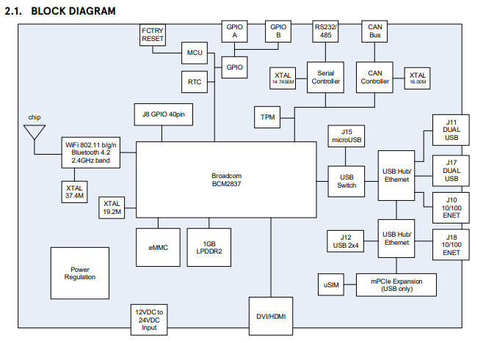

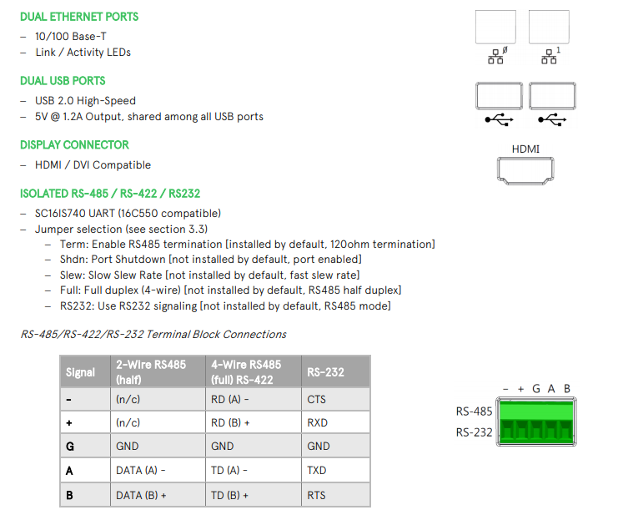

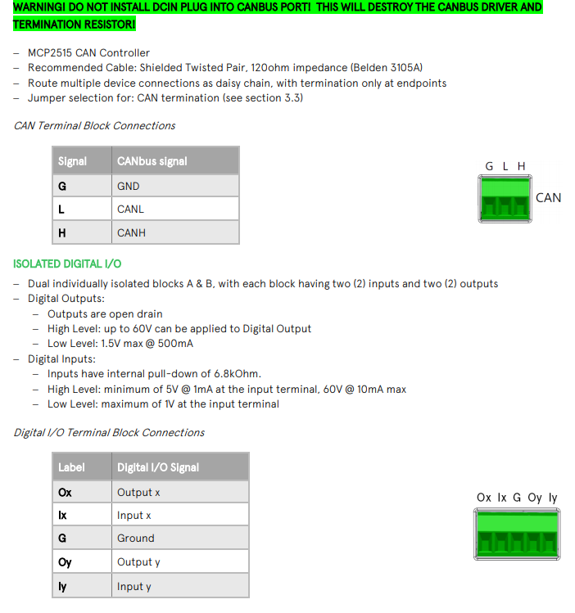

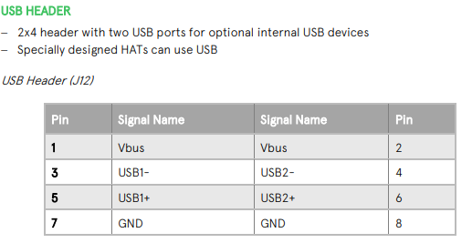

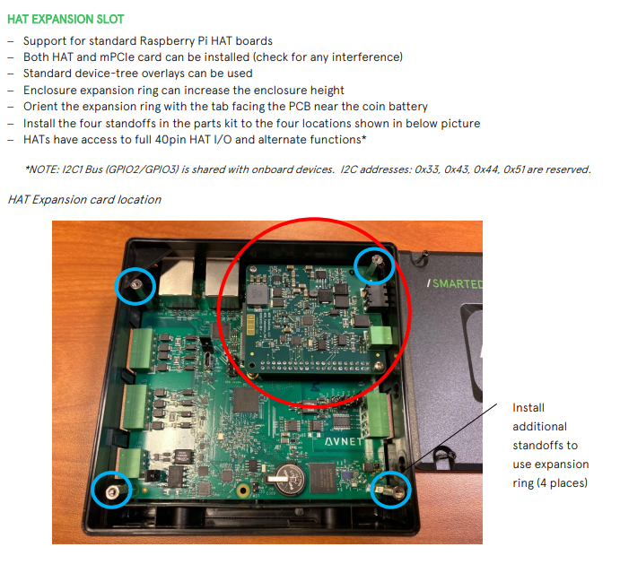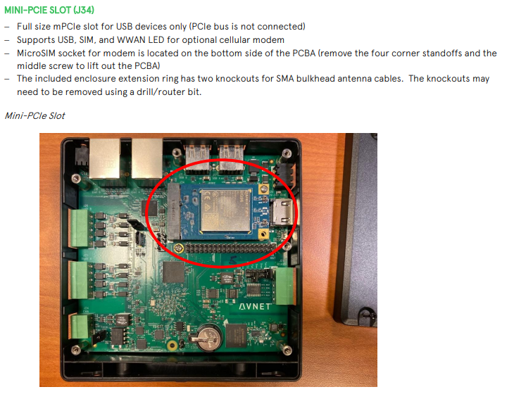

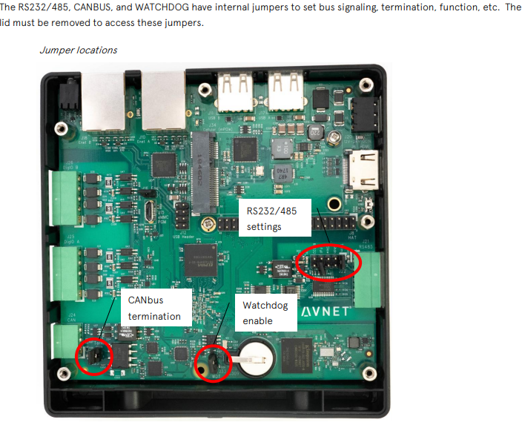

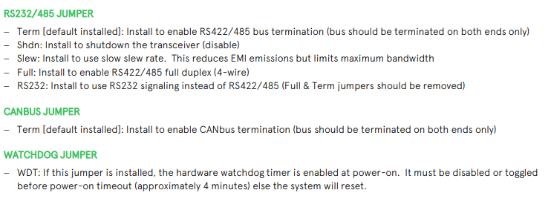

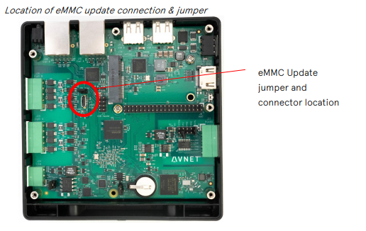

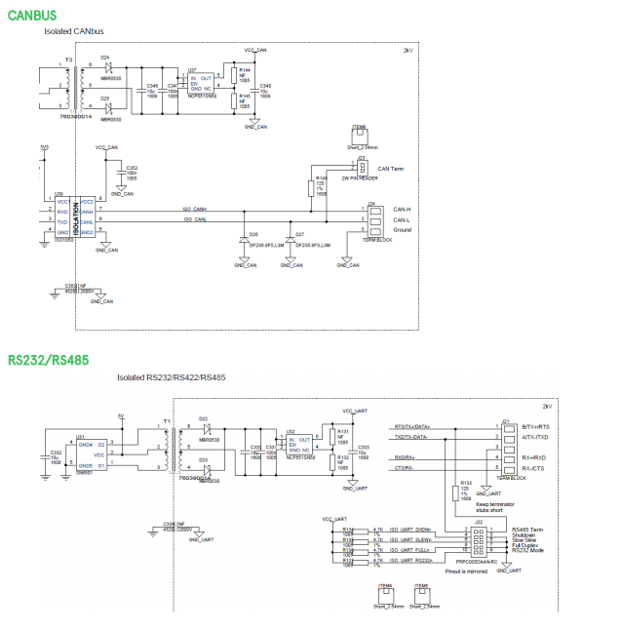

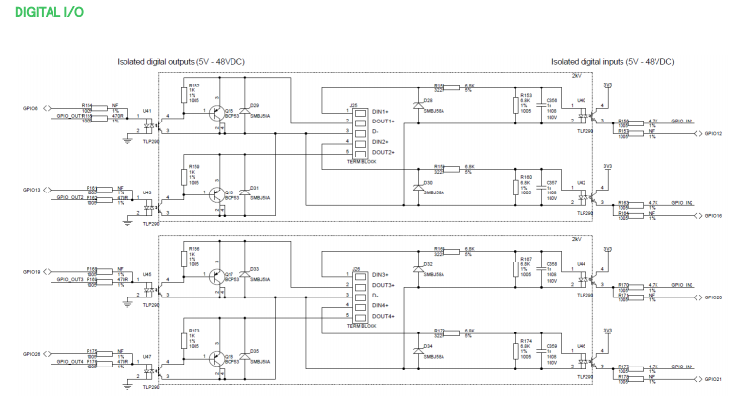

# **Gateway XYZ Hardware Reference**