# **Smart Tour Booking CRM for Tourism & Travel Sector**

# **Phase 2: Org Setup & Configuration**

**1.Salesforce Editions**

* Successfully created a Salesforce Developer Edition Org.
* This Org will be the base environment for configuring, customizing, and testing the Smart Tour & Booking CRM.

**2.Company Profile Setup**

Basic org details are configured under Setup → Company Information → Edit to establish the foundational settings for the Smart Tour Booking CRM org.

* Name: Smart Tour Booking CRM
* Time Zone: GMT+05:30 Asia/Kolkata
* Locale: English (India)
* Language: English
* Currency: INR

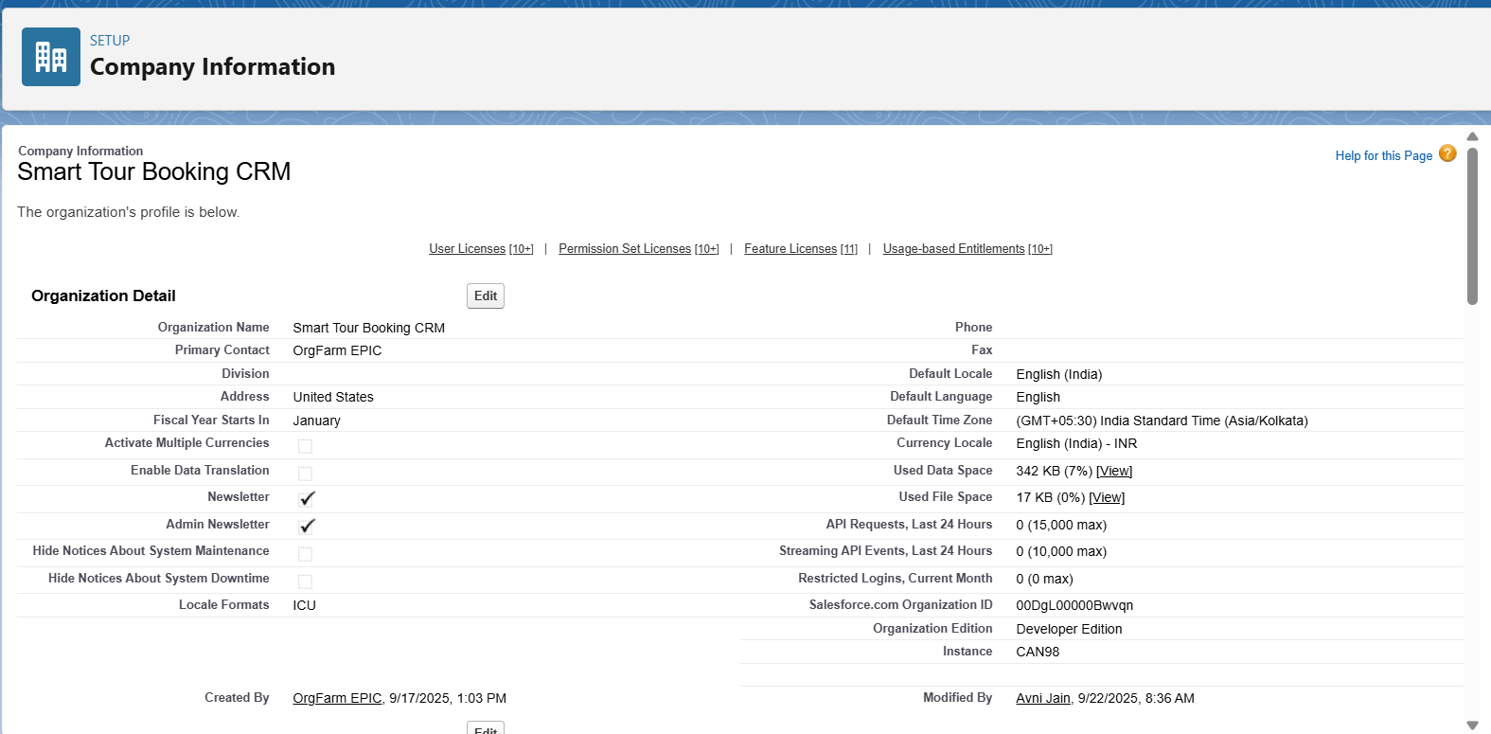

## 

## **3.Business Hours Setup**

Working hours are configured to reflect tour booking operating times for case management, inquiry follow-ups, and SLA tracking.

* Path: Setup → Business Hours → New
* Name: Standard Tour Booking Hours
* Time Zone: GMT+05:30 Asia/Kolkata
* Working Hours: Mon–Sat 9:00 AM – 6:00 PM (Closed on Sundays & Public Holidays)

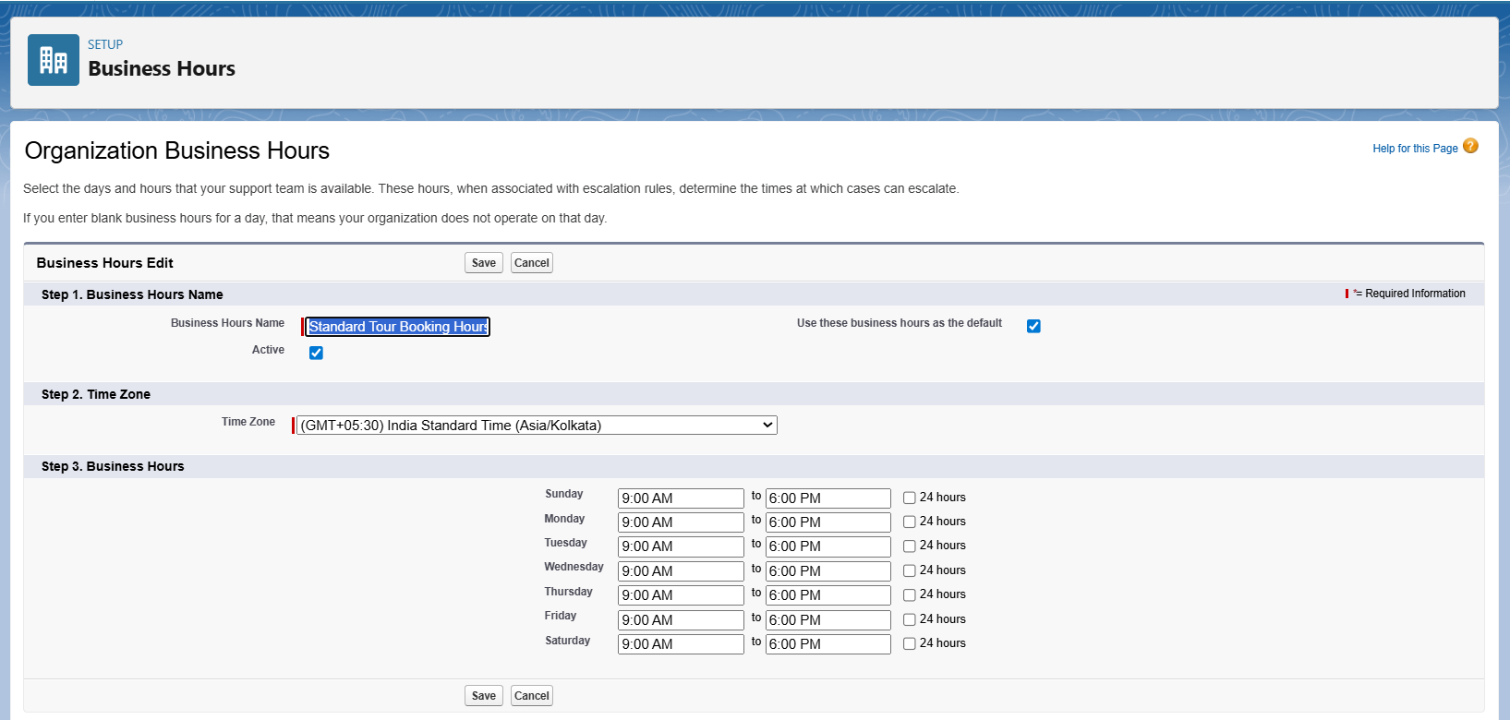

**4.Fiscal Year Setup**

A standard fiscal year is established to define reporting periods for tour sales, bookings, and revenue analysis.

* Path: Setup → Fiscal Year
* Type: Standard Fiscal Year
* Configuration: Starting month is set to April (aligned with the Indian financial year: April–March).

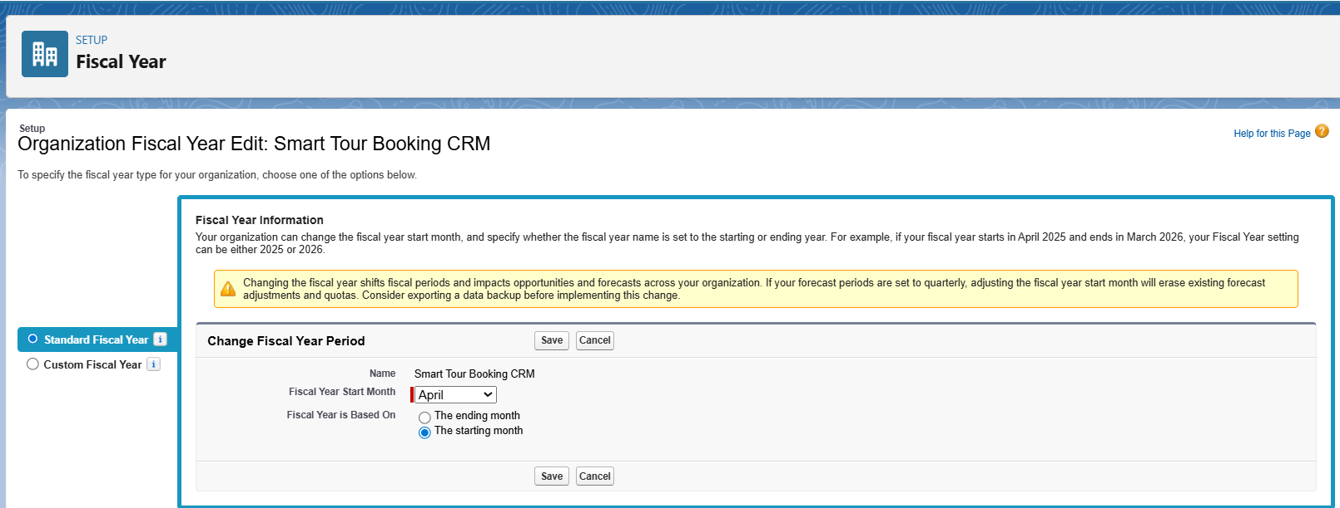

## **5.User Setup & Licenses(Profiles, Roles, Permission Sets, Users)**

Users are added to the org with appropriate profiles and permissions to ensure they can perform their roles efficiently in the Smart Tour Booking CRM. Licenses define what Salesforce features are available to each user**.**

1. **Agent Profile**: Handles bookings and customer interactions with restricted system access.

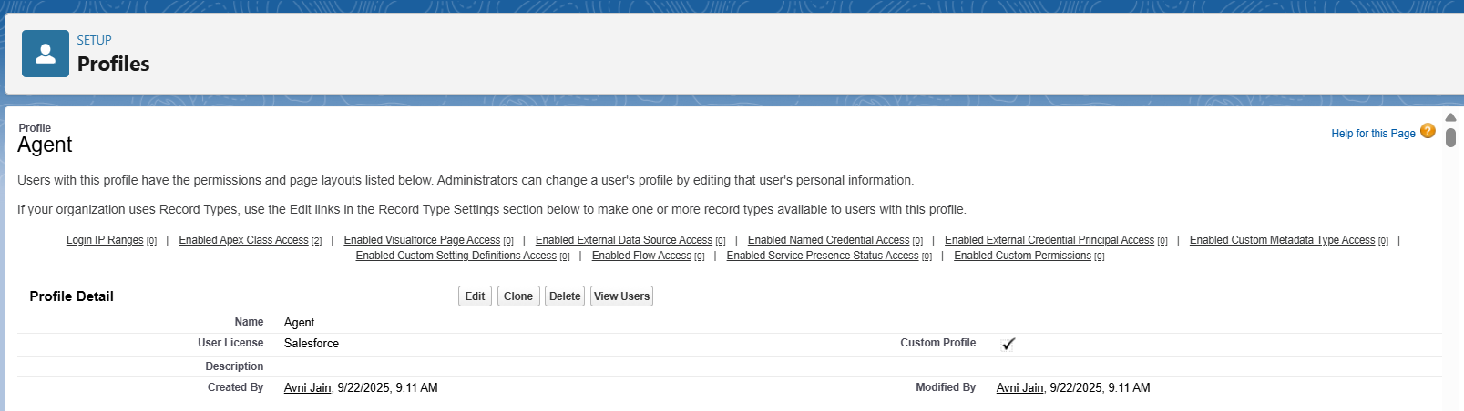

2.**Manager Profile:** Full access for managing operations, reporting, and system configuration.

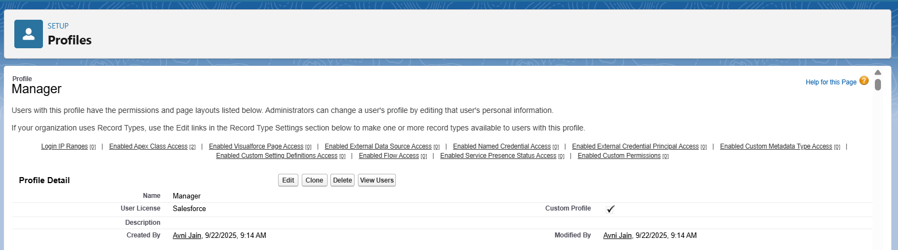

**3.Role Hierarchy Setup**

The hierarchy defines the data access and reporting structure within the organization.

* Path: Setup → Roles → Set Up Roles
* Top-Level Role: CEO
* Manager Role: Added as a child of the CEO
* Agent Role: Added as a child under the Manager
* Resulting Hierarchy: CEO → Manager → Agent

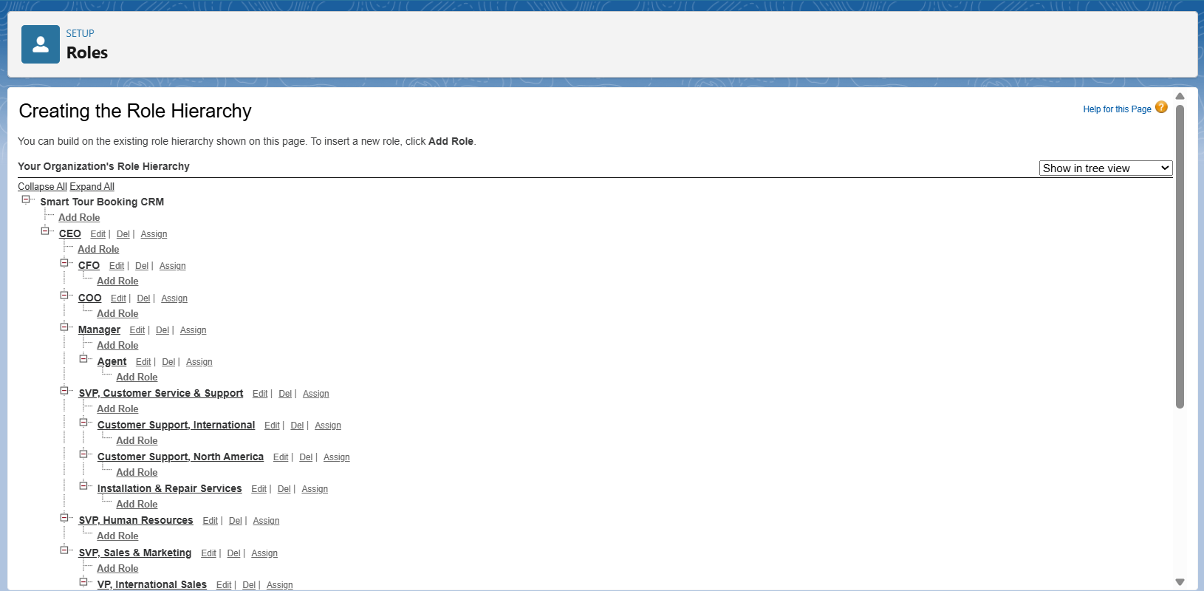

## **4.Permission Set Setup**

Permission sets are used to grant additional permissions to users without changing their profile, allowing flexibility in access control.

* Path: Setup → Permission Sets → New.
* Permission Set Name: Booking Reports Access .
* License: None
* Assigned Users: Agents or Managers depending on the permission requirements
* Purpose: To allow extra access such as exporting reports, viewing marketing data, or special features beyond the base profile

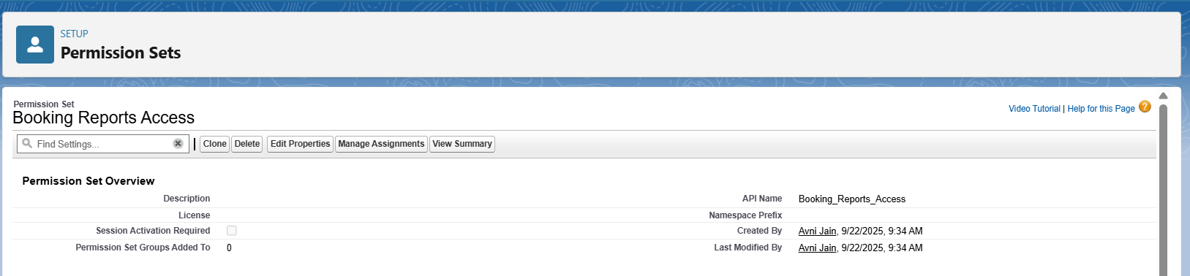

### **5.Users**

Sample users were created and assigned the appropriate profiles and roles:

* ceo1 → Manager_Profile, Role: CEO
* manager1 → Manager_Profile, Role: Manager
* agent1 → Agent_Profile, Role: Agent  
  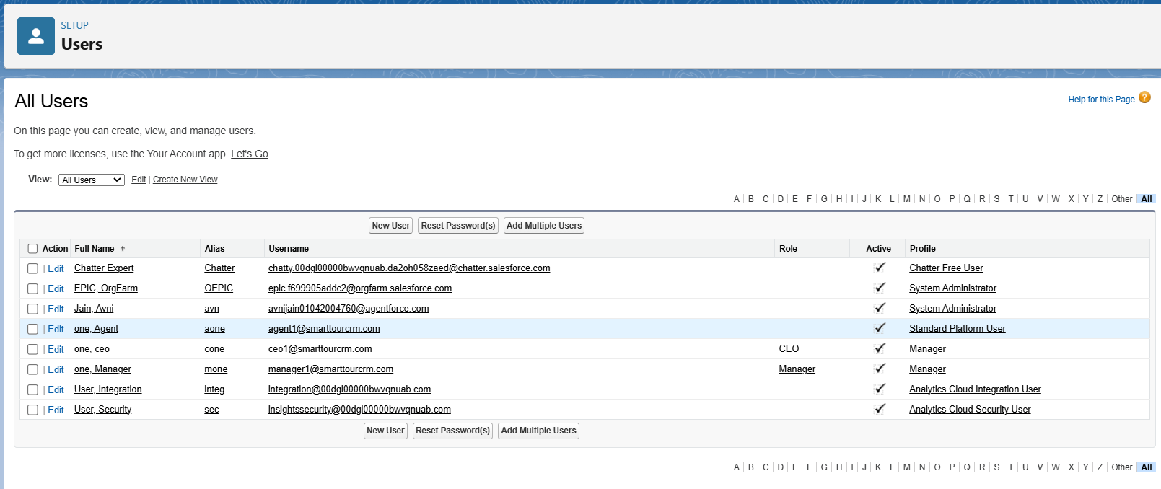

**6.OWD & Sharing Rules**

* OWD (Org-Wide Default): This will be configured in Phase 3, as the settings need to be applied to the custom objects that will be created then.
* Sharing Rule: This will also be implemented in Phase 3 after the custom objects and OWD settings are in place.

**7.Login Access Policies**

Login Access Policies determine **who can log in as a user** and for how long. This is useful for **admin troubleshooting** and security monitoring.

* **Path:** Setup → Security → Login Access Policies

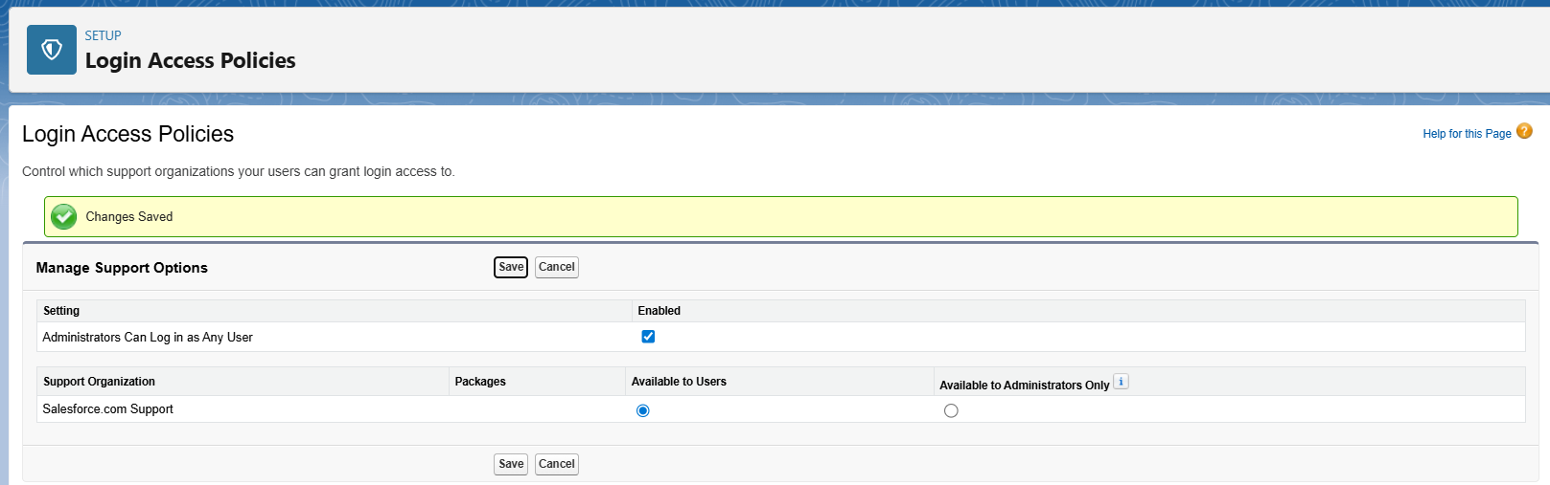

**8.Dev Org Setup**

The Salesforce Developer Org was set up as the **foundation for the Smart Tour Booking CRM**:

* Provided a **sandbox environment** for building and testing the system.
* Configured **company profile, time zone, currency, and locale**.
* Security settings such as **Login Access Policies** and **OWD** were established.
* Profiles, roles, permission sets, and sample users were created for **role-based access control**.
* Business Hours and Fiscal Year were defined to support case management and reporting.

**9. Developer Sandbox**

A **Developer Sandbox** was used to build and test the Smart Tour Booking CRM without impacting the live environment.

* Profiles, roles, permission sets, and sample users were configured in the sandbox.
* Business Hours, Fiscal Year, and objects were tested.
* This approach ensured **safe development, testing, and validation** before moving changes to production.