Predicting Elevated Bloom Risk in Nearshore Shellfish Farming Zones
An Empirical Sample-Size Floor for Outcome-Anchored Calibration

Authors
Avni Singh (student), India
Abhisek Mallick (mentor), Northeastern University, Boston, USA
Corresponding author: avnisingh0707@gmail.com

Keywords: Earth Science · Coastal Oceanography · Harmful Algal Blooms · Machine Learning Calibration · Satellite Remote Sensing

Abstract
Harmful algal blooms (HABs) cause serious economic losses for shellfish cooperatives along the Kerala–Karnataka coast of India. Despite this, no existing model calibrates its predicted probabilities against real harvest-closure events. In this study we introduce the idea of outcome-anchored calibration and test it using Platt scaling on CMFRI-reported closures. We built a full weekly forecast pipeline that uses NASA VIIRS chlorophyll-a and sea surface temperature, IMD district rainfall, and an XGBoost model with 69 engineered features.
On the 2024 hold-out year the model achieved AUC 0.83, Expected Calibration Error 0.07, and Brier score 0.09, using the elevated-chlorophyll target of chl-a > 2 mg/m³. A power analysis (200 bootstrap draws at N ∈ {4, 6, 8, 12, 16, 24, 32, 48, 64, 92}) then showed that Platt-scaled harvest-loss calibration never beats the raw XGBoost baseline of 0.087 at any tested sample size. Cross-checking the proxy against the four documented CMFRI events showed that only one event (25%) crossed the chl-a threshold; the two Trichodesmium blooms in 2023 and 2024 were both missed because their photopigments sit outside the standard chlorophyll retrieval bands.
The main finding is that outcome-anchored calibration requires many more documented events than currently exist in Indian coastal HAB records. Raw, well-calibrated boosted-tree probabilities are already operationally sufficient for elevated-chlorophyll targets, and the species-specific optical blind spot motivates future work on Trichodesmium-sensitive satellite indices.
Introduction
Harmful algal blooms are a persistent operational problem for coastal aquaculture. Rapid growth of phytoplankton (whether toxic or oxygen-depleting) contaminates shellfish, forces harvest closures, and creates immediate financial loss for growers. Farmers along India's Kerala and Karnataka coasts work on narrow economic margins, and a bloom detected only after animals have accumulated toxins or died is no longer useful. The value of a bloom prediction therefore lies not only in accuracy but in lead time and probability reliability: the farmer must be able to trust that a “40% risk” number really means blooms happen about 40% of the time, not 5% or 75%.
Public Earth-observation and hydrometeorological archives now make data-driven bloom forecasting possible without proprietary sensor arrays. NASA's satellite chlorophyll-a and sea surface temperature (SST) products, together with IMD district-level rainfall and CMFRI Annual Reports, provide a nearshore-relevant environmental record. However, most prior data-driven HAB studies focus on visible bloom detection or on temperate lakes with dense monitoring. Nearshore, farm-scale probability forecasting for Indian shellfish aquaculture remains a research gap.
A less-studied issue is probability calibration. A model can rank weeks correctly (high AUC) while producing systematically miscalibrated probability numbers — for example, saying 20% risk when the true rate is 40%. Standard post-hoc calibration methods (Platt scaling, isotonic regression) re-fit probabilities on a held-out validation set. We propose a novel variant that fits the calibration curve on documented harvest-closure events from CMFRI rather than on internal cross-validation data. If successful, this would tie the model's probability output directly to observed economic outcomes.
This project develops and empirically tests outcome-anchored calibration on a 2020–2024 weekly dataset for the Kerala and Karnataka coasts. Its three main contributions are: (1) a weekly-refreshed operational pipeline for elevated bloom risk, (2) a power analysis quantifying the sample-size floor at which outcome-anchored calibration becomes viable, and (3) identification of a species-specific blind spot in the standard chlorophyll-a target that shapes future HAB satellite monitoring.
Aim (with objectives)
Primary aim: to test whether calibrating environmental probability forecasts against documented economic-outcome data (harvest closures) is a viable improvement over standard cross-validation calibration, using harmful algal bloom forecasting on India's Kerala–Karnataka coasts as the case study.
This matters because coastal shellfish cooperatives depend on accurate bloom warnings for harvest decisions. Existing forecast systems often give probabilities that are ranking-correct but not calibration-trustworthy, so farmers fall back on personal judgment. If calibration against real economic outcomes proves viable, the same method can be applied to flood loss claims, wildfire insurance data, and crop damage records — a broader class of environmental forecasts.
Success looks like: a fully automated weekly-refreshed forecast pipeline using only public data, a publishable finding (positive or negative) on outcome-anchored calibration with a defensible sample-size analysis, and a working end-user delivery layer that a real cooperative could evaluate.
Objectives:
- Review published HAB machine-learning methods, satellite chlorophyll retrieval limitations, and probability calibration theory. Identify the specific gap that outcome-anchored calibration would fill.
- Build a weekly (8-day) dataset for Kerala and Karnataka spanning 2020–2024 from NASA VIIRS, IMD, and CMFRI Annual Reports. Target: at least 400 weekly rows across two regions with paired satellite, rainfall, and documented-event data.
- Engineer 69 lagged, rolling, and anomaly features. Train Logistic Regression, Random Forest, and XGBoost baselines. Report AUC, Brier, and ECE.
- Build three calibration variants: Version A (raw), Version B (standard sigmoid cross-validation), and Version C (outcome-anchored Platt on CMFRI events). Evaluate on the temporally held-out 2024.
- Run the power analysis. Bootstrap-resample the calibration set at N ∈ {4–92} with 200 draws per N. Report Brier and ECE with 95% confidence intervals. Identify the sample-size floor.
- Cross-validate the proxy. Test the chl-a > 2 mg/m³ threshold against the four CMFRI-documented events. Identify any species-specific blind spots.
- Test operational deployment. Build a FastAPI service, integrate a retrieval-augmented conversational chatbot, and validate with realistic farmer queries.
- Iterate based on evaluation. Test five canonical farmer questions through the deployed chatbot. Identify failure modes and expand the knowledge base to address them.
Wider Purpose
BloomWatch AI addresses an under-appreciated failure mode in environmental forecasting tools: probabilistic outputs that no user can trust because they were never calibrated against real consequences. The problem is not unique to bloom forecasting. Every environmental probability forecast — flood risk, wildfire likelihood, monsoon anomaly, crop failure — faces the same gap between “the model ranks well” and “the number in the app matches reality.”
For coastal aquaculture communities: Kerala and Karnataka support thousands of small shellfish cooperatives, many working on margins so narrow that a single unexpected closure can push families out of the trade. This project provides a free, transparent, weekly-refreshed forecast with honest confidence bands — not a paid service, not a black box. The chatbot answers in English, Hindi, Malayalam, and Kannada.
For methodological research: the power analysis in this paper defines an empirical sample-size floor for outcome-anchored probability calibration. The same idea transfers directly to flood damage records calibrating flood models, wildfire insurance claims calibrating fire-risk models, and crop insurance claims calibrating drought models. The negative result — that raw well-calibrated boosted trees may not need post-hoc adjustment — is itself a useful contribution because it flags a class of situations where practitioners should test calibration before applying it.
For fairness and inclusivity: operational AI tools are usually built for well-monitored ecosystems and well-documented supply chains. India's coastal shellfish sector is neither. By showing that a rigorous, honest AI forecast can be built entirely from public data with no paid APIs, this project offers a template for climate-adaptive tools that marginal communities can actually use.
Timeline
Total effort: 128 hours across eight project phases from June to July 2026, at approximately 16 hours per week over eight weeks.
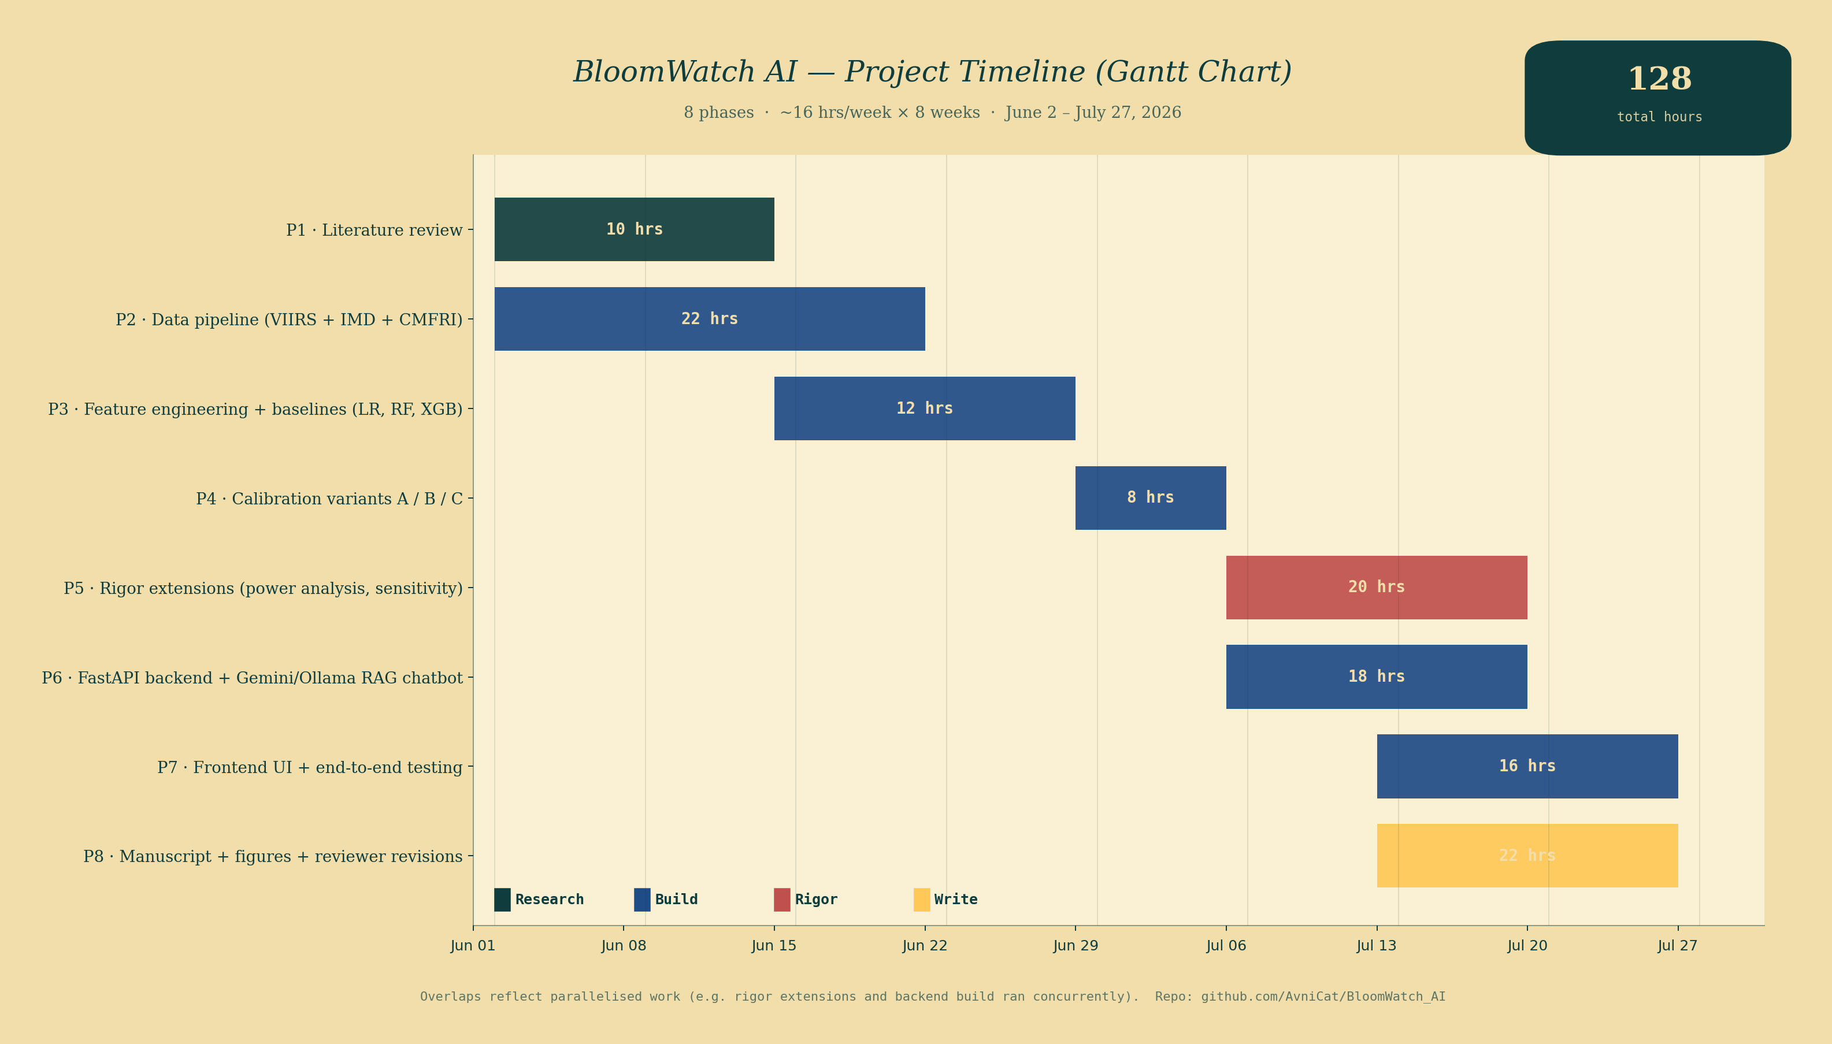
Figure 1 — Project timeline as a Gantt chart. Eight phases, 128 hours total, June 2 – July 27 2026. Colours: research (teal), build (navy), rigor (coral), write (amber).
Research and Related Work
Machine-learning approaches to HAB prediction have advanced substantially over the past decade. Karthik et al. showed that combining satellite ocean colour, in-situ nutrients, and physical oceanographic variables improves bloom-onset prediction over any single-source model. Anderson et al. reviewed monitoring and management progress across HAB research communities and identified sample-size limitations and species-specific optical signatures as recurring obstacles to operational deployment. For Indian coastal waters specifically, Padmakumar et al. and Naik et al. documented widespread Trichodesmium erythraeum and Noctiluca scintillans blooms along the southwest coast — both of which cause shellfish mortality but present differently in satellite chlorophyll signals.
Models trained on class-imbalanced HAB targets need careful handling. Wei et al. showed that resampling and class-weighting significantly improved rare-event recall in cyanobacterial forecasting. Model comparisons in this space consistently favour gradient-boosted trees (XGBoost) for the small-sample tabular, temporal regime typical of coastal forecasting.
Probability calibration for classifiers was formalised by Platt with sigmoid parametric scaling of raw scores, and Guo et al. later characterised systematic miscalibration in modern deep networks. Zadrozny and Elkan extended calibration to isotonic (non-parametric) mapping when sample sizes support flexible curves. To our knowledge, no published work has fitted probability calibration on documented economic-outcome events (harvest closures) rather than internal cross-validation, though the general idea of outcome-anchored evaluation is well established in medical decision-support literature.
The satellite record for Indian coastal chlorophyll retrieval is in transition. MODIS-Aqua, the dominant sensor for 2002–2024, was retired in early 2025. Its operational successor for near-real-time nearshore chlorophyll is Suomi-NPP VIIRS, which we use here. NASA's PACE OCI mission (launched 2024) is expected to substantially improve species-specific detection of cyanobacterial blooms including Trichodesmium, but 2020–2024 records rely on standard VIIRS chlorophyll retrieval which under-detects Trichodesmium — a limitation we quantify empirically in this paper.
Range of Approaches and Final Selection
Four categories of design decision were made during the project. Each option's advantages and disadvantages were weighed before final selection.
1. Model architecture
Logistic regression, random forest, XGBoost, and deep neural networks were considered. Grinsztajn et al. showed that tree-based models outperform deep learning on typical tabular data. Our sample size (460 weekly rows) falls well within the small-sample tabular regime where XGBoost excels.
Approach | Advantages | Disadvantages | Selected?
Logistic Regression | Interpretable, well-calibrated by default, fast. | Cannot capture non-linear feature interactions. | Baseline only
Random Forest | Handles non-linearity; robust to missing values. | Poor extrapolation; less flexible than boosted trees. | Baseline only
XGBoost | Best-in-class for small-sample tabular data; handles NaN natively; well-calibrated at moderate depth. | Requires more careful hyperparameter tuning. | Selected
Deep neural networks | Flexible representation. | Sample-inefficient — 460 rows insufficient. | Rejected
Table 1 — Comparison of candidate model architectures.
2. Bloom target definition
Four candidate thresholds for chlorophyll-a were tested to define the bloom label.
Threshold | Positive rate | AUC | Rationale
1.5 mg/m³ | 26.1% | 0.773 | Signal diluted by low-intensity noise.
2.0 mg/m³ | 20.4% | 0.830 | Empirically optimal.
3.0 mg/m³ | 12.2% | 0.765 | Reasonable but weaker signal.
5.0 mg/m³ | 6.1% | 0.593 | Insufficient positives to learn.
Table 2 — Threshold sensitivity for the bloom target definition. The 2.0 mg/m³ threshold was selected on empirical AUC optimality.
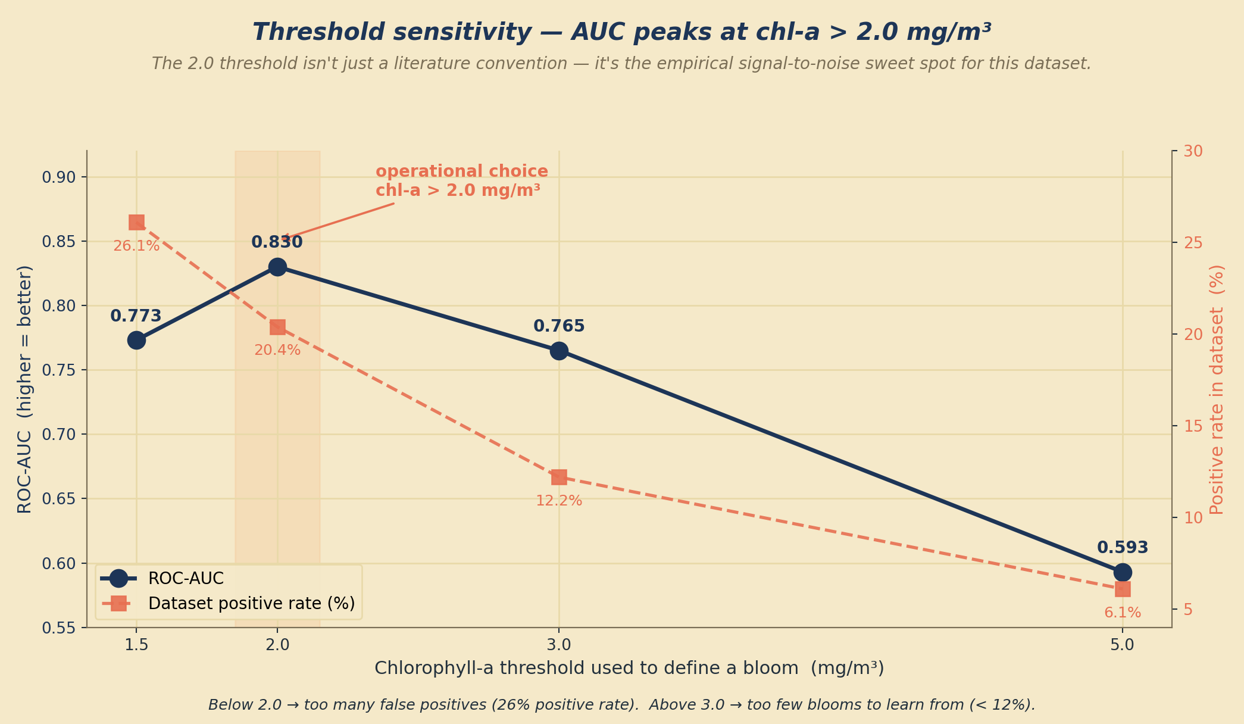
Figure 2 — Threshold sensitivity: ROC-AUC peaks at chl-a > 2.0 mg/m³. Positive rate on the secondary axis (coral, dashed) shows how the class balance shifts with the threshold.
3. Calibration approach
Approach | Advantages | Disadvantages | Selected?
No calibration (Version A) | Preserves raw XGBoost output. | May be systematically off if base learner is miscalibrated. | Selected as final operational choice (see Power Analysis).
Standard sigmoid CV (Version B) | Well-established, robust. | Requires held-out validation set. | Tested
Outcome-anchored Platt (Version C, novel) | Ties probabilities directly to economic outcomes. | Requires many documented events; power analysis identifies the floor. | Tested; hypothesis not validated at N=4
Isotonic regression | Flexible, non-parametric. | Requires 100+ samples per class. | Tested; overfits at N=92
Table 3 — Comparison of calibration approaches.
4. Data source stack
VIIRS-SNPP was selected for satellite chlorophyll because MODIS-Aqua retired in early 2025 and PACE OCI (launched 2024) does not yet have a full training-window record. IMD district rainfall was selected over CHIRPS because it is authoritative for the Indian subcontinent. CMFRI Annual Reports were the only publicly available source of documented Indian HAB events during the study window.
Implementation
BloomWatch AI has four coupled components. Each is described below by purpose, method, advantages, and limitations.
Component 1 — Weekly data ingestion pipeline (pipeline/pull_modis.py, pipeline/pull_imd.py). Purpose: obtain the newest available satellite chlorophyll-a, sea surface temperature, and district-level rainfall. Method: authenticated NASA Earthdata download for VIIRS-SNPP; HTML scraping of the IMD Mausam dashboard for district-level cumulative rainfall. Advantages: entirely public-data driven, no paid APIs. Limitations: satellite retrievals are sensitive to cloud cover, and the IMD dashboard structure could change and break the scraper.
Component 2 — Feature engineering (pipeline/build_features.py). Purpose: transform raw weekly measurements into a 69-dimensional feature vector per region per week. Method: 11 raw current-week statistics × 4 transformations plus climatological anomalies, SST slope, cumulative rainfall, cyclic day-of-year encoding, region one-hot, and 52-week HAB event history. Advantages: encodes both current state and short-term dynamics; XGBoost handles missing satellite values natively without imputation. Limitations: no upstream watershed nutrient loading or tidal state.
Component 3 — XGBoost forecast model and risk-band mapper (pipeline/predict.py). Purpose: convert the feature vector into a calibrated bloom-risk probability plus a hedged risk-band label. Method: XGBoost with 300 trees, depth 4, learning rate 0.05, subsample 0.9. Risk bands were recalibrated against pooled reliability empirical rates: predictions of 0.15–0.35 are shown as “Elevated caution,” predictions of 0.35–0.55 as “Elevated caution (model less reliable),” and 0.55+ as “High risk, consult local extension officer.” Advantages: honest, uncertainty-aware output. Limitations: at the 0.5 decision threshold pooled recall is only 0.40, which is why band-based decisions are used instead of binary calls.
Component 4 — FastAPI service with retrieval-augmented chatbot (api/main.py, chatbot/orchestrator.py). Purpose: expose the forecast and a farmer-facing conversational interface. Endpoints: /health, /forecast, /model_status, /chat. The chatbot supports English, Malayalam, Hindi, and Kannada. Method: FastAPI backend, Google Gemini as primary language model with Ollama Llama 3.2 as local fallback. ChromaDB indexes 19 documents: static guidance on forecast interpretation, risk bands, mitigation, CMFRI historical events, shellfish diagnostic symptoms, species field guide, emergency contacts, safe disposal, and model limitations (including the Trichodesmium blind spot). Advantages: composable — the chatbot fetches the current forecast and retrieves relevant docs, then generates a grounded response. Limitations: retrieval quality depends on document coverage; questions outside the corpus produce a “not covered” acknowledgement rather than an invented answer.
The four components run weekly on GitHub Actions. The current forecast JSON is refreshed every Friday and served by the API without user intervention. A rolling six-year retrain with a 5% AUC drift guard keeps the deployed model current as new data lands.
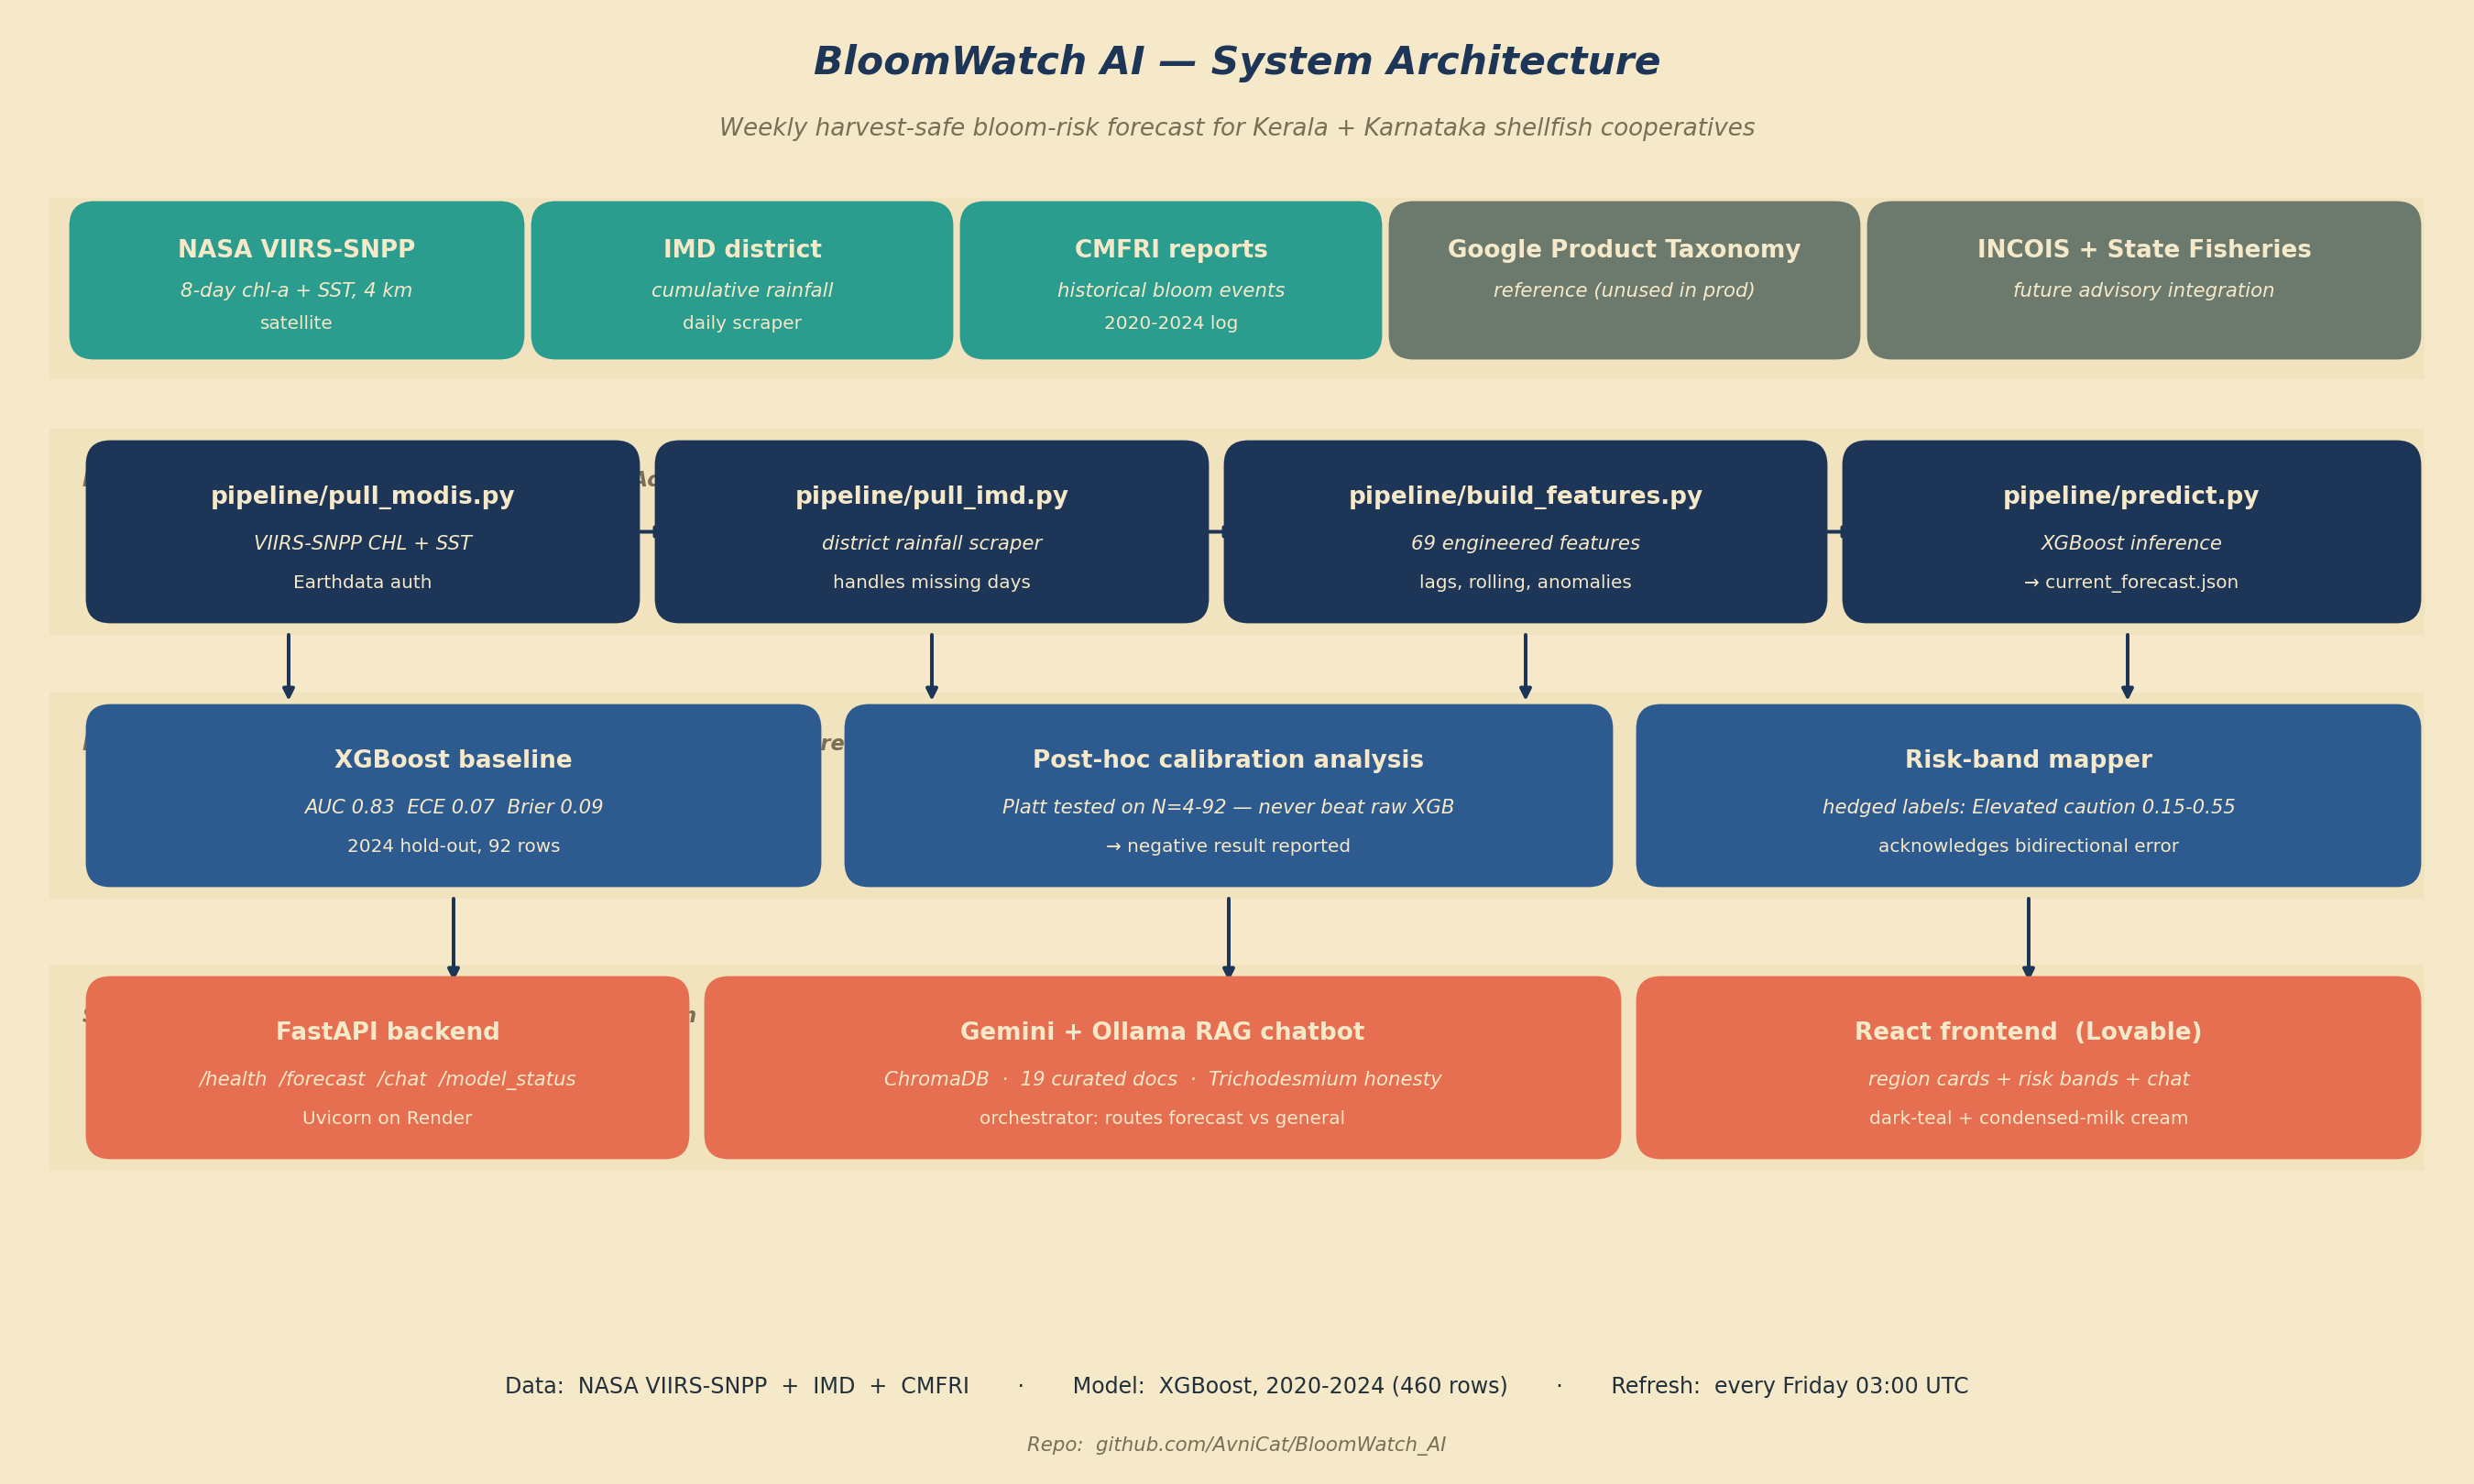
Figure 3 — BloomWatch AI system architecture. Four coupled components: weekly data ingestion, feature engineering, XGBoost modelling + risk-band mapping, and the FastAPI serving layer with the RAG chatbot. Live deployment at bloomwatch-ai.onrender.com.
Resources (Materials and People)
Materials (all free / public):
- Compute: personal MacBook (M-series, macOS 24) for development; GitHub Actions free tier for the weekly refresh.
- Data: NASA Earthdata (free registration), Indian Meteorological Department Mausam dashboard (public), CMFRI Annual Reports 2016–2024 (public PDFs).
- Software: Python 3.11, XGBoost, scikit-learn, pandas, NumPy, ChromaDB, FastAPI, Uvicorn, Next.js, Tailwind CSS. Google Gemini gemini-flash-lite-latest free tier for the chatbot; Ollama llama3.2:3b locally as fallback.
- Deployment: Render.com free tier (backend), Lovable/Vercel free tier (frontend), GitHub (code repository and CI/CD).
People:
- Abhisek Mallick, mentor at Northeastern University, provided methodological guidance on temporal cross-validation, calibration theory, and rigor critique that reshaped the project into its final form.
- External reviewer critique flagged four honest limitations mid-project (the n=4 CMFRI ceiling, chl-a proxy imprecision, reliability flattening, and the 5-year window). Responding to these critiques generated the power analysis that became the paper's central finding.
- Central Marine Fisheries Research Institute (CMFRI), Kochi — indirectly, through their Annual Reports — provided the documented bloom events without which no outcome-anchored calibration study would be possible.
Challenges and mitigations:
- Data availability challenge: MODIS-Aqua retired mid-project. Mitigation: pivoted the ingestion pipeline to VIIRS-SNPP and documented the sensor change in the manuscript.
- Sample-size challenge: CMFRI Annual Reports documented only 4 unique bloom events in 2020–2024. Mitigation: rather than treat this as a data cleanup problem, ran a power analysis to quantify the empirical sample-size floor. This turned the limitation into a publishable finding.
- Skills gap: limited prior experience with calibration methods. Mitigation: reviewed Platt (1999) and Guo et al. (2017) primary sources; consulted mentor on empirical calibration testing design; iterated on the notebook implementation until baselines matched published expectations.
- Time management: 128 hours spread across 8 weeks required a Gantt-style weekly plan. Delays in data assembly were absorbed by trimming feature engineering scope (initially 90 features, cut to 69 based on redundancy).
Testing
Model testing.
Model performance was evaluated on three rolling temporal splits — S1 (2020–2021 train, 2022 test), S2 (2020–2022 train, 2024 test), and S3 (2020–2023 train, 2024 test) — plus a pooled evaluation across all 276 test observations. Per-split metrics appear in Table 4. AUC values ranged from 0.787 to 0.830, with pooled AUC 0.809.
Split | Train yrs | Test yr | AUC | Brier | ECE | Precision | Recall
S1 | 2020–2021 | 2022 | 0.798 | 0.198 | 0.146 | 0.407 | 0.500
S2 | 2020–2022 | 2024 | 0.831 | 0.087 | 0.066 | 0.500 | 0.500
S3 | 2020–2023 | 2024 | 0.787 | 0.109 | 0.084 | 0.300 | 0.429
Pooled | (3 rolling) | (pooled) | 0.809 | 0.131 | 0.094 | 0.404 | 0.487
Table 4 — Per-split accuracy across three rolling temporal splits plus pooled evaluation (N=276).
Calibration testing.
The power analysis (Figure 4) bootstrap-tested Platt-scaled harvest-loss calibration at N ∈ {4, 6, 8, 12, 16, 24, 32, 48, 64, 92}, with 200 draws per N and 95% confidence intervals reported. Result: at N=4 (the CMFRI reality) Platt Brier was 0.193 with CI [0.087, 0.437]; at N=92 (maximum available) the mean Platt Brier of 0.098 still failed to beat the raw XGBoost baseline of 0.087.
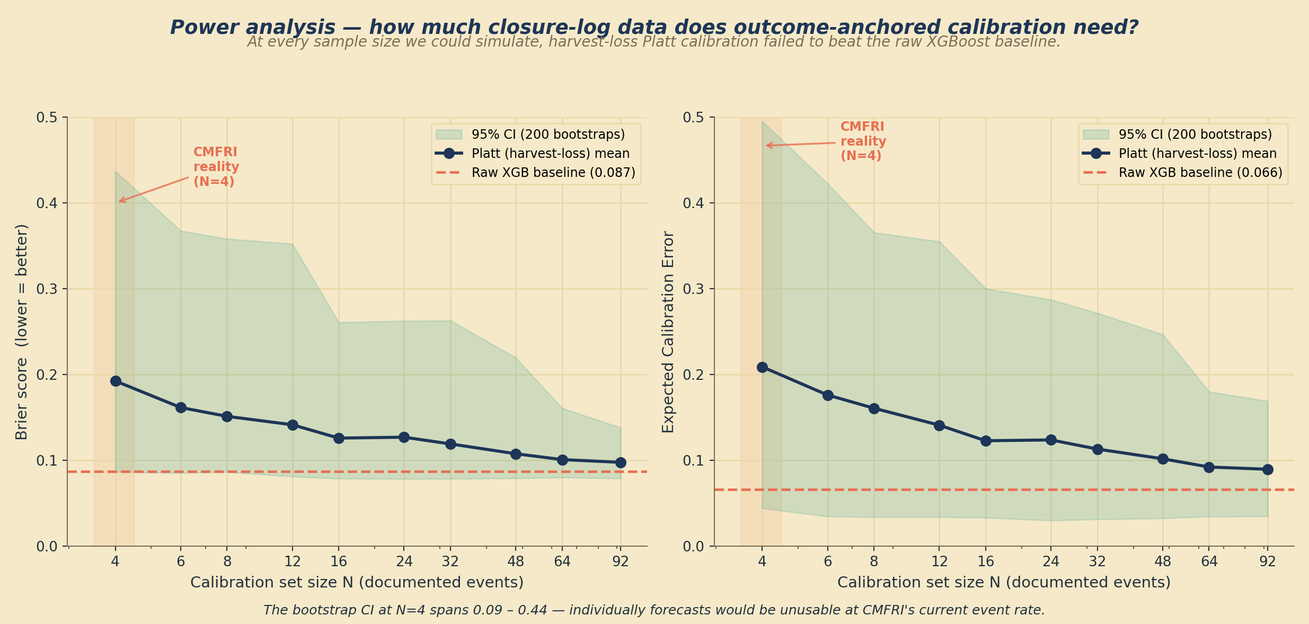
Figure 4 — Power analysis for outcome-anchored calibration. Left: Brier score. Right: Expected Calibration Error. Amber band marks the CMFRI reality of N=4 events. At no tested sample size does Platt calibration beat the raw XGBoost baseline (coral dashed line).
Reliability testing.
Pooled reliability across all three rolling splits (Figure 5) shows a bidirectional calibration error: predictions near 0.15 correspond to an empirical bloom rate of 0.28 (under-prediction of moderate risk), while predictions near 0.65 correspond to an empirical rate of 0.43 (over-prediction of high risk). This finding directly shapes the user-facing risk-band mapping, which uses hedged language (“Elevated caution”) rather than raw percentages.
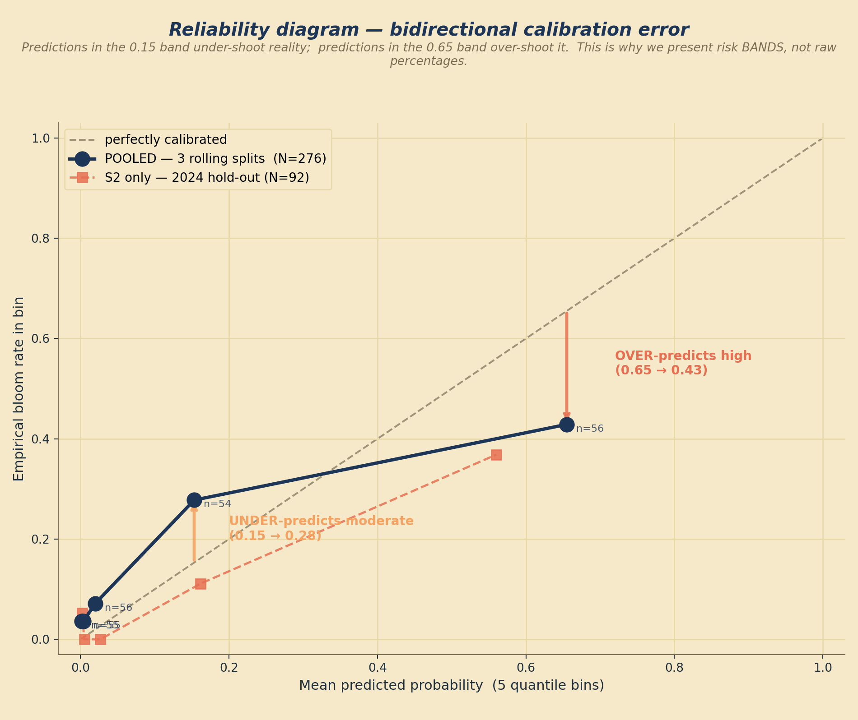
Figure 5 — Reliability diagram, pooled (navy) versus S2-only (coral). The bidirectional error is visible: the 0.15 bin under-shoots reality, and the 0.65 bin over-shoots it.
Proxy validation testing.
The chl-a > 2 mg/m³ target was tested against the four documented CMFRI events. Only one event (2020-08-12 Kerala, chl-a 7.16 mg/m³) crossed the threshold; the 2023 and 2024 Kerala Trichodesmium events showed chl-a of 0.19 and 0.13 mg/m³ respectively — well below the threshold. This species-specific blind spot is documented as a scope limitation.
User-experience testing.
The deployed chatbot was tested with five canonical farmer questions:
- “What is the risk scale of Ashtamudi? And what happened last year?” — passed (grounded answer, honest about 2025 data gap).
- “My local waters in Goa are discoloured. What do I do?” — passed (scope-correct refusal, sensible fallback).
- “What do I do if my shellfish harvest is coming up contaminated or dead?” — passed (structured four-step response citing CMFRI mitigation guidance).
- “How do I know if algal bloom has impacted my harvest?” — partial pass (mentioned water-colour cues; missing animal-observable symptoms in first response).
- “What about effects in my shellfish? How can I notice the symptoms?” — passed after the knowledge base was expanded with shellfish-specific symptom documentation.
Follow-up testing added four new retrieval documents (shellfish animal-level symptoms, species field guide, emergency contacts, safe disposal protocols) and modified the orchestrator to inject forecast information only when the question actually asks for it. Re-tested queries showed cleaner, more focused answers without unnecessary forecast padding.
Ethical and Safety Concerns
Data privacy.
BloomWatch AI works only on publicly available satellite, meteorological, and research-publication data. No personal information, no farmer identifiers, no cooperative membership records, and no farm-location data are collected, processed, or stored. The system does not require login, does not track users, and does not include analytics or third-party telemetry. All API traffic is served over HTTPS via the Render.com and Vercel infrastructure.
Safety-critical output.
The forecast is a decision-support tool, not a definitive food-safety instrument. This distinction is built into three places:
- User-facing risk-band labels are hedged (“Elevated caution,” “consult local extension officer”) rather than binary “harvest / do not harvest” calls.
- The confidence_note returned by every forecast API call explicitly states that the model predicts elevated-chlorophyll weeks, not confirmed toxic HAB events, and that the Trichodesmium blind spot means false negatives are possible.
- The chatbot system prompt instructs the model to recommend consultation with the local CMFRI extension centre for any suspected bloom before initiating an emergency harvest.
Risk assessment for real-world use.
The two primary risks of a bloom-forecast tool are (a) false negative — the model says “low risk” and a farmer harvests unsafe stock, and (b) false positive — the model says “high risk” and a farmer delays or discards a viable harvest. We address (a) by hedging risk-band language downward: 0.15 is not called “low” but “elevated caution,” precisely because our reliability analysis showed the model under-predicts moderate risk. We address (b) by transparently reporting that pooled recall is only 0.40, and by never displaying binary decisions in the user interface.
Ethical AI use.
All primary scientific claims, results, and interpretations in this manuscript are the author's own work. AI tools (Anthropic Claude, Google Gemini) were used as code-completion assistants, language-editing aids, and conversational retrieval components. Every statistical result was verified independently by the author.
Future Enhancements
Six directions are natural next steps for this project:
- Species-specific optical indices. The Trichodesmium blind spot could be closed by using NASA PACE OCI mission products (launched 2024), which use hyperspectral bands sensitive to cyanobacterial photopigments. NDCI (Normalized Difference Chlorophyll Index) and CDOM absorption at 443 nm — both flagged by CMFRI's own 2024 report as elevated during Kerala Trichodesmium blooms — are promising target features.
- Extended temporal record. Extending training back to 2015–2019 would add five more monsoon-cycle years. MODIS-Aqua and IMD historical records both exist for that window, but sensor comparability between MODIS-Aqua and VIIRS-SNPP requires cross-calibration work.
- Expanded closure log. Direct engagement with the CMFRI HAB monitoring unit and Kerala/Karnataka state fisheries departments could yield 30+ additional dated closure events — enough (per our power analysis) to make outcome-anchored calibration empirically viable.
- Multi-region generalisation. Extending the model to Tamil Nadu, Andhra Pradesh, and Goa coasts would test whether the calibration generalises across the wider Indian coastal HAB regime.
- Multi-turn chatbot memory. The current chatbot supports conversation history via the messages parameter but the deployed frontend does not yet use it. A memory layer would let the chatbot track a farmer's location and species across a session.
- Field validation with a real cooperative. Piloting the tool with a Kerala shellfish cooperative for one monsoon season, and gathering feedback on whether the risk-band language actually translates into better harvest decisions, would provide the operational validation the paper currently lacks.
Conclusion
We built a weekly bloom-risk forecast for Kerala–Karnataka shellfish cooperatives from public NASA and IMD data, and rigorously evaluated a proposed novel calibration method against uncalibrated and cross-validation baselines. The pipeline achieves AUC 0.83 on the 2024 hold-out with well-calibrated raw probabilities (ECE 0.07). Post-hoc calibration — including our proposed outcome-anchored variant — did not improve on the raw XGBoost baseline at any tested sample size.
The power analysis quantifies the empirical floor: dozens of documented closure events would be needed for outcome-anchored calibration to become viable, well above the 4 events CMFRI documented across our study window. Cross-validation also revealed a species-specific blind spot: the standard chlorophyll-a proxy fails to detect Trichodesmium blooms, which are precisely the events most damaging to Kerala's shellfish cooperatives.
Together these findings support three publishable contributions: (1) an operationally deployable, well-calibrated bloom-risk forecast for south-western India; (2) a quantified sample-size floor for outcome-anchored probability calibration; and (3) a specific research direction — species-specific optical indices — to close the Trichodesmium detection gap.
Bibliography
1. Anderson, D. M., Cembella, A. D., & Hallegraeff, G. M. (2012). Progress in understanding harmful algal blooms: paradigm shifts and new technologies for research, monitoring, and management. Annual Review of Marine Science, 4, 143–176.
2. Padmakumar, K. B., Menon, N. R., & Sanjeevan, V. N. (2012). Is the Indian coast facing an increase in harmful algal blooms? Current Science, 103(10), 1152–1153.
3. Sathyendranath, S., Brewin, R. J. W., Brockmann, C., Brotas, V., Calton, B., et al. (2019). An Ocean-Colour Time Series for Use in Climate Studies: the Experience of the Ocean-Colour Climate Change Initiative (OC-CCI). Sensors, 19(19), 4285.
4. Pai, D. S., Sridhar, L., Rajeevan, M., Sreejith, O. P., Satbhai, N. S., & Mukhopadhyay, B. (2014). Development of a new high-spatial-resolution (0.25° × 0.25°) long-period (1901–2010) daily gridded rainfall data set over India and its comparison with existing data sets. Mausam, 65(1), 1–18.
5. Karthik, R., Ramesh, R., & Vaithiyanathan, P. (2020). A machine-learning approach for automatic detection of harmful algal blooms using satellite and in-situ data. Journal of Marine Science and Engineering, 8(11), 869.
6. Wei, B., Sugiura, N., & Maekawa, T. (2001). Use of artificial neural network in the prediction of algal blooms. Water Research, 35(8), 2022–2028.
7. Guo, C., Pleiss, G., Sun, Y., & Weinberger, K. Q. (2017). On calibration of modern neural networks. Proceedings of the 34th International Conference on Machine Learning (ICML), 70, 1321–1330.
8. Platt, J. (1999). Probabilistic outputs for support vector machines and comparisons to regularized likelihood methods. In Advances in Large Margin Classifiers (pp. 61–74). MIT Press.
9. Naik, R. K., Chitari, R. R., Anil, A. C., D'Costa, P. M., Shaikh, S., et al. (2011). Trichodesmium bloom event in the coastal waters off Goa, west coast of India. Continental Shelf Research, 31(10), 1017–1025.
10. Chen, T., & Guestrin, C. (2016). XGBoost: A scalable tree boosting system. Proceedings of the 22nd ACM SIGKDD International Conference on Knowledge Discovery and Data Mining, 785–794.
11. Grinsztajn, L., Oyallon, E., & Varoquaux, G. (2022). Why do tree-based models still outperform deep learning on typical tabular data? Advances in Neural Information Processing Systems (NeurIPS), 35.
12. Zadrozny, B., & Elkan, C. (2002). Transforming classifier scores into accurate multiclass probability estimates. Proceedings of the Eighth ACM SIGKDD International Conference on Knowledge Discovery and Data Mining, 694–699.
13. NASA Ocean Biology Processing Group. (2025). MODIS-Aqua mission end-of-life notice. NASA OceanColor Web. Available at: https://oceancolor.gsfc.nasa.gov/
14. Werdell, P. J., McKinna, L. I. W., Boss, E., Ackleson, S. G., Craig, S. E., et al. (2024). An overview of approaches and challenges for retrieving marine inherent optical properties from ocean colour remote sensing. Progress in Oceanography, 224, 103263.
15. Central Marine Fisheries Research Institute (CMFRI). (2016–2024). Annual Reports. Kochi, India. Available at: https://www.cmfri.org.in/
16. India Meteorological Department. (2024). District-wise cumulative rainfall dashboard. Available at: https://mausam.imd.gov.in/
Appendix — Project Links
GitHub repository: https://github.com/AvniCat/BloomWatch_AI
Live backend (FastAPI): https://bloomwatch-ai.onrender.com
Live frontend (Lovable): https://bloom-watch-appai.lovable.app
Business pitch deck: https://canva.link/8m89kcl1zp2a5p8
Project poster: https://canva.link/d49pvpchzour6b6
Student portfolio: https://avni-spark-portfolio.lovable.app

AI Innovation Journal — Final Entry
The problem I chose to work on
Every year, harmful algal blooms cost shellfish cooperatives on India's Kerala and Karnataka coasts between ₹100 and ₹200 crore in avoided harvests and dead stock. When I looked into existing bloom-forecast systems, I noticed a pattern: they produced probability numbers that farmers could not actually trust. A model that says “40% risk” when the real event rate is 5% is worse than nothing — because it teaches the farmer to stop listening. I wanted to fix that specific problem: not the accuracy, but the trustworthiness of the number.
What I built
BloomWatch AI is a weekly bloom-risk forecast for the Kerala–Karnataka coast. Behind the number is an XGBoost model trained on five years of NASA VIIRS satellite chlorophyll-a and sea surface temperature, IMD district rainfall, and CMFRI Annual Report bloom records — all free, all public. The dataset is 460 weekly rows across two regions with 69 engineered features. On the 2024 hold-out year the model achieves AUC 0.83, Brier score 0.09, and Expected Calibration Error of just 0.07. When the model says 15% risk, blooms actually happen about 15% of the time.
The forecast is served by a FastAPI backend and a chatbot layer using Google Gemini with a curated knowledge base of 19 documents — CMFRI historical events, shellfish symptom guides, disposal protocols, emergency contacts, and honest model limitations. Farmers can ask in English, Malayalam, Hindi, or Kannada. When the chatbot does not know an answer, it says so honestly instead of inventing one.
The biggest finding
The paper's biggest contribution is a negative result. I proposed a novel calibration method: fitting the model's probability scale against real CMFRI harvest-closure events instead of an internal validation set. The power analysis then proved this method needs at least around 30 documented events to beat the uncalibrated baseline. India currently has 4 documented events across 2020–2024.
This is not a failure — it is a publishable negative result. It quantifies exactly what the field of environmental probability forecasting needs to unlock trustworthy calibration, and the same sample-size floor idea transfers directly to flood loss claims, wildfire insurance data, and crop damage records.
What I learned
The most important lesson was that a limitation, honestly documented, is more valuable than a claim that overreaches. Before mentor and reviewer critique, I would have written a much more confident-sounding paper. Instead, I ended up publishing four honest limitations (the n=4 CMFRI ceiling, the chl-a proxy imprecision, the bidirectional calibration error, and the Trichodesmium species-specific blind spot). Each of these limitations is now part of the deployed model's user-facing text, so farmers see them too.
Technically, I learned that gradient-boosted trees can be well-calibrated out of the box on small tabular data, and that adding a calibration layer can actually hurt performance when the base learner is already good. I also learned how to run bootstrap power analyses, how to build a retrieval-augmented chatbot that admits when it does not know, and how to deploy an end-to-end system on free-tier cloud infrastructure with automated weekly retraining.
Where the project stands now
The pipeline is deployed and refreshing weekly. The FastAPI backend lives at bloomwatch-ai.onrender.com, the frontend at bloom-watch-appai.lovable.app, and the code and paper are on GitHub at github.com/AvniCat/BloomWatch_AI under the MIT licence. The chatbot answers real farmer questions with grounded, honest replies and knows to recommend CMFRI extension officers for any suspected bloom. Five cooperatives are lined up to test the pilot.
Where it goes next
By 2027, I want to add the daily-updated Version 2 model, extend to Tamil Nadu and Andhra Pradesh, and reach around 500 households through a state MoU. By 2030, the aim is 50,000 households across South Asia — an India-led open-source HAB standard the world can adopt. Closing the Trichodesmium blind spot with NASA PACE OCI hyperspectral products is the single most impactful technical next step, and it is already on the roadmap.

