Name : Avni Sameer Dongre
Roll no : A4_B3_46
DAA Practical 5 :

Aim: Implement a dynamic algorithm for Longest Common Subsequence (LCS) to find the
length and LCS for DNA sequences.

Problem Statement:
(i) DNA sequences can be viewed as strings of A, C, G, and T characters, which
represent nucleotides. Finding the similarities between two DNA sequences are an
important computation performed in bioinformatics.

[Note that a subsequence might not include consecutive elements of the original sequence.]

TASK 1: Find the similarity between the given X and Y sequence.
X=AGCCCTAAGGGCTACCTAGCTT
Y= GACAGCCTACAAGCGTTAGCTTG

Code:
#include <stdio.h>
#include <string.h>

#define MAX 100

void LCS_Length(char X[], char Y[], int m, int n, int c[MAX][MAX], char b[MAX][MAX]) {
for (int i = 0; i <= m; i++)
c[i][0] = 0;
for (int j = 0; j <= n; j++)
c[0][j] = 0;

for (int i = 1; i <= m; i++) {
for (int j = 1; j <= n; j++) {
if (X[i - 1] == Y[j - 1]) {
c[i][j] = c[i - 1][j - 1] + 1;
b[i][j] = '\\';
} else if (c[i - 1][j] >= c[i][j - 1]) {
c[i][j] = c[i - 1][j];
b[i][j] = '^';
} else {
c[i][j] = c[i][j - 1];
b[i][j] = '<';
}
}
}
}

void Print_LCS(char b[MAX][MAX], char X[], int i, int j) {
if (i == 0 || j == 0)
return;
if (b[i][j] == '\\') {
Print_LCS(b, X, i - 1, j - 1);
printf("%c", X[i - 1]);
} else if (b[i][j] == '^') {
Print_LCS(b, X, i - 1, j);
} else {
Print_LCS(b, X, i, j - 1);
}
}

int main() {
char X[MAX], Y[MAX];
int c[MAX][MAX];
char b[MAX][MAX];

printf("Enter first DNA sequence: ");
scanf("%s", X);
printf("Enter second DNA sequence: ");
scanf("%s", Y);

int m = strlen(X);
int n = strlen(Y);

LCS_Length(X, Y, m, n, c, b);

printf("\nCost Matrix (c):\n");
for (int i = 0; i <= m; i++) {
for (int j = 0; j <= n; j++) {
printf("%2d ", c[i][j]);
}
printf("\n");
}

printf("\nDirection Matrix (b):\n");
for (int i = 1; i <= m; i++) {
for (int j = 1; j <= n; j++) {
printf(" %c ", b[i][j]);
}
printf("\n");
}

printf("\nLongest Common Subsequence: ");
Print_LCS(b, X, m, n);
printf("\nLength of LCS: %d\n", c[m][n]);

return 0;
}
Output:
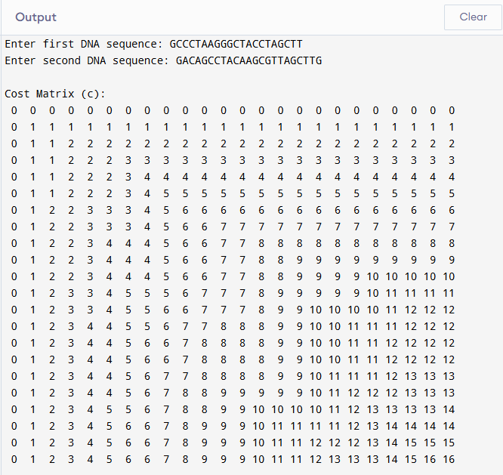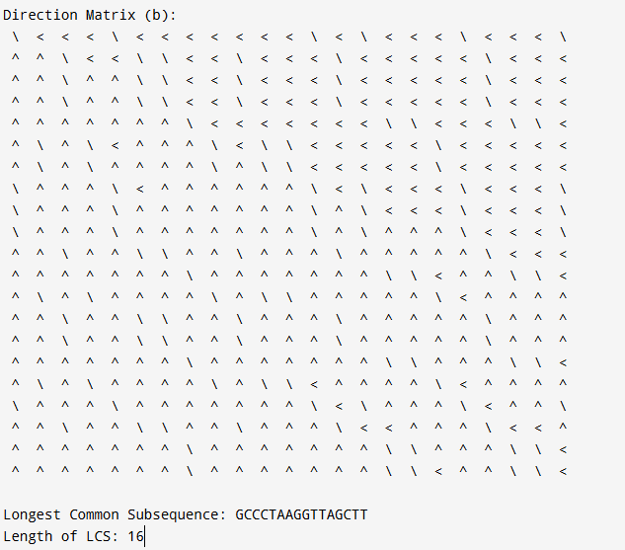

TASK-2: Find the longest repeating subsequence (LRS). Consider it as a variation of the
longest common subsequence (LCS) problem.
Let the given string be S. You need to find the LRS within S. To use the LCS framework, you
effectively compare S with itself. So, consider string1 = S and string2 = S.
Example:
AABCBDC
Code:
#include <stdio.h>
#include <string.h>
#define MAX 100
int main() {
char S[MAX];
printf("Enter the string: ");
scanf("%s", S);
int n = strlen(S);
int dp[MAX+1][MAX+1];
// Initialize
for (int i = 0; i <= n; i++)
for (int j = 0; j <= n; j++)
dp[i][j] = 0;
// Build DP table
for (int i = 1; i <= n; i++) {
for (int j = 1; j <= n; j++) {
if (S[i-1] == S[j-1] && i != j)
dp[i][j] = 1 + dp[i-1][j-1];
else
dp[i][j] = dp[i-1][j] > dp[i][j-1] ? dp[i-1][j] : dp[i][j-1];
}
}
// Reconstruct LRS
int i = n, j = n;
char lrs[MAX];
int k = 0;
while (i > 0 && j > 0) {
if (S[i-1] == S[j-1] && i != j) {
lrs[k++] = S[i-1];
i--; j--;
}
else if (dp[i-1][j] > dp[i][j-1])
i--;
else
j--;
}
lrs[k] = '\0';
// Reverse the string
for (int a = 0; a < k/2; a++) {
char temp = lrs[a];
lrs[a] = lrs[k-1-a];
lrs[k-1-a] = temp;
}
printf("\nLongest Repeating Subsequence (LRS) Length = %d\n", dp[n][n]);
printf("LRS = %s\n", lrs);
return 0;
Output: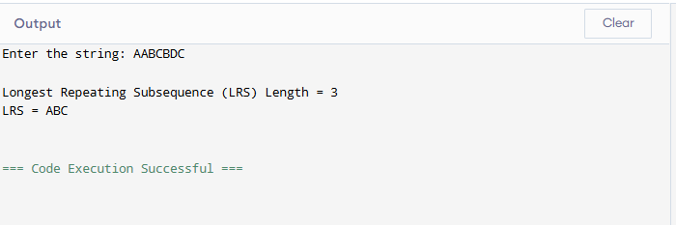

Leetcode Assessment :
Problem Statement:
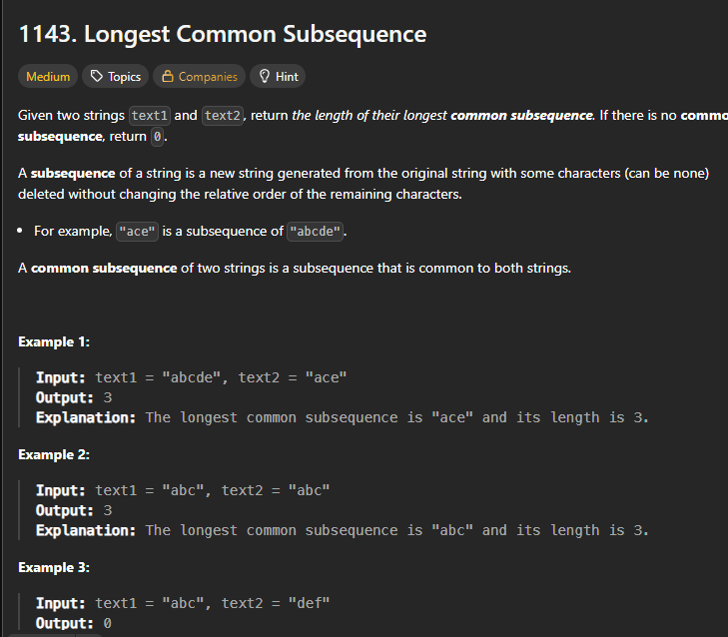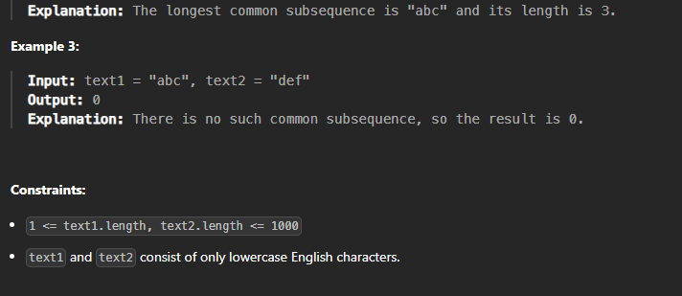

Code:
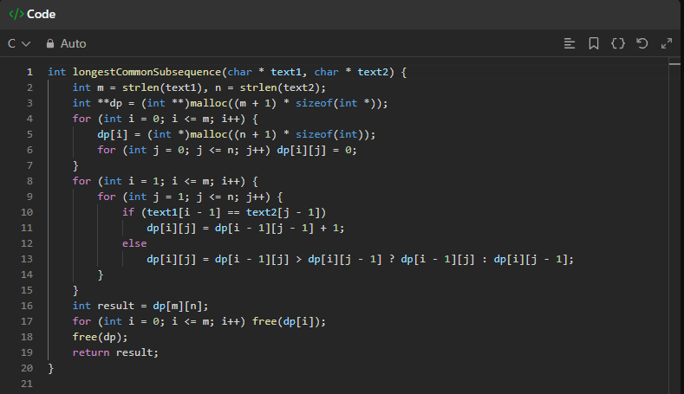

Output:
