Avni Osmani, Klement Mucha, Ibrahim Khalily, Ekaterina Kandisnkaya

Cis 3400

“Pills By Dre”

Documentation

Proposal

Our database is about a doctor’s clinic. The objective of this database is to create a user friendly environment for finding information quickly. The database will include information on patients, doctors, visits, insurance companies, billing, and results. We will record the patient’s and doctor’s information, along with the insurance companies that each patient is associated with. We will keep track of all of the appointments and visits for each patient. The database will record the total amount of bills the patient accumulated and their diagnosis and which prescription the doctor’s prescribed.

ER Diagram

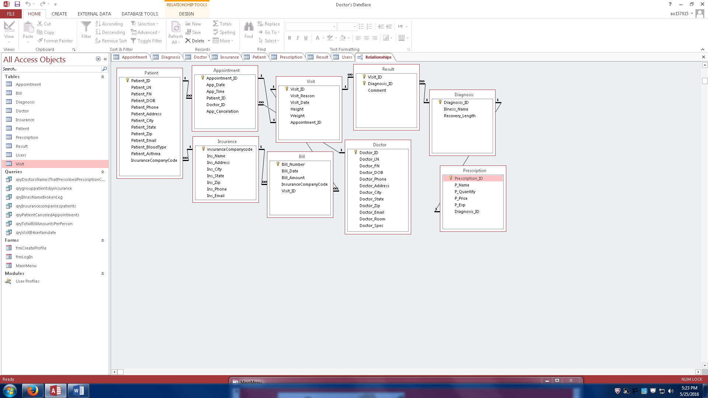

Relational Model

Patient {Patient ID, Last Name, First Name, Date of Birth, Phone Number, Address, City, State, Zip Code, Email, Blood Type, Asthma, Insurance Company Code}

PK {Patient ID}

FK {Insurance Company Code} ref PK of Insurance Company

Third Normal Form

Doctor {Doctor ID, Last Name, First Name, Date of Birth, Phone Number, Address, City, State, Zip Code, Email, Room Number, Specialization}

PK {Doctor ID}

Third Normal Form

Appointment {Appointment ID, Date, Time, Patient ID, Doctor ID, Appointment Cancellation}

PK {Appointment ID}

FK1 {Patient ID} ref PK of Patient

FK2 {Doctor ID} ref PK of Doctor

Third Normal Form

Insurance Company {Insurance Company Code, Name, Address, City, State, Zip Code, Phone Number, Email}

PK {Insurance Company Code}

Third Normal Form

Visit {Visit ID, Reason, Date, Height, Weight, Appointment ID}

PK {Visit ID}

FK {Appointment ID} ref PK of Appointment

Third Normal Form

Bill {Bill ID, Amount, Date, Insurance Company Code, visit ID}

PK {Bill ID}

FK {Insurance Company Code} ref PK of Insurance Company

FK {visit ID} ref PK of Visit

Third Normal Form

Diagnosis {Diagnosis ID, Illness, Recovery Length}

PK {Diagnosis ID}

Prescription {Prescription ID, Name, Quantity (milligrams), Price per Gram, Expiration Date, Diagnosis ID}

PK {Prescription ID}

FK {diagnosis ID} ref PK of Diagnosis

Third Normal Form

Result {Comment, visit id, diagnosis id}

PK {visit id, diagnosis id}

FK {visit id} ref pk of visit

FK {diagnosis id} ref pk of diagnosis

Third Normal Form

Queries

Doctor’s prescription - This query asks the user the name of the prescription then retrieves the names of the doctors that have prescribed that prescription.

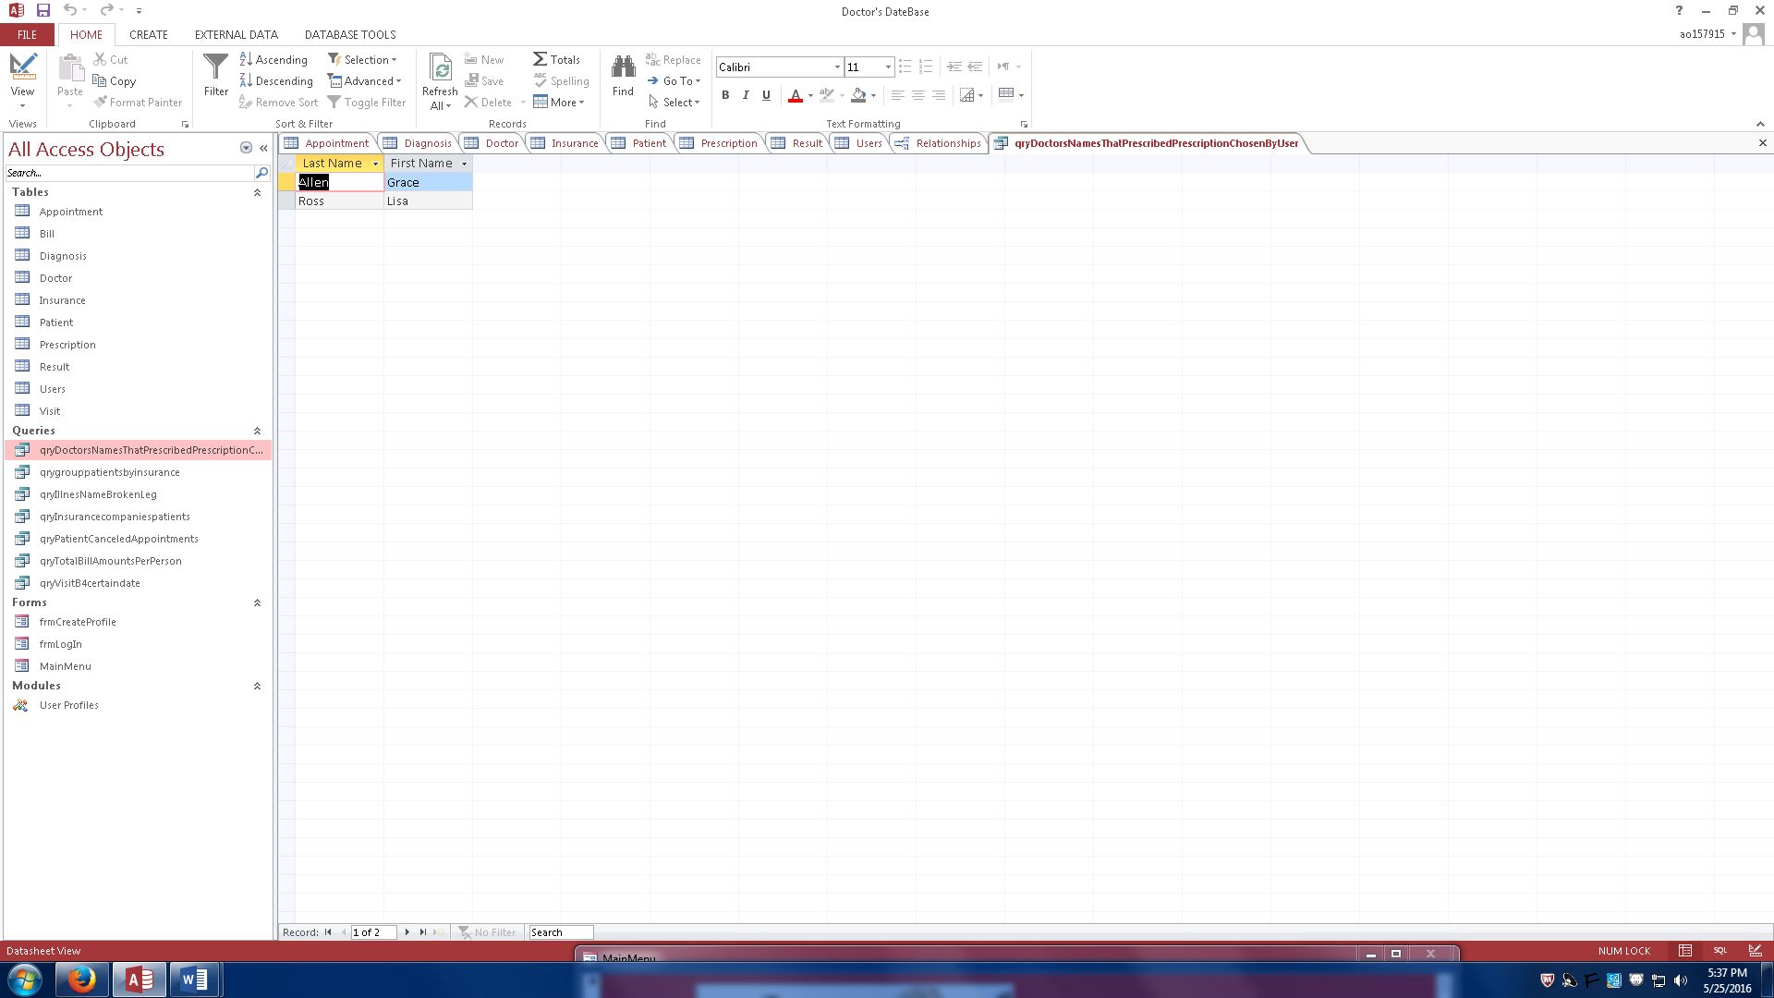

Group patient by insurance - groups patients by their insurance.

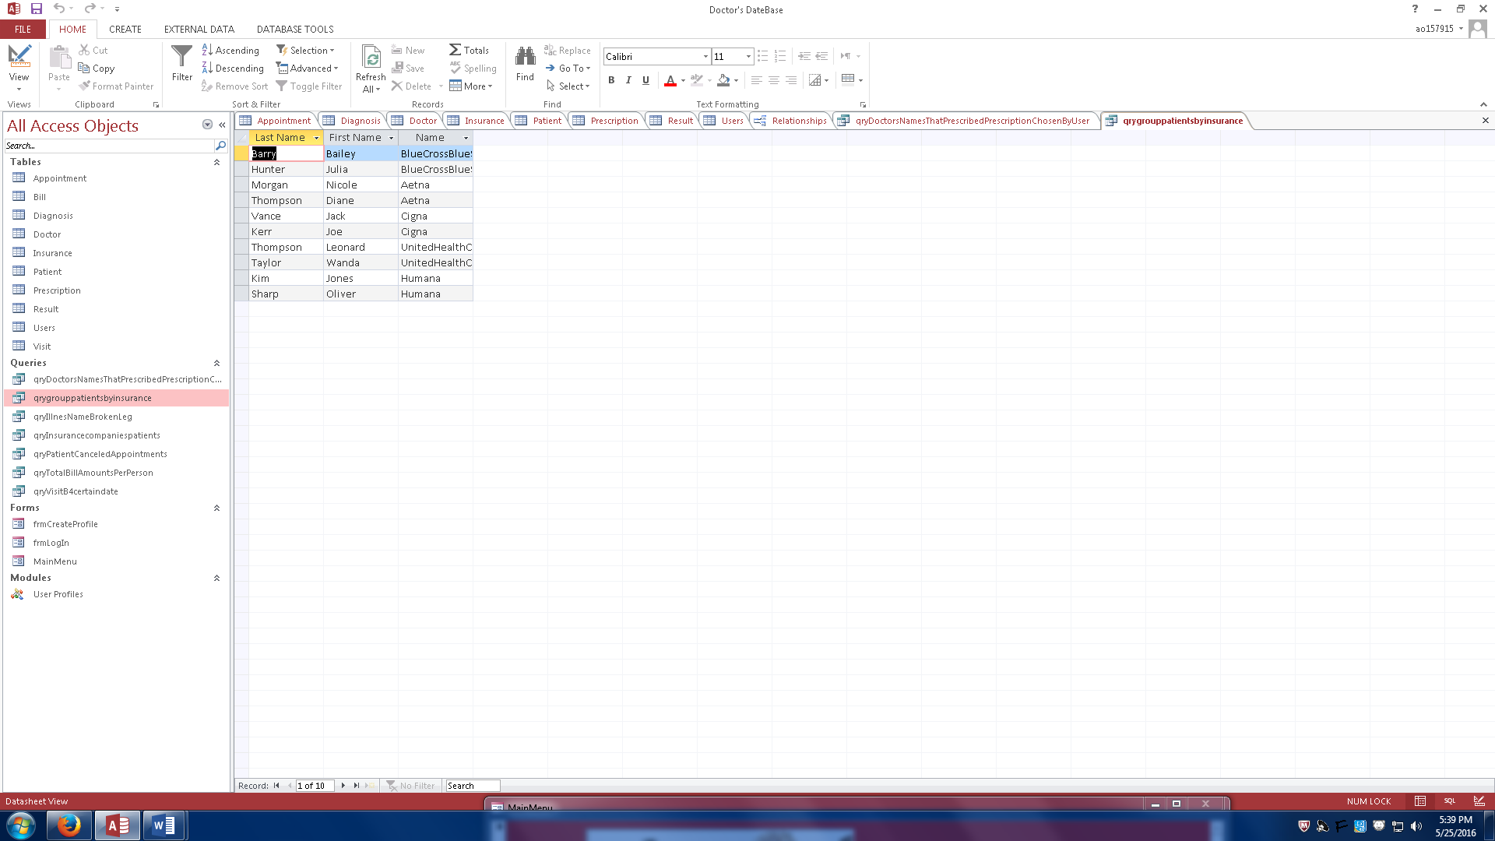

Broken Leg – finds everyone that has a broken leg.

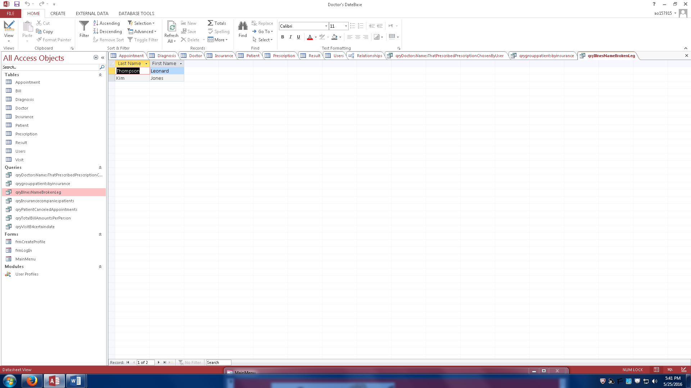

Insurance company – this query tells us the number of patients that each insurance company is liable for.

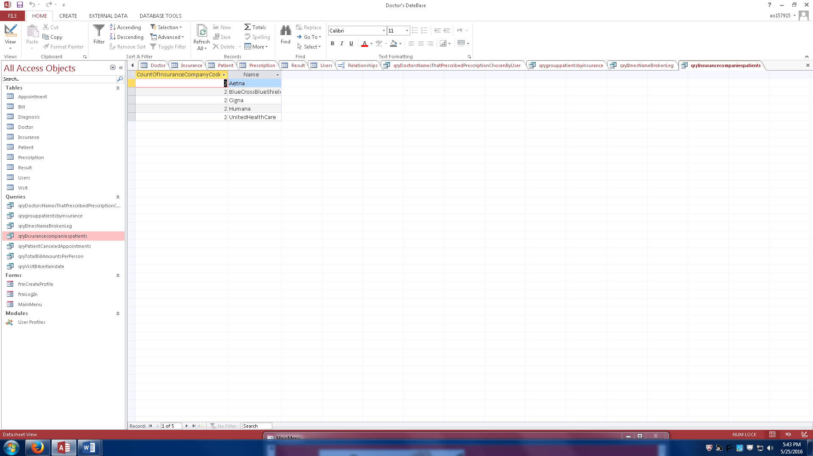

Cancelled Appointments – retrieves every patient that has cancelled an appointment in the past.

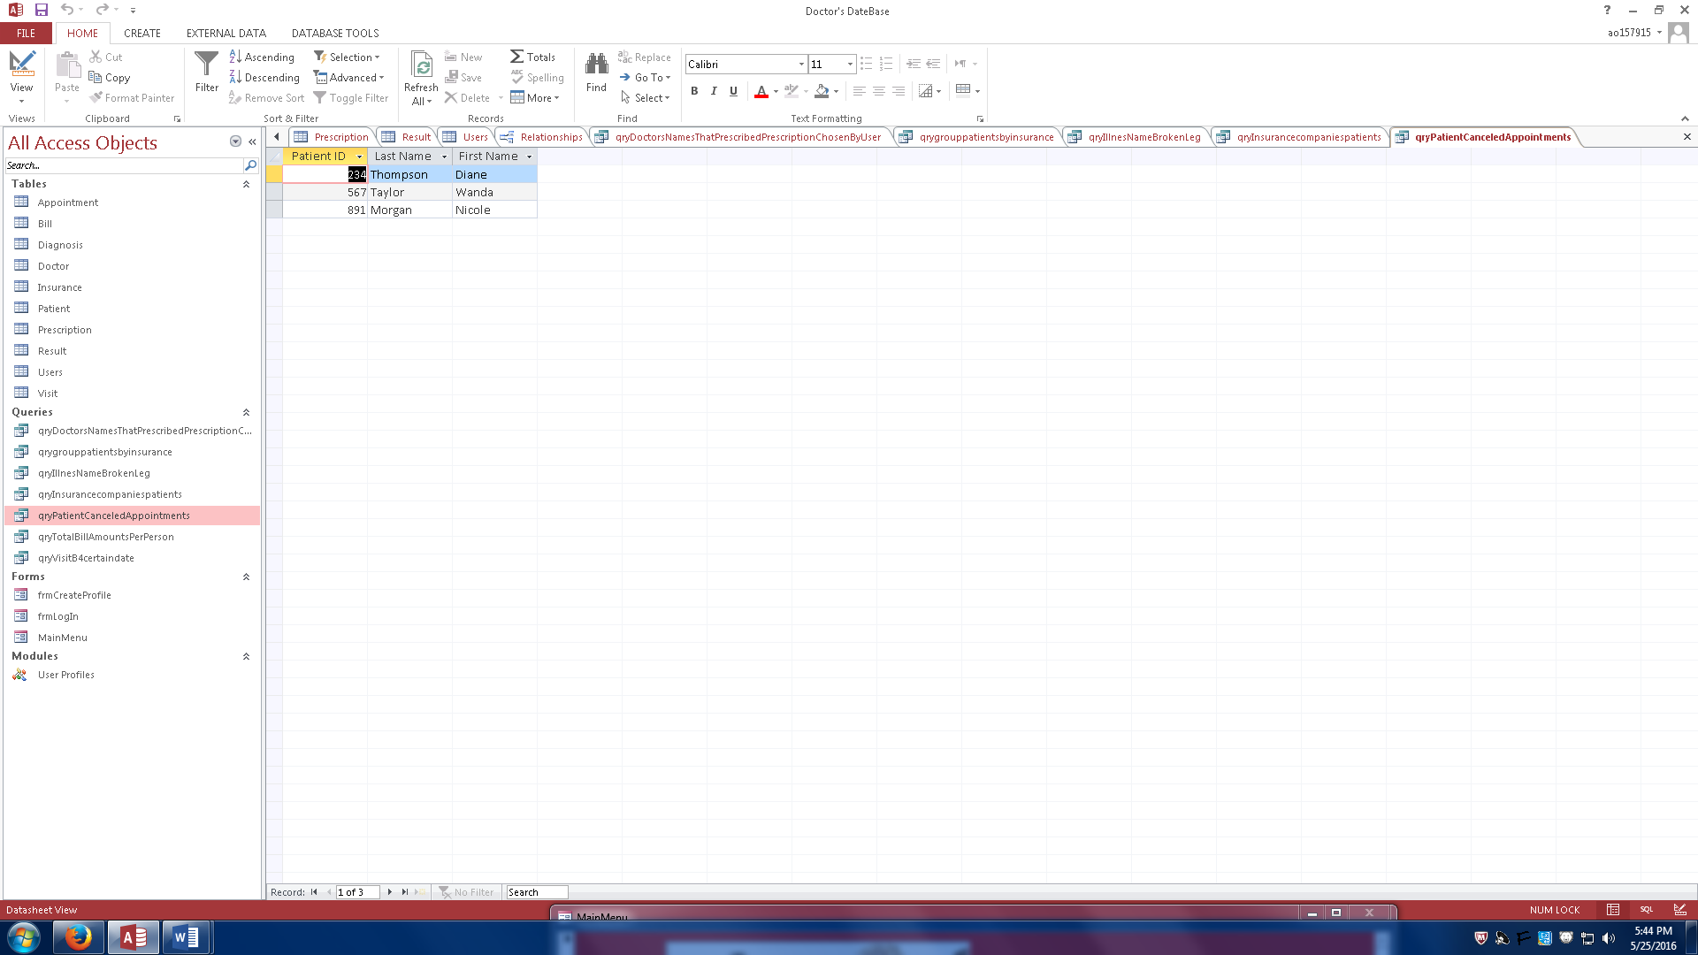

Total Bill Amounts – This query shows us the total amount of bills that each patient has accumulated thus far.

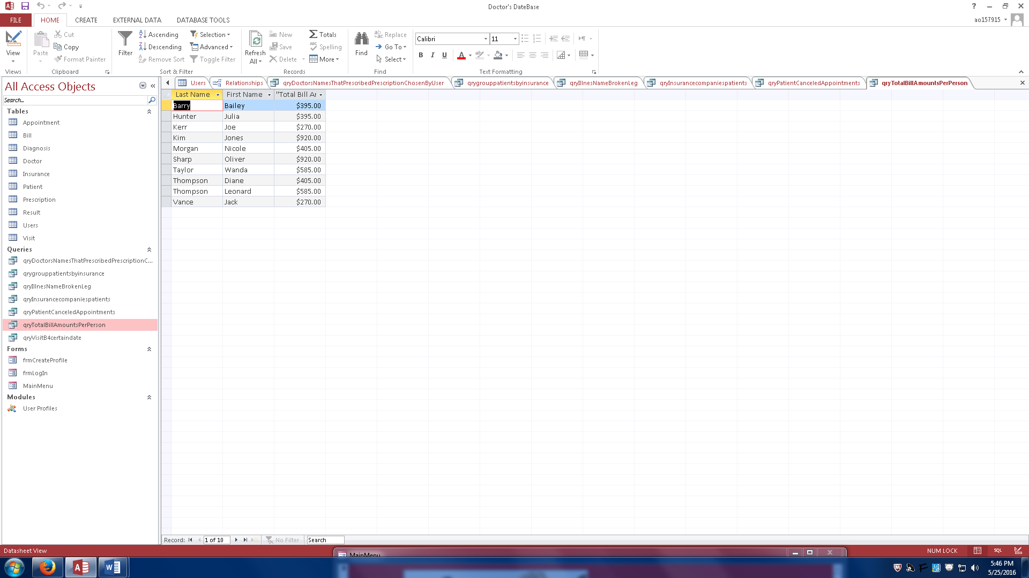

Past Visits – This query retrieves all of the visits that occurred before May 14, 2016.

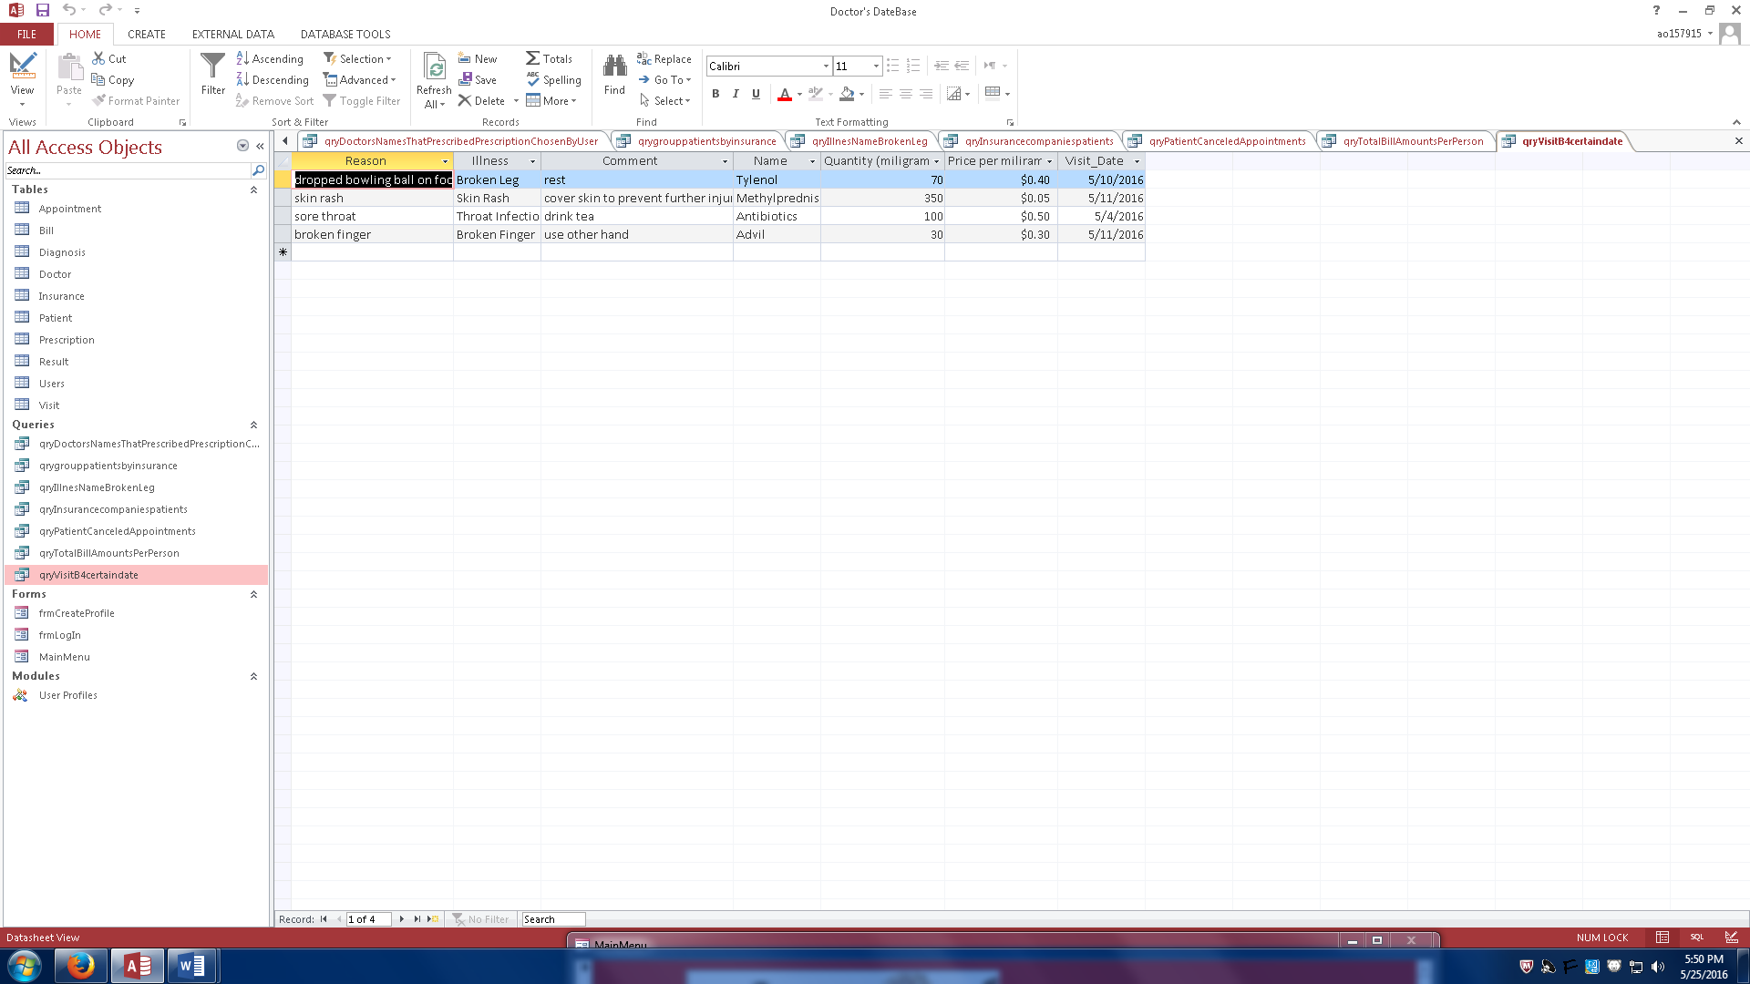

Reports

Patient visits at clinic – this report shows the first and last name of each patient, their appointment and visit dates, and their reason for visiting our clinic.

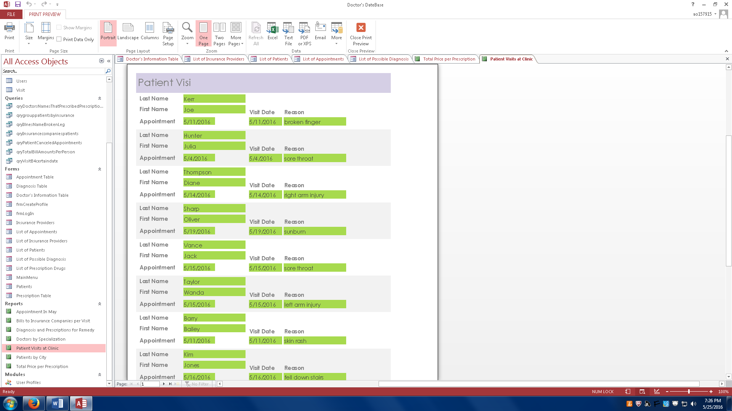

Total price per prescription – this report shows the name of each drug, the quantity of the drug administered in milligrams, the price per milligram, and the function computing total price per drug.

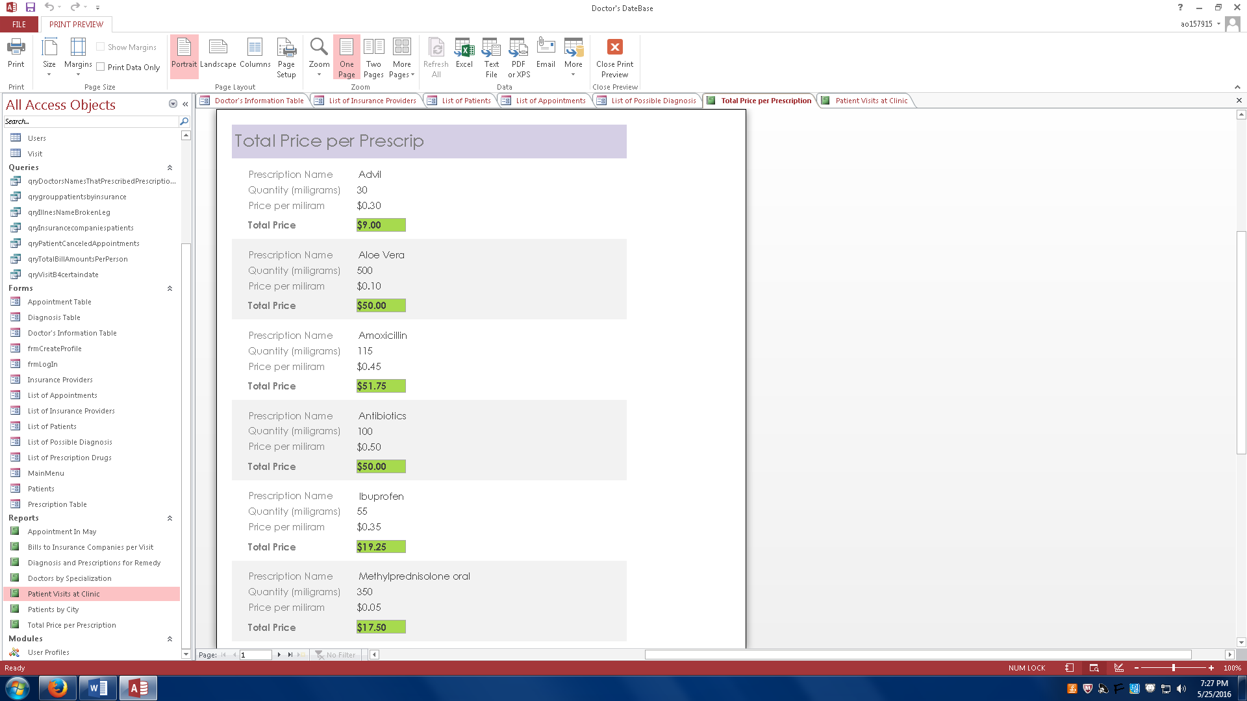

Billing report – this report groups the bills by insurance company so that we can see how many bills each insurance company has to pay.

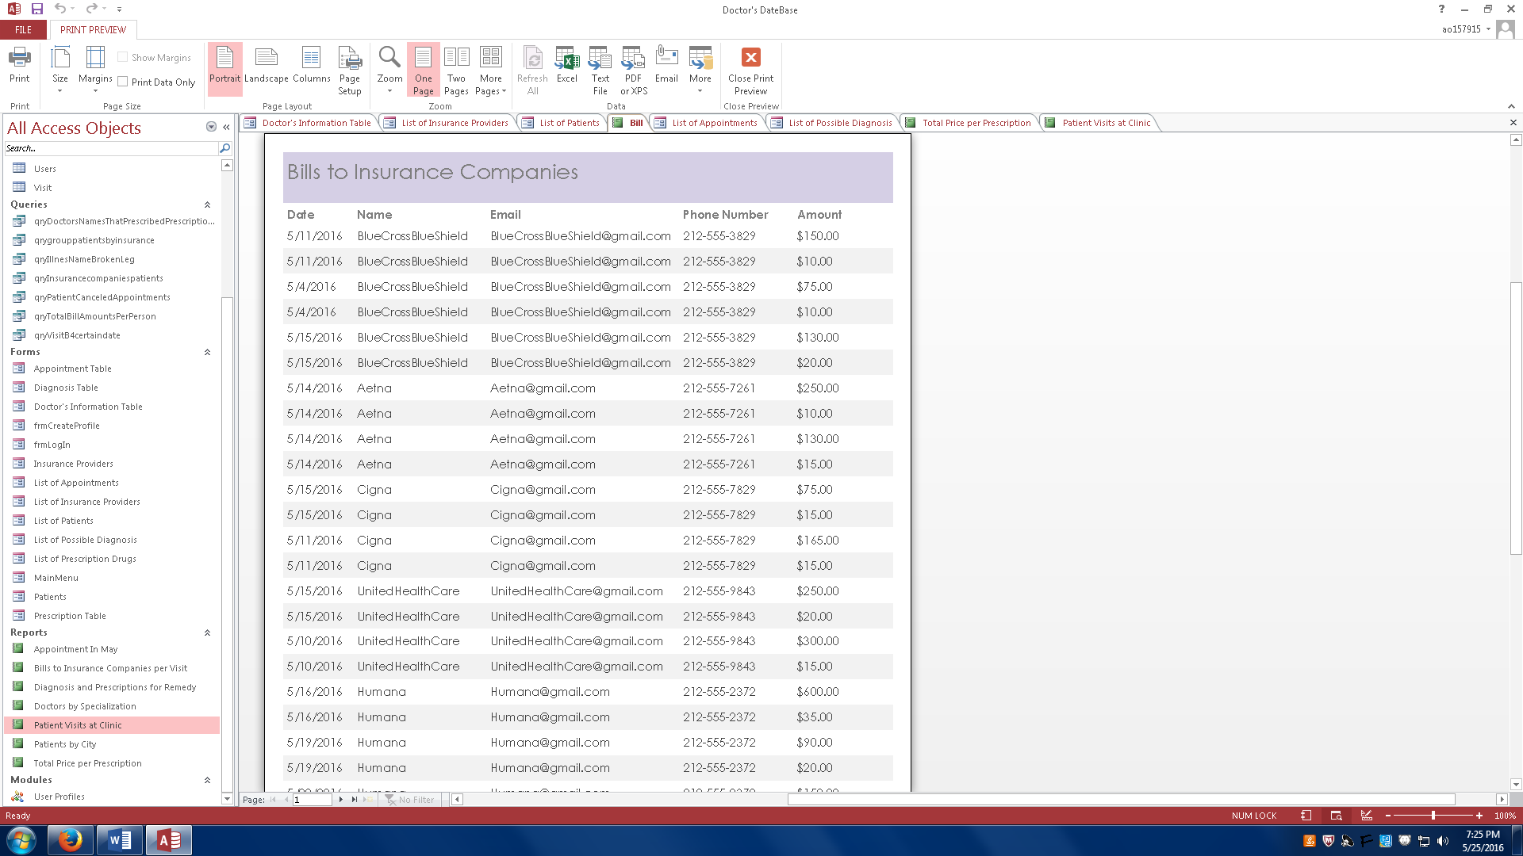

Appointments and Cancellations – this report shows all clinic scheduling for the month of May, prioritizing by cancellation.

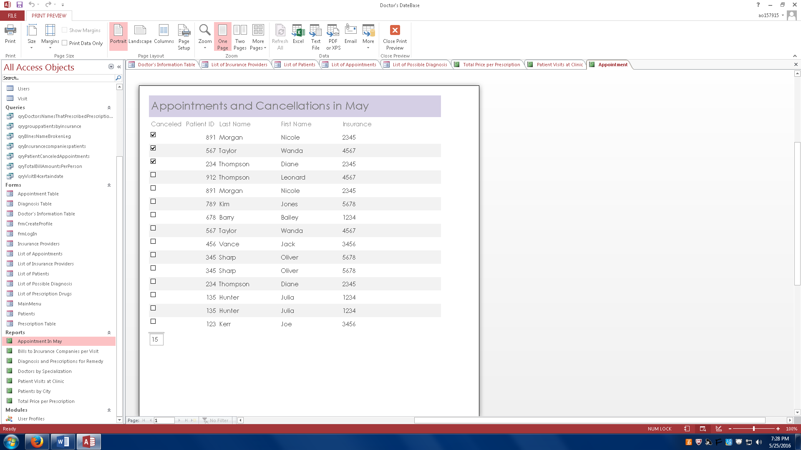

Diagnosis and Prescription – this report shows us each prescription and the diagnosis that it corresponds to.

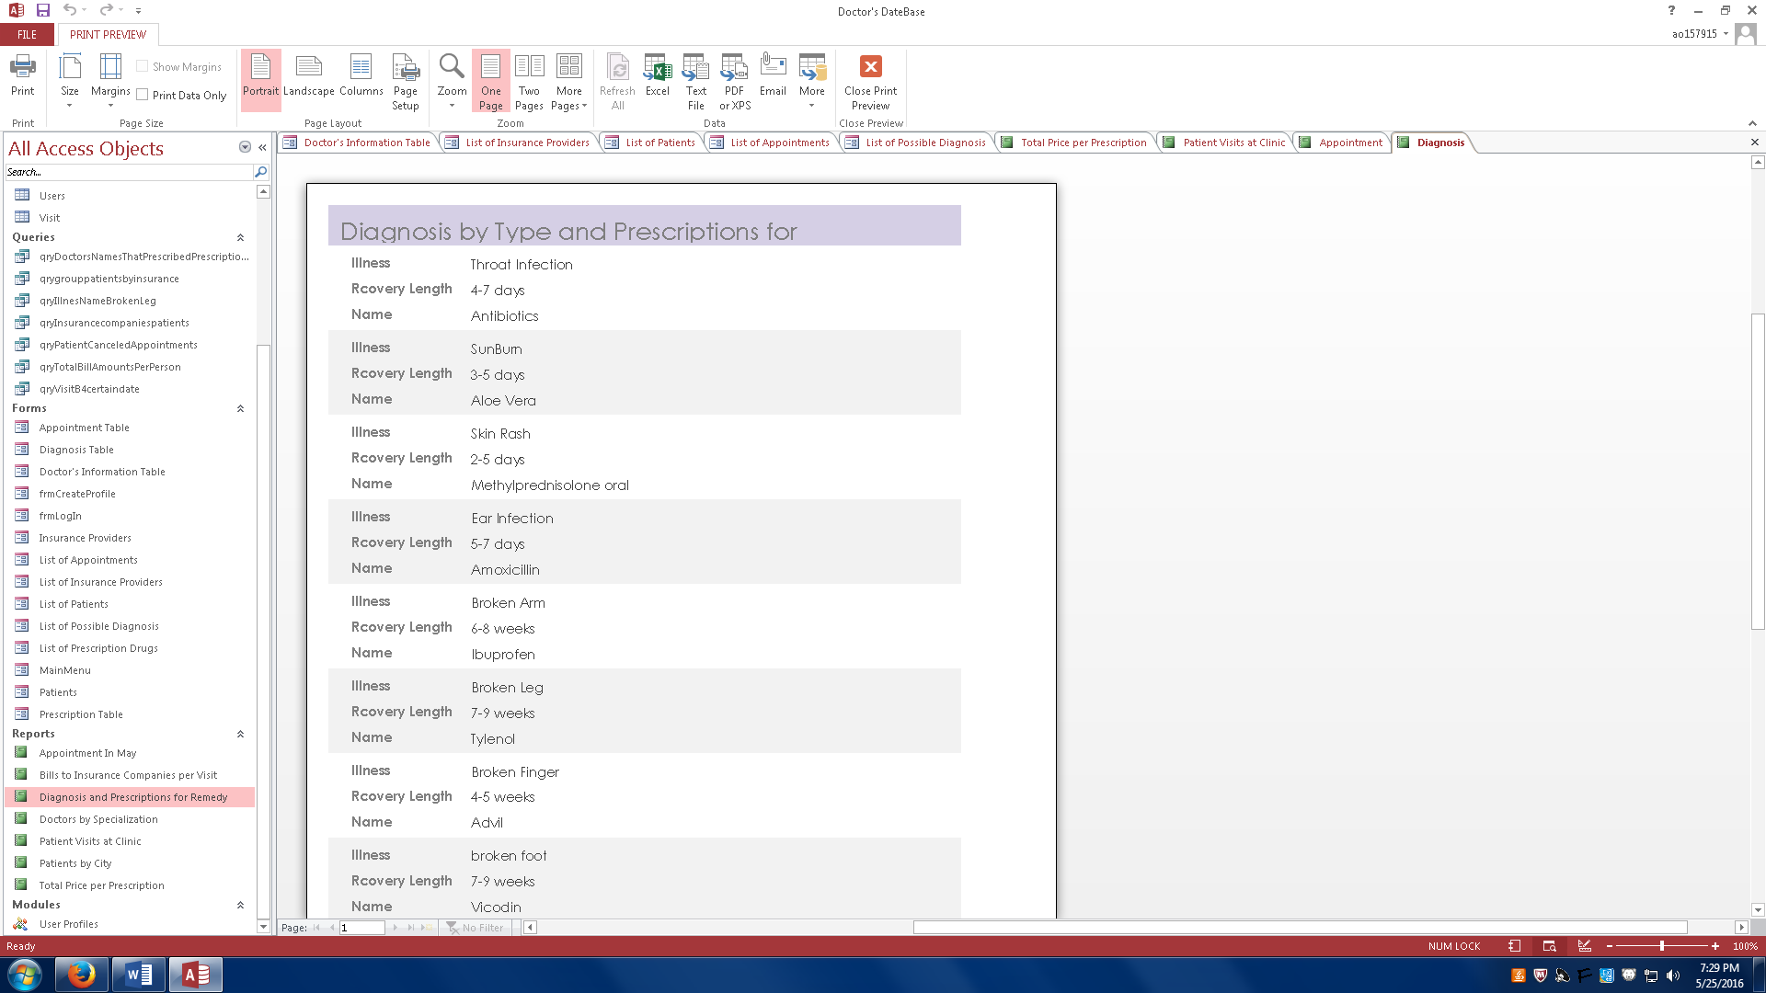

Doctor Specialization – this report groups all of our clinic’s doctors by specialization.

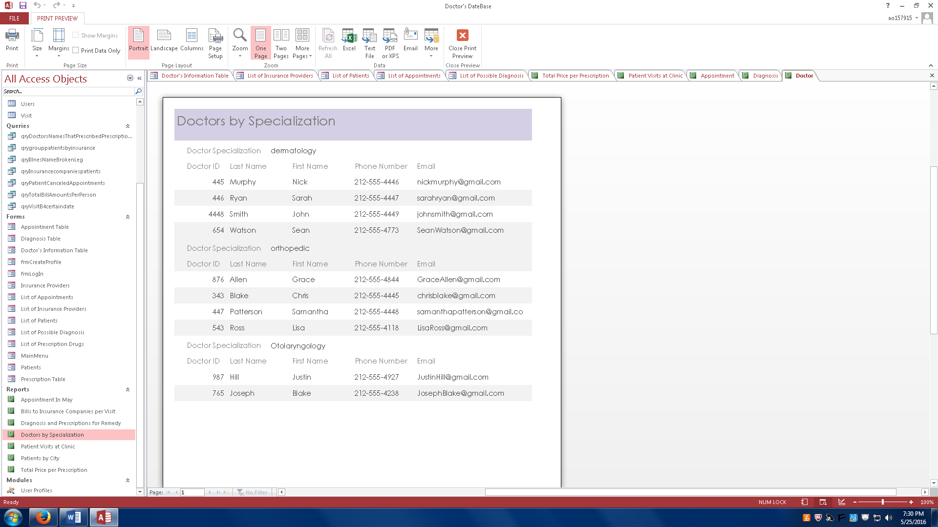

Patient by city – this report shows us which patients are form which cities for marketing purposes.

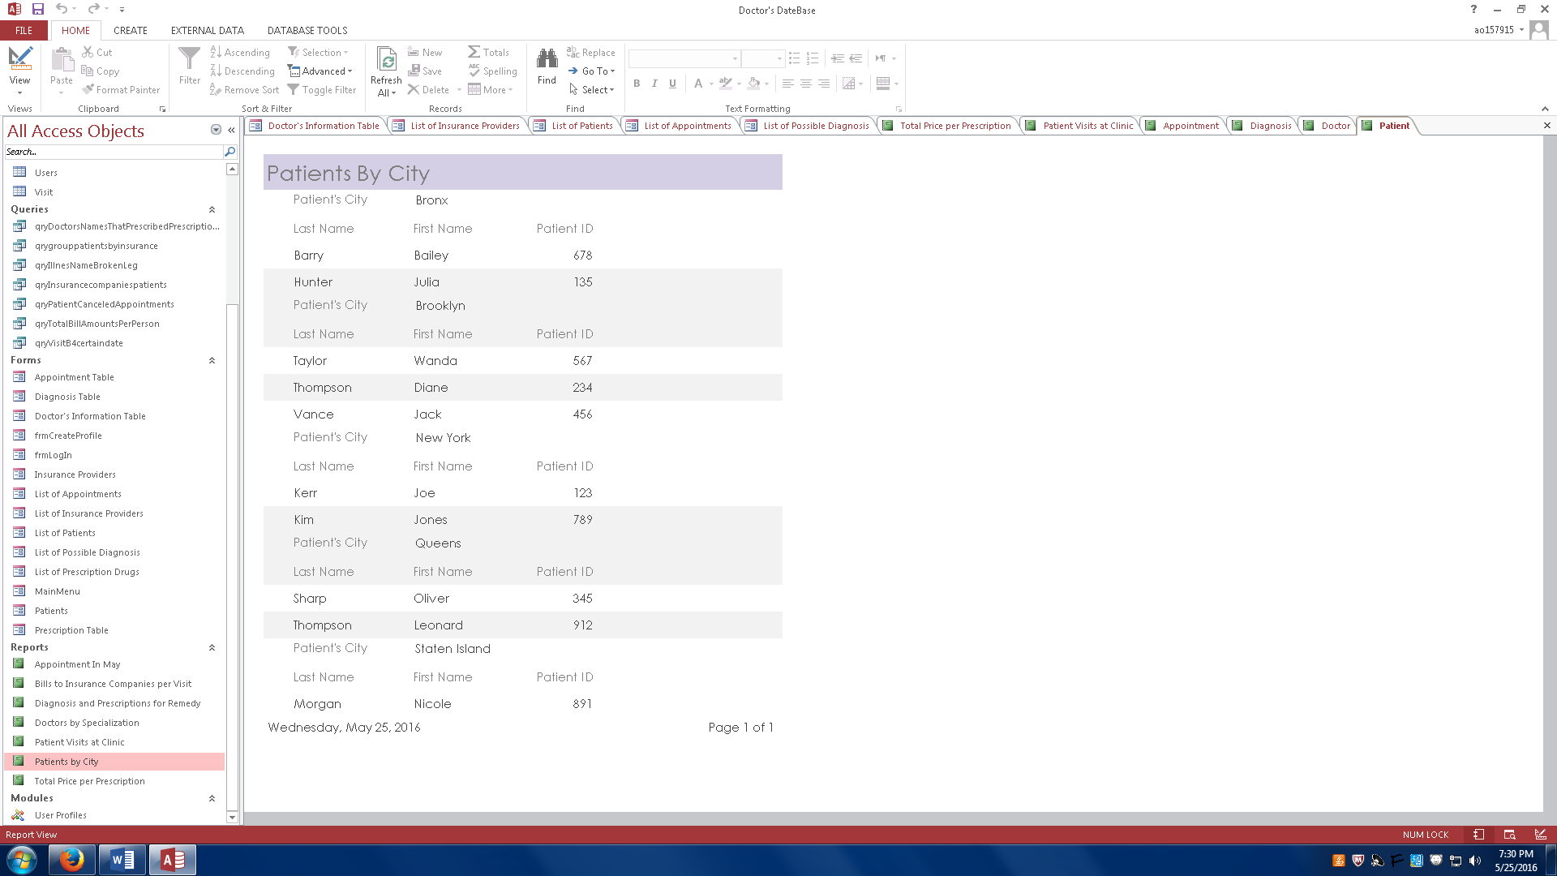

Main Menu – User Guide

Login Menu

Create – allows the user to create a new profile.

Login – allows the user to login after they have entered a valid username and password.

Quit – closes the database

Clinic information

Doctors – Opens the doctor table.

Insurance Provider – Opens the insurance table.

Our Patients – Opens the patient table.

Scheduling

Billing – Shows us a report of all of the bills and the total amount that has been paid to out clinic.

Appointments – Displays all of the appointments.

Medical Information

Diagnosis – Displays diagnosis

Prescriptions – Displays Prescriptions

Patient Visits – Displays all of the information for each visit and the reason for the visit.

Additional Reports

Each button opens that specific report

Conclusion

This turned out to be an enjoyable project, once we created the ER diagram implementing the idea into access was a great experience. The most challenging parts of the project was to writing the macro to create the login screen. Implementing buttons and linking the entire database through a main menu was a challenge. The simplest parts of the project were creating the queries and reports. This might be because there are many options for queries and reports that we could have made that are related to our idea of a doctor’s clinic. What we could have done differently was managing our time a better. The fact that access is not a server really slowed us down because when we were not together we had to wait for one person to finish what they were doing so the next person could continue and add to the database. This did not allow us to implement the database simultaneously.