Bad
Public buses are one of the worst mediums of transportation in Armenia.

Public buses in Yerevan can be very overcrowded, especially during rush hour. This can make it very uncomfortable for passengers and can also be dangerous. There have been reports of people being pushed, shoved, and sexually harassed on public transport in Yerevan.

Another alarming aspect of public transport in Yerevan is that it can be prolonged. This is because the city is often congested with traffic, and public transport vehicles can get stuck in traffic just like any other vehicle. This can be very frustrating for passengers, especially if they are in a hurry.

Finally, public transport in Yerevan can be pretty dirty. This is because the vehicles are not cleaned very often, and passengers can frequently track dirt and mud into the vehicles. This can be very unpleasant for passengers and can also be a health hazard.
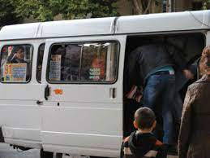

Moderate
One of the more decent aspects of transportation in Yerevan is the Metro system. All stations have free wifi access and cell coverage. It's cool there during the hot summer months and warm in winter.

If you've been to places like NY, you'll appreciate how clean it is inside the train. The advantages of the metro system in Yerevan, Armenia, are that it is relatively fast, very cheap, a clean and safe way to travel, and an excellent way to avoid traffic congestion.

However, It has one huge disadvantage - the coverage is very inadequate for such a large city. A one-line metro system is not very comprehensive, as it does not manage to cover major parts of the town with its ten stations, resulting in difficulty trying to navigate to parts of the city.

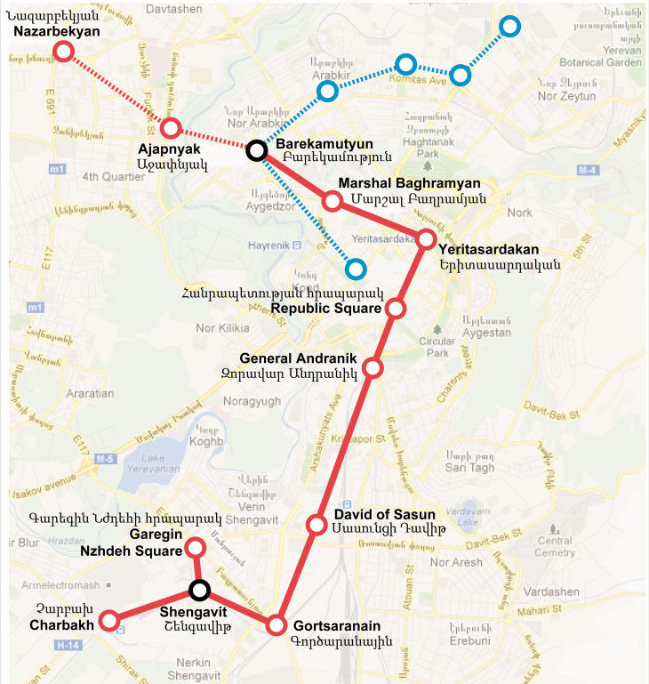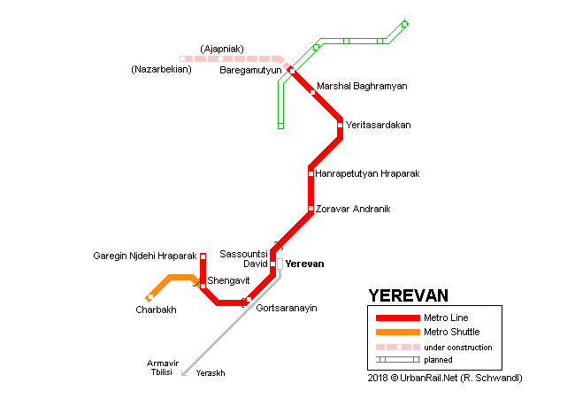

Good
Walkability
The streets are generally well-paved and wide, making it easy to get around on foot. There are also plenty of sidewalks and pedestrian paths, so you can usually find a safe route to walk on. The city is also relatively flat, so you won't have to deal with too much uphill walking.

