The Flaws in Yerevan’s Metro System
Awadis Shikoyan
ENV 211 - Sustainable Cities
Defining a challenge/opportunity (Part 2 Problem Definition and Method)

The Yerevan Metro system has been in operation since 1981 and has a network of three lines totaling 27 kilometers in length. The system serves the Armenian capital city of Yerevan and has a daily ridership of approximately 41,950 people. The Metro system is considered to be a relatively reliable form of public transportation in the city, as it presents many challenges and inconnveniences to people who may want to rely on it daily.

The Metro system has a number of advantages over other forms of transportation in Yerevan. It is an affordable option for city residents, as fares are subsidized by the government. The Metro is also a fast and efficient way to get around the city, with trains running every few minutes during peak hours. The Metro system is also well-connected to other forms of public transportation in Yerevan, such as buses and trolleybuses. All stations have free wifi access and cell coverage. It's cool there during the hot summer months and warm in winter.

If you've been to places like NY, you'll appreciate how clean it is inside the train. Additionally, the trains are relatively fast, very cheap, a clean and safe way to travel, and an excellent way to avoid traffic congestion, which is very common in Yerevan.

However, It has one huge disadvantage - the coverage is very inadequate for such a large city. A one-line metro system is not very comprehensive, as it does not manage to cover major parts of the town with its ten stations, resulting in difficulty trying to navigate to parts of the city. The Metro system also does not reach all areas of the city, so residents living on the outskirts of Yerevan may have to use other forms of transportation to get around.

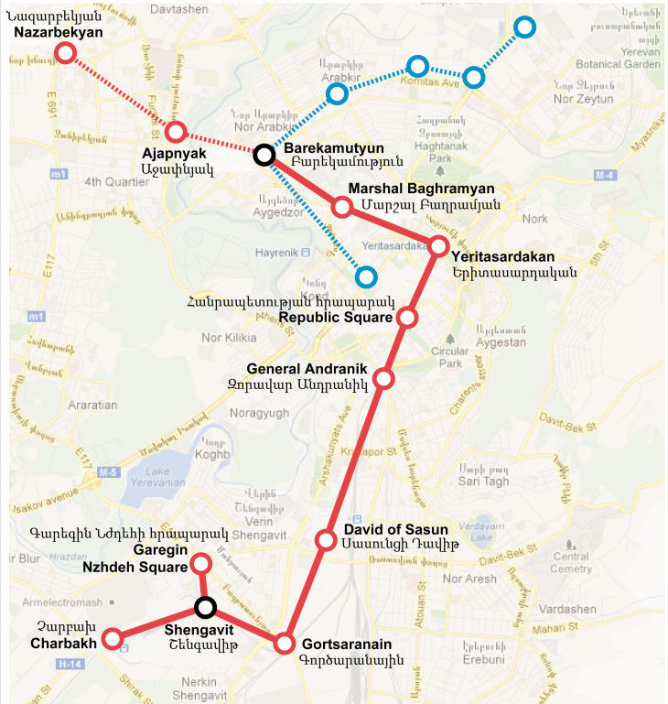
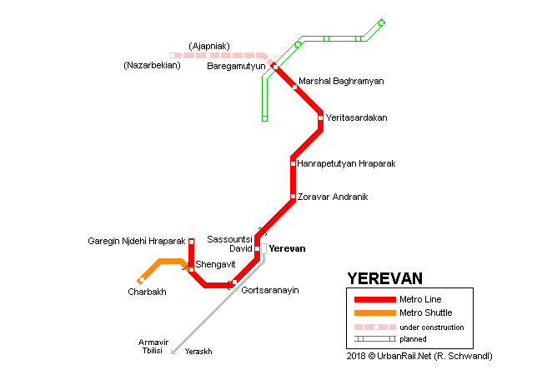

The images above show all the stations that work, are in development, and are planned for the future. We can see the one-way line has its flaws as well, with quite long distances between the station David of Sasun to General Andranik, which is coming close to the center of the city. Additionally, the future stations that are intended to be built have not received any significant updates and it still does not cover the far east and the far west of the city. Areas that are not covered as of today include Nor Nork, Avan, Malatia-Sebastia, Erebuni, Ajapnyak and Kanaker-Zuvank, and Komitas, which form up to large chunks of the city with a big population in them.

Furthermore, the residents of Yerevan also have to bear with the fact of long wait times and frequent delays. Each train should frequently come around every 5-6 minutes which is always never the case, and waiting time can reach up to around 9 minutes of waiting time. Thus, it makes it very unpredictable for someone to predict when to go out so they can catch the train at the right time.

