Javascript Trivia Website Project Outline

Delaney Heffernan, Noah Tuff

November 14th, 2022

Our website will be a Trivia website about the hit game, League of Legends.

We will have 3 pages of trivia questions. The home page will be where you can guess a champion based on an ability icon. The second page will be where you can guess a champion based on a voiceline they say in game. The third page will be where you can guess a champion based on the name of their ability.

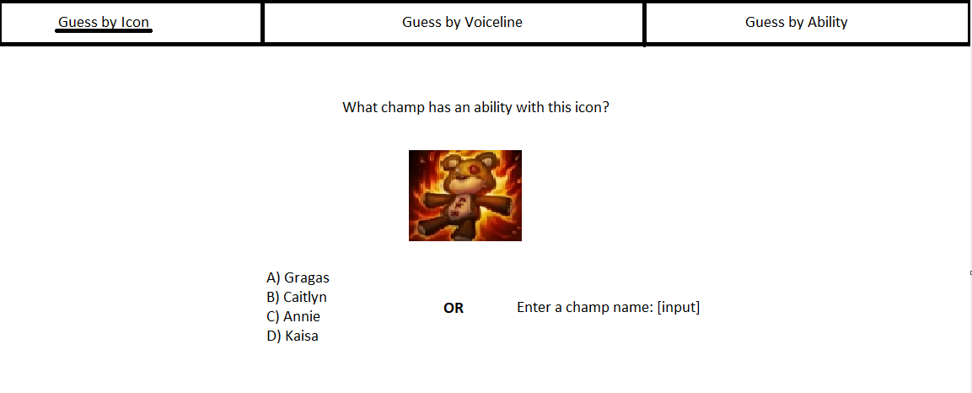

*Above: Mockup diagram of website homepage*

The majority of the files needed can come directly from the game files of League of Legends, or from the League of Legends fandom website, <https://leagueoflegends.fandom.com/wiki/Champion>

Here is a link to the repository for our project: <https://github.com/AvocadoSteam/CP1210TriviaSite> It is a private repository, so we will need your Github username so we can add you to it.