Design and Analysis of Algorithms

CS375 Spring 2016

Theory Assignment 4
Release Date: 4/20/2016
Due: 5/2/2016 (Monday) at start of class

Remember to include the following statement at the start of your answers with a signature by the side.

“I have done this assignment completely on my own. I have not copied it, nor have I given my solution to anyone else. I understand that if I am involved in plagiarism or cheating I will have to sign an official form that I have cheated and that this form will be stored in my official university record. I also understand that I will receive a grade of 0 for the involved assignment for my first offense and that I will receive a grade of “F” for the course for any additional offense.”

All solutions of theory assignments must be typed (no handwritten solutions) and submitted in hard copy. Advance electronic submission to the TA is acceptable if the student is expected to miss the class on the due date.

- [20%] A set {3, 4, 5, 8} is given. For the set, find every subset that sums to S = 13. Find the subsets via the backtracking algorithm. In your solution, draw a pruned state space tree. For each node in the tree, show its current subset sum and its upper bound of the sum (i.e., weightSoFar + totalPossibleLeft). Number the nodes in the sequence of visiting them. Also, identify the node that represents the solution found at the end of the search.
- [15%] When the capacity of the knapsack is 15, solve the following 0-1 knapsack problem using the backtracking algorithm that uses the optimal fractional knapsack algorithm to compute the upper bound of the profit.
i p_{i} w_{i} p_{i} / w_{i}
1 $10 5 $2
2 $30 2 $15
3 $40 5 $8
4 $30 10 $3
In your solution, draw a pruned state space tree. For each node in the tree, show its profit, weight, and upper bound of the profit. Number the nodes in the sequence of visiting them. Also, identify the node that represents the optimal solution found at the end of the search.
- [15%] For the same problem in Question 2, solve it using the best-first-search branch and bound algorithm. Follow the same instructions above to produce your solution.

- [15%] Apply Prim's algorithm for finding a minimum spanning tree for the following graph. Start with node a. Show the steps by filling out the following table (see the example on slide 31 of lecture 25). Show the selected tree nodes in the first column of the table, for each of the rest of the nodes, show its minimum distance D to the current tree and its nearest node in the current tree, in the remaining columns.

Node added to the current tree | D(a),  nearest node | D(b),  nearest node | D(c),  nearest node | D(d),  nearest node
{}

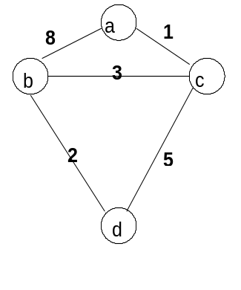
- [10%] Apply Kruskal’s algorithm for finding a minimum spanning tree for the following graph. In your solution, show edges picked in order and the total weight of the final minimum spanning tree.
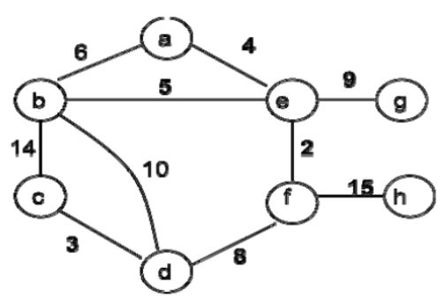
- [15%] Using Dijkstra’s algorithm, find the shortest path to visit each vertex starting from vertex s in the following graph. In your solution, order the vertexes in terms of their shortest path distances to the vertex s, and show the shortest path and its distance for each vertex. 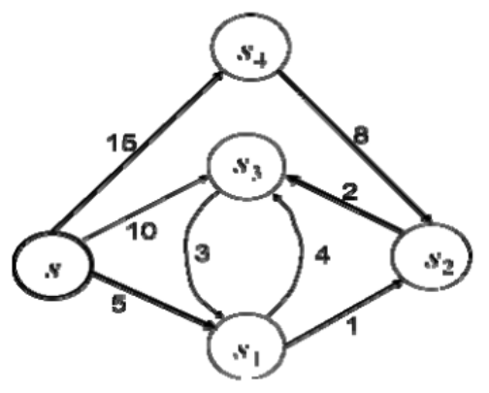
- [10%] Apply Floyd-Warshall algorithm to the following directed graph with the initial distance matrix representing the direct distance between every pair of vertices, and produce the updated distance matrices for every iteration of the algorithm.
