**# 1: First test run. Training set on the order of 10^4**

enc_layers = 4

dec_layers = 6

num_tx_bits = 200

enc_in_len = 300

channel = {'type':'erasure','chan_param':1.00}

num_epochs = 10

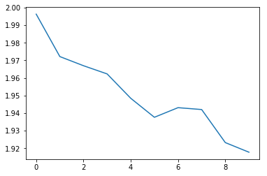

**#2: Reduced dimensions of enc inputs and channel bits. Increased training set to 10^6**

**enc_layers = 4**

**dec_layers = 6**

**num_tx_bits = 30**

**enc_in_len = 25**

**channel = {'type':'erasure','chan_param':1.00}**

**num_epochs = 10**

**num_train = int(1e6)**

**num_test = int(1e4)**

**batch_size = 1000**

**max_batch = int(num_train / batch_size)**

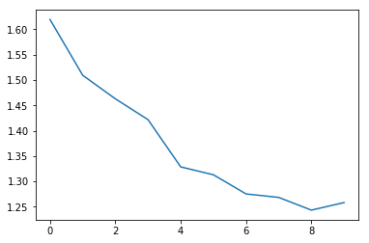

Epoch: 10 Accuracy: 0.66964 Training iteration: 10000 Training time: 320.7715289592743 s Training loss: 1.25824

Test accuracy: 0.74672

#3. **Set enc layers and dec layers both to 6.**

enc_layers = 6

dec_layers = 6

num_tx_bits = 30

enc_in_len = 25

channel = {'type':'erasure','chan_param':1.00}

num_epochs = 20

num_train = int(1e6)

num_test = int(1e4)

batch_size = 1000

max_batch = int(num_train / batch_size)

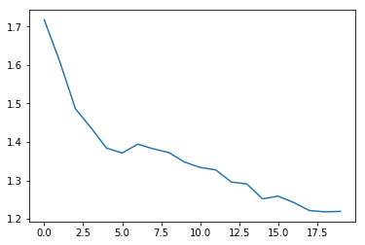

Epoch: 20 Accuracy: 0.67136 Training iteration: 20000 Training time: 690.895622253418 s Training loss: 1.21952

Test accuracy: 0.74196

#4 **Brought enc and dec layers down to 1 each.**

enc_layers = 1

dec_layers = 1

num_tx_bits = 30

enc_in_len = 25

channel = {'type':'erasure','chan_param':1.00}

num_epochs = 30

num_train = int(1e6)

num_test = int(1e4)

batch_size = 1000

max_batch = int(num_train / batch_size)

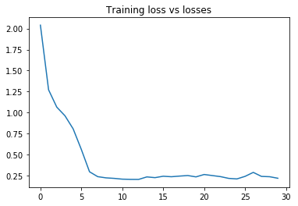

Epoch: 30 Accuracy: 0.94576 Training iteration: 29002 Training time: 685 s Training loss: 0.21824

Test loss: 0.20608

Test accuracy: 0.94956

#5 Reduced enc input dimensionality to 10 and channel bits to 20.

enc_layers = 1

dec_layers = 1

num_tx_bits = 20

enc_in_len = 10

channel = {'type':'erasure','chan_param':1.00}

num_epochs = 20

num_train = int(1e6)

num_test = int(1e3)

batch_size = 1000

max_batch = int(1000)

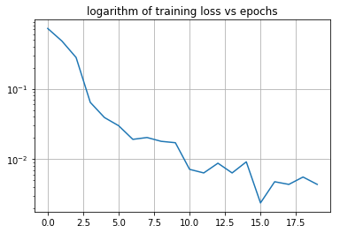

Epoch: 20 Accuracy: 0.9989 Training iteration: 20000 Training time: 369 s Training loss: 0.0044

Test loss: 0.0

Test accuracy: 1.0

#6 **Increase enc input dim to 15. Channel bits still at 20**

enc_layers = 1

dec_layers = 1

num_tx_bits = 20

enc_in_len = 15

channel = {'type':'erasure','chan_param':1.00}

num_epochs = 20

num_train = int(1e6)

num_test = int(1e3)

batch_size = 1000

max_batch = int(1000)

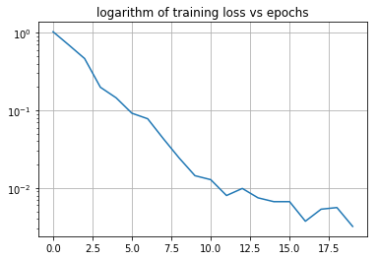

Epoch: 20 Accuracy: 0.999 Training iteration: 20000 Training time: 461 s Training loss: 0.0032

Testing...

Test loss: 0.0

Test accuracy: 1.0

#7 **Increased enc input dim to 40 and channel bits to 50.**

enc_layers = 1

dec_layers = 1

num_tx_bits = 50

enc_in_len = 40

channel = {'type':'erasure','chan_param':1.00}

num_epochs = 25

num_train = int(1e7)

num_test = int(1e3)

batch_size = 1000

max_batch = int(1000)

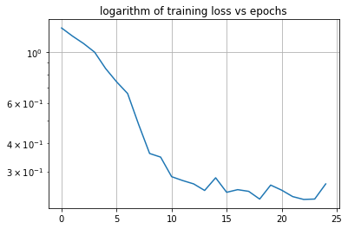

Epoch: 25 Accuracy: 0.93315 Training iteration: 25000 Training time: 1008 s Training loss: 0.2644

Testing...

Test loss: 0.2325

Test accuracy: 0.941875

#8: Increased chan bits from 50 to 60 to increase redundancy.

enc_layers = 1

dec_layers = 1

num_tx_bits =60

enc_in_len = 40

channel = {'type':'erasure','chan_param':1.00}

num_epochs = 25

num_train = int(1e7)

num_test = int(1e3)

batch_size = 1000

max_batch = int(1000)

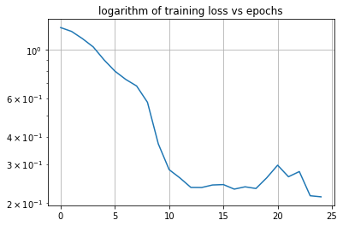

Epoch: 25 Accuracy: 0.946925 Training iteration: 25000 Training time: 1099 s Training loss: 0.2127

Testing...

Test loss: 0.1671

Test accuracy: 0.958225

#9: **Increased number of layers from (8)**

enc_layers = 2

dec_layers = 2

num_tx_bits =60

enc_in_len = 40

channel = {'type':'erasure','chan_param':1.00}

num_epochs = 25

num_train = int(1e7)

num_test = int(1e3)

batch_size = 1000

max_batch = int(1000)

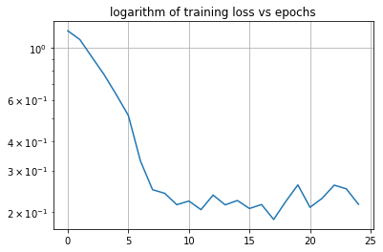

Epoch: 25 Accuracy: 0.94585 Training iteration: 25000 Training time: 1151 s Training loss: 0.2152

Testing...

Test loss: 0.2002

Test accuracy: 0.94995

**#10: Fixed bug in code – num layers ACTUALLY brought down to 1**

enc_layers = 1

dec_layers = 1

num_tx_bits = 40

enc_in_len = 40

channel = {'type':'erasure','chan_param':1.00}

num_epochs = 30

num_train = int(1e6)

num_test = int(1e4)

batch_size = 100

max_batch = int(1e4)

Epoch: 11 Accuracy: 0.99375 Training iteration: 110000 Training time: 701 s Training loss: 0.021

Training stopped prematurely.   
  
Testing accuracy expected: 1.0

#11 **Reduced keep_prob for erasure**

enc_layers = 1

dec_layers = 1

num_tx_bits = 20

enc_in_len = 10

channel = {'type':'erasure','chan_param':.95}

num_epochs = 5

num_train = int(1e6)

num_test = int(1e4)

batch_size = 100

max_batch = int(1e4)

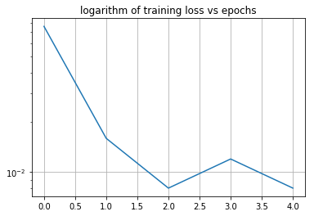

Epoch: 5 Accuracy: 0.995 Training iteration: 50000 Training time: 217 s Training loss: 0.008

Testing...

Test loss: 0.008

Test accuracy: 1.0

#12: **Increase encoder input length from 10 🡪 15 while keeping chan bits constant**

enc_layers = 1

dec_layers = 1

num_tx_bits = 20

enc_in_len = 15

channel = {'type':'erasure','chan_param':.95}

num_epochs = 20

num_train = int(1e6)

num_test = int(1e4)

batch_size = 100

max_batch = int(1e4)

Testing accuracy ~ 98.3 %

#13**: Added 1 layer to enc and dec**

enc_layers = 2

dec_layers = 2

num_tx_bits = 20

enc_in_len = 15

channel = {'type':'erasure','chan_param':.95}

num_epochs = 20

num_train = int(1e6)

num_test = int(1e4)

batch_size = 100

max_batch = int(1e4)

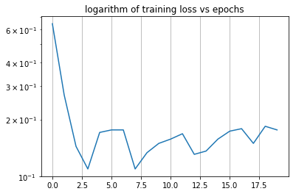

Epoch: 20 Accuracy: 0.96466666 Training iteration: 200000 Training time: 3209 s Training loss: 0.176

Testing...

Test loss: 0.064

Test accuracy: 0.98866665

#14 **Increased enc len to 30 and bit len to 40.**

enc_layers = 1

dec_layers = 1

num_tx_bits = 40

enc_in_len = 30

channel = {'type':'erasure','chan_param':.95}

num_epochs = 20

num_train = int(1e6)

num_test = int(1e4)

batch_size = 100

max_batch = int(1e4)

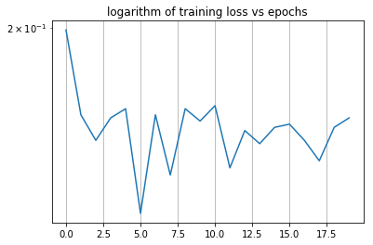

Epoch: 20 Accuracy: 0.963 Training iteration: 200000 Training time: 1346 s Training loss: 0.156

Testing...

Test loss: 0.078666665

Test accuracy: 0.988

#15 Increased enc input and channel dims to (200, 300). Number of layers was 2 each.

enc_layers = 2

dec_layers = 2

num_tx_bits = 300

enc_in_len = 200

channel = {'type':'erasure','chan_param':.95}

num_epochs = 100

num_train = int(1e6)

num_test = int(1e4)

batch_size = 100

max_batch = int(1e4)

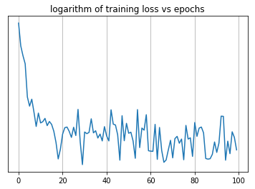

Training...

Epoch: 1 Accuracy: 0.5207 Training iteration: 10000 Training time: 273 s Training loss: 1.7912

Epoch: 2 Accuracy: 0.52515 Training iteration: 20000 Training time: 542 s Training loss: 1.7678

Epoch: 3 Accuracy: 0.5263 Training iteration: 30000 Training time: 818 s Training loss: 1.758

……

Epoch: 100 Accuracy: 0.54645 Training iteration: 1000000 Training time: 27527 s Training loss: 1.6654

Testing...

Test loss: 1.4424

Test accuracy: 0.63205

#16: Increased num dec layers by 1

enc_layers = 2

dec_layers = 3

num_tx_bits = 300

enc_in_len = 200

channel = {'type':'erasure','chan_param':.95}

num_epochs = 100

num_train = int(1e6)

num_test = int(1e4)

batch_size = 100

max_batch = int(1e4)

Epoch: 1 Accuracy: 0.58245 Training iteration: 10000 Training time: 313 s Training loss: 1.6006

Epoch: 2 Accuracy: 0.58215 Training iteration: 20000 Training time: 661 s Training loss: 1.5756

Epoch: 3 Accuracy: 0.58115 Training iteration: 30000 Training time: 995 s Training loss: 1.552

Epoch: 4 Accuracy: 0.5808 Training iteration: 40000 Training time: 1354 s Training loss: 1.5376

Epoch: 5 Accuracy: 0.58075 Training iteration: 50000 Training time: 1697 s Training loss: 1.5294

….

Epoch: 16 Accuracy: 0.6123 Training iteration: 160000 Training time: 5171 s Training loss: 1.4378

Epoch: 17 Accuracy: 0.6088 Training iteration: 170000 Training time: 5457 s Training loss: 1.455

#17 **Changed ALL inner act funcs to tanh**

enc_layers = 2

dec_layers = 3

num_tx_bits = 300

enc_in_len = 200

channel = {'type':'erasure','chan_param':.95}

num_epochs = 100

num_train = int(1e6)

num_test = int(1e4)

batch_size = 100

max_batch = int(1e4)

Epoch: 1 Accuracy: 0.6741 Training iteration: 10000 Training time: 272 s Training loss: 1.275

Epoch: 2 Accuracy: 0.6998 Training iteration: 20000 Training time: 566 s Training loss: 1.1158

Epoch: 3 Accuracy: 0.74435 Training iteration: 30000 Training time: 840 s Training loss: 0.9548

Epoch: 4 Accuracy: 0.7529 Training iteration: 40000 Training time: 1130 s Training loss: 0.9366

Epoch: 5 Accuracy: 0.75525 Training iteration: 50000 Training time: 1418 s Training loss: 0.9578

…..

Epoch: 24 Accuracy: 0.73255 Training iteration: 240000 Training time: 6587 s Training loss: 1.0112

Epoch: 25 Accuracy: 0.71325 Training iteration: 250000 Training time: 6890 s Training loss: 1.0694

#18 **Same tanh hidden act funcs, but num of hidden layers 1 for both enc and dec**

enc_layers = 1

dec_layers = 1

num_tx_bits = 300

enc_in_len = 200

channel = {'type':'erasure','chan_param':.95}

num_epochs = 100

num_train = int(1e6)

num_test = int(1e4)

batch_size = 100

max_batch = int(1e4)

Epoch: 1 Accuracy: 0.76585 Training iteration: 10000 Training time: 207 s Training loss: 0.908

Epoch: 2 Accuracy: 0.78265 Training iteration: 20000 Training time: 417 s Training loss: 0.8342

Epoch: 3 Accuracy: 0.81945 Training iteration: 30000 Training time: 647 s Training loss: 0.6798

Epoch: 4 Accuracy: 0.93445 Training iteration: 40000 Training time: 901 s Training loss: 0.2648

Epoch: 5 Accuracy: 0.95515 Training iteration: 50000 Training time: 1129 s Training loss: 0.181

Epoch: 6 Accuracy: 0.95905 Training iteration: 60000 Training time: 1346 s Training loss: 0.1646

Epoch: 7 Accuracy: 0.95985 Training iteration: 70000 Training time: 1558 s Training loss: 0.1552

Epoch: 8 Accuracy: 0.96125 Training iteration: 80000 Training time: 1768 s Training loss: 0.1454

…….

Epoch: 41 Accuracy: 0.867 Training iteration: 410000 Training time: 9008 s Training loss: 0.5168

Epoch: 42 Accuracy: 0.8658 Training iteration: 420000 Training time: 9223 s Training loss: 0.5282

Epoch: 43 Accuracy: 0.852 Training iteration: 430000 Training time: 9443 s Training loss: 0.5568

Epoch: 44 Accuracy: 0.8482 Training iteration: 440000 Training time: 9675 s Training loss: 0.5802

Epoch: 45 Accuracy: 0.83285 Training iteration: 450000 Training time: 9918 s Training loss: 0.6242

Epoch: 46 Accuracy: 0.8234 Training iteration: 460000 Training time: 10151 s Training loss: 0.6744