PLACEMENT PORTAL APPLICATION V2
Modern Application Development II | Project Report
IIT Madras BS Degree Program | 2026

1. Student Details

- Name: Avra Paul
- Roll Number: 24f1002255
- Email: 24f1002255@ds.study.iitm.ac.in
- About Me: I am a student of the IIT Madras BS Degree program with a strong interest in full-stack web application development, database architecture, and asynchronous automation. I enjoy building scalable, clean systems that combine robust backends with intuitive user interfaces.

2. Project Details

- Project Title: Placement Portal Application V2
- Problem Statement: Institutes rely on spreadsheets and manual emails to coordinate campus recruitment, making company approvals, drive management, student registrations and application tracking error-prone and slow.
- Approach: A role-based web application was built using Flask (REST API backend), Vue.js 3 via CDN (SPA frontend), SQLite + SQLAlchemy (data persistence), Redis (caching & Celery broker) and Bootstrap 5 (responsive UI). Three actor roles — Admin, Company, Student — each have their own dashboard and API scope.

3. AI / LLM Usage Declaration

An AI coding assistant (Antigravity) was used for project scaffolding, API route design, Celery task templates, Vue.js component structure, and documentation formatting. All integration, debugging, eligibility logic, and final deployment verification were completed manually.

MAD-2 Component Usage Breakdown
Component / Tool | Purpose / Role in Project | MAD-2 Usage %
Flask (App + API) | Backend routing, request handling, REST API | 15%
SQLite + SQLAlchemy | Data modelling, relationships, persistence | 12%
HTML + Jinja2 | Entry-point template (CDN approach only) | 2%
Bootstrap 5 / CSS | Styling, grid layout, responsive design | 8%
JavaScript (vanilla) | Minimal interactivity replaced by Vue | 2%
Authentication (JWT) | Token-based login and role-based access control | 10%
Admin CRUD Logic | Company/drive/student management via APIs | 5%
User Application Logic | Core student flow: apply, shortlist, select | 7%
Validation (Client + Server) | Vue-side and Flask-side input validation | 3%
Charts / Visualization | Chart.js analytics on admin/company dashboards | 2%
Testing / Debugging | Manual API testing and local verification | 1%
APIs / External Integration | Internal REST API design and consumption | 5%
Vue.js (Core + Router) | Reactive SPA, component system, client-side routing | 22%
Fetch API (async calls) | Handling async API calls from Vue frontend | 4%
Vuex / Pinia | Reactive localStorage-based auth store | 2%

4. Technologies and Frameworks Used

Technology / Library | Purpose
Flask | Core backend REST API framework
SQLAlchemy | ORM for SQLite – model definitions and relationships
Vue.js 3 (CDN) | Reactive Single-Page Application frontend
Bootstrap 5 | Responsive UI components and grid layout
Chart.js | Interactive analytics charts on dashboards
Flask-JWT-Extended | Token-based authentication and route access guards
Flask-Caching | Redis-backed caching for high-traffic endpoints
Celery | Async background worker for CSV export and batch jobs
Redis | Message broker (Celery) and cache backend
Flask-Mail | Automated reminder and monthly report emails
SQLite | Lightweight, file-based relational database

5. Database Schema / ER Diagram

Table | Description
users | Unified login credentials; role field (admin / company / student), is_active toggle for blacklisting.
company_profiles | Company name, HR contact, website, description, and admin approval_status.
student_profiles | Student academic details: branch, CGPA, graduation year, and resume file path.
placement_drives | Drive name, job title, eligibility criteria (branch / CGPA / year), salary, location, deadline, and admin-approved status.
applications | Tracks each student-drive pairing; status (applied → shortlisted → selected / rejected), interview type, and company remarks.

Relationships
- One-to-One (1:1) users → company_profiles | users → student_profiles (via user_id)
- One-to-Many (1:N) company_profiles → placement_drives | student_profiles → applications | placement_drives → applications
- Unique Constraint (student_id, drive_id) in applications – prevents duplicate applications

ER Diagram (generated via dbdiagram.io)
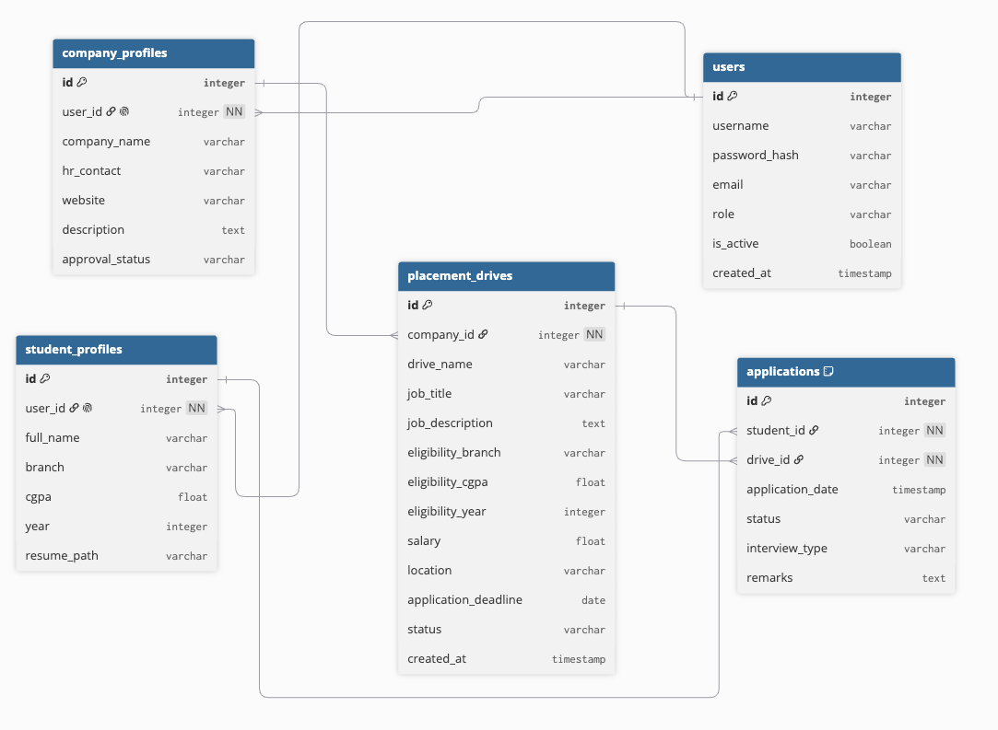

6. API Resource Endpoints

Endpoint | Method | Description
/api/auth/register | POST | Register a student or company account
/api/auth/login | POST | Authenticate credentials – returns JWT token
/api/auth/me | GET | Fetch the currently logged-in user's profile
/api/admin/dashboard | GET | Aggregated statistics (cached via Redis)
/api/admin/companies | GET | List all registered companies
/api/admin/companies/<id>/approve | PUT | Approve a pending company registration
/api/admin/companies/<id>/reject | PUT | Reject a company registration
/api/admin/companies/<id>/blacklist | PUT | Toggle active/blacklist state for a company
/api/admin/students | GET | List all registered students
/api/admin/students/<id>/blacklist | PUT | Toggle active/blacklist state for a student
/api/admin/drives | GET | List all placement drives
/api/admin/drives/<id>/approve | PUT | Approve a placement drive
/api/admin/drives/<id>/reject | PUT | Reject a placement drive
/api/admin/search | GET | Search students or companies by name
/api/company/profile | GET/PUT | View or update company profile
/api/company/drives | GET/POST | List or create placement drives
/api/company/drives/<id>/applications | GET | View all applicants for a specific drive
/api/company/applications/<id>/status | PUT | Shortlist, select, or reject an applicant
/api/student/profile | GET/PUT | View or update student profile
/api/student/profile/resume | POST | Upload resume (PDF/DOC/DOCX)
/api/student/drives | GET | List approved drives filtered by eligibility
/api/student/drives/<id>/apply | POST | Apply to a placement drive
/api/student/applications | GET | View own active applications
/api/student/applications/history | GET | Complete placement application history
/api/student/applications/export | POST | Trigger async CSV export (Celery)

7. Architecture and Features (Optional)

Project Directory Structure:
Placement-Portal-V2-24f1002255-Avra-Paul/
├── run.py # App entry-point
├── requirements.txt # Python package dependencies
├── backend/
│ ├── app.py # Factory, blueprint registration, admin seeding
│ ├── config.py # DB / Redis / Celery / Mail settings
│ ├── models.py # SQLAlchemy ORM models
│ ├── tasks.py # Celery async tasks & beat scheduler
│ ├── utils.py # Role decorator & eligibility checks
│ └── routes/
│ ├── auth.py # Login / Register
│ ├── admin.py # Admin management routes
│ ├── company.py # Company drive & applicant routes
│ └── student.py # Student browse, apply & export routes
└── frontend/
├── index.html # Vue 3 SPA (CDN) with Bootstrap 5
└── src/
├── api.js # Network request helper & localStorage auth store
├── app.js # Root app wrapper & page routing switch
└── views/
├── admin.js # Admin panel view
├── company.js # Company dashboard view
├── login.js # Login page form
├── register.js # Registration form
└── student.js # Student panel & resume upload
Key Features Implemented:
- Role-based access control (Admin / Company / Student) enforced at API level via JWT.
- Automatic eligibility filtering — students see only drives they qualify for (CGPA, branch, year).
- Duplicate-application prevention via a database unique constraint (student_id, drive_id).
- Redis caching on high-traffic read endpoints (admin dashboard, student drive listing).
- Automated Celery Beat jobs: daily deadline reminders and monthly HTML placement reports by email.
- User-triggered async CSV export of application history delivered by email once ready.
- Resume file uploads (PDF / DOC / DOCX) with server-side extension validation.
- Chart.js analytics panels on Admin and Company dashboards.

8. Video Presentation

- Drive Link: https://drive.google.com/file/d/your-video-link-here
(Accessible to anyone with the link – set permission to "Viewer" before submission.)

Placement Portal Application V2 | Avra Paul | 24f1002255 | IIT Madras BS 2026

