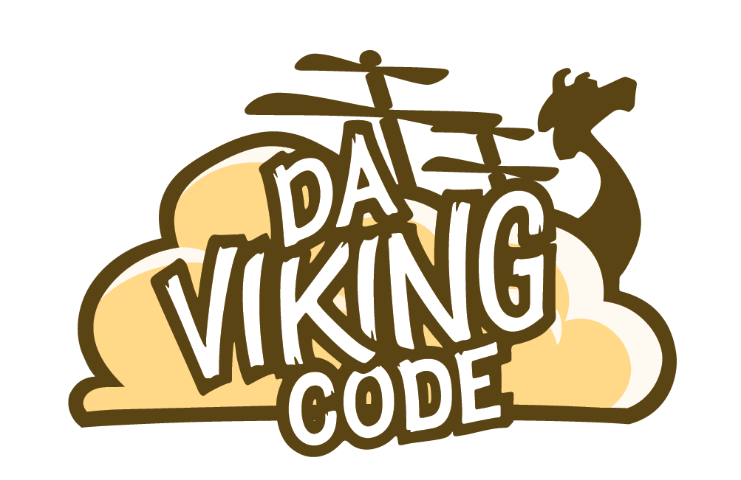

[**http://davikingcode.com**](http://davikingcode.com)

**$P Point-Cloud Recognizer**

The [$P Point-Cloud Recognizer](http://depts.washington.edu/aimgroup/proj/dollar/pdollar.html) is a 2-D gesture recognizer designed for rapid prototyping of gesture-based user interfaces. In machine learning terms, $P is an instance-based nearest-neighbor classifier with a Euclidean scoring function, i.e., a geometric template matcher. $P is the latest in the dollar family of recognizers that includes [$1 for unistrokes](http://depts.washington.edu/aimgroup/proj/dollar/index.html) and [$N for multistrokes](http://depts.washington.edu/aimgroup/proj/dollar/ndollar.html). Although about half of $P's code is from $1, unlike both $1 and $N, $P does not represent gestures as ordered series of points (i.e., strokes), but as unordered point-clouds. By representing gestures as point-clouds, $P can handle both unistrokes and multistrokes equivalently and without the combinatoric overhead of $N. When comparing two point-clouds, $P solves the classic [assignment problem](http://en.wikipedia.org/wiki/Assignment_problem) between two bipartite graphs using an approximation of the [Hungarian algorithm](http://en.wikipedia.org/wiki/Hungarian_algorithm).

This is an adaptation of the original C# code for working with Unity.

In the demo, only one point-cloud template is loaded for each of the 16 gesture types. You can add additional templates as you wish, and even define your own custom gesture templates.

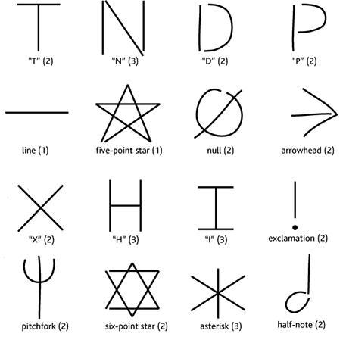

**Setup :**

Import the package via Unity Asset Store. You will get a PDollar folder with a demo. An explanation of what you will get in the sub-folder :

* Prefabs : One prefab named *GestureOnScreen* which is basically a *Line Renderer* for displaying user gesture.
* Resources : 16 pre-made gestures saved as xmls.
* Scene : The demo scene.
* Scripts : The demo script and the PDollar algorithm.

The *Demo Script* is attached to the *Main Camera* and the prefab *GestureOnScreen* must be linked to this *Demo Script*.

Features :

Using the PDollar algorithm you can recognize features with multi-strokes and register new one. You can register new gestures running Unity demo directly or on mobile. They will be saved at [Application.persistentDataPath](http://docs.unity3d.com/ScriptReference/Application-persistentDataPath.html). Note you can’t save the xml generated on Unity Web Player.

Support & issues : <https://github.com/DaVikingCode/PDollar-Unity>

Contact : [hello@davikingcode.com](mailto:hello@davikingcode.com)