MX Integer Pipeline Variants

1. Emulation (current library)
Scale is baked into FP32 values before MAC. Everything stays FP32.
a: FP32 w: FP32
| |
v v
[MX quantize] [MX quantize] <- divide by 2^se, clip mantissa, multiply back
| |
FP32 (low prec) FP32 (low prec)
| |
+--------+--------+
|
v
[FP32 x FP32]
|
FP32
|
v
[FP32 accum] <- all blocks accumulated together, no scale separation
|
FP32
|
v
[elemwise quant]
|
FP32 / BF16

In code: mx_ops.py lines 285-292 (before MAC):
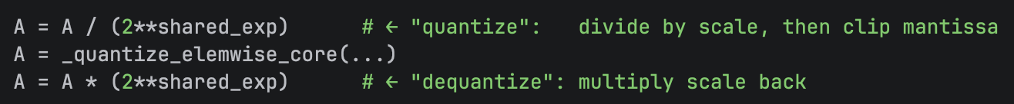

2. HW Variant A - Scale before MAC (dequantize first)
Scale applied before multiply. Target format depends on hardware MAC unit - not necessarily FP32. Examples: MXINT4/INT6 -> dequantize to INT8 -> INT8xINT8 MAC; MXINT8 -> INT16xINT16; MXFP4 -> FP16xFP16.

a: MXINTN + S_a w: MXINTN + S_w
| |
v v
[x 2^S_a] [x 2^S_w] <- dequantize to wider integer or float
| |
INT8/INT16/FP16 INT8/INT16/FP16
| |
+---------+----------+
|
v
[INT8xINT8 / INT16xINT16 / FP16xFP16]
|
INT16/INT32/FP32
|
v
[accum in wider format]
|
FP32 output

3. HW Variant C - Scale after block accumulator (MX spec / NVIDIA)
Each block accumulates fully in INT32, then one scale per block. Cross-block sum in FP32.
Block 0 Block 1 Block 2
a0:INT8 w0:INT8 a1:INT8 w1:INT8 a2:INT8 w2:INT8
| | | | | |
+----+----+ +----+----+ +----+----+
| | |
v v v
[INT8 x INT8 MAC] [INT8 x INT8 MAC] [INT8 x INT8 MAC]
| | |
INT32 INT32 INT32
| | |
v v v
[x (S_a0 x S_w0)] [x (S_a1 x S_w1)] [x (S_a2 x S_w2)]
| | |
FP32 FP32 FP32
| | |
+----------+-----------+----------+-----------+
|
v
[FP32 accum] <- cross-block sum in FP32
|
FP32 output
This is the MX HW model (confirmed by NVIDIA NVFP4 paper):
One INT32 accumulator per block -> scale once -> sum block results in FP32: "Tensor Cores compute partial dot-products over the block, multiply each partial product by the corresponding scale factors to descale the inputs scaled during quantization, and accumulate the partial results in higher precision to produce the final dot-product in FP32." (https://arxiv.org/pdf/2509.25149).

