Online Energy Utility Platform

Laboratory 2, Project 2

Avram Andrei-Alexandru

30444

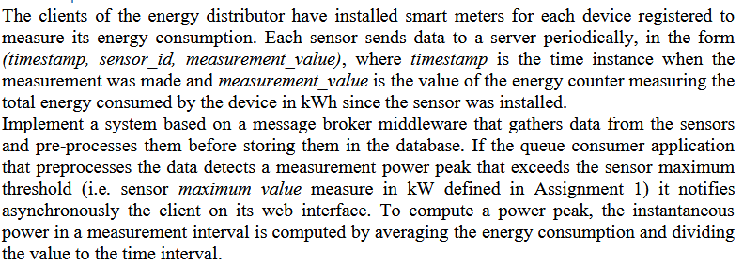

Problems that I came across during the implementation of this assignment:

1. Entity framework caching. When retrieving a device from the database the returned device gets cached and the updated maximum energy consumption will not be seen in the messaging service. This was fixed by forcing entity framework to reload the object in memory.

2. SignalR connection problem because the JWT token authentication was enabled. Startup class was updated to support SignalR.

3. CI/CD of the frontend Angular 11 application. Documentation for GitHub YAML file for Angular deployment using docker containers was hard to find online.

4. Kendo Angular library current version required licensing.