🏗️ Solution & Deep-Dive: Task 1 (High-Volume E-Commerce REST API)

1. Complete RESTful URI & Endpoint Specification
REST Resource Layout
│
┌─────────────────────┴────────────┐
▼ ▼
/api/v1/orders /api/v1/orders/{order_id}
(Collection Resource) (Item Resource)
• POST: Create new order • GET: Fetch order details
• GET: Filter & Paginate • PATCH /items/{item_id}: Modify item
• POST /cancellations: Transition state
Workflow | HTTP Verb | URI Path | Headers / Query Params | Expected Status Codes
1. Create Order | POST | /api/v1/orders | Header: Idempotency-Key: <UUID> | 201 Created (Location: /api/v1/orders/ord_101), 409 Conflict, 422 Unprocessable
2. Update Item Quantity | PATCH | /api/v1/orders/{order_id}/items/{item_id} | Request Body: {"quantity": 4} | 200 OK, 400 Bad Request, 404 Not Found
3. Warehouse Query | GET | /api/v1/orders | ?status=pending&sort=-created_at&limit=50&cursor=eyJpZCI... | 200 OK, 400 Bad Request
4. Cancel Order | POST | /api/v1/orders/{order_id}/cancellations | Request Body: {"reason": "customer_changed_mind"} | 200 OK (or 202 Accepted if async), 409 Conflict (already shipped)

2. Deep-Dive: Idempotent Order Creation via Idempotency-Key

The Problem
When a mobile app sends POST /api/v1/orders, a network hiccup or mobile tower handoff might drop the TCP connection after the backend creates the order and charges the card, but before the client receives the 201 Created response. If the client automatically retries, naive backends create duplicate charges and duplicate orders.

The Solution: Distributed Idempotency Filter
We mandate an Idempotency-Key header containing a client-generated UUIDv4.
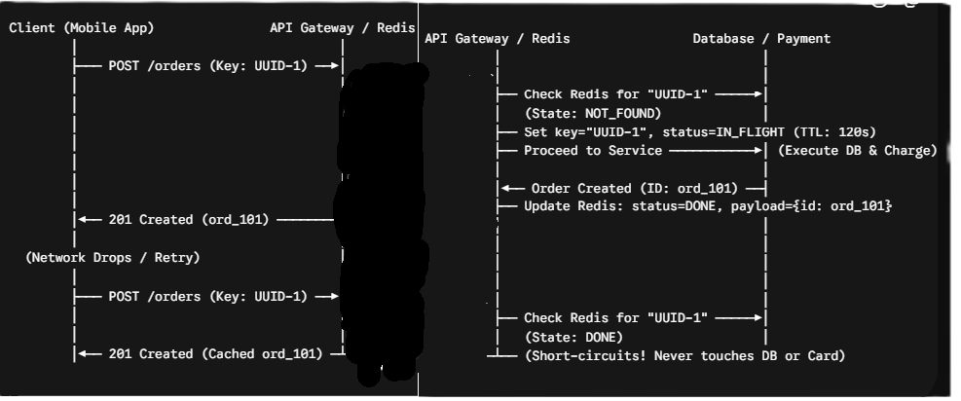Card)
- Atomic Lock / Check: The API layer inspects Redis for idempotency:order:<UUID>.

- If In-Flight: If the request is currently processing, it returns 409 Conflict or waits on a distributed lock.

- If Completed: If the operation already completed, it short-circuits, immediately returning the cached response payload and HTTP status code without re-running payments or database writes.

- If New: It processes the order, caches the result in Redis with a 24-hour TTL, and returns 201 Created.

3. Deep-Dive: Cursor-Based vs. Offset-Based Pagination

The Choice: Cursor-Based Pagination
For warehouse queries against millions of records, Cursor-Based Pagination (?limit=50&cursor=<encoded_token>) must be used instead of Offset/Limit (?offset=500000&limit=50).

Offset Pagination (O(N) Degradation):
DB reads 500,000 index entries ──► Discards 500,000 rows ──► Returns 50 rows (Slow, High I/O)

Cursor Pagination (O(1) Constant Time):
DB seeks directly to index position (created_at, id) < (cursor_time, cursor_id) ──► Returns 50 rows
- Eliminates Database Degradation ($O\left(1\right)$ vs $O\left(N\right)$): OFFSET 500000 forces PostgreSQL to scan and discard 500,000 records before returning the next 50. A cursor uses a composite B-Tree index (created_at, id), executing a direct index seek in constant time regardless of how deep the user paginates.

- Prevents Pagination Drift (Missing/Duplicate Rows): If 10 new orders arrive while a warehouse worker navigates between page 1 and page 2, offset pagination shifts rows down, causing the worker to see duplicate items on page 2. Cursors point to an immutable timestamp/ID landmark.

4. Deep-Dive: State Transitions vs. Hard Deletions

Why DELETE /api/v1/orders/{id} is Bad Design
- In financial and e-commerce domains, data must be immutable for accounting and legal audit logs.

- Cancelling an order changes its internal State Machine (PENDING $→$ CANCELLED), releases inventory locks, and initiates refund pipelines. It does not erase the record from storage.

Modeling Approaches:
- Sub-Resource Pattern (Recommended): POST /api/v1/orders/{order_id}/cancellations (Creates a cancellation event record).

- Patch State Pattern: PATCH /api/v1/orders/{order_id} with payload {"status": "cancelled"}.

- Error Handling: If the order status is already SHIPPED, the state transition is invalid. The server rejects the call with 409 Conflict (stating that the resource is in an incompatible lifecycle state).

🏗️ Solution & Deep-Dive: Task 2 (Multi-Protocol Fintech Architecture)

1. Protocol Allocation Architecture
┌────────────────────────────────────────────────────────┐
│ Fintech Gateway Ingress │
└───────┬───────────────────┬───────────────────┬────────┘
│ │ │
REST (HTTP/2 JSON) WebSockets (Duplex) gRPC (Protobuf / HTTP/2)
│ │ │
▼ ▼ ▼
[ Web / Mobile App ] [ Market Ticker ] [ Internal Settlement ]
• Portfolio views • Millisecond price • C++ Matching Engine
• Account management streams to UI • Go Risk Ledger
• Statement caching • 2-byte framing • High throughput RPC
Feature Area | Selected Protocol | Transport / Framing | Data Format
1. Public Web & Mobile App | RESTful API | HTTP/2 or HTTP/1.1 | JSON
2. Real-Time Price Ticker | WebSockets (or SSE) | TCP Persistent Duplex / HTTP Stream | Compact JSON / FlatBuffers
3. Internal Settlement Engine | gRPC | HTTP/2 Multiplexed Streams | Binary Protocol Buffers (.proto)

2. Architectural Justifications & Trade-Offs

Feature 1: Public Web & Mobile App $→$ RESTful API
- Caching Capabilities: Client requests (like monthly transaction PDF downloads or static portfolio summaries) benefit heavily from HTTP edge caching headers (Cache-Control, ETag, Last-Modified) on CDNs and API gateways.

- Compatibility & Debugging: Zero special client proxying required. Standard JSON payloads make frontend integration, browser tooling, and mobile networking libraries simple and reliable.

- Why not gRPC: Web browsers cannot natively speak binary HTTP/2 gRPC framing without a translation proxy like Envoy / grpc-web.

Feature 2: Real-Time Live Market Ticker $→$ WebSockets (or SSE)
- Framing Overhead: In financial tickers updating multiple times per second, HTTP/REST polling incurs massive overhead (TCP handshakes + 500–1000 bytes of HTTP headers per request). WebSockets establish a single TCP connection and exchange updates with a framing overhead of only 2 to 10 bytes.

- Full-Duplex: Allows the client to dynamically subscribe/unsubscribe to specific stock tickers over the same open socket channel without opening new HTTP connections.

- (Alternative) Server-Sent Events (SSE): If the ticker strictly pushes data from server-to-client and requires no client upstream messages, SSE over HTTP/2 is simpler to operate, avoids firewall WebSocket blocks, and has native automatic reconnection.

Feature 3: Internal Settlement Engine $→$ gRPC (C++ $↔$ Go)
- Type-Safe Polyglot Contracts: Both the C++ Matching Engine and Go Ledger import the identical compiled .proto definitions. This eliminates runtime type mismatches, missing fields, or numeric floating-point parsing bugs between languages.

- Binary Serialization Throughput: Protocol Buffers serialize into compact binary structures. Encoding/decoding Protobuf is 5x to 10x faster than parsing string-based JSON, saving CPU cycles on high-frequency transaction loops.

- HTTP/2 Multiplexing: Multiple internal RPC requests and responses flow concurrently across a single persistent TCP connection, preventing TCP connection pool starvation under heavy transaction spikes.

3. Failure & Error Modeling Across Protocols
┌─────────────────┬───────────────────────────────────┬─────────────────────────────────────┐
│ Protocol │ Error Transport Mechanism │ Payload / Error Format │
├─────────────────┼───────────────────────────────────┼─────────────────────────────────────┤
│ **REST** │ HTTP Status Codes (4xx, 5xx) │ RFC 7807 Problem Details (JSON) │
│ **WebSockets** │ WS Close Codes / App-level Frames │ JSON Error Event Messages │
│ **gRPC** │ HTTP/2 Trailing Headers │ Canonical Status Codes + Proto Model │
└─────────────────┴───────────────────────────────────┴─────────────────────────────────────┘
- REST Error Handling:
Uses standard HTTP status codes combined with structured JSON bodies adhering to standard error specs (e.g., RFC 7807):

JSON
HTTP/1.1 422 Unprocessable Entity
Content-Type: application/problem+json

{
"type": "https://api.trading.com/errors/insufficient-funds",
"title": "Insufficient Balance",
"status": 422,
"detail": "Account balance of $120.00 is below required order margin of $500.00."
}
- WebSocket Error Handling:
Because the transport connection remains open, errors are delivered as Application Frames:

JSON
{
"event": "error",
"topic": "ticker:AAPL",
"code": "SUBSCRIPTION_LIMIT_EXCEEDED",
"message": "Maximum of 50 active ticker streams per connection."
}
If a catastrophic authentication error occurs, the server closes the entire socket with a standard WebSocket Close Code (e.g., 1008 Policy Violation).

- gRPC Error Handling:
gRPC avoids HTTP status codes entirely and uses 16 canonical status codes (e.g., INVALID_ARGUMENT, DEADLINE_EXCEEDED, NOT_FOUND, UNAVAILABLE) sent via HTTP/2 trailing headers (grpc-status: 3, grpc-message: "Invalid account ID"). Rich error metadata is embedded using the standard google.rpc.Status protobuf model.

