Team Bash
Mission: Design a small survey drone that photographs a 5 ha farm to spot unhealthy crop patches.

Introduction
After receiving our problem statement, we swiftly moved to assessing the main objectives.
Tackling them one by one, we moved forward by making decisions like choosing to make a quadcopter, as a small fixed-wing would have difficulty with the mandated lawnmower path. Turning to our main objective, we found a hybrid RGB+NIR camera, which helped improve the efficiency of our recognition program. As we moved forward in our project, we calculated essential things like the centre of gravity and thrust-to-mass ratio while staying well within the constraints.
NIR VS RGB?
While choosing this essential aspect, we had to weigh the pros and cons.
If we use only RGB, then we can only apply a remedy when the crop has already been damaged, but NIR gives us the earliest symptoms of crop damage too, or the CNN model might also easily confuse a patch of brown soil or shadow with a dead plant. On the contrary, using only NIR faces issues in cases where crops experience stress as the internal structure starts to collapse, and NIR reflectance starts to drop. RGB provides visual confirmation, such as leaf curl or spots. Furthermore, if we use only either RGB or NIR, then the 6-channel CNN completely fails, as the NDVI formula needs data from both the Red band and the NIR band to calculate the true NDVI.
Back-End Development
In a nutshell, the plan is to take pictures of the farm using the drone and process both RGB & NIR spectrum images, which will be transmitted back to the ground station in real time. Then, all these images in the dataset will be stitched together into an orthomosaic to avoid any discrepancy that may come from the lawnmower survey path. To go along with the lawnmower survey path while trying to maintain minimum flight duration, we use 70% wide overlap and 80% front overlap.
We’re using the See3CAM_CU83 - 4K AR0830 RGB-IR USB 3.2 Gen 1 Camera Module, which has a lens of focal length 3.16 mm and yields a wide 80.86° Horizontal FOV. Using this and the fact that the drone hovers 50 metres above the ground, we find out that the swath of the drone is 85.19m horizontal and approximately 47.40 metres vertical.
Ground Sample Distance (GSD): Represents the physical distance represented by a single pixel in the resulting image.
- Horizontal GSD= 85.20 m /1920 px= 4.44 cm/px
- Vertical GSD= 47.40m/1080 px=4.39 cm/px

Lawnmower Grid Execution:
Calculating for the 70 per cent and 80 per cent overlaps:-
Side Spacing = 85.20 * (1-0.30)=25.56 m
Front Spacing = 47.40 * (1-0.20)=9.48 m
Hence, no. of flight lines = 223.61m/25.56m=8.74, which rounds up to 9 considering full edge-to-edge coverage.
To avoid any motion blur and for proper stitching, we keep a trigger distance of 9.48 metres and the drone cruises at a comfortable speed of 6 m/s, which means that the camera takes a picture every 1.58 seconds, which is well above the minimum trigger interval of the camera

Flight Distance:
Linear Distance = 9 lines *223.61 m= 2012.49m
Turning distance =8 turns * 25.56m=204.48m
Total flight distance = 2217m(approx.)

Flight Area:
Effective Rate = Size Spacing*Speed
= 25.56*6
=153.36m²s⁻¹
Therefore, Total Area =153.36*505
=77446.8
The image analysis will be performed in two separate stages:
Pre-flight processing
Post-flight processing

Pre-Flight Processing
Before the UAV takes flight, a couple of prerequisites have to be taken care of, such as calibrating and training the ML model on the dataset from various online sources. For this purpose, firstly, the dataset containing the RGB & NIR aerial images of the crops will be processed using the NDVI (for NIR images) & VARI (for the RGB images) formulae, and then the raw data along with the output from the formulae will be stacked to create a 6-channel input vector for each unit as [Red, Green, Blue, NIR, NDVI, VARI] instead of the default 3-channel first convolutional layer. This vector will then pass through the CNN algorithm using PyTorch as training data, which will train it to differentiate between the good & bad patches of the crop on binary parameters such that 0 stands for damaged/bad patches of the crop and 1 stands for healthy/good patches of the crop, and then these can be further assigned colour codes like red for damaged and green for healthy patches of the crop.

NDVI=(NIR-Red)/(NIR+Red)
VARI =(Green – Red)/(Green + Red- Blue)

Post-Flight Processing
After the drone flies the 5-hectare farm while live-relaying the images to the ground station, the images stored here at the ground station are stitched together into an orthomosaic from which we will cut standard 224*224 pixel tiles, which we pass through our trained CNN using a sliding grid window. After this, the CNN classifies the images as healthy/unhealthy crop patches. The resulting heatmap from PyTorch is not just a picture, but can be exported as spatial data, which can further be used for several purposes, like smart tractors or automated spray drones to deploy targeted chemical treatments for immediate response.

Safety Protocols:
The drone has a SpeedyBee flight controller which runs on ArduPilot, and also has a hardware GPS module to enable strict Return to Launch (RTL) protocol.
Failsafe Triggers: The drone will be programmed to automatically trigger RTL upon RC telemetry loss or low battery voltage.
Clearance Altitude: The RTL altitude is set at 30 metres to ensure that the drone climbs above all trees and farm structures before flying back to its launch coordinates.

CAD Modelling
Using Fusion 360, the CAD models for the quadcopter are prepared keeping in mind the passive airflow near the electronics for efficient cooling and the strength required in various parts of the UAV depending on the purpose they serve. The materials Team BASH uses in this project are:
Carbon Fibre
G10 fiberglass
EPP (Expanded Polypropylene) Foam

Carbon fibres are specifically used as the arms of the quadcopter and to hold the motors. Because of the high tensile strength and low density, carbon fibres are the perfect match. Then, for the main body of the UAV, which holds all the electronics, G10 fibreglass is used, which has high tensile strength (comparable to Aluminium) at a density nearly half that of Aluminium and is comparatively very cheap. EPP Foam is used as a coating over the carbon fibre to hold the motors for absorbing vibrations and also around the camera to reduce the damping effect.

Apart from this, we have used a multi-rotor system instead of a fixed-wing system because using a quadcopter gives better mobility or manoeuvrability capability, which is required in the lawnmower path. In addition to this, the capability of Vertical Take-Off & Landing (VTOL) makes it ideal for confined agricultural spaces.

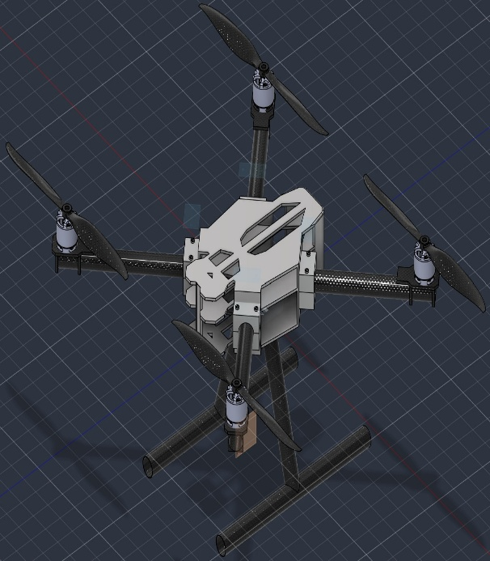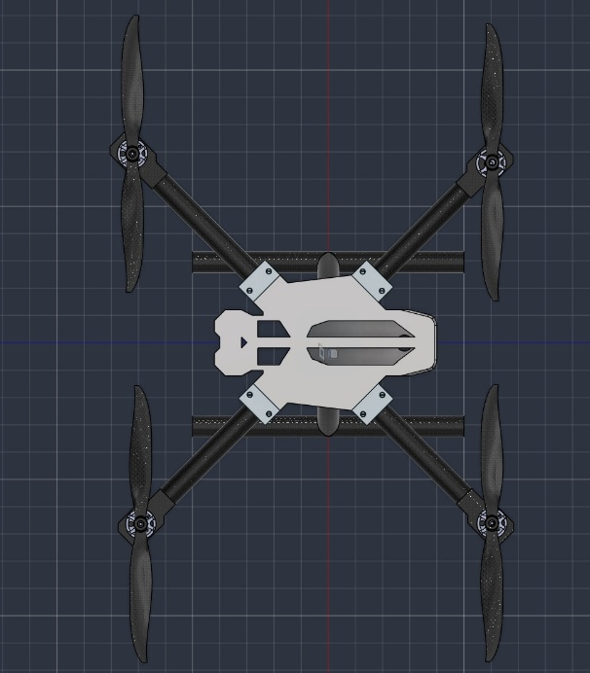

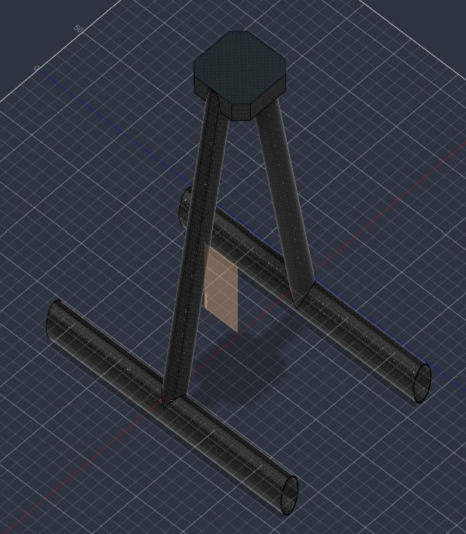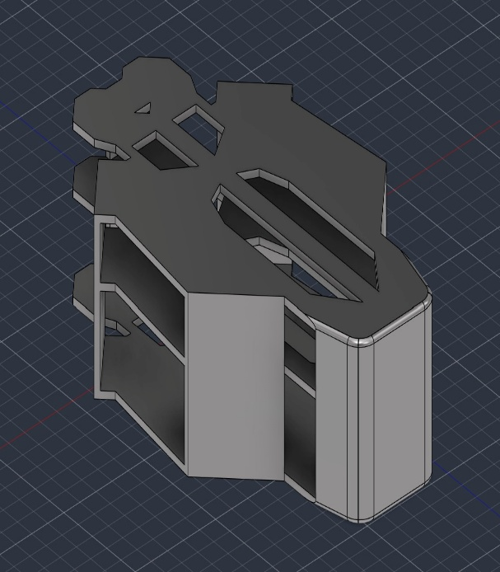

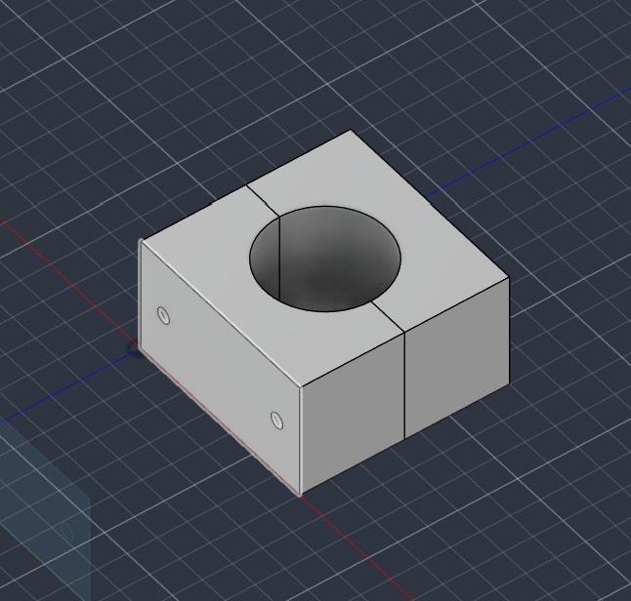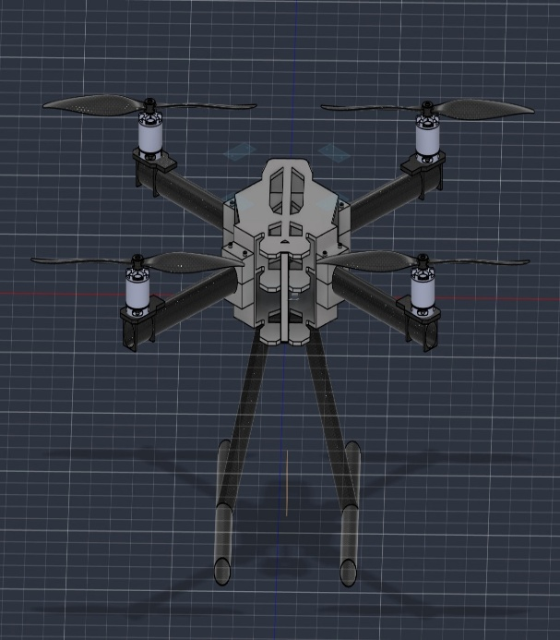

Component List
Given below is a list of our internal components with vital details like weight, power consumption and price.

S.no | Components | Type | Price | Weight(gram) | Power
1 | SunnySky X2216 880KVx4 | Motor | 7351.08 | 270 | 260
2 | HJ Carbon fibre 1045 propellersx4 | Propeller | 2,100 | 44 | 0
3 | Raspberry Pi 4 Model B | Companion Computer | 11,469 | 50 | 2.5
4 | HC-12 Wireless Serial Port Module | Transceiver | 250 | 2 | 0.5
5 | SanDisk High Endurance SD card 32gb | SD Card | 761 | 0.26 | 0
6 | Standard Aluminium 4-Set (Passive) | Computer Cooler | 30 | 4 | 0
7 | Auline 21700 4S 14.8V 9600mAh 4S2P Li-ion Battery | Power Supply | 7353.97 | 580 | 0
8 | Secret DESIRES Silicone Thermal Pad | Battery Cooler | 470 | 90 | 0
9 | SpeedyBee F405 AIO 40A | Compound Flight Controller | 7,599 | 13.6 | 0
10 | U-blox NEO-M8N GPS | GNSS | 2,097.90 | 33 | 0.25
11 | Holybro SiK Telemetry Radio V3 - 100mW (433MHz) | Ground Link | 9,446 | 13.6 | 0.5
12 | RadioMaster Pocket (ELRS 2.4GHz version) | Radio Fail Safe | 6,999 | 0 | 0
13 | RadioMaster RP1 Nano Receiver | Radio Fail Safe | 2,599 | 2.2 | 0.25
14 | See3CAM_CU83 - 4K AR0830 RGB-IR USB 3.2 Gen 1 Camera | Camera | 9580.77 | 300 | 7
15 | Drone Structure | Carbon fibre | 2074.56 | 138.304 | 0
 |  | Aluminium | 53.49 | 198.112 | 0
 |  | G10 | 189.08 | 343.791 | 0
Total |  |  | 70423.85 | 2082.867 | 271
Table 1
Doing calculations based on this data, we get the following stuff:-
- Thrust to weight ratio:2.208
- Total efficiency:48.2%
- Propeller Thrust:1000 g to 1150 g
- Static Thrust: 4000 g to 4600g
Conclusion
We surfed many options for components before finally settling on the ones that really suited our needs. We checked off all objectives while adding a dash of our innovation wherever possible. This drone has huge real life applications for farmers. We made sure to have a priority on keeping the budget at a minimum so that it can be easily available to them.
Team Members
Avrodeep Ghosh
Abhinav
Kalaiventhan
Shreshth Sharma

