MIMIC-III ICU Outcomes Analysis: Mortality Risk and Long-Stay Prediction
By Christopher Leung
Introduction
Intensive Care Units (ICUs) typically house critically ill patients who require continuous care from multidisciplinary medical teams. They are usually the wing of the hospital where most mortality occurs(1). As such, intense interest is shown in factors linked to mortality. Past research into the field has shown that the intensity of staffing, source of admission, GCS level at admission, duration of ICU stay, treatment with inotropes, age, septic shock status, intubation, vasopressor drug use, ventilation requirement, existing comorbidities, gender, mobility, and retroviral infection status are all highly linked to mortality outcome for ICU patients (1-4). Due to the electrolyte imbalances and vital statuses normally associated with these conditions, they are often associated with mortality as well(1-3). While little is done to investigate the linkage between ICU type and mortality in the existing literature, an investigation by Rosenthal and co. found that there was little to statistically link ICU type themselves to mortality, despite certain ICU types showing larger percentages of mortality than others(4). Similarly, it’s been found in multiple studies that prolonged stay in ICU, 3 or more days, is highly correlated to mortality outcome in multiple studies, with both groups sharing many of the same characteristics (5-8). Such patients are generally frailer than non-long-term stay patients, with many patients not being independent before or after treatment(6). While a minority of the total ICU patient population, it has been found that long-term stay patients generally disproportionate consume more than 50% of ICU resources(8).
Statistical Modelling: ICU Mortality
The goal of this research is to use logistic regression to study the various causes of ICU mortality in MIMIC III data and, through it, balance out the effects of confounding factors and to identify whether ICU type is linked to increased mortality in patients(9).
Methods
A total of fifteen files from Mimic III were used. They are admissions,antibiotics,bloodculture, gcs_hourly(GCS hourly results),icd9_diag(ICD9 Diagnosis),icustays(ICU stay results),labs_hourly(hourly laboratory results) ,output_hourly(urine output), patients,pt_icu_outcome(ICU patient outcome), pt_weight(patient weight) ,pv_mechvent(mechanical ventilation status), transfers,vasopressors and vitals_hourly(hourly vitals data). Analysis was all done using R-Studio. The csv files were merged based on the unique identifier ICU Stay ID, which is unique for every ICU admission, even if the patient was admitted to the same ICU twice in the same hospital stay.
Each file was cleaned for inconsistent data or implausible data before being joined together. Only patients who had an ICU outcome were involved in the study. Similarly, to prevent ICU types being confounded, only patients with a single hadm_id( indicating they have not been transferred to other ICU wards) were chosen. Patients also had to be 18 or above, as paediatric patients would likely have different profiles that would skew statistics. Only statistics from first 24 hours of a patient’s stay or 24 hours before the patient’s stay were used to give a baseline review of the patient status when they were transferred to the ICU ward, as the study intends to study the effects of the ICU type on the patient and that information post-24 hours of ICU stay could potentially be confounded by the ICU type’s treatment. Due to only a few or a fraction of patients having blood culture data, antibiotic use, mechanical ventilation and vasopressor use, a decision was made to create binary variables of the data, with individuals who were in those files being Yes for the Treatment/observation and other ICU patients who were not involved being No. GCS hourly, laboratory results from labs_hourly, output data from outputs_hourly, patient weights, were summarised using median per ICU Stay ID for the first -24 to 24 hours of stay before being linked back to the main data to be used. Similarly, a calculation of comorbidity was performed using the Charlson score, which was based on the comorbidity data listed in ICD-9_DIAG.
After the data was all merged, the identifiable data and future data which were either of no use statistically or would provide confounding effects were all removed, with the remaining variables then subjected to correlation tests to the Hospital Expire Flag, which indicated mortality in the hospital. Chi-square tests, as shown in Table 1, were used to examine the correlation between various binary or categorical variables to the Hospital mortality outcome.
Table 1 Chi-square test results

Variable | p-value
ICU UNIT | p-value < 2.2e-16
Gender | p-value = 2.893e-06
Endotracheal Status | p-value < 2.2e-16
Ventilated or Not | p-value < 2.2e-16
Vasopressor Usage Status | p-value < 2.2e-16
Positive Blood Culture or Not | p-value < 2.2e-16
Admission Type | p-value < 2.2e-16
Admission Location | p-value < 2.2e-16
Insurance Status | p-value < 2.2e-16
Language | p-value < 2.2e-16
Religion | p-value < 2.2e-16
Marital Status | p-value < 2.2e-16
Ethnicity | p-value < 2.2e-16
Diagnosis | p-value < 2.2e-16
T-tests and Wilcox tests, as shown in Table 2, were used to examine numerical variables to the Hospital Mortality outcome instead. All categorical variables were highly significant, while numerical variables were all significant in either T-Test or Wilcox Test, often both.
Table 2 T-Test and Wilcox Test results
Variable | T-Test p value | Wilcox Test
Neutrophil | p-value = 0.0686 | p-value < 2.2e-16
C-Reactive Protein | p-value = 0.005977 | p-value = 0.000599
White Blood Cell | p-value < 2.2e-16 | p-value < 2.2e-16
Partial Pressure O2 | p-value < 2.2e-16 | p-value < 2.2e-16
Bicarbonate | p-value < 2.2e-16 | p-value < 2.2e-16
Lactate | p-value < 2.2e-16 | p-value < 2.2e-16
Troponin | p-value = 0.3793 | p-value = 2.265e-06
Blood Urea Nitrogen | p-value < 2.2e-16 | p-value < 2.2e-16
Creatinine | p-value < 2.2e-16 | p-value < 2.2e-16
Alanine Transaminase | p-value = 1.038e-14 | p-value < 2.2e-16
Aspartate Transaminase | p-value < 2.2e-16 | p-value < 2.2e-16
Haemoglobin | p-value = 3.42e-14 | p-value < 2.2e-16
INT Normalised Ratio | p-value < 2.2e-16 | p-value < 2.2e-16
Platelet | p-value = 8.123e-10 | p-value < 2.2e-16
Albumin | p-value < 2.2e-16 | p-value < 2.2e-16
Chloride | p-value = 0.0001481 | p-value = 4.888e-06
Glucose(from vitals data) | p-value < 2.2e-16 | p-value < 2.2e-16
Sodium | p-value = 0.004619 | p-value = 1.295e-05
Bilirubin | p-value < 2.2e-16 | p-value < 2.2e-16
Haematocrit | p-value = 0.3172 | p-value = 0.055
Spo2 Median | p-value = 1.621e-10 | p-value = 0.02166
FiO2 Median | p-value < 2.2e-16 | p-value < 2.2e-16
Temperature Median | p-value < 2.2e-16 | p-value < 2.2e-16
Respiratory Rate Median | p-value < 2.2e-16 | p-value < 2.2e-16
Systolic Blood Pressure Median | p-value < 2.2e-16 | p-value < 2.2e-16
Diastolic Blood Pressure Median | p-value < 2.2e-16 | p-value < 2.2e-16
Glucose Media/Glucose (from laboratory values) | p-value < 2.2e-16 | p-value < 2.2e-16
Mean Arterial Pressure | p-value < 2.2e-16 | p-value < 2.2e-16
GSC Score Median | p-value < 2.2e-16 | p-value < 2.2e-16
Charlson Score | p-value < 2.2e-16 | p-value < 2.2e-16
Median Urine Output | p-value < 2.2e-16 | p-value < 2.2e-16
Average Weight | p-value < 2.2e-16 | p-value < 2.2e-16

Next, multicollinearity was investigated between different numerical variables using Pearson’s Correlation test. Table 3 shows all the highly correlated numerical pairs whose correlation was 0.3 or above.
Table 3 High Correlation pairs
Variable 1 | Variable 2 | Correlation
Haemoglobin | Haematocrit | 0.9414658
Diastolic Blood Pressure Median | Mean Arterial Blood Pressure | 0.8666846
Alanine Transaminase | Aspartate Transaminase | 0.8906865
Systolic Blood Pressure Median | Mean Arterial Blood Pressure | 0.7327271
Glucose | Glucose Median | 0.7136022
Blood Urea Nitrogen | Creatinine | 0.5918131
Chloride | Sodium | 0.6523323
Systolic Blood Pressure Median | Diastolic Blood Pressure Median | 0.4520825
Bicarbonate | Chloride | -0.4099899
Bicarbonate | Lactate | -0.3651235

To investigate multicollinearity between categorical and binary variables, Cranmer’s V was used instead, which showed a correlation of 0.442 between Endotracheal Status and Ventilated Status. Next, the correlation between numerical and categorical/binary variables was also studied, with binary variables correlated to numeric variables using point biserial correlation, while the correlation between categorical values and numerical variables is measured using ANOVA ETA Squared. The pairs with strong correlation are shown in Table 4.
Table 4: Effect size, Categorical vs Numeric data for multicollinearity
Variable 1 | Variable 2 | Effect Size
GCS Median | Endotracheal Status | 0.832 Point Biserial
Age Years | Insurance | 0.418 ETA
Troponin | Diagnosis | 0.179 ETA
Partial Pressure O2 | ICU Unit | 0.177 ETA
Age Years | Marital Status | 0.170 ETA
Partial Pressure O2 | Diagnosis | 0.149 ETA

The quality of Data was a serious concern in the exercise. As Table 5 demonstrates, many of the numerical variables are missing data.
Figure 1: Missing Variables by Percentage

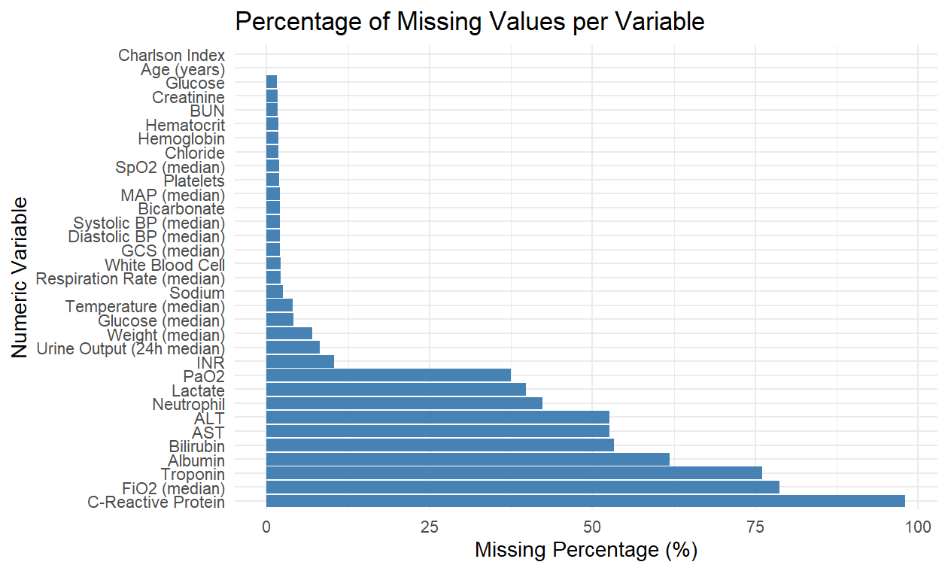
Many of the missing numerical data points are the result of implausible physiological data being eliminated to prevent unrealistic outliers. Table 5 shows the numerical variables with unrealistic ranges, where a range was subsequently set up for a physiologically plausible range in consultation with regular lab values(10-13). A total of 13390 out of 928195 rows with implausible values were eliminated using this method before summarising for a median. The resulting data frame was then merged back to the main data frame for analysis. 522662 out of 7292362 rows from the hourly vitals were also eliminated this way. Special care was taken to accommodate high to allow some leeway outside the regular laboratory values, but still physiologically plausible range, as patients in hospitals generally have outliers outside normal laboratory values. No attempts, for example, were made to limit the range of White Blood Cells, as White Blood Cells were known to far exceed normal ranges in conditions like leukaemia (14). Troponin was capped at 30, as troponin was known to elevate to the high 20s in emergency heart episodes (15). Similarly, ALT and AST were capped at 10,000, far above the normal range, because such figures are plausible in cases of severe liver problems(16). Creatinine was capped at 20mg/dl similarly(17).

Table 5: Range of Physiological Values allowed
Variable | Minimum Allowed | Maximum Allowed
Sodium (mEq/L) | 110 | 160
Glucose (mg/dL) | 40 | 600
Alanine transaminase IU/L | 1 | 10000
Aspartate Transaminase U/L | 1 | 10000
INR | 0.1 | 10
Chloride mEQ/L | 80 | 120
Creatinine SCr mg/dL | 0.2 | 20
Neutrophil % | 0.1 | 100
Bilirubin mg/dL | 0.1 | 100
Troponin ng/mL | 0.01 | 30
SpO2 % | 50 | 100
FIO2 % | 21 | 100
Temperature(Degrees) | 32 | 42
Respiratory Rate(beats/min) | 5 | 60
Heart Rate(beats/min) | 30 | 220
Systolic Blood Pressure(mm HG) | 40 | 250
Diastolic Blood Pressure(mm HG) | 20 | 140
Mean Arterial Pressure(mm HG) | 40 | 120

Missing values were less of a concern in the categorical and binary data, as categorical data could be coded as missing, while the binary data, such as blood cultures, automatically assumed that a patient did not have an infection if their Stay ID was not in the blood culture file. While a more in-depth examination of figures such as infection type in blood cultures, antibiotic type used, dosages, vasopressor type used, dosage, and ventilation data, such as airway pressure, is available, it was decided that due to only a portion of patients having such information or are exposed to such treatments, heavy bias would be introduced if they were included. To deal with the missing data, variables with more than 20% missing data, such as C-Reactive Protein, FiO2, Troponin, Albumin, Bilirubin, AST, ALT, Neutrophils, Lactate, and Partial Pressure O2, were removed from the statistical model in alignment with a similar study(18).

Next, only one of the variables that showed a strong association with one another, at least 0.3 association were used. The chosen variable was the one with fewer missing values or had a more significant p-value. Haematocrit, Systolic Blood Pressure, Blood Nitrogen Urea, Endotracheal Status, Bicarbonate, Diastolic Blood Pressure, Glucose(from labs hourly) and Sodium were thus removed in favour of haemoglobin, Mean Arterial Blood Pressure, Ventilation Status, glucose(from Vitals hourly), creatinine, and chloride. With far less missing information, ICU IDs with remaining missing variables were then discarded, as shown in Figure 2. ICU Unit,Haemoglobin, antibiotics status,INR, white blood cell count,platelets, chloride, glucose, Spo2, Temperature, Respiratory Rate, Mean Arterial Pressure, Charlson Score, Urine Output, Average Weight, Ventilation Status, Vasopressor usage, admission type, Insurance Status, Marital Status and Diagnosis were then used to construct a logistic regression model with hospital mortality as the outcome given AIC did not seriously increase despite removing certain variables with p-values higher than 0.05 like positive culture status and gender in a stepwise approach.

Figure 2 Data Extraction and Cleaning
Under 18(n=8200)
Duplicate ICU Id (n=1)
More than 1 Hadm Id(n=6788)
ICU ids where first care unit is not the last (n=3263)
Have transfer record(n=293)

Patients with ICU outcomes(n=61533)

No underage patients(n=42988)

Illogical death or survival records, ambiguity regarding whether patient died in hospital or not(n=40)

No illogical survivals (n=42948)
Patients with unknown White Blood Cell,Creatinine, Haemoglobin,INR,platelets,chloride,glucose,Spo2,Temperature,Respiratory Rate,Mean Arterial Pressure,GCS Score,Charlson Score, Urine Output,and Weight(n=10,031)

Clean Data (n=32917)

The final variables(Icu Unit, Age,White Blood Cells,

Results
The model showed a strong area under the curve of 0.8891. As shown in Figure 3, it was reasonably strong.

Figure 3 ROC Curve
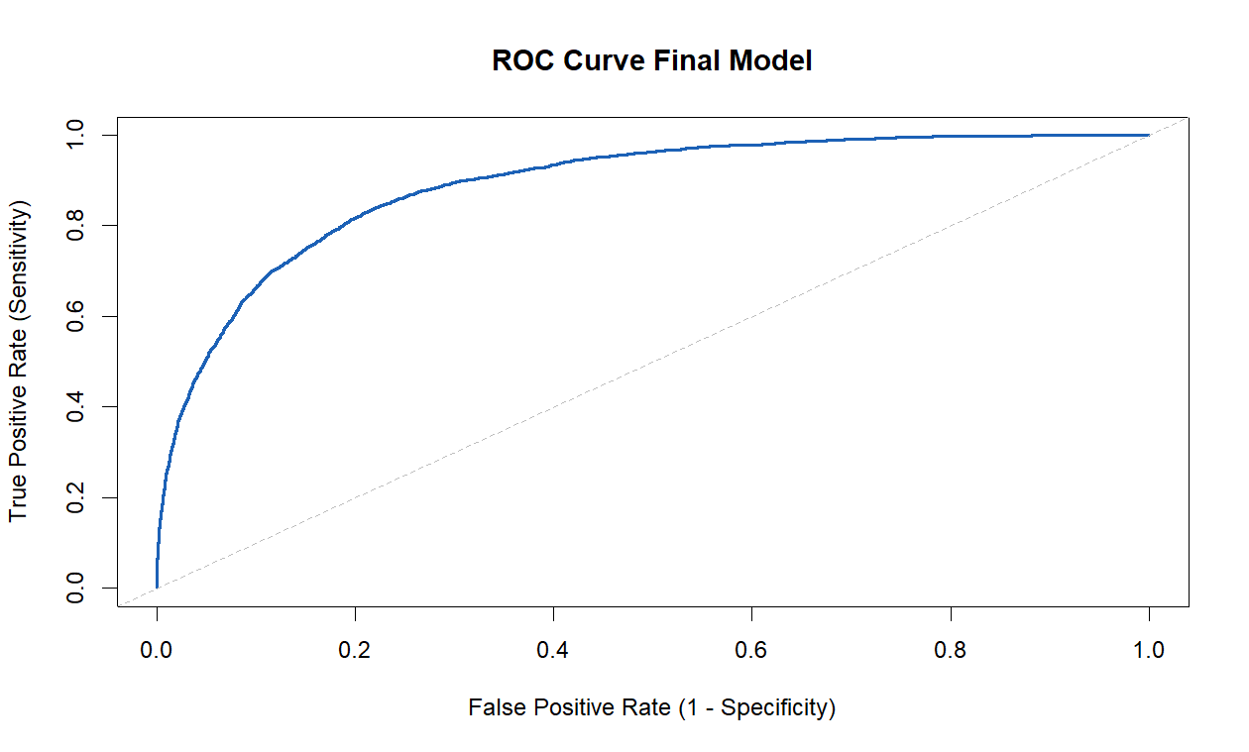
Table 6 ICU Unit Odds Ratio and p-value with CCU as reference
ICU Unit | Odds Ratio | CI Lower | CI Upper
CSRU | 0.258 | 0.205 | 0.323
MICU | 1.254 | 1.077 | 1.463
SICU | 0.910 | 0.758 | 1.092
TSICU | 0.920 | 0.748 | 1.132

Of the ICU Units, CSRU and MICU both showed extremely strong p-values, < 2e-16
and 0.01764, respectively. As shown in Table 6,Odds ratio for CSRU was roughly 0.258, and for MICU was 1.254. This showed that CSRU patients are much less likely to die compared to the reference CCU, while MICU patients have a 0.254 higher odds of dying. As the SICU and TSICU confidence intervals encompassed 1, they likely have similar odds of mortality to the CCU. The results suggest that ICU unit does have an impact on patient hospital mortality.

Discussion and Conclusion
Nevertheless, the results should be interpreted with a degree of scepticism as there are many limitations to this study. Almost half the data from the beginning of 61532 was eliminated due to data quality issues, patient eligibility and inconsistencies. Similarly, much of the patient laboratory, hourly and binary data had to be imputated as well. The model does not account for potential biases in data quality issues, favouring certain types of patients. The study also deliberately removed future variables such as length of stay, which are noted to be linked to mortality in previous studies, as they are post-exposure variables that may be impacted by different ICU exposures.
The results are contrary to the study by Rosenthal et al., one of the few studies examining ICU unit and mortality, who themselves noted the scarcity of research in this area. Their study reported no differences in patient mortality between ICU units(4). Differences could range from the group using a different dataset, with Rosenthal et al using a dataset from 10 different Middle Eastern countries, where many aspects of the health data were specifically noted to be different to that of the US, from which the MIMIC III dataset was derived (4). Similarly, Rosenthal et al apparently also used length of stay as a research variable, which could potentially confound mortality(4).

Problematically, some important variables, such as smoking status(which ironically is linked to lower in-hospital mortality) were not present in the dataset(19). Individual comorbidities were also not analysed, many of which might have just as important an effect on patient mortality as the admission diagnosis. Furthermore, as Ikumi et al’s study suggested, mortality is linked to staffing and funding issues in individual ICU units (2). It is therefore not known whether ICU type itself is linked to mortality rates or whether the funding structure is what’s linked to it. Finally, MIMIC III only used patients from a single source, the Beth Israel Deaconess Medical Center in Boston, Massachusetts. Therefore, it is impossible to say that ICU type is linked with in-hospital mortality as opposed to there being indications that ICU type is linked to mortality within said hospital itself only.

Machine Learning: Long-Stay Prediction
For long-term stays, 7 or more days of treatment in an ICU unit is an important indicator of mortality, and such patients require more intensive resources for their treatment. The ability to predict whether a patient would stay long-term would be extremely useful in the medical setting, as special resources could be devoted to the treatment of such patients early on(8).
Part 2 of the research aims to examine whether a machine learning algorithm could be reliably developed using MIMIC III ICU patient data to predict long-term patient stays using early patient data(first 24 hours).

Method and analysis

A total of fourteen MIMIC-III tables were used in this study: admissions, antibiotics, bloodculture, gcs_hourly, icd9_diag, icustays, labs_hourly, output_hourly, patients, pt_icu_outcome, pt_weight, pv_mechvent, vasopressors, and vitals_hourly. Data extraction and cleaning were performed in RStudio, and model development was performed in Python.
Only adult patients (≥18 years) were included. Because individual patients may experience multiple ICU admissions during the same hospitalization, only the first ICU stay of each hospital admission was retained to avoid within-patient correlation. Patients who died within the first seven days were excluded to ensure that the long-stay outcome reflected prolonged clinical need rather than early mortality.
Outcome Definition
ICU length-of-stay (LOS) was calculated as the difference between ICU intime and outtime. The binary long-stay outcome was defined as LOS ≥ 168 hours (7 days).
Time Window for Feature Extraction
Except for blood culture data—which used values from −24 to +24 hours relative to ICU admission—only measurements recorded during the first 24 hours of the ICU stay were used. This was chosen under the assumption that early physiological disturbances and treatments are unlikely to change significantly within this window.
Data Cleaning and Preprocessing
Hourly laboratory and vital sign measurements were cleaned using physiologically plausible caps based on Table 5 from Part 1, to remove extreme values likely caused by documentation errors. For each patient, median values over the first 24 hours were computed.
Exploratory analysis as shown in Figure 3 and Figure 4 showed that aggregating laboratory and vital variables substantial missing values in many variables, and that modelling data over shorter windows(e.g. every 6 hours may result in many more missing values. Therefore, full-day medians were used in the final dataset.
Figure 4: Missingness per Lab Variable

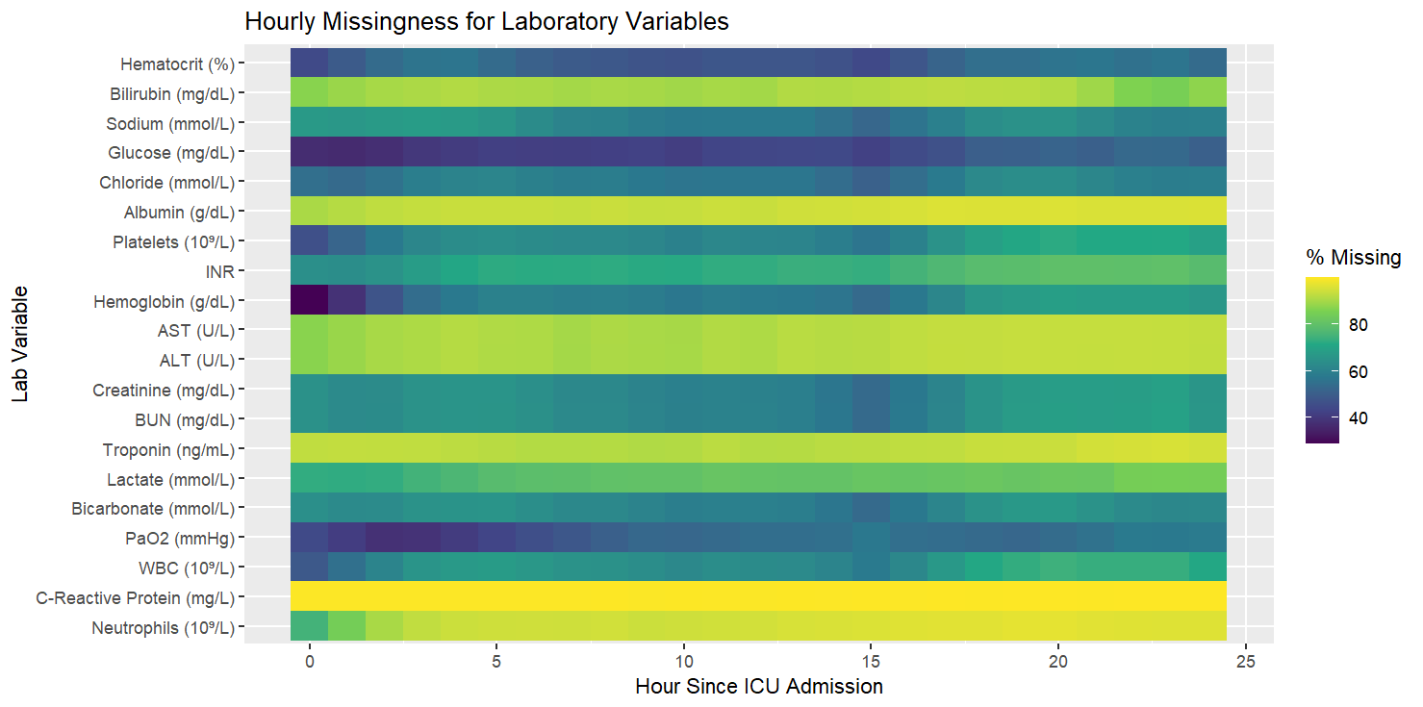
Figure 5: Missingness per Vital Variable

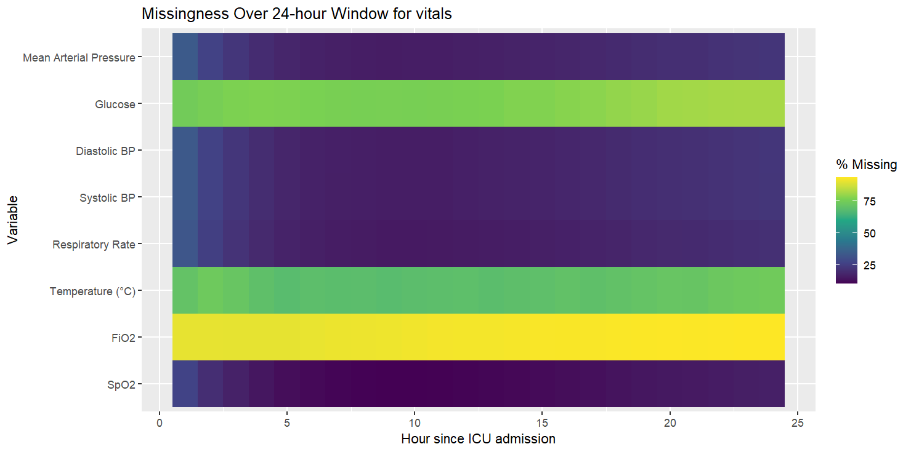
GCS scores and urine output were similarly summarized using 24-hour medians. Endotracheal intubation was encoded as a binary indicator reflecting whether any instance of intubation occurred in the first 24 hours.
Charlson Comorbidity Index scores were derived from icd9_diag. Mechanical ventilation and vasopressor use were captured using binary indicators. For ventilator parameters (e.g., airway pressure) and vasopressor infusion rates, median values over the first 24 hours were used.As shown in Table 7, Implausible values were removed using clinically supported ranges with some leeway due to sick patients generally having outlier values(13, 20-23).

Table 7 Clinical Supported Ranges vs range used with some leeway
Drug | Minimum Clinical Range | Maximum Clinical Range | Minimum Range for Cleaning | Maximum Range for Cleaning
Norepinephrine | 0.05 µg/kg/min | 0.5 µg/kg/min | 0.01 µg/kg/min | 0.8 µg/kg/min
Epinephrine | 0.05 µg/kg/min | 0.5 µg/kg/min | 0.01 µg/kg/min | 0.8 µg/kg/min
Dobutamine | 5 µg/kg/min | 20 µg/kg/min | 1 µg/kg/min | 30 µg/kg/min
Dopamine | 5 µg/kg/min | 20 µg/kg/min | 1 µg/kg/min | 30 µg/kg/min

For vasopressors, the highest dose administered within 24 hours was selected because vasopressor titration typically escalates to the dose that stabilises the patient in shock(24-26). Full-period dose aggregation was considered but abandoned due to inconsistencies in documentation (e.g., mis-entered doses outside plausible ranges).
Patient weight was medianized across the first 24 hours before merging, with highly implausible ranges being eliminated first. Blood culture and antibiotic results were kept as binary indicators, as there are hundreds of different microorganism species and more than 27 antibiotic types, making detailed modelling infeasible. Demographic and admission-related information was additionally cleaned before merging without exclusions.

Figure 6 Data Extraction and Cleaning for Part 2
Patients with ICU Outcomes (n = 61533)

Duplicate ICU ID (n=1)
Individuals aged under 18(n=8200)
Patients without an ICU out-time (n=3)
Patients whose length of stay is under 24 hours(n=8076)

More cleaned data(n=45253)

Individuals who died within 7 or less days(n= 3364)
Second or more ICU entries(n=2465)

Final Dataset (n=39424)

Wilcox tests and Chi-squared tests were done as shown in Figure 7 and 8.

Table 7 Wilcox test Results of Numerical Variables
Variable | Median Difference | p-value
GCS scores(median) | -5.0000 | <1e-16
Median Urine Output per hour | -35.0000 | <1e-16
Mean Airway pressure | 1.0000 | <1e-16
Blood Nitrogen Urea | 4.5000 | <1e-16
Set Peep | 0.0000 | <1e-16
Plateau Pressure | 3.0000 | <1e-16
Total urine in 24 hours | -320.0000 | <1e-16
Albumin | -0.4000 | <1e-16
White Blood Cell | 1.3000 | <1e-16
Glucose(vitals file) | 9.0000 | <1e-16
Bicarbonate | -1.0000 | <1e-16
Peak Inspiration Pressure | 2.5500 | <1e-16
Temperature | 0.1667 | <1e-16
Spo2 | 0.8000 | <1e-16
Glucose(laboratory results) | 8.0000 | <1e-16
Minute Volume | 0.9500 | <1e-16
Lactate | 0.2000 | <1e-16
Creatinine | 0.1000 | <1e-16
Respiratory Rate | 1.0000 | <1e-16
Charlson Score | 1.0000 | <1e-16
Partial Pressure O2 | -14.5000 | <1e-16
INR | 0.0000 | <1e-16
Set Tidal Volume | -50.0000 | <1e-16
AST | 13.5000 | <1e-16
Systolic Blood Pressure | -3.0833 | <1e-16
Inspiratory Time | 0.0000 | <1e-16
Total Peep | 1.0000 | <1e-16
Epinephrine max rate | 0.0100 | <1e-16
Norepinephrine max rate | 0.0999 | <1e-16
Average Weight | 2.6625 | <1e-16
Vasopressor Count | 0.0000 | <1e-16
Observed Tidal Volume | -23.0000 | <1e-16
Bilirubin | 0.1000 | 2.295e-14
Sodium | 0.0000 | 5.278e-13
ALT | 5.0000 | 8.458e-12
Fio2 | 0.0000 | 9.61e-11
Diastolic Blood Pressure | -1.0000 | 1.759e-10
Platelets | -7.0000 | 3.701e-09
Dobutamine max | 0.0000 | 2.52e-06
Haemoglobin | -0.1500 | 7.184e-06
Dopamine Max | 2.0000 | 7.483e-05
Mean Arterial Pressure | -1.0000 | 0.0001123
Neutrophil | 1.3000 | 0.0001825
Haematocrit | -0.3000 | 0.001172
Ventilation Number | 0.0000 | 0.005383
C Reactive Protein | 23.7000 | 0.01075
Troponin | 0.0150 | 0.02165
Negative Inspiratory Force | 5.0000 | 0.02457
Spontaneous Tidal Volume | -17.0000 | 0.03101
Age in years | 1.0000 | 0.1359
Time when High APRV | 0.0000 | 0.2031
Chloride | 0.0000 | 0.3751
Pressure when APRV is high | 5.0000 | 0.8251
Pressure when APRV is low | -10.0000 | 0.8298
Time when APRV is low | 0.0000 | 0.8432

Table 8 Binary or Categorical Values
Variable | P-value
ICU Unit | < 2.2e-16
Admission Type | < 2.2e-16
Language | < 2.2e-16
Admission location | < 2.2e-16
Diagnosis | < 2.2e-16
Gender | 0.4462
Endotracheal status | < 2.2e-16
Ventilation Status | < 2.2e-16
Vasopressor usage or not | < 2.2e-16
Norepinephrine used or not | 1.245e-12
Epinephrine used or not | 1.658e-07
Dopamine used or not | 0.001771
Dobutamine used or not | 0.0009654
Multiple vasopressors used or not | < 2.2e-16
Insurance Status | 0.008138
Religion | 0.1885
Marital Status | < 2.2e-16
Ethnicity | 2.669e-13

The tests revealed several variables with zero median differences but a significant p-value. Data visualisation was further done across all variables. In particular, EDA revealed, as shown in the Figures, that while median differences may be close to zero, many variables, especially the ones where the p-value was significant, showed completely different distributions.

Figure 6 Boxplot of FIO2 levels by ICU stay
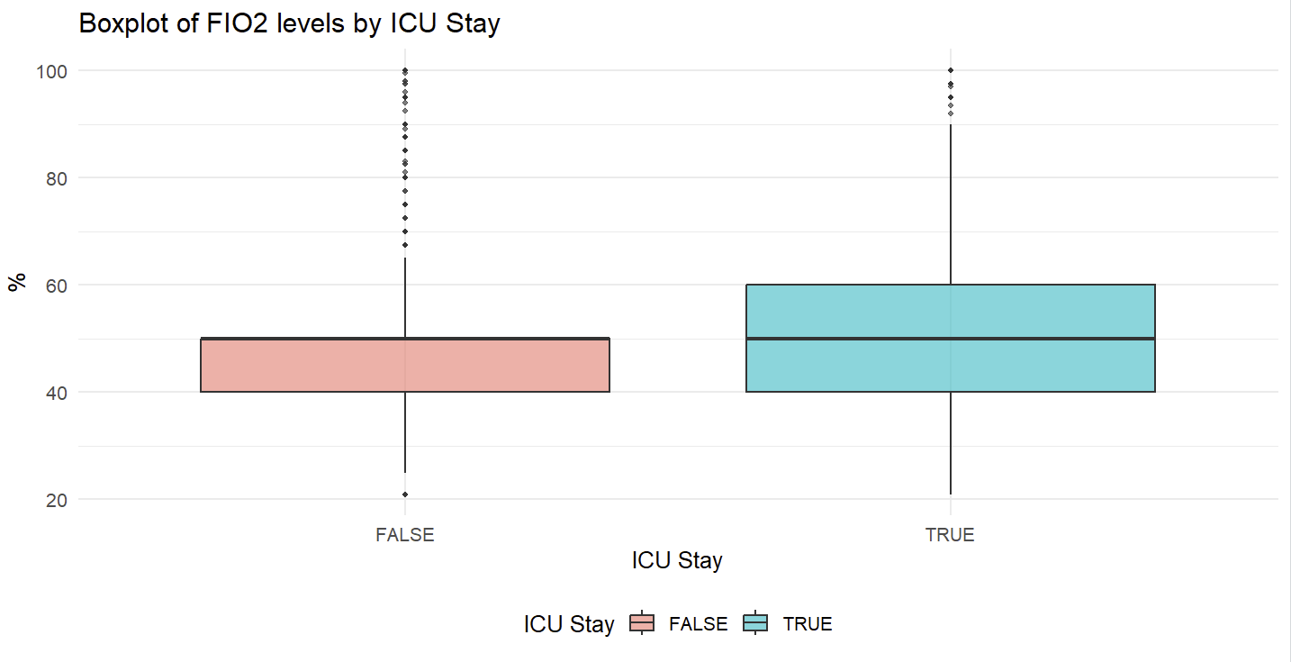
Figure 7 Boxplot of High airway pressure by ICU Stay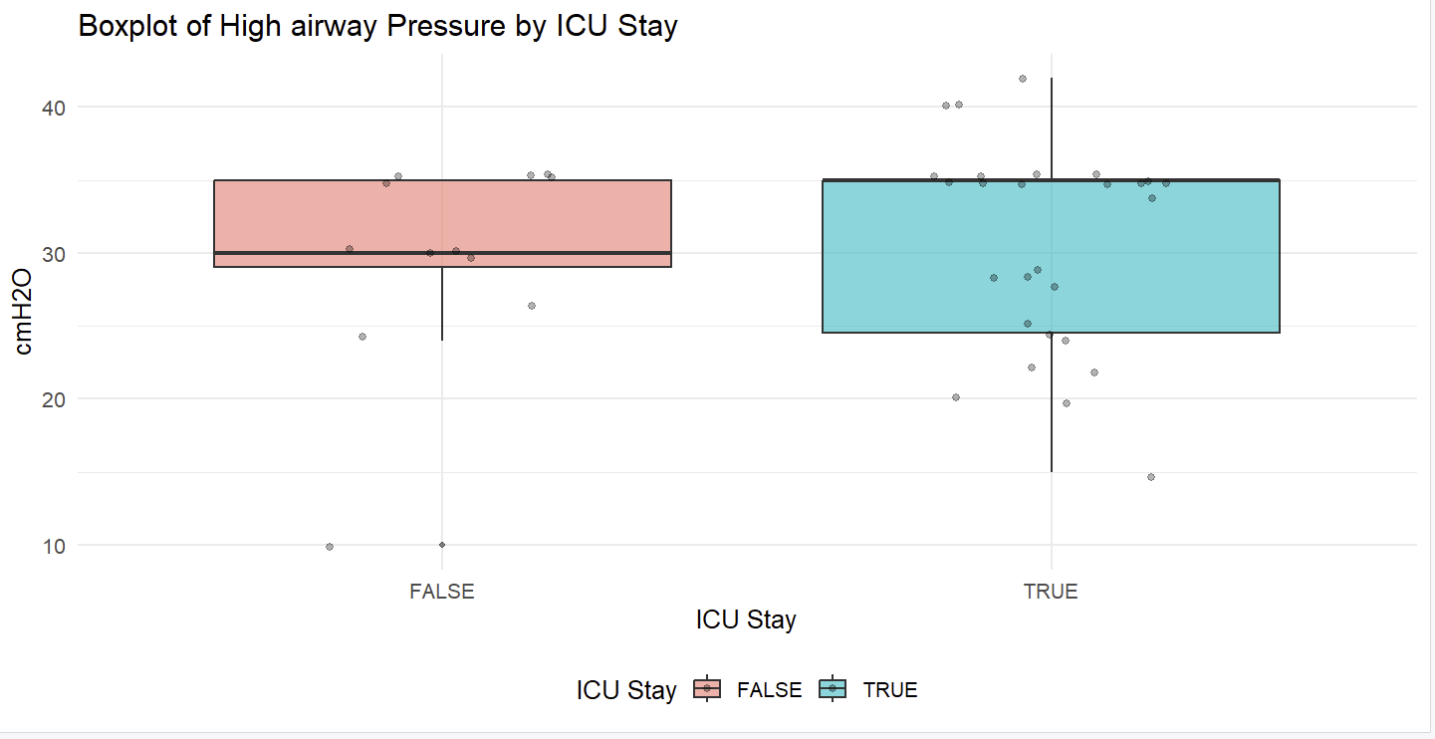

Some further visualisations revealed some more questionable variables, such as sodium, ventilation number and sodium, as shown in Figures 8-10, where distributions were not particularly significant as well.
Figure 8 Boxplot of Chloride level by ICU Stay
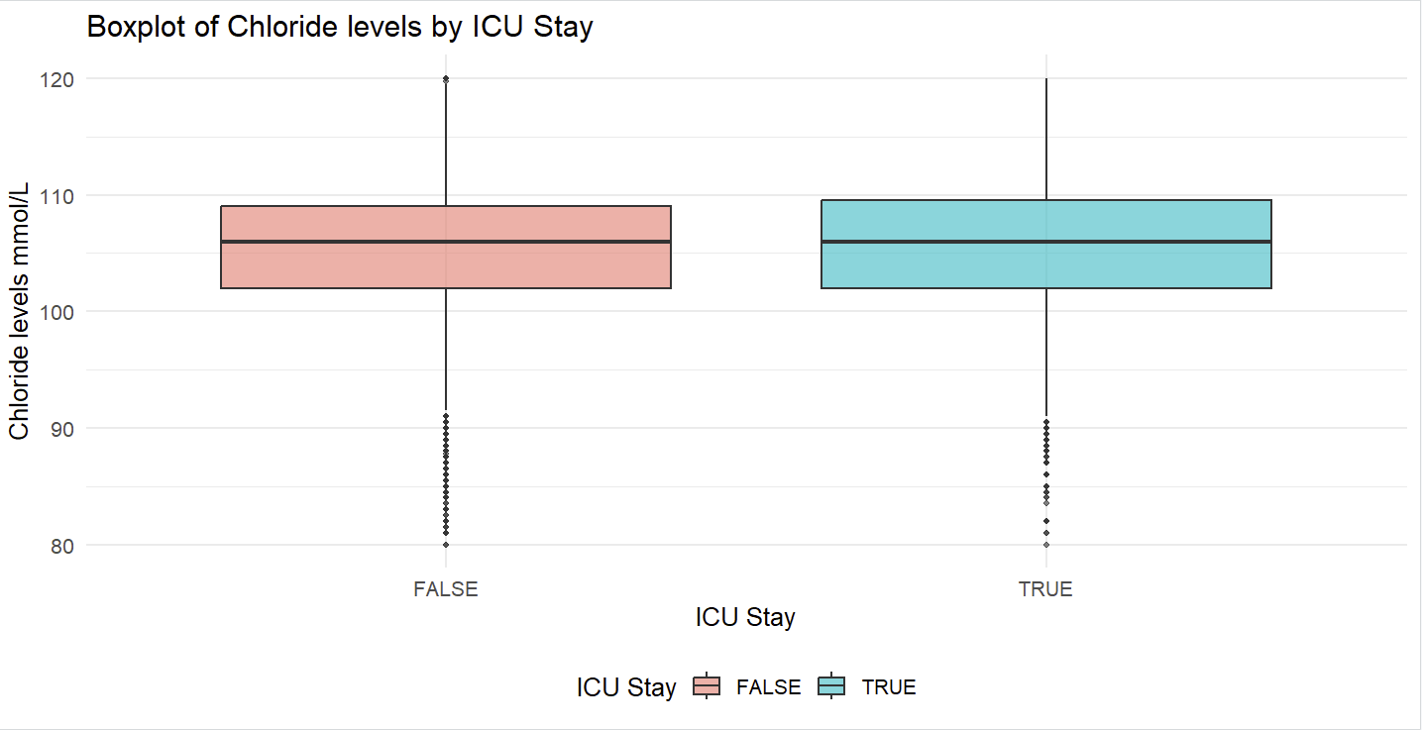

Figure 9 Boxplot of Ventillation Number by ICU Stay
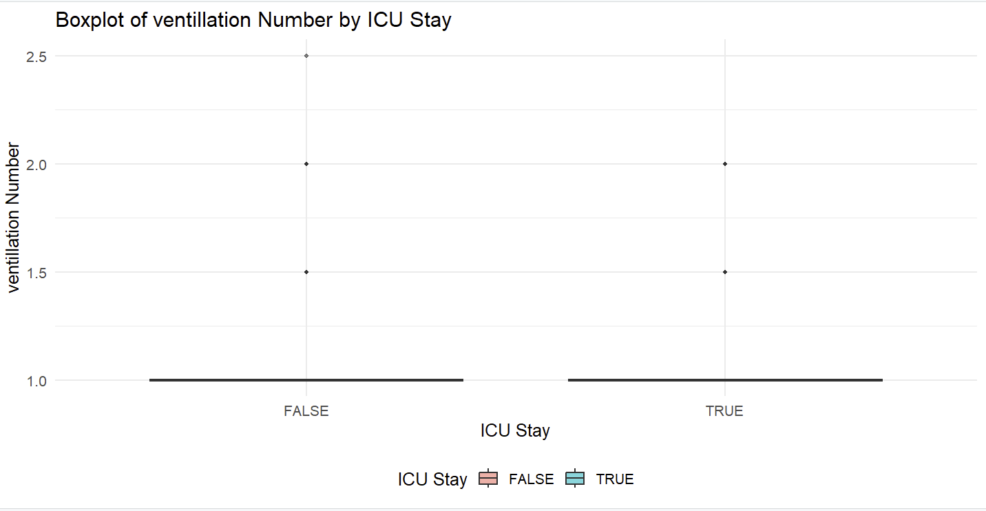

Figure 10 Boxplot of Sodium levels by ICU Stay
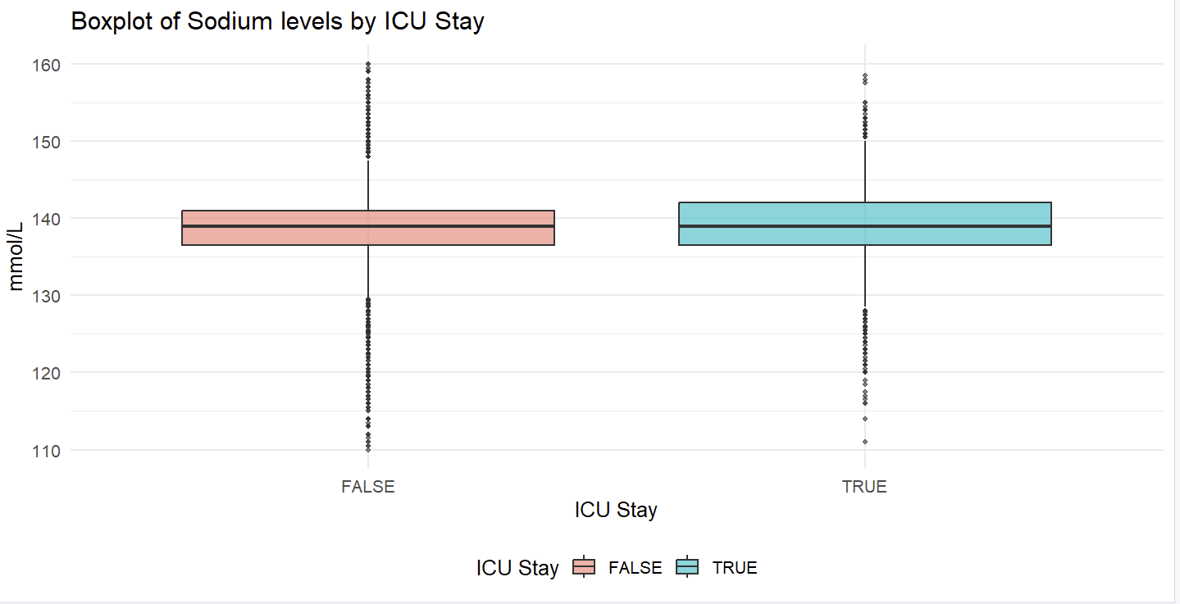
Ventilation number was completely eliminated from the model while Sodium and chloride variables are under scrutiny. The missing analysis as shown in Figure 11, also revealed large numbers of missingness amongst variables.

Figure 11: Missing variables analysis
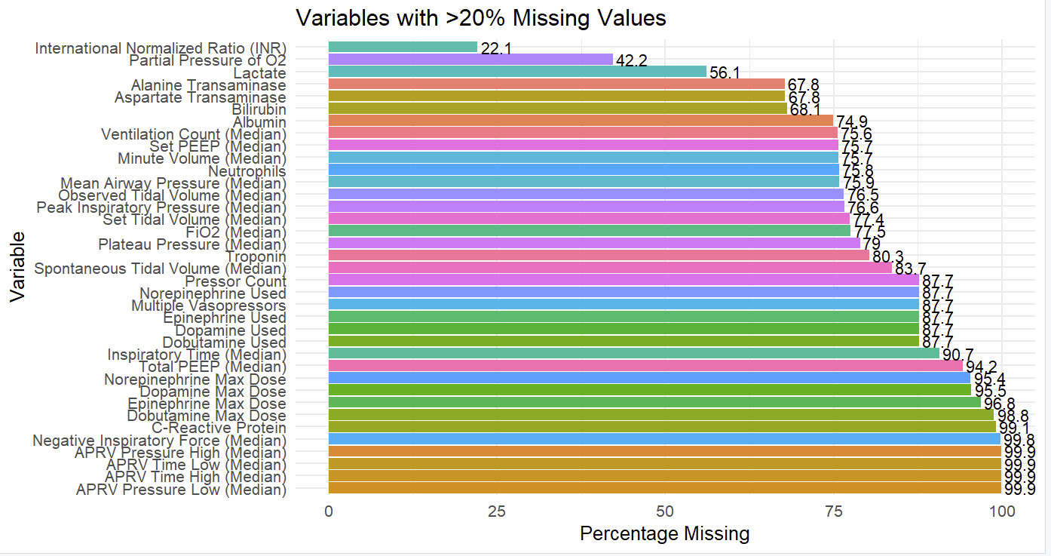
Figure 12 also revealed that there was severe class imbalance.

Figure 12 Long ICU Stay distribution
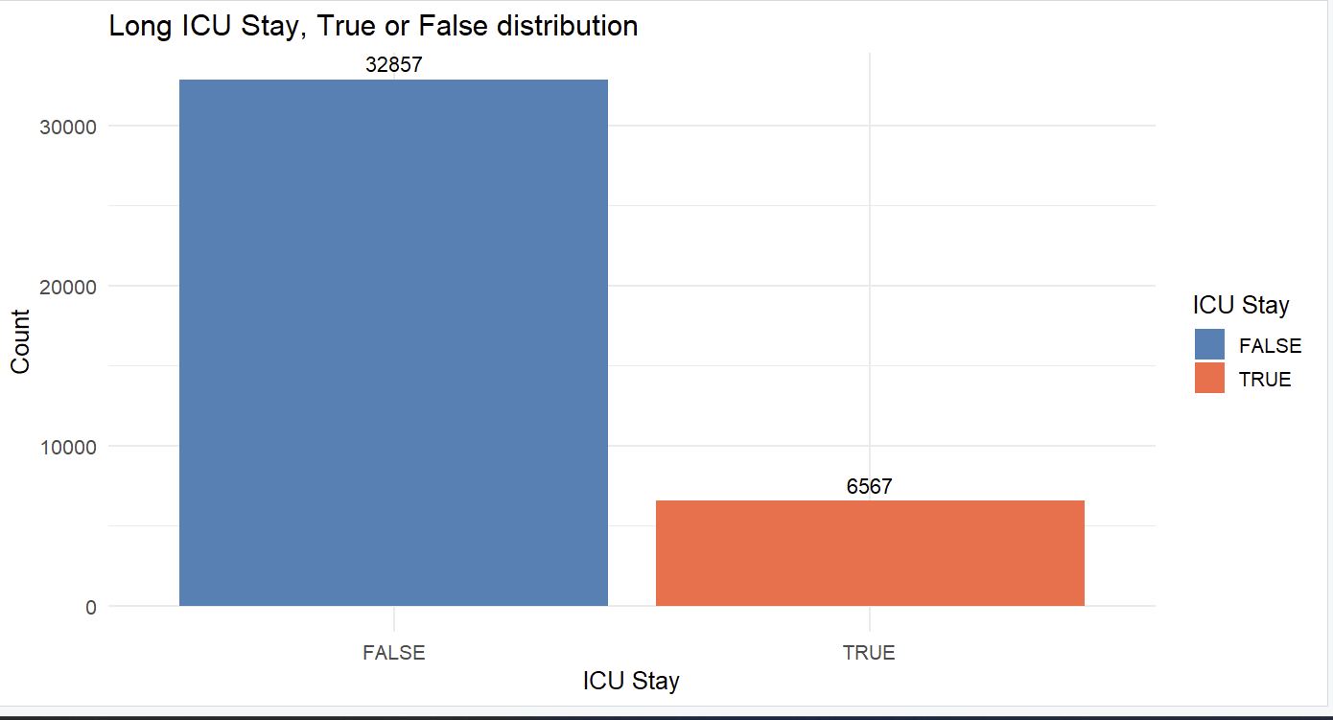

Modeling Approach
Due to substantial missingness in data —XGBoost was selected as the prediction algorithm. XGBoost accommodates missing values internally by learning optimal directions for missing data during tree splitting, enabling the inclusion of patients who otherwise would require imputation or exclusion(27). Python was used to construct the machine learning model after exporting the datasets cleaned using R.
XGBoost was also chosen because many variables exhibited similar medians but markedly different distributions (as shown in Figures 6-7). Due to its non-linear, tree-based mechanism, XGBoost can potentially detect that certain subgroups have higher values than others, even when overall medians are similar, by splitting the data into nodes that separate observations based on thresholds within the feature distribution(27). Outliers and multicollinearity were dealt with similarly(28).
The long-stay outcome was highly imbalanced, with the majority of patients experiencing ICU stays shorter than 7 days. To address class imbalance, scale_pos_weight was used to adjust the relative weight of the minority class(29).
Three models were constructed using the following approach after removing identifiers and redundant variables, such as duplicate measurements(only one glucose measure was kept).

Model 1:
- Started with the full set of remaining variables after preprocessing: demographics, ICU unit, lab results, vitals, ventilator settings, medications, admission info, comorbidities, and diagnosis.
- Purpose: establish a comprehensive baseline model including all potentially relevant predictors.
Model 2:
- Refined Model 1 by removing variables with low statistical significance (high p-values) or no meaningful differences in visualisations between outcome groups.
- Examples: sodium, chloride, FIO2, certain ventilator pressures/timings, age, gender, vasopressor counts, and religion.
- Purpose: reduce noise.
Model 3:
- Further refined Model 2 by removing variables with high missingness (>40%), including most remaining airway measurements, detailed vasopressor information, and several lab measurements (CRP, lactate, neutrophils, troponin, AST/ALT, albumin, bilirubin).
- Purpose: More potential noise reduction.

The following hyperparameters were fine tuned: n_estimator,max_depth,learning_rate,subsample,colsample_by_tree, gamma.
Colsample_by_tree determines what percentage of columns would be used to construct ;eacch tree;gamma determines minimum reduction loss required to make a new leaf node;subsample determines amount of training data randomly sampled to make a new tree;learning_rate determines the rate subsequent trees learns from the errors of previous trees, max_depth determines the depth of each tree; n_estimator determines the number of trees to be built(29, 30).

Results

As Figures 13-18 showed, all three models showed relatively similar results, although Model 1, with the least variable removals, did slightly better than the other two models.

Figure 13 Model 1 Performances
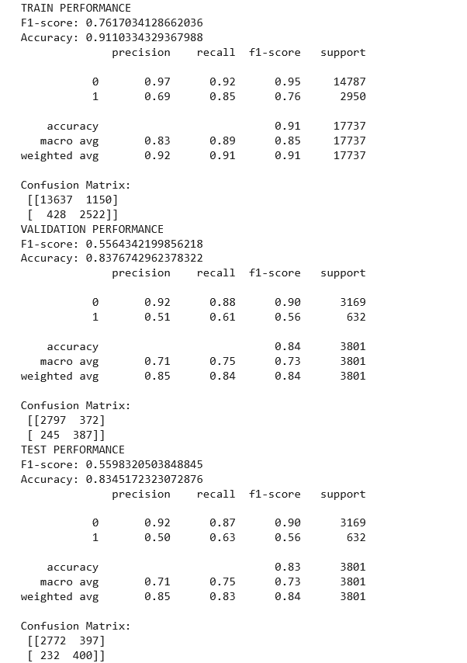

Figure 14 Model 1 AUC and ROC Curve 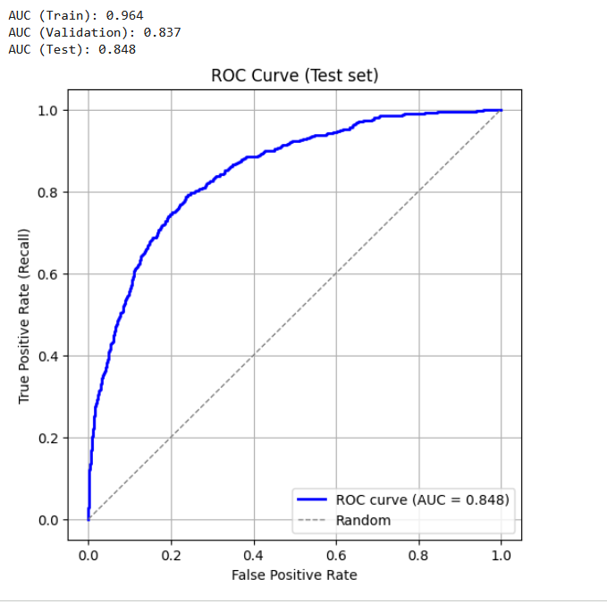
Figure 15 Model 2 Performance

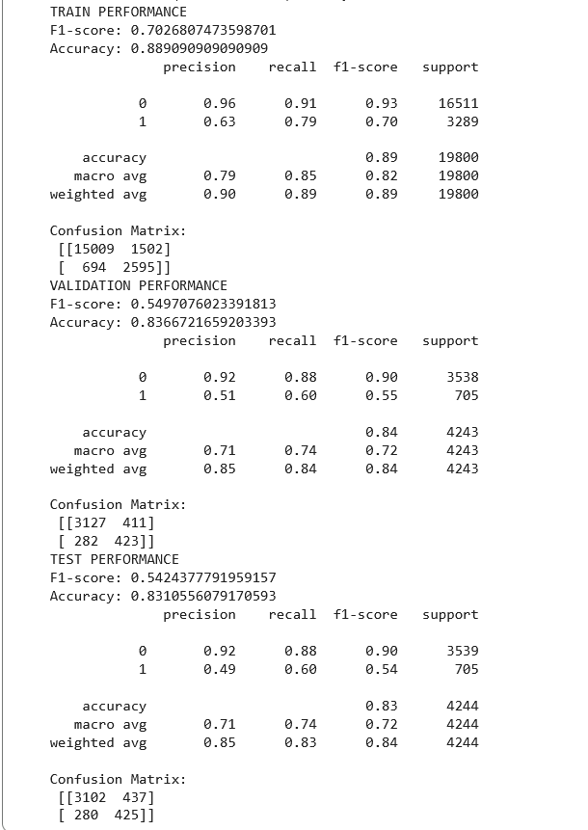

Figure 16 Model 2 AUC and ROC Curve

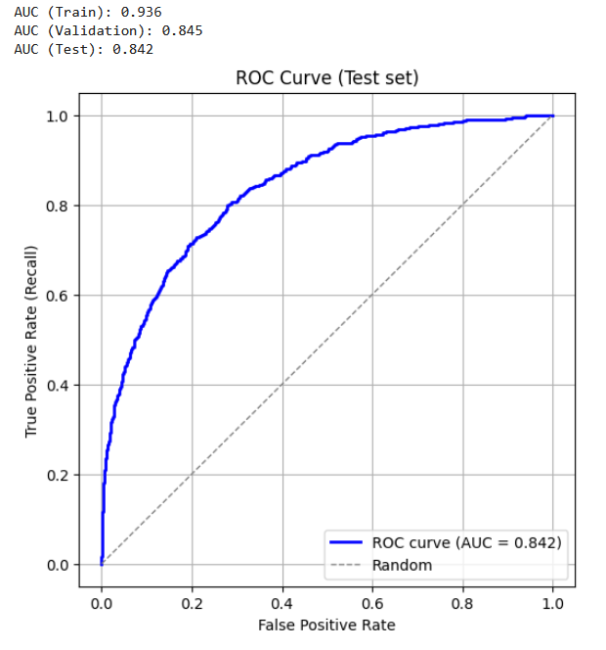

Figure 17 Model 3 Performance
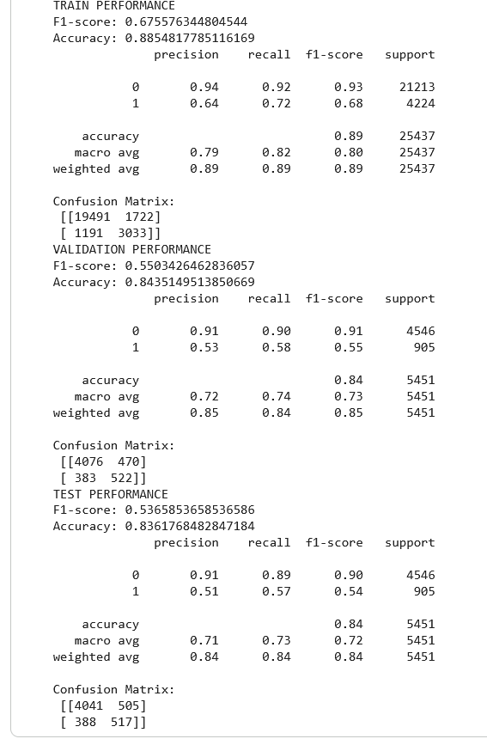

Figure 18 Model 3 AUC and ROC Curve
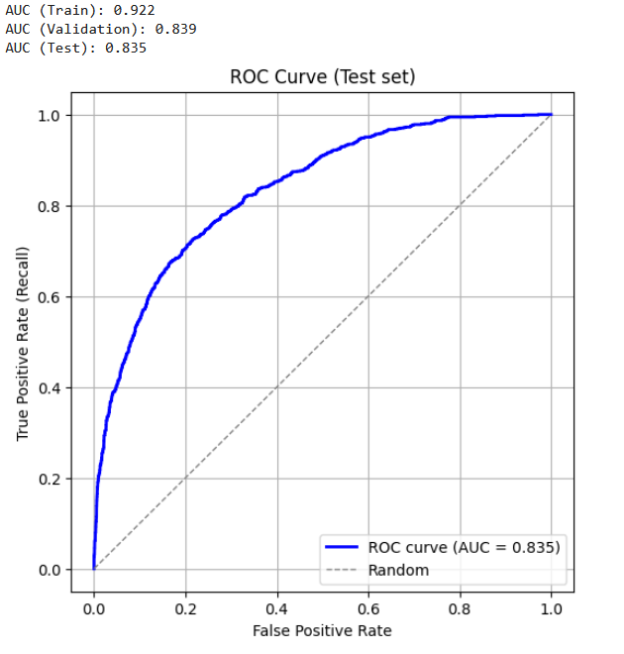
Table 9 AUPRC test

Model | AUPRC
Model 1 Train | 0.872
Model 1 Validation | 0.567
Model 1 Test | 0.584
Model 2 Train | 0.797
Model 2 Validation | 0.574
Model 2 Test | 0.587
Model 3 Train | 0.745
Model 3 Validation | 0.566
Model 3 Test | 0.562

All three models boosted high AUCs and accuracy, but did relatively poorly in terms of finding long stays, only around 0.54-0.56 for F1 score.As Model 1 boosted slightly higher results, in both AUC and in Recall for long stays, it was the model chosen. Recall is critically important as it determines that those who have long stays are actually properly classified and thus given proper due care. Precision is slightly less important in the medical context by comparison, as it would not lead to harm to patients directly, although it would add unnecessary costs to the medical system.Nevertheless, the model built showed that long stays could be identified, although with many missed.

Discussion
With a test AUC of 0.848 and an AUPRC of 0.584, the model performed similarly to Wu’s model predicting prolonged length of stay, whose AUCROC and AUPRC were 0.747 and 0.536, respectively(31). Differences may be due to differences in data cleaning as Wu’s model involved the elimination of all patients who had 30% or more variables missing, as well as different categorisation as long length of stay, with Wu’s study defining long length of stay in IOCU as more than 3 days as opposed to 7 or more days(31). On the other hand, the model performed extremely poorly compared to Lars’, despite a similar approach(32), which diagnosed over 90% of long stays correctly. Possible reasons for this are likely due to much larger numbers of long stays in the MIMIC IV dataset and definition of long stays as more than four days, with 9,624 long stays vs 31,849 short stays (32). Lar’s study in fact found that estimations grow exponentially worse as length of stay days increases, with mean errors increasing from 1.5 for a LOS of 5 to 6.5 with a LOS of 10 (32).

A severe weakness in the model that could potentially be improved in a subsequent iteration would be a more robust study of comorbidities in a patient, instead of summing comorbidities through a Charlson score. This loses granularity. Furthermore, the model could potentially be improved with greater demographic information, such as the patient’s smoking status, which are not currently present. The model could also potentially use the lowest values of a patient in various vital and laboratory scores as it could be a better indication of the severity of the patient than the median, would could have been modified by care within 24 hours of intensive care.

Conclusion
The model showed that prolonged ICU stay could be predicted through early ICU(first 24 hour) data, though not particularly accurately and that more could be done to refine the model.

1. Melaku EE, Urgie BM, Dessie F, Seid A, Abebe Z, Tefera AS. Determinants of Mortality of Patients Admitted to the Intensive Care Unit at Debre Berhan Comprehensive Specialized Hospital: A Retrospective Cohort Study. Patient Relat Outcome Meas [Internet]. 2024 1/11/2025 PMC10895994]; 15:[61-70 pp.]. Available from: https://pmc.ncbi.nlm.nih.gov/articles/PMC10895994/.
2. Ikumi S, Shiga T, Ueda T, Takaya E, Iwasaki Y, Kaiho Y, et al. Intensive care unit mortality and cost-effectiveness associated with intensivist staffing: a Japanese nationwide observational study. Journal of Intensive Care [Internet]. 2023 6/11/2025; 11(1):[60 p.]. Available from: https://doi.org/10.1186/s40560-023-00708-w.
3. Soares Pinheiro FGdM, Santana Santos E, Barreto ÍDdC, Weiss C, Vaez AC, Oliveira JC, et al. Mortality Predictors and Associated Factors in Patients in the Intensive Care Unit: A Cross-Sectional Study. Critical Care Research and Practice [Internet]. 2020; 2020(1):[1483827 p.]. Available from: https://onlinelibrary.wiley.com/doi/abs/10.1155/2020/1483827.
4. Rosenthal VD, Jin Z, Memish ZA, Mohammad Abdellatif D, Majeda Afeef Al R, Hussien NH, et al. Risk factors for mortality in ICU patients in 10 middle eastern countries: The role of healthcare-associated infections. Journal of Critical Care [Internet]. 2022 20/11/2025]; 72. Available from: https://www.sciencedirect.com/science/article/abs/pii/S0883944122001782?via%3Dihub.
5. Bekele TG, Melaku B, Demisse LB, Abza LF, Assen AS. Outcomes and factors associated with prolonged stays among patients admitted to adult intensive care unit in a resource-limited setting: a multicenter chart review. Scientific Reports [Internet]. 2024 2024/06/17; 14(1):[13960 p.]. Available from: https://doi.org/10.1038/s41598-024-64911-x.
6. Wozniak H, Beckmann TS, Dos Santos Rocha A, Pugin J, Heidegger C-P, Cereghetti S. Long-stay ICU patients with frailty: mortality and recovery outcomes at 6 months. Annals of Intensive Care [Internet]. 2024 2024/02/24; 14(1):[31 p.]. Available from: https://doi.org/10.1186/s13613-024-01261-x.
7. Moitra VK, Guerra C, Linde-Zwirble WT, Wunsch H. Relationship Between ICU Length of Stay and Long-Term Mortality for Elderly ICU Survivors. Crit Care Med [Internet]. 2016 20/11/2025 PMC4792682]; 44(4):[655-62 pp.]. Available from: https://pmc.ncbi.nlm.nih.gov/articles/PMC4792682/.
8. Kose I, Zincircioglu C, Yasemin Kilic O, Senoglu N, Erbay RH. Characteristics and Outcomes of Patients with Prolonged Stays in an Intensive Care Unit. European Journal of General Medicine [Internet]. 2016 Apr 2016
2023-11-23 27/11/2025]; 13(2):[127-33 pp.]. Available from: https://www.ejgm.co.uk/download/characteristics-and-outcomes-of-patients-withprolonged-stays-in-an-intensive-care-unit-7323.pdf.
9. Sperandei S. Understanding logistic regression analysis. Biochem Med (Zagreb) [Internet]. 2014 20/11/2025]; 24(1):[12-8 pp.]. Available from: https://pmc.ncbi.nlm.nih.gov/articles/PMC3936971/.
10. Pharmacy ACoC. Reference Values for Common Laboratory Tests n.d. [24/11/2025]. Available from: https://www.accp.com/docs/sap/Lab_Values_Table_PSAP.pdf.
11. Clinic C. Vital Signs [updated 03/15/202324/11/2025]. Available from: https://my.clevelandclinic.org/health/articles/10881-vital-signs.
12. Bhandari ASAMP. Vital Sign Assessment. May 1, 2023 [cited 24/11/2025]. In: StatPearls [Internet] [Internet]. Treasure Island, Florida: StatPearls Publishing, [cited 24/11/2025]. Available from: https://www.ncbi.nlm.nih.gov/books/NBK553213/.
13. Semler MW, Casey JD, Lloyd BD, Hastings PG, Hays MA, Stollings JL, et al. Oxygen-Saturation Targets for Critically Ill Adults Receiving Mechanical Ventilation. N Engl J Med [Internet]. 2022 10/11/2025]; 387(19):[1759-69 pp.]. Available from: https://pmc.ncbi.nlm.nih.gov/articles/PMC9724830/.
14. Majhail NS, Lichtin AE. Acute leukemia with a very high leukocyte count: Confronting a medical emergency. Cleveland Clinic Journal of Medicine [Internet]. 2004 12/11/2025]; 71(8):[633-7 pp.]. Available from: https://www.ccjm.org/content/ccjom/71/8/633.full.pdf.
15. Al-Maskari M, Al-Makhdami M, Al-Lawati H, Al-Hadi H, Nadar SK. Troponin Testing in the Emergency Department: Real world experience. Sultan Qaboos Univ Med J [Internet]. 2017 Nov 24/11/2025]; 17(4):[e398-e403 pp.]. Available from: https://pmc.ncbi.nlm.nih.gov/articles/PMC5766294/.
16. Minter VLMZDA. Liver Function Tests. 2023 July 30, 2023 [cited 24/11/2025]. In: StatPearls [Internet]. Treasure Island, Florida: StatPearls Publishing, [cited 24/11/2025]. Available from: https://www.ncbi.nlm.nih.gov/books/NBK482489/.
17. Micarelli D, Cristi E, Taddei AR, Rovere FRD, Mercanti C, Feriozzi S. A case of acute renal failure with multiple origins of the renal injury. CEN Case Rep [Internet]. 2020 27/11/2025]; 9(4):[437-41 pp.]. Available from: https://pmc.ncbi.nlm.nih.gov/articles/PMC7502086/.
18. Hou N, Li M, He L, Xie B, Wang L, Zhang R, et al. Predicting 30-days mortality for MIMIC-III patients with sepsis-3: a machine learning approach using XGboost. Journal of Translational Medicine [Internet]. 2020 25/11/2025; 18(1):[462 p.]. Available from: https://doi.org/10.1186/s12967-020-02620-5.
19. De Luca G, Algowhary M, Uguz B, Oliveira DC, Ganyukov V, Zimbakov Z, et al. Impact of Smoking Status on Mortality in STEMI Patients Undergoing Mechanical Reperfusion for STEMI: Insights from the ISACS–STEMI COVID-19 Registry. Journal of Clinical Medicine [Internet]. 2022 5/12/2025]; 11(22):[6722 p.]. Available from: https://www.mdpi.com/2077-0383/11/22/6722.
20. Pannu AK. Circulatory shock in adults in emergency department. Turk J Emerg Med [Internet]. 2023 22/11/2025]; 23(3):[139-48 pp.]. Available from: https://pmc.ncbi.nlm.nih.gov/articles/PMC10389095/.
21. Sahetya SK, Wu TD, Morgan B, Herrera P, Roldan R, Paz E, et al. Mean Airway Pressure As a Predictor of 90-Day Mortality in Mechanically Ventilated Patients. Crit Care Med [Internet]. 2020 May 02/12/2025]; 48(5):[688-95 pp.]. Available from: https://pmc.ncbi.nlm.nih.gov/articles/PMC8273919/.
22. Nickson C. High airway and alveolar pressures: Life in the Fastlane; 2015 [2/12/2025]. Available from: https://litfl.com/high-airway-and-alveolar-pressures/.
23. Pennsylvania Uo. Ventilator Overview and Troubleshooting Pennsylvania: University of Pennsylvania Unknown [2/12/2025]. Available from: https://www.med.upenn.edu/uphscovid19education/assets/user-content/documents/vent-pocket-card-4.6.2020-qr.pdf.
24. Bloom JE, Chan W, Kaye DM, Stub D. State of Shock: Contemporary Vasopressor and Inotrope Use in Cardiogenic Shock. Journal of the American Heart Association [Internet]. 2023 19/11/2025]; 12(15):[e029787 p.]. Available from: https://www.ahajournals.org/doi/abs/10.1161/JAHA.123.029787.
25. St-Arnaud C, Éthier J-F, Hamielec C, Bersten A, Guyatt G, Meade M, et al. Prescribed targets for titration of vasopressors in septic shock: a retrospective cohort study. CMAJ Open [Internet]. 2013 23/11/2025]; 1(4):[E127-E33 pp.]. Available from: https://www.cmajopen.ca/content/cmajo/1/4/E127.full.pdf.
26. Care S. Inotropes and vasopressors Victoria: Victorian Government; [updated December 2018. Available from: https://www.safercare.vic.gov.au/best-practice-improvement/clinical-guidance/critical/inotropes-and-vasopressors.
27. Chen T, Guestrin C. XGBoost: A Scalable Tree Boosting System2016 19/11/2025]:[785-94 pp.]. Available from: https://arxiv.org/abs/1603.02754.
28. Montomoli J, Romeo L, Moccia S, Bernardini M, Migliorelli L, Berardini D, et al. Machine learning using the extreme gradient boosting (XGBoost) algorithm predicts 5-day delta of SOFA score at ICU admission in COVID-19 patients. J Intensive Med [Internet]. 2021 Oct 02/12/2025]; 1(2):[110-6 pp.]. Available from: 10.1016/j.jointm.2021.09.002.
29. Xgboost. Xgboost Parameter Tuning: XGboost; 2025 [26/11/2025]. Available from: https://xgboost.readthedocs.io/en/stable/tutorials/param_tuning.html.
30. Documentation X. Notes on Parameter Tuning 2025 [26/11/2025]. Available from: https://xgboost.readthedocs.io/en/stable/tutorials/param_tuning.html.
31. Wu J, Lin Y, Li P, Hu Y, Zhang L, Kong G. Predicting Prolonged Length of ICU Stay through Machine Learning. Diagnostics (Basel) [Internet]. 2021 Nov 30 05/12/2025]; 11(12). Available from: https://pmc.ncbi.nlm.nih.gov/articles/PMC8700580/.
32. Hempel L, Sadeghi S, Kirsten T. Prediction of Intensive Care Unit Length of Stay in the MIMIC-IV Dataset. Applied Sciences [Internet]. 2023 5/12/2025]; 13(12):[6930 p.]. Available from: https://www.mdpi.com/2076-3417/13/12/6930.
AI Declaration:
Deepseek , google gemini and chatgtp has been used for the purpose of coding and correcting grammar issues.

