בס"ד

**Exrecize 1**

|  |  |  |  |
| --- | --- | --- | --- |
| **פרטי המגישים** | | | |
| שם | ת.ז | שם משתמש | קבוצה |
| אבשלום תם | 203829478 | tamavsh |  |
| אור פז |  |  |  |
|  |  |  |  |

**Q1**

**//we assumed the name of the column should stay "name".**

SELECT name

FROM category

ORDER BY name;



**Q2**

**// we assumed the name of the column should stay "last_name"**

SELECT DISTINCT last_name

FROM actor

WHERE first_name='Susan';



**Q3**

**// we assumed the length should be greater(>) not equals greater(>=).**

SELECT title as 'Title', length as 'Length';

FROM film WHERE length > 183

ORDER BY length DESC,title ASC;

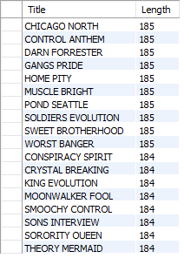

**Q4**

**// any assumptions you made regarding q1 should be written here...**

**Q5**

**// any assumptions you made regarding q1 should be written here...**

**Q6**

**// any assumptions you made regarding q1 should be written here...**

SELECT country,count(*)

FROM customer c, address a,city cty,country ct

WHERE c.address_id = a.address_id AND

a.city_id = cty.city_id AND

cty.country_id = ct.country_id

GROUP BY country

HAVING count(*) > 10 AND count(*) < 20

ORDER BY count(*) DESC;

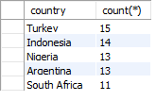

**Q7**

**// any assumptions you made regarding q1 should be written here...**

**Q8**

**// any assumptions you made regarding q1 should be written here...**

**Q9**

**// any assumptions you made regarding q1 should be written here...**

**Q10**

**// any assumptions you made regarding q1 should be written here...**