DK-SOFNN CCPP — Visual Results
This document contains all visual results extracted from DK_SOFNN_CCPP Main-OP.ipynb.

Figures 11 & 12: Structure Adjustment Process
Fig 11: Source FNN rule number convergence (K0=10 and K0=20)
Fig 12: Target FNN (DK-SOFNN) rule number convergence
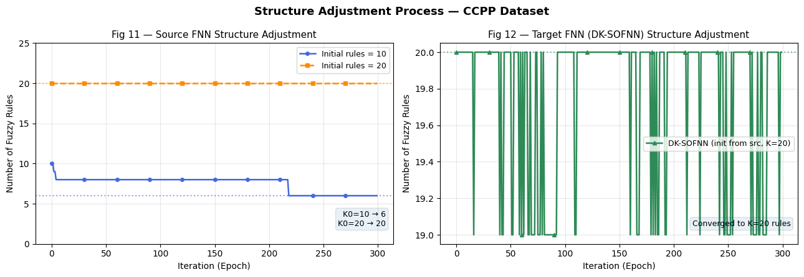

Figure 13: Training RMSE Comparison — Different Fixed Structures
Shows training convergence for K=11, 13, 15 rule networks
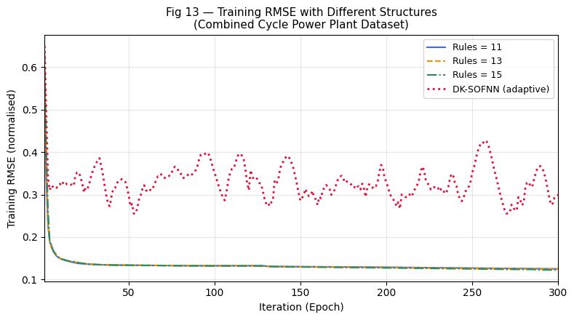

Figures 14 & 15: Testing Values and Testing Error — Different Fixed Structures
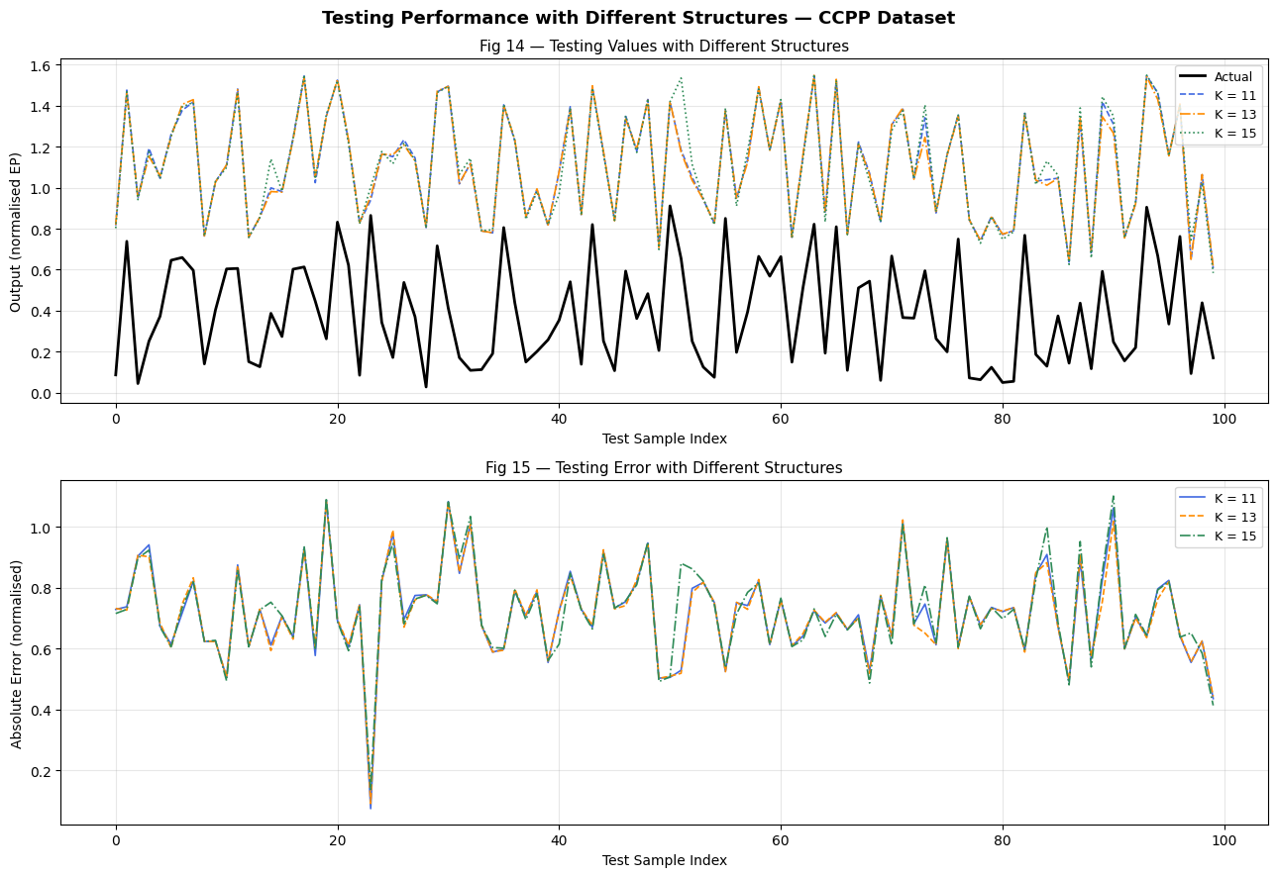

Figures 16 & 17: Testing Values and Testing Error — Method Comparison
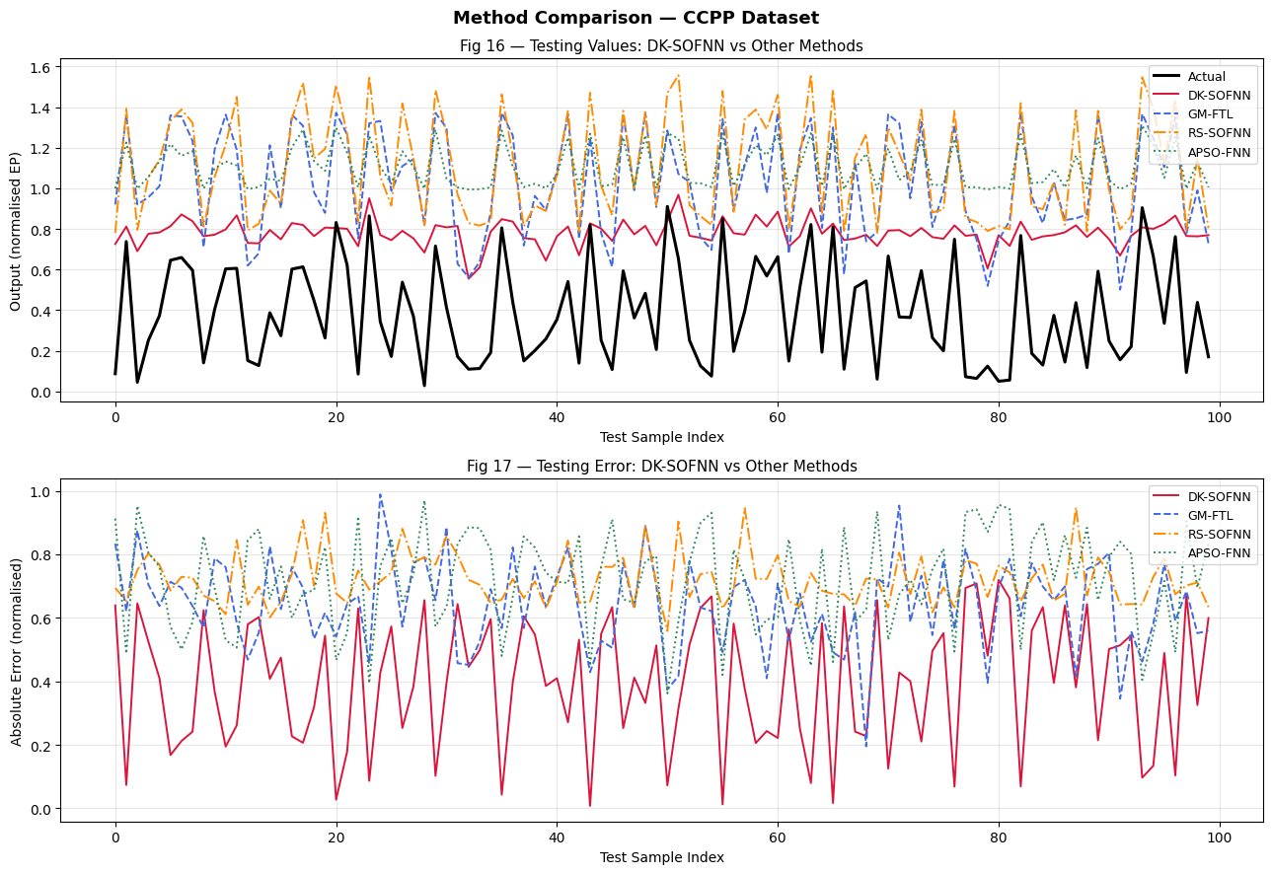

Summary Dashboard — All Results in One Figure
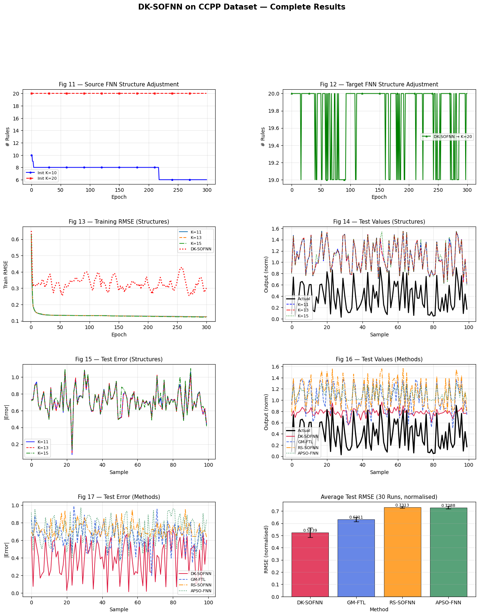

======================================================================
Fuzzy Rules — DK-SOFNN Target (IF-THEN format) (total rules: 20)
======================================================================
Rule 1: IF AT ≈ 0.4494 (±0.1376) AND V ≈ 0.4509 (±0.3006) AND AP ≈ 0.4240 (±0.0141) AND RH ≈ 0.8855 (±0.1657)
THEN PE_output_weight = 0.2250

Rule 2: IF AT ≈ 0.6488 (±0.0195) AND V ≈ 0.6349 (±0.1857) AND AP ≈ 0.4438 (±0.2387) AND RH ≈ 0.3744 (±0.3364)
THEN PE_output_weight = 0.2108

Rule 3: IF AT ≈ 0.6286 (±0.1572) AND V ≈ 0.7048 (±0.3820) AND AP ≈ 0.5452 (±0.3338) AND RH ≈ 0.4112 (±0.2745)
THEN PE_output_weight = 0.7775

Rule 4: IF AT ≈ 0.5420 (±0.1826) AND V ≈ 0.4216 (±0.3128) AND AP ≈ 0.2454 (±0.0916) AND RH ≈ 0.4006 (±0.2106)
THEN PE_output_weight = 0.2832

Rule 5: IF AT ≈ 0.5441 (±0.0173) AND V ≈ 0.6851 (±0.3073) AND AP ≈ 0.3210 (±0.1877) AND RH ≈ 0.6540 (±0.2539)
THEN PE_output_weight = 0.3309

Rule 6: IF AT ≈ 0.4898 (±0.2032) AND V ≈ 0.6185 (±0.1860) AND AP ≈ 0.4162 (±0.0402) AND RH ≈ 0.5686 (±0.3130)
THEN PE_output_weight = 0.5114

Rule 7: IF AT ≈ 0.5575 (±0.1087) AND V ≈ 0.5221 (±0.2941) AND AP ≈ 0.6164 (±0.0833) AND RH ≈ 0.6593 (±0.2100)
THEN PE_output_weight = 0.4503

Rule 8: IF AT ≈ 0.2621 (±0.3168) AND V ≈ 0.4363 (±0.2925) AND AP ≈ 0.4750 (±0.2486) AND RH ≈ 0.6101 (±0.3162)
THEN PE_output_weight = 1.1360

Rule 9: IF AT ≈ 0.5745 (±0.0486) AND V ≈ 0.5641 (±0.1736) AND AP ≈ 0.4597 (±0.2302) AND RH ≈ 0.6033 (±0.3190)
THEN PE_output_weight = 0.5645

Rule 10: IF AT ≈ 0.4803 (±0.0444) AND V ≈ 0.4817 (±0.2801) AND AP ≈ 0.5141 (±0.2148) AND RH ≈ 0.6808 (±0.1557)
THEN PE_output_weight = 0.6048

Rule 11: IF AT ≈ 0.4432 (±0.1066) AND V ≈ 0.4626 (±0.1296) AND AP ≈ 0.3733 (±0.1546) AND RH ≈ 0.6966 (±0.2706)
THEN PE_output_weight = 0.6525

Rule 12: IF AT ≈ 0.3305 (±0.2635) AND V ≈ 0.3920 (±0.3744) AND AP ≈ 0.4924 (±0.3630) AND RH ≈ 0.6147 (±0.3513)
THEN PE_output_weight = 1.2215

Rule 13: IF AT ≈ 0.4497 (±0.0477) AND V ≈ 0.3971 (±0.3375) AND AP ≈ 0.5454 (±0.2170) AND RH ≈ 0.5412 (±0.2159)
THEN PE_output_weight = 0.7947

Rule 14: IF AT ≈ 0.5655 (±0.1035) AND V ≈ 0.3595 (±0.2101) AND AP ≈ 0.4703 (±0.1361) AND RH ≈ 0.6291 (±0.2034)
THEN PE_output_weight = 0.5757

Rule 15: IF AT ≈ 0.6148 (±0.1160) AND V ≈ 0.4360 (±0.2104) AND AP ≈ 0.4133 (±0.1807) AND RH ≈ 0.6870 (±0.2407)
THEN PE_output_weight = 0.5739

Rule 16: IF AT ≈ 0.5568 (±0.1049) AND V ≈ 0.4121 (±0.2117) AND AP ≈ 0.5271 (±0.1734) AND RH ≈ 0.6739 (±0.1896)
THEN PE_output_weight = 0.7708

Rule 17: IF AT ≈ 0.6236 (±0.1282) AND V ≈ 0.4495 (±0.1328) AND AP ≈ 0.2889 (±0.2100) AND RH ≈ 0.7305 (±0.1418)
THEN PE_output_weight = 0.7376

Rule 18: IF AT ≈ 0.3426 (±0.1463) AND V ≈ 0.3668 (±0.1473) AND AP ≈ 0.5907 (±0.1552) AND RH ≈ 0.7526 (±0.1891)
THEN PE_output_weight = 1.0707

Rule 19: IF AT ≈ 0.5937 (±0.1207) AND V ≈ 0.4463 (±0.1037) AND AP ≈ 0.2686 (±0.1770) AND RH ≈ 0.7384 (±0.1210)
THEN PE_output_weight = 0.5572

Rule 20: IF AT ≈ 0.1510 (±0.3045) AND V ≈ 0.2323 (±0.2445) AND AP ≈ 0.6906 (±0.1398) AND RH ≈ 0.4447 (±0.1910)
THEN PE_output_weight = 0.4568

======================================================================

BASE PAPER COMPARISON :
IMPLEMENTED WORK :
