ABSTRACT

NO.
 | TABLE OF CONTENT
CHAPTER
NO. | TITLE  ABSTRACT | PAGE  iv
 | SDGs ALIGNMENT | vii
 | LIST OF TABLES  LIST OF FIGURES | viii  ix
 | LIST OF ABBREVATIONS | x
1. | INTRODUCTION | 1
 | 1.1 Background and Context | 1
 | 1.2 Objective | 2
 | 1.3 Problem Statement | 2
 | 1.4 Social Impact | 3
2. | LITERATURE REVIEW | 5
3. | SYSTEM STUDY | 17

  - Pooling Based Vision Transformer (PiT)

17
  - Contrastive Learning Framework

18
  - Lightweight Bayesian Inference Weighting

19

SYSTEM DESIGN 21
  - Architecture of System Design 21
  - Overview of Stage 1 21
  - Overview of Stage 2 22
  - Overview of Stage 3 22
40

SYSTEM IMPLEMENTATION

Stage 1 40

    - Unlabled Video Samples 40
    - Data Augmentation 41
    - Face and Landmark Detection 42
    - Glass Detection 42
    - Glasses Removal 42
    - Hybrid visual Feature Extraction 43
      - Local Binary Patterns 43
      - Discrete Cosine Transform 43
      - Optical Flow 44
    - Clustering 44
  - Stage 2 44
    - Json File 44
    - PiT Block 45
    - PiT Encoder 45
    - Projection Head 46
    - Classification Head 46
    - Contrastive Loss 46
    - Similarity Queue 47
    - Model Training 47
  - Stage 3 48
    - Trained Encoder 48
    - Discriminative Feature 48
    - Clustering 49
5.3.4. Bayesian Inference Weighting 49
    - Correlation Comparision 50
    - Classification 50
- RESULTS AND DISCUSSION 51
  - Results 51
  - Performance Analysis 52
    - ROC Curve Analysis 53
    - Data-set wise Performance 53

 | 6.2.3 Confusion Matrix Analysis | 55
 | 6.3 Graphical User Interface | 57
7. | CONCLUSION AND FUTURE ENHANCEMENT | 61
 | 7.1 Conclusion | 61
 | Appendix - A | 68
 | Appendix - B | 98
 | Appendix - C | 99
 | REFERENCE | 62

s

SDGs ALIGNMENGT

SDG Icons | Relevance of SDG in the context of project | Section Name(s) | Page number(s)
   | Deepfakes threaten democratic institutions, security, and trust. Tackling this aligns with SDG 16. Innovation in AI detection relates to SDG 9. | Background, Objectives, problem statement and Social Impact | 1, 2, 3 and 4
   | Literature on AI transparency and ethics supports educational advancement and responsible innovation with SDG 4 and 9. | Review of past research, gaps, and relevance | 5 - 16
 | Lightweight models promote energy-efficient computing and sustainable AI practices with SDG 12. | System Design | 17 - 39

   | Provides tools to combat misinformation, ensuring media integrity with SDG 16, and contributes to open research efforts with SDG 17. | System Implementation | 40 – 50
     | Addresses how deepfakes often target marginalized groups (e.g., women), and how AI tools can reduce such misuse and protect equality with SDG 5, 10 and 16. | Interpret findings, evaluate performance | 51 – 60
   | Scalable AI tools can be integrated into digital infrastructures, supporting safe, smart societies with SDG 9 and 11. | Summarize findings, propose improvements | 61 - 67

TABLE NO.

LIST OF TABLES

TABLE NAME PAGE
NO.

      - Performance Comparison of Deepfake Detection Frameworks 54
(our unsupervised model Vs Deepfakeucl )

LIST OF FIGURES

FIGURE NO. | FIGURE CAPTION | PAGE NO.
3.1.1 | Architecture of PiT -Based Feature Encoder | 34
3.2.1 | Contrastive Learning Framework with Nearest Neighbour Support | 36
4.1.1 | Architecture of System Design | 38
5.1.1.1 | Examples illustrating key visual features for deepfake detection | 41
6.2.1 | Performance evaluation of the proposed deepfake detection model | 52
across multiple datasets, including ROC curve analysis (A) and comparative accuracy, precision, recall, and F1-score assessments on FF++ (B), UADFV (C), DFD (D), DFDC (E), and Celeb-DF (F)
datasets
      - Accuracy Comparison of Deepfake Detection Models 55
      - Confusion matrix with BIW and Without BIW 55
    - GUI - Website : Home page 57
    - GUI - Website : Try 57
    - GUI - Website : Upload videos for classification 58
    - GUI - Website : Classifying videos are real or deepfake 58
    - GUI - Website : Tech Stack page 59
    - GUI - Website : About Us page 59
    - GUI - Website : Contact Us page 50

LIST OF ABBREVATIONS

ABBREVATIONS | EXPANSION
MLP | Multi - layer Perceptron
PiT | Pooling based vision transformer
CNN | Convolutional Neural Network
BIW | Bayesian Inference Weighting
DCT | Discrete Cosine Transform
LBP | Local Binary Patterns
AUC | Area Under the Curve
RNN | Recurrent Neural Network
FF ++ | Face Forensics ++
SOTA | State -of -the -art
UADFV | University of albany deepfake video dataset
DFD | Deepfake Detection Dataset
DFDC | Deepfake Detection Challenge

CHAPTER 1 INTRODUCTION

BACKGROUND AND CONTEXT

In the past years, the expansion of artificial intelligence has had an intense impact on digital media, leading to new applications and menacing threats. Fake videos have severe repercussions, ranging from spreading misinformation, financial scams, and invasion of privacy. Although supervised deepfake detection models have been proposed to address the challenge, they require large labeled datasets and hence are hard to scale and vulnerable to adversarial attacks. Hence, reliable and scalable unsupervised detection methods are needed to detect deepfake content successfully.

In order to address such issues, researchers have resorted to contrastive learning and Bayesian inference weighting as possible solutions for unsupervised deepfake detection. Contrary to supervised models, contrastive learning exploits intrinsic differences between deepfake and real videos without labeled training data. Bayesian inference is also a probabilistic solution towards enhancing the credibility of detection using weighting classification with confidence levels. Despite this, existing unsupervised methods still lag behind, particularly when addressing occlusions, lighting variations, and small adversarial manipulations. New augmentations, such as glasses artifact detection, are the promising solutions towards enhancing feature extraction and classification accuracy.

The suggested framework provides a novel unsupervised solution by the combination of lightweight Bayesian inference weighting, feature clustering, and vision transformers for improving deepfake detection accuracy. The framework utilizes a multi-stage pipeline with feature extraction, pseudo-labeling with K-Means clustering, self-supervised contrastive learning, and final-stage classification with Bayesian inference. Additionally, a new glasses artifact detection approach is presented to minimize occlusions in facial structures. Experimental results on benchmarking dataset (FF++, Celeb-FF, DFDC, etc.) shows improvement in detection accuracy, confirming

the effectiveness of the proposed framework to detect deepfake content in real time applications.

OBJECTIVES

The primary objective of this research is to design an end-to-end unsupervised deepfake video detection model that enhances the detection accuracy, robustness, and scalability without access to labeled data. In this direction, the solution utilizes contrastive learning for precise feature differentiation, Bayesian inference weighting for more reliable classification, and glasses artifact detection for dealing with inconsistencies due to occlusion. The architecture is designed to identify unique facial features by using both geometric method and hybrid visual feature extraction methods, identify essential facial landmarks using Dlib-based algorithms, and utilize K-Means clustering for pseudo-labeling to reduce the dependence on ground-truth labels. Moreover, the extracted feature are strengthened through the incorporation of a Pooling-based Vision Transformer (PiT) encoder along with inter-frame correlation to assists in the identification of unnatural transitions indicating deepfake manipulation. By combining these novel approaches, the system aims to outperform existing state-of- the-art unsupervised methods on benchmarked datasets such as FF++, Celeb-DF, and DFDC, with dramatic improvements in accuracy and resilience to adversarial attacks. The work generally propels unsupervised deepfake detection through a scalable, efficient, and practical solution for real-world applications where deepfake attacks keep evolving.

PROBLEM STATEMENT

Deepfake videos are increasingly becoming a threat to media authenticity, cyber security, and popular trust. The majority of the current detection schemes rely on supervised learning and require large amounts of labeled training data, which is often difficult to obtain and expensive to buy. They also generalize inadequately, not performing well when confronted with new deepfake production algorithms or adversarial attacks. Their pre-training dependence also subjects them to lighting changes, occlusions, and facial obstructions (e.g., glasses).To offer solutions for such

issues, this paper presents an unsupervised deepfake detection framework utilizing contrastive learning and Bayesian inference weighting.

In eliminating the requirement for labeled datasets, our suggestion enhances detection reliability through pseudo-labeling, feature extraction (landmark detection through Dlib-based), and clustering (K-Means). Moreover, adding glasses artifact detection enhances accuracy through eliminating inconsistencies introduced by facial occlusions. Our method surpasses traditional unsupervised methods with respect to performance, particularly in complex situations, with higher detection accuracy on benchmark data. This achievement presents a scalable, practical solution that can successfully defeat deepfake threats.

SOCIAL IMPACT
The unsupervised deepfake detection has far-reaching societal inference, particularly towards the promotion of media, preventing disinformation, and improving digital security.

    - Fighting Misinformation & Disinformation: Deepfake videos are frequently employed to circulation of false stories, political misinformation, and artificial content. By offering a high-accuracy, unsupervised detection model, this research assists media platforms, fact-checkers, and governments in detecting and preventing the dissemination of artificial content before it goes viral.

    - Protecting Individuals and Public Personalities: Deepfakes are increasingly used for purposes of identity theft, fraud, and loss of reputation against celebrities, politicians, and individuals. The system enhances personal online security through the ability to detect manipulated videos before they can cause harm.

    - Improving Cybersecurity and Law Enforcement: The model can be utilized by the police to identify fake videos employed in fraud, evidence tampering, and cybercrime. Through the incorporation of the framework within forensic evidence analysis, the authorities will be able to verify video evidence and safeguard against law abuse.

    - Maintaining Digital Trust & Social Media Integrity: Since social media continues to be a primary source of information, websites can incorporate this detection mechanism to identify,screen, or alert users of deepfakes, minimizing public confusion and providing genuine digital interactions.

    - Promoting Ethical AI & Healthy Media Consumption : The increasing sophistication of AI-generated content also raises important issues around artificial intelligence ethics and appropriate technology use. This method encourages ethical use of AI to allow organizations to fight digital lies without being constrained in their ability to express themselves.

CHAPTER 2 LITERATURE SURVEY

Robust Frame-Level Detection for Deepfake Videos With Lightweight Bayesian Inference Weighting (2024).
L. Zhou et al.[1] showed a robust frame level deepfake detection method with lightweight Bayesian inference weighting (BIW). It addressed the challenge of detecting manipulated frame samples in deepfake videos by Bayesian inference weight.This enabled the model’s ability to better identify faint inconsistencies that are introduced by deepfake generation algorithms, thus improving detection accuracy with minimal computational costs for the detection. The lightweight of the Bayesian weighting scheme renders it ideal for real-time or low-resource applications, providing a trade-off between performance and feasibility.

Fully Unsupervised Deepfake Video Detection Via Enhanced Contrastive Learning (2024).
T. Qiao et al.[2] work introduced a fully unsupervised deepfake video detection system using improved contrastive learning. Through the removal of the need on labeled data, the paper removes the scalability issues based on the conventional supervised approaches. This new method uses contrastive learning to learn discriminative representations directly from unlabeled videos, thus capturing the differences between real and manipulated material. The improvements to the contrastive learning includes function optimization and data augmentation techniques, further facilitate the capability to detect deepfakes in the absence of direct supervision, making it extremely effective in learning to generalize to new manipulation methods.

Statistical model-based detector via texture weight map: Application in re-sampling authentication (2018).
M. Chen et al.[8] proposed a statistical model-based detector for re-sampling authentication with texture weight map in this work A new but with statistical model detector for re-sampling authentication is developed.The authors acknowledged that re- sampling steps, which are standard manipulations in the image processing field can result in non-destructive texture inconsistencies that may be used for forensic purposes.

It considers a statistical model that suits the texture occurrences in normal images as the methodology being involved. With this information, the detector creates a texture weight map depicting parts of deviation in the predicted model and hence, the apparent manipulated regions. This statistical method is a strong and interpretable way that can be used to detect re-sampling artifacts because it relies on solid statistical principles.

Face2face: Real-time face capture and reenactment of RGB videos (2016).
J. Thies et al.[5] presented Face2Face, an innovative system for real-time RGB video captured and replayed face capture. The authors presented a pipeline to transfer faithful facial expressions from source actor to target video in real-time. Using a compact 3D facial model in conjunction with novel tracking methods, the system recovers fine-grained facial motions and appearance from an input video. The captured expressions are then projected onto target video to create a convincing reenactment. To my knowledge, the reality of what Face2Face provides is that you can manipulate video content (facial expressions) in real time. The impact of this technology across VR, motion picture visual effects/specials to real-time video conferencing is tremendous illustrating a promising future for immersive and interactive facial manipulation.

Exposing Deepfake videos by detecting face warping artifacts (2019).
Y. Li et al.[6] aimed to discover deepfake videos by identifying the minuscule warping artifacts caused by the manipulation. Though usually deepfake generation methods have distinct kinds of artifacts in the facial areas around eyes, mouth and jawline according to the author. This approach is to detect these patches by studying the spatial patterns and gross inconsistencies in facial geometry. It enhances, via methods such as optical flow, geometric distortion estimation — the areas of the face that have been altered. Such an approach is good for forensic studies since it exploits deepfake generation limitations. Since the physical distortions of how manipulation is done are carefully chosen, the method exposes deepfakes in a robust way.

Multi-attentional Deepfake detection (2022).

J. Zhang et al.[8] present an approach for deepfake detection with multi- attentional deep learning network which utilizes multi-dimensional attention to highlight the significant elements in video frame. In order to make the model focus on more salient parts in face for detecting subtle manipulation artifacts, authors strive to help model pay attentions. They do this by marrying multiple attention modules to a deep learning framework that lets the model simultaneously attend to disparate facial regions and features. Multiple attention heads can yield a more holistic contextualization of facial features in which the model may infer inconsistencies that are missed by single-headed approaches. The method improves the capabilities of the model in terms of isolating relevant cues which makes it more accurate for deepfake detection, and reduces a more human-like approach.

Detecting compressed Deepfake videos in social networks using frame- temporality two-stream convolutional network (2022).
J. Hu et al. [9] tackled the problem of detecting compressed social deepfake video using frame- temporality two-stream convolutional network. Given the fact that compression may mask manipulation trails, the authors propose a joint spatial-temporal analysis network. The method follows a two-stream pipeline, i.e. the spatial details are first captured by a frame stream and the temporal relationship between frames is then exploited to spot any anomalies. This was achievable through the integration of these streams with the network then indicate Deeps of Fakes — even so in Artifact- compression. The scenario is more critical for social network applications as videos are compressed and re-compressed therefor efficient detection methods should be robust even in presence of degradation.

Hierarchical contrastive inconsistency learning for Deepfake video detection (2022).
    - Verma et al.[10] presented a hierarchical contrastive inconsistency learning for deepfake video detection to learn disimilarities at different levels of abstractions. Both the authors acknowledge Deepfake can vary in pixel patterns at low-level, or semantic features on high-level. This work trains a model under hierarchical contrastive learning of which the strategy is to teach the model represent some discriminative features. Through salient feature representation across disparate scales, the model learns to identify inconsistencies at multiple levels. This hierarchical inference enables

the model to learn a more powerful manipulation of the artifacts from low-level to high- level features, boosting the effectiveness in detection. Using contrastive learning they achieve much better generalization of their models compared to traditional approaches without requiring many labeled data.

Unsupervised learning based framework for Deepfake video detection (2021).
C. Fan et al. [11] introduced an unsupervised learning architecture for deepfake video detection working around the scope of supervised methods with large labeled dataset requirements. The authors introduced a method that utilizes the difference in real-world vs manipulated videos for training a detection model based on statistics. Using clustering and anomaly detection, the framework learns to identify typical fashions and anomalies of deepfake manipulations without any direct label. It was particularly necessary for keeping pace with the evolving dynamics of deepfakes since the particular manipulation patterns are not specified. The unsupervised nature in the framework allows transfer learning to unseen manipulation methods, yielding a generalizable solution to deepfake detection.

Improving the efficiency and robustness of Deepfakes detection through precise geometric features (2021).
L. Wang et al. [14] were trying to improve deepfake detection performance and generic robustness by identifying careful geometric features. Authors acknowledged that subtle changes in facial geometry are inadvertently introduced to deepfakes which can be useful for detecting whether an image/video has been manipulated. Precise Geometric Features: What They Do They are the core of its approach to feature extraction and analysis, Facial Land marks, shape Deformations, Motion Patterns The detection model could be able to recognize those manipulations without getting fooled by other confounding factors (compression artifacts or lighting variations, for example). This method increases the accuracy and the strength of detections by focusing on noise and video content variations-resistant features, therefore this technique has the potential utility for forensic purposes.

Capsule-forensics: Using capsule networks to detect forged images and videos (2019).

H. H. Nguyen et al. [15] introduced Capsule-Forensics: Towards Visual Forgeries Identification using Capsule Networks the authors suggested that capsule networks, which are able to characterize hierarchies among features from input will be useful in detecting slight corruptions induced by manipulation. Their method consisted in training a capsule network to recognise the spatial relationships and feature dependencies shifted by forgery. The capsule network can recognise the unalignment that is meant to be an anomaly encoded in the part-whole relationships of images/video. This was the one of the most robust and interpretable approaches towards forgery detection, as it makes use of the capsules structure of visual data which capsules (from visual) hold to represent relationships in hierarchical visual features. This work highlighted the feasibility of capsule networks in forensic analysis and their effectiveness for the robust content manipulation detection.

Fighting fake news: Two stream network for Deepfake detection via learnable SRM (2020).
L. Li et al.[16] tackled deepfake detection towards countering fake news by proposing a novel two-stream network that utilizes learnable Spatial Rich Model (SRM). That SRM filters can pick up statistical discrepancies even in deepfakes that are often introduced by the author has recognized to be subtle, plausible with learned from usages of Spatial Rich Model will extract noise residual is the idea. The solution was splitted in two-stream architecture, where one stream convolves for color/noise and spatial patterns whereas the latter learns SRM layer for noise in an end-to-end fashion. Integrating these two streams can therefore allow the network to easily deal with deepfakes, i.e. it learns to identify clear visual artifacts of statistical anomalies. The learnable SRM provided a fine-grained level of abstraction to enable the network to learn common patterns of different types of deepfakes and thus generalizes better. Fake news will be better combatted by such a method as it will increase accuracy of deepfakes detection over current approaches.

Face X-ray for more general face forgery detection (2021).
L. Li et al. [17] introduced 'Face X-ray', contributions of a new general approach to face forgery detection that should make for better analyzing facial manipulations. The authors admitted consistency in deepfakes and other forms of face manipulation are not something that's necessarily found via the traditional methods, as they often

imply themselves subtly. They proposed an 'X-ray of face' representation which visualizes the fine structure and consistency of facial traits. The above representation emphasized the small differences in the geometry, texture, and illumination of face single out the anomalous areas for manipulation artifacts. Face Xray supports a richer, interpretable analysis of facial manipulations, enabling solid inference on many types of face forgeries from deepfakes to face swapping to retouching. This method bolsters the precision and faith of face forgery detection, an important forensic tool.

Finding facial forgery artifacts with parts based detectors (2018).
Steven Schwarcz et al .[18] explored methods of detecting facial forgery artifacts based on parts-based detectors (which aims to boost the detection accuracy by handling partial regions of facial) The authors acknowledged that deepfakes locally damage individual parts of images, which can be efficiently worked out in a local analysis context of facial parts. To do so they came up with training the detectors on identifying local inconsistency occuring in facial landmarks, specifically eyes, nose and mouth. The technique can observe parts-based detector effectively detects the fine manipulation artifacts that are global analysis might fail. This efficiently boosted up the detection accuracy by concentrating on the low-level informative part of a face, a solution more robust and cleaner way to identify face forgeries.

Deep clustering for unsupervised learning of visual features (2018).
M. Caron et al.[19] investigated a deep clustering for an unsupervised visual feature learning, the goal being to discover discriminative representation from a set of unlabeled data. The difficulty of learning meaningful visual features from labelled data is a challenge acknowledged by the authors. They do so by training a deep neural network to group together similar visual features is a way, which balances learning representation giving intuition that should be learned from data. As we may get better representations, deep clustering can provide the model to learn useful patterns and relations between data points. This is of great interest for use cases where labeled data is hard to find or unavailable such as image retrieval and deep fake detection. The work is a step toward unsupervised learning methods — something critical for a large number of computer vision tasks.

Celeb-DF: A large-scale challenging dataset for Deepfake forensics (2020).

Yuezun Li et al.[20] Celeb-DF: A Large Scale and Challenging Dataset for the Advancement of Deepfake Forensics This work presented Celeb-DF,a novel dataset for deepfake forensics that addresses the challenge of building high-quality datasets useful in the practice-oriented development and evaluation of deepfake detection methods. Celeb-DF is a large-scale collection of high-quality deepfake videos created via state- of-the-art approaches for various subjects, situations and types. The inspiring and challenging dataset Celeb-DF enables further deepfake detection research on the edge of computer vision/expression/tunnel slam as well as more robustly detection methods. This dataset is of great utility for researchers, and practitioners to benchmark their deepfake detection methods on a well defined rigorous manner. Dataset diversity and quality have been instrumental towards preventing overfitting and allow the trained models to be more applicable in real world cases.

The Deepfake detection challenge (DFDC) dataset (2020).
This paper [21] presented the Deepfake Detection Challenge (DFDC) dataset – a large scale and comprehensive dataset created for boosting research on deepfake detection. The authors understand the importance of a strong benchmark for testing and fine-tuning deepfake detection accordingly. The DFDC dataset is a large-scale repository of real and manipulated real life videos produced via diverse deepfake methods on a wide spread pool of people &scenarios. The dataset is so complex and large to test the current detection methods to push the limits to much smarter algorithms. The DFDC dataset provides a common benchmark to enable a fair comparison across various approaches and fosters collaborative research in deepfake detection. It has made a large effort to the development of deepfake forensics by offering a realistic and hard- to-work-with dataset.

Fake news and deepfakes: A dangerous threat for 21st century information security (2015).
The author [23] examined the developing scourge of fake news and deepfakes as a menace for 21st Century information security. Manipulation improving, and it is harder to trust in the public and destabilizing democratic constructs according to the authors. Deepfakes are a special problem because these almost create completely real video/filmed content that can be falsified in a way which is hard to disprove. The paper covers different modes to create deepfakes and the kind of devastation these can cause

if they start spreading much wider. It too tests the difficulties of identification and prevention to deepfakes (corrective algorithms, societal awareness) In providing a context for information security, this paper prioritizes the importance of addressing deepfake and fake news.

MesoNet: A compact facial video forgery detection network (2020).
S. Afchar et al. [24] presented MesoNet, a deep learning based compact network for fast detection of deepfakes in videos. Table: The authors tackled the problem of deploying lightweight models into resource-constrained environments. MesoNet aimed to disentangle the mesoscopic disparity, i.e. the mid-level frequency alteration injected by deepfake generation. The model was built upon a shallow structure with efficient convolutional layers, that allows highly detection accuracy but also small model size. Especially helpful for real-time applications and mobiles as computational resources are scarce. MesoNet is a solution for the detection of deepfakes that strikes a good compromise between performance and resources.

FaceForensics++: Learning to detect manipulated facial images (2018).
K. Rossler et al. [25] introduced a FaceForensics++, a large benchmark dataset and benchmark for learning to manipulate face images. Authors acknowledged the importance of a comprehensive dataset and expose many methodological manipulations by crowding those variety in the same place. FaceForensics++ is a comprehensive dataset of real, manipulated faces (like deepfakes, face-swaps and attribute-manipulation). This dataset is specifically designed to benchmark the detection performance on various manipulation types and compression levels. FaceForensics++ establishes a common ground for the comparison of approaches and thus advances research on facial manipulation detection. The robustness and variety of this dataset is very useful for training as well as testing deep learning models for forensic analysis.

EfficientNet: Rethinking model scaling for convolutional neural networks (2023).
This paper [26] scaled up to the model-level with a new efficient scaling method that scales depth, width and resolution uniformly in CNNs— EfficientNet. The authors

noted that mainstream scaling methods are usually concentrated on scaling one dimension that can perform badly. It was EfficientNet which a smart scaling method that scales all three individually by applying a single compound coefficient which is simple yet efficient. It outperformed traditional or common methods to scale convolutional neural networks in terms of both accuracy and efficiency, more affordable. As EfficientNet rips state-of-the-art results on multiple image classification benchmarks with far fewer parameters and computations than existing models. We present an important building block for the design and scaling of convolutional neural networks, leading towards more efficient and powerful models.

In Ictu Oculi: Exposing AI created fake videos by detecting eye blinking (2018).
Y. Li et al. [28] took the form of 'In Ictu Oculi' a technique revealing AI created synthetic fake videos through eye blink inconsistencies of the latter. The authors found that ordinary natural eyeblinks are not very successfully replicated in deepfake generation techniques. The method was based on temporal patterns of eye blinks across different video sequences to capture anomalous events that would be typical for deepfakes. This way of detecting discrepancies in the frequency, duration and coherence of blinking are shown to be efficient fake video exposure. This is a neat and intuitive approach for deepfake detection that utilizes the most basic human characteristic. This research pointed to a tool of forensic computation grounded in tractable features which are both observable and biologically based.

Recasting residual-based local descriptors as convolutional neural networks:An application to image forgery detection (2019).
T. Nguyen et al. [29] proposed to recast residual based local descriptors into convolutional neural networks (CNN) for image forgery detection. The authors admitted that manipulations are to be detected and residual-based descriptors that summarize subtle statistical anomalies are useful. Their idea was to represent these descriptors as CNN layers and then incorporate them in deep learning networks. The method also can be effectively learning discriminative features for forgery detection with residual analysis serving as a CNN framework. This method improves the performance of various different forgery detection models by exploiting the power of

both pre-trained network and residual analysis. This paper demonstrates the feasibility to fuse deep learning method with classical forensic methods.

Fast face-swap using convolutional neural networks (2018).
Z. Nirkin et al. [31] proposed a method for fast face-swapping through convolutional neural networks (CNNs), aimed at delivering high-quality results with minimal computation. Real-Time Face Swap. The authors addressed the challenging problem of real-time face swapping and propose a CNN architecture capable of being good enough to be imperceptibly accurate. The idea was to train such a network that learns the mapping from the facial landmarks of source face into target face, making identity transfer painless. Using appropriate design of network and a suitable training process, this method leverages for fast and reliable face-swapping that can be real-time. This demonstrates]ed the usefulness of CNNs for simple but efficient and high-quality face manipulation.

Spatiotemporal inconsistency learning for DeepFake video detection (2022).
J. Zhang et al.[34] explored the spatiotemporal inconsistency learning for deepfake video detection that aims to model both spatial and temporal anomaly injection by the deep fake manipulation. The authors noted that deepfakes frequently break both temporally and spatially ascorbic. They took a stance of in which they train a model to perceive the local spatial patterns and the global temporal regularity of video sequences for finding such anomalies. The network leverages the simultaneous exploitation of spatial and temporal information to effectively handle deepfakes. This works stresses on how important is to take spatial and temporal information in deepfake detection, i.e., a holistic methodology that captures a lot more manipulation artifacts.

Learning self-consistency for deepfake detection (2021).
C. Sun et al. [35] learned to self-consist for deepfake detection is presented which exploits the very manipulations that are done to generate such synthetic videos. The self-consistency of video sequences is disrupted by deepfakes, some authors note and this can make self-consistency inference from video relationships between parts of the video an anomaly. They had a exploitation method of training a model to learn self- consistency of video sequence and then looking for inconsistency caused by deepfakes. Using video content internal consistency, this network can not only detect but also

understand manipulations. The former was a strong and interpretable manner for the deepfake detection, a new view to forensic. It detected inconsistencies in the frame frames and between frames as a real video would not haveù self consistency.

Deepfake video detection using convolutional vision transformer (2022).
J. Chen et al. [37] investigated convolutional vision transformers for deepfake video detection which amalgamates convolutional neural networks and transformer in the form. The authors acknowledge that transformers are excellent models for finding long-distance relations, though this could make them appropriate to identify temporal inconsistencies in videos. Their framework is made out of the convolutional layers for describing local characteristics and transformer layers for long-range context modeling. The network can recover the local and global manipulation artifacts by merging these two architectures. It makes a promising vision transformer-based identity method for the detection of deepfakes and thus the forensic analysis.

Deep convolutional pooling transformer for deepfake detection (2021).
Y. Zhao et al .[38] proposed a deep convolutional transformer pooling for deepfake detection to better model local and global features using a more robust model. In the paper, we introduce a novel network architecture where convolutional layers for local feature learning, pooling layers for feature aggregation, and transformer layers for global context modeling. By gluing together these variety of layers, network can be efficient to learn a lot of manipulation artifacts. This works mitigates the false alarm rate, as well boosts detection accuracy and robustness to provide a complete solution of deepfake forensics.

Deepfakes detection with automatic face weighting (2021).
H. Huang et al. [40] addressed a deepfakes detection using face weighting and attempt to improve model's face focus by automatically detecting those region is more informative. The authors point out that not all areas of faces may be adulterated to the same extent in different parts. The proposed approach is training the network to compute facial region-wise weights so that relevant cues can be literally over emphasized by the model. Automatic face weighting allows the network to slightly leverage on those manipulation artifacts. This approach enhances the detection precision and robustness with natural deepfake forensics.

Sharp multiple instance learning for DeepFake video detection (2023).
T. Wang et al. [41] have investigated the use of sharp multiple instance learning (MIL), for detection of deep fake video trying to make the model capable of processing noised/ambiguous data better. The authors admitted that there are usually some of nuanced manipulation artifacts in deepfakes that are hard to identify with classical approaches. They proposed to leverage sharp MIL which can handle the noisy and ambiguous data better by having a strong focus on informative instances. Sharp MIL the network can capture accurately the subtle manipulation artifacts from high- resolution images and this alters data fidelity in favour of better image masking. This approach is an enhancement in detection accuracy and robustness leading to a more reliable method for deepfake forensics.

CHAPTER - 3 SYSTEM STUDY

Pooling-based Vision Transformer (PiT)

Architecture
Figure 3.1.1 : Architecture of the PiT-Based Feature Encoder

Pooling layers that reduce computational overhead by replacing token reduction in standard Vision Transformer(ViT), PiT is an enhancement over ViT with an
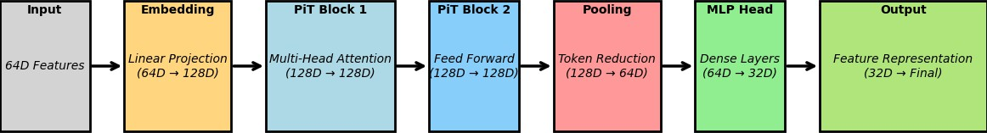
architecture that follows -
Input Features (64D) : 64D feature vectors extracted via Optical Flow(LAB), Texture (LBP), Frequency (DCT), Face landmarks.
Embedding Layer (Linear Projection / [64D → 128D]) : The linear projection layers map a 64-dimensional features to be in a larger 128-dimensional space that is useful later on.
PiT Block 1 (Multi-Head Attention: 128 ← → 128) :A multi-head self-attention operates on long-term dependencies in the feature representation. The attention allows the model learn everything useful about relationship between different features extracted from these frames.
PiT Block 2(among FiF:128D → 128D) : Fully connected feed-forward network to refine feature embeddings.This process makes the non-linearity and increases the feature extraction of component more flexible.
Pooling Layer (Token reduction (128D → 64D) : It is of activations from convolutional layers via Pooling Layer.It differs from the conventional ViTs that PiT brings in token reduction pooling to compress features from 128D to 64D.This step reduces computation and increases efficiency of the model.
Deeper MLP Head (dense layers: 32D → 64D):This decreases the dimension of features from 64D to 32D by one more multi-layer perceptron (MLP) head, see multi- label classification.

32D representation of final (Output Feature Representation -- 32D):Feature representation used to classify the deepfake detection system.

Purpose of PiT in Deepfake Detection
- PiT: Efficient Feature Processing to Leverage OccAM's razor in reducing feature redundancy while retaining salient properties.
- Easy to Compute: Fewer operations needed, PiT has better computational efficiency than standard Vision Transformers when we reduce redundant tokens.
- Strong In-Depth Representation Learning: Multi-head attention plus pooling to signal their token and help the model to learn more subtle deepfakes.

Contrastive Learning framework
Contrastive learning is a self-supervised learning approach to improve feature- level representation by maximizing similarity between the positive-sample pairs and miminating the negative pairs. Used mainly for unsupervised deepfake detection, since labeled data is not abundant in this method. In the suggested system, contrastive learning are incorporated into the framework to boost feature extraction as well clustering damage. The essential modules are
Feature Representation: Extracted features from landmarks of a face, texture, frequencies and motion analysis are mapped into Embeddings
contrastive Loss Function — the framework implements a contrastive loss to isolate embeddings of false and true video frame and bring similar embeddings closer.
Pseudo-labeling with K-Means Clustering – After contrastive learning, K-Means clustering is used to form pseudo-labels by grouping similar samples together.
Self-supervised Training with Pooling-based Vision Transformer (PiT) – The learned feature representations are fed into the PiT Encoder for classification refinement.
t-SNE Visualization – The model uses t-SNE (t-Distributed Stochastic Neighbor Embedding) to visually assess the separation of deepfake and real videos after contrastive learning.

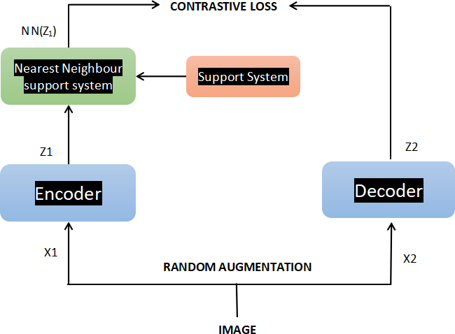

Figure 3.2.1 : Contrastive Learning Framework with Nearest Neighbor Support

Bayesian Inference Weighting
The Bayesian Inference Weighting(BIW), the probabilistic way to produce confidence scores that will be assigned from prior knowledge and observation data about predictions. BIW in the deepfake detection task further improves classification by using uncertainty estimation to yield decisions that are probabilistically weighted, not hard threshold. The deepfake detection system uses Bayesian Inference Weighting framework as:
Feature Extraction : Input frames are processed to obtain facial landmarks, texture features (LBP), frequency representations (DCT) and motion cues ( Optical Flow).The aforementioned features are used as input to a Vision Transformer (PiT) encoder for classification.
Estimate the initial probability:The PiT classifier in the VP provides a rough classification score (real or fake) per frame.Interpreted as the likelihood in Bayesian inference of observing this score.

Infer dependencies with the prior assignation :After that, the prior probability is according to historical data such as the probability of occurrence a deepfake video in a set of dataset.Deepfake vs Fakeface artifacts in distribution.
Calculation of Posterior Probability (Bayes' Theorem) :Bayesian inference is used to update classification score w/ observable evidence.
Confidence Score Generation: Posterior probability is a confidence score translated our model gives for all classification decisions.A value which we dynamically update based on the uncertainty to minimize false positive rates.
Final Classification Decision: We use a thresholding approach, where real or fake is assigned to video entirely based on its probability weighted.If uncertainty is high, follow up refinement on features (e.g., geometric landmark assessment).

Role Bayesian Inference Weighting in Deepfake Detection :
- Decrease False Classification – BIW: (Balanced) Dynamic Classification Score Adjustment leads to fewer false positives/negatives.
- Uncertainty incorporation — instead of hard-thresholding, BIW considers uncertainty in factoring (e.g., lighting, occlusions etc.).
- Resilient to New data— Bayesian inference is “learning” data as it comes, resulting
in adaptability for real-world problems.

CHAPTER 4 SYSTEM DESIGN

ARCHITECTURE OF SYSTEM DIAGRAM

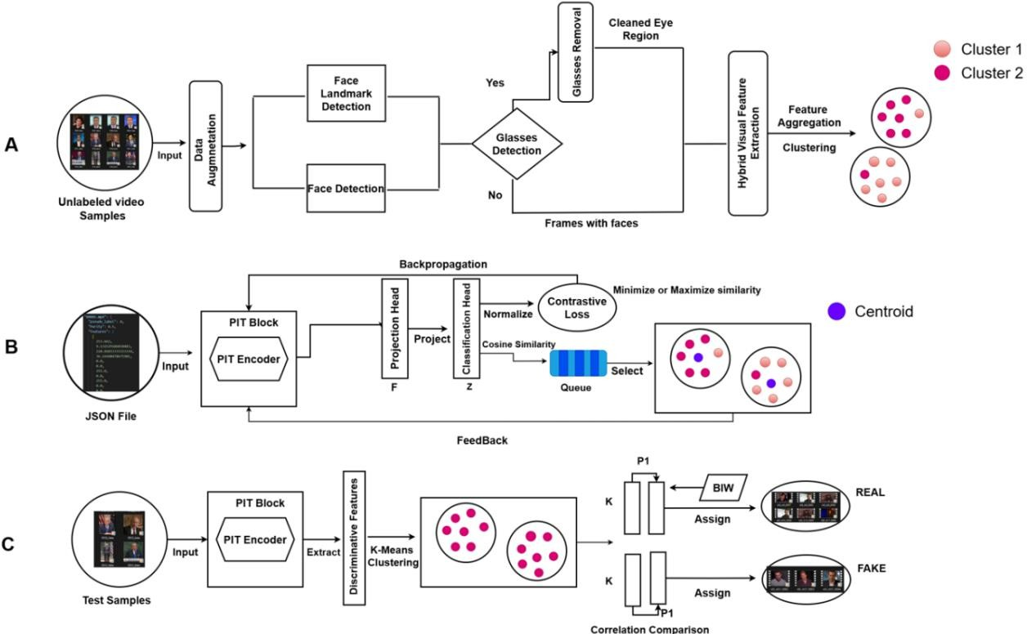
Figure 4.1.1 Architecture of System Design

OVERVIEW OF STAGE 1

The proposed deepfake detection framework in the report is split into three stages for classification accuracy and robustness improvement. In this stage, Feature Extraction and Pseudo-Labeling, video frames are pre-processed by using data augmentation [49] flips, rotations, and color jittering. Using frontal face detector by Dlib and extracting 68 landmarks to represent the geometric structures of facial facial The Glasses artifact detection is present to handle occlusion issue by Gussian blurring of eye regions before feature extraction. Based on Hybrid visual features LBP(Local Binary Patterns) for micro-textural information, Discrete Cosine Transform (DCT) on frequency based patterns and Optical Flow to represent differences in inter-frame motion. Features Extraction are clustered using K-Means, and then we are assigning

pseudo-labels according to cluster purity. For better visual interpretability, t-SNE [7] is used for dimensionality reduction to get a two-dimensional view of in clustering result via reduce from clustering.

OVERVIEW OF STAGE 2
During the second stage Self-Supervised Contrastive Learning, where feature representation in stage A will be sent into PiT Encoder of Pooling based vision transformer (PVT), which is a deep learning algorithm that takes high dimensional input data, employing multi-head self-attention and feedforward layers to extract compact feature embeddings.(3) The extracted features are then projected to an lower dimensional space through a projection head to improve feature separability. The embeddings are then composed using a contrastive loss for minimizing similarity of similar (positive) pairs and maximizing similarity of dissimilar (negative) pairs. We compute cluster centroids for each pseudo-label, and select samples above a particular similarity threshold to train our models even more reducing the number of training data which is useful only.

OVERVIEW OF STAGE 3
At Binary Classification with Bayesian Inference Weighting in Stage 3, test samples are processed by using convolutional neural network (CNN) for feature extraction and pre-trained PiT encoder to yield frame-level embedding.Step 3: Feature extraction of test samples with a convolutional neural network & pre-trained PiT encoder for the frame-level embeddings (K-Means clustering → embedding encoded into two clusters) Performance evaluation with temporal consistency inter-frame correlation between frames to ensure that there are no unnatural transitions as popular in the deepfake content. The confidence scores are to be assigned for the predictions according to Bayesian Inference Weighting so that the score dynamically scales the segment contribution in final classification decision. If a cluster has the higher average correlation, then fit regests in Bauleech, the other cluster called Real. Through the synergistic data mining of feature extraction, clustering & correlation analysis and Bayesian inference, the final classification decision made finally which is guaranteed more accurate and robust for onset deep-tuning.

CHAPTER 5

SYSTEM IMPLEMENTATION

  - Stage 1

UNLABLED VIDEO SAMPLES
As the framework mainly focusing on the unsupervised learning, here data collection plays a crucial role. Since the model does not directly rely on pre-labeled dataset, the approch involves gathering of all unlabled deepfake video dataset samples. In this section, these datasets are introduced as following.

- FF ++
- UADFV
- Celeb-DF
- DFD
- DFDC
- Glasses
FF ++ : One of the most popular deepfake detection datasets.Contains both real and fake videos generated using various face manipulation techniques. 1,000 (original realistic videos downloaded from the YouTube) and 4,000 fake videos (generated by deep leaning-based methods Deepfake (DF) and NeuralTextures (NT) and Face2Face (F2F) and FaceSwap (FS).

UADFV : One of the first datasets created for deepfake detection. Limited in size. 49 real videos and 49 fake videos. Basic face-swapping models (low- resolution, early deepfake techniques.

Celeb-DF: A large-scale dataset featuring high-quality deepfake videos.It includes realistic deepfakes with minimal visual artifacts. This dataset contains 590 real videos and 5,639 more realistic synthetic videos.

DFD: Created by Google to support deepfake research.Focuses on high-quality deepfake manipulations.This dataset includes 363 real videos and 3,068 fake videos where deepfaked videos are generated by multiple AI-based face- swapping methods.

DFDC : The largest deepfake dataset, released by Facebook as part of a competition. It contains diverse real and fake videos of 128,154 videos in total, and 5 facial forgery manners.

GLASSES :I have additionally collected 200 videos with a glasses.




Figure 5.1.1.1 : Examples illustrating key visual features for deepfake detection.

DATA AUGMENTATION
The data augmentation process is applied to artificially expand the training dataset by applying various transformation techniques to input data.The techniques used in work are
- Random Erasing
- Random Resized Crop
- Horizontal and Vertical Flip
- Color Jitter
Random Erasing : Randomly removes small rectangular patches from an image.This helps the model learn robust features by ignoring irrelevant areas.
Random Resized Crop : Randomly crops a portion of the image and resizes it to a fixed dimension.
Horizontal & Vertical Flip : Flips images horizontally and vertically with a probability of 50%.
Color Jitter : This method adjusts brightness, contrast, saturation, and hue randomly to the input data frame.

FACE DETECTION

Face Detection is a process of identifying and localizing human faces in an image or frame.This act as a basic step in our framework. This is done by using Dlib’s frontal face detector which will locate faces in the frame. If multiple faces are detected then first face is selected ans cropped for further process.Once the face is detected and cropped from a frame, then using 68 key facial points from Dlib we can analyze the facial parts also know as geometric structures of the face. The 68 key facial points are

- Eyebrows (17-26)
- Eyes (36-47)
- Nose (27-35)
- Lips (48-67)
- Jawline (0-16)

GLASSES DETECTION
This is very essential aspect of deepfake analysis, as the presence of glasses can alter the facial feature, obstruct the key landmarks and affect the performance of face detection model.We have detected the presence of glasses in a frame using deep learning based model called ResNet-18.The decision making for this is based on the probability value, if the probability is less than 0.6 then the person is wearing glasses. To verify this, bounding box is drawn on the glasses detected area with it’s probability value.

GLASS REMOVAL
After detecting the presence of glasses, a glasses removal process is applied to counteract their influence on facial landmark detection. This is achieved through the application of Gaussian blur on the region of the eyes in a selective way, thereby weakening the sharpness of the occluded areas without losing the overall face structure. Applying a 15×15 Gaussian kernel and a sigma value of 30, the fine details of the glass are smoothed while avoiding keeping distortions on landmark points into the picture. The landmark-based feature extraction is made more robust, so facial recognition as well as deepfake detection models are not affected by glass occlusions.

HYBRID VISUAL FEATURE EXTRACTION

This hybrid visual feature extraction method combines multiple feature descriptors to enhance facial analysis by capturing the texture, frequency and motion based information.The are

- Texture Features (Local Binary Patterns)
- Frequency Features (Discrete Cosine Transform)
- Motion Features (Optical Flow)

      - Local Binary Patterns : It extract the micro textural details (such as wrinkles,pores and skin roughness) and encodes the relation between a pixel surrounded by it’s neighbour pixels forming a histogram based texture descriptors.This helps to identify the morphing region on face.
𝑝−1
𝐿𝐵𝑃^{𝑟}(𝑥, 𝑦) ∑ 𝑠(𝐼 − 𝐼 ). 2𝑖
𝑝 𝑖 𝑐
𝑖=0

Where Ic is the center pixel, Ii are the neighboring pixels in a circular pattern, and :
(𝑥) = {1, 𝑥 ≥ 0
0, 𝑥 < 0
The resulting LBP histogram forms the texture descriptor.

      - Discrete Cosine Transform: It extracts the frequency based features by decomposing an image into different frequency components. It distinguishes broad structural patterns from fine details, only first 100 low frequency DCT coefficients are retained to dominant facial structures.
𝑀−1

𝑁−1
𝐷𝐶𝑇 (𝑢, 𝑣) = 𝛼(𝑢)𝛼(𝑣) ∑ ∑ 𝐼(𝑥,𝑦) 𝑐𝑜𝑠 (
𝑦=0
(2𝑥 + 1)𝑢𝛱
2𝑀 ) 𝑐𝑜𝑠 (
(2𝑦 + 1)𝑣𝛱
2𝑁 )

Where,
𝑥=0

𝛼(𝑘) =

1
, 𝑘 = 0
√𝑀

√2
, 𝑘 > 0
{√𝑀

Only the first 100 low-frequency DCT coefficients are retained, capturing dominant structural patterns while reducing dimensionality.

      - Optical Flow : It captures inter frame movement inconsistencies,between consecutive frames using the Farneback method. This method estimates pixel-wise motion which frames a descriptor that highlights dynamic facial transition which plays a major role for detecting deepfake.

𝜕𝐼

𝜕𝑥
𝑢 +
𝜕𝐼

𝜕𝑦
𝑣 +
𝜕𝐼
= 0
𝜕𝑡

where (u,v) represent motion in the x and y directions. The computed flow vectors form a motion descriptor highlighting unnatural transitions.

CLUSTERING
Here K-Means clustering is used to group similar data points based on geometric structure and extracted features, helping to categorize facial data efficiently. This partitions the feature vectors into two groups (real and deep fake) based on similarity.Based on this purity is calculated, purity

𝑘
𝐼

𝑃𝑢𝑟𝑖𝑡𝑦 =
𝑁 ∑ 𝑚𝑎𝑥 |𝐶_{𝑖} ∩ 𝐿_{𝐽}|
𝑖=1

is defined to compute how well the algorithm distinguishes between real and deep fake faces. High purity indicates that the most faces within a cluster share the same characteristics, making the cluster more reliable.

STAGE 2
    - JSON FILE (INPUT)
The output of the stage 1 is saved in a JSON file which serves as the input to stage 2 to store, manage and retrieve the extracted features, clustering results. This file have pseudo lable, purity, extracted features and finally cluster lables for each frames. Here pseudo label is the dominant cluster label assigned to the video based on the individual cluster label, purity is a metric indicating how well the clustering has separated the data, features is a list of extracted facial landmark and hybrid visual features used in clustering and cluster labels are assigned labels for each processed frames.

PiT BLOCK

The PiT Block (Pooling-based Vision Transformer Block) is a fundamental building block of the PiT model that seeks to enhance efficiency and robustness in deep learning models. Unlike conventional self-attention mechanisms, the PiT Block uses spatial reduction pooling to reduce feature dimensions systematically, thus enhancing computational efficiency. Multi-head self-attention (MHSA)
𝑄𝑘^{𝑇}
𝐴𝑡𝑡𝑒𝑛𝑡𝑖𝑜𝑛 (𝑄, 𝐾, 𝑉) = 𝑠𝑜𝑓𝑡𝑚𝑎𝑥 ( ) 𝑣
√𝑑_{𝑘}
where Q, K, and V represent query, key, and value matrices, respectively, and dk is the dimension of the key is used for feature extraction, while a multi-layer perceptron (MLP) is employed for the enhancement of feature representation. Layer normalization and dropout methods are applied for training stabilization and to avoid overfitting. Pooling in the PiT
Block eliminates redundant information but preserve significant spatial representations, which is particularly beneficial for challenging tasks such as image and facial feature analysis.

PiT ENCODER
PiT Encoder consists of a stack of multiple PiT Blocks that is specifically implemented to process high-dimensional data efficiently through progressively improving feature representations incrementally. The encoder first applies a fully connected projection layer for projecting raw inputs to an embedding space. Following that, hierarchical feature extraction is done by a series of PiT Blocks with consecutive reduction in dimensions using downsampling-based pooling, maintaining major patterns. This structure significantly enhances the computational efficiency with no loss in accuracy. Under the adopted structure, the PiT Encoder acts as a feature extractor for face analysis to embed facial embeddings onto a low-dimensional and descriptive embedding, which is then passed to projection and classification heads for the detection of deepfakes.

PROJECTION HEAD

Projection Head refers to a neural network component utilized to map the obtained feature representations into a lower-dimensional space so that contrastive learning can be practically performed. In this implementation, the projection head is comprised of two fully connected (FC) layers with a ReLU activation layer in between. The extracted feature vector F is passed through a projection head to obtain Z, using the following transformation:

𝑍 = 𝑊2. 𝑅𝑒𝐿𝑈 (𝑊1. 𝐹 + 𝑏1 + 𝑏2)
The initial layer increases the feature representation to 2048 dimensions, and the second one projects it to the output dimension (64 in our case). The projection head plays an important role to increase feature separability such that the model learns more important differences and similarities between samples.

CLASSIFICATION HEAD
The Classification Head is a straightforward fully connected layer that accepts the projected features and projects them onto a fixed number of classes (e.g., real or fake). It is the last decision-making unit in the pipeline. The model employs this head during training and refinement to label inputs with pseudo-labels. The outputs of the classification head are usually treated with a softmax activation function that transforms raw scores (logits) into probabilities of each class. It makes the model capable of producing understandable and precise predictions in deepfake detection.

CONTRASTIVE LOSS
Contrastive loss is a main fundamental building block of self-supervised learning, where the model learns to identify similar and dissimilar examples. The contrastive loss here is computed by normalizing feature vectors, calculating a similarity matrix, and also by applying a temperature-scaled softmax function.
exp (𝑠𝑖𝑚(𝑍𝑖, 𝑍𝑗)/𝑇

𝐿 = −𝑙𝑜𝑔
𝛴^{𝑁} 𝑒𝑥𝑝 (𝑠𝑖𝑚(𝑍 , 𝑍
)/𝑇)

𝑘=1 𝑖 𝐾

Here, sim (Z_{i}, Z_{j}
= Zi .Zj ) is the Cosine Similarity and τ is the temperature
||Zi||||Zj||

parameter that controls the sharpness of the similarity distribution.
The loss function learns to optimize positive pairs (same labels) to be close and negative pairs (different labels) to be far. This method enhances the model's capacity to detect fine-grained facial differences and enhances feature representation robustness.

SIMILARITY QUEUE
A similarity queue is a way of storing and comparing feature representations in an efficient manner over numerous iterations. Instead of only relying on the current batch for contrastive learning, a queue keeps the previously computed feature vectors, from which the model can learn using a greater number of samples.This helps stabilize training and generalizes more by reducing noise while computing similarities. The similarity based on the queue is extremely useful in handling huge datasets over contrastive learning settings.

MODEL TRAINING
The training is done through various rounds of fine-tuning where the model keeps improving its ability to project and categorize the facial features. Feature extraction is done by PiT Encoder, which is fed to Projection Head and Classification Head.

𝐶𝑘 =
1
|𝑠𝑘
| ∑ 𝑓_{𝑖}
𝑖 ∈ 𝑆𝑘

where Sk is the set of samples with pseudo-label k, and fi is the feature vector of Sample
i. Samples are selected as confident if their cosine similarity to the centroid exceeds a threshold:
𝑓𝑖 . 𝐶𝑘
𝐶𝑜𝑛𝑓𝑖𝑑𝑒𝑛𝑐𝑒 (𝑓 , 𝐶 ) = ≥ 𝑡ℎ𝑟𝑒𝑠ℎ𝑜𝑙𝑑

𝑖 𝑘

||𝑓 || ||𝐶 ||

𝑖 𝑘
AUC scores are tracked across iterations to measure model performance. Gradient clipping, weight decay, and early stopping techniques are employed during training to prevent overfitting and improve stability. The learned model of the last is saved for deployment into deepfake detector applications.

STAGE 3
TEST SAMPLES (INPUT)
The test sample here refers to video inputs that undergo processing to determine their authenticity. This is given real time by the users to detect whether the video is deepfaked or not.

TRAINED ENCODER
The Stage 2 trained encoder is employed to learn deepfake-detecting informative video representations. The previously frame-level feature-trained encoder is initialized in Stage 3. It accepts frame-wise feature vectors derived using a convolutional neural network (CNN)-based Frame Feature Extractor and fine-tunes them into compact, high-level embeddings that capture both spatial and temporal patterns of the video. These encoded features are then further examined with inter- frame correlation measurement and Bayesian Inference Weighting (BIW) to provide better classification accuracy. The pre-trained ability of the encoder to identify subtle variation in frame sequences is exploited for the discrimination of real and fake videos through hierarchical feature abstraction. By embedding this trained encoder, the classification pipeline is enhanced and is capable of strong clustering-based classification via K-Means as well as video authenticity recognition based on learned temporal inconsistencies.

DISCRIMINATIVE FEATURE
Discriminative features are the deep features representation of video frames that most discriminatively distinguish between real and fake viode samples. With a convolutional feature extractor followed by a PiT-based encoder, each frame is transformed into an informative feature vector. These vectors capture the important facial features, motion dynamics, and visual changes so that the system is able to capture the fine-grained information required for classification. The encoder then adjusts these representations using contrastive learning to strengthen them for downstream classification and clustering.

CLUSTERING
Clustering is also a primary process in separating the real and the deceptive videos on the basis of feature representations. After feature extraction, K-Means

clustering is applied for grouping videos into two groups based on thier cluster difference by applying unsupervised learning for finding latent patterns. By reducing intra-cluster variance and maximizing inter-cluster separation, this process efficiently detects latent structures in the data. The cluster attributions are then fine-tuned based on inter-frame correlation analysis to provide a proper distinction between original and altered content.

BAYESIAN INFERENCE WEIGHTING
Bayesian Inference Weighting (BIW) is used to assign video segments statistically with reliability scores.Confidence scores are assigned to video redictions using Bayesian inference [8]. For a segment of predictions p = {p1, p2, . . . , pl} with l frames, the reliability of the segment is given by:
𝑙

𝑅 (𝑎, 𝑏, 𝑙) ∑ (𝑙) ( 𝑎
𝑖 𝑎 + 𝑏
𝑖=[𝑙⁄2]
𝑖 𝑏
) (
𝑎 + 𝑏
𝑙−𝑖
)

where a and b are the hyperparameters of the Beta distribution. The segment weight W is calculated as:

𝑊 =
𝑅 (𝑎, 𝑏, 𝑙)

𝑚𝑒𝑎𝑛 (𝑅 (𝑎, 𝑏, 𝑙𝑖))

where R(a, b, lj ) is the reliability of other segments. The final weighted score for the video is:

𝑆 =
𝑛
𝑗=1
∑
𝑊𝑗 . 𝑚𝑒𝑎𝑛 (𝑃𝑗)

𝑛
∑
𝑗=1
𝑊𝑗

where n is the number of segments in the video. BIW quantifies the likelihood of a sequence of frames in terms of whether they can be labeled as being in the same category (real or fake) based on segment length and probability distributions. By computing the probability of observing a given segment's distribution under different assumptions, the approach dynamically scales the contribution of each segment to the final classification. This enhances robustness by minimizing misclassification due to short-term changes in feature similarity.

CORRELATION COMPARISON

Inter-frame correlation analysis is applied for estimating the coherence of successive frame features in such a way that temporal consistency of classification is realized. By calculating pairwise correlation coefficients between video frames, the approach identifies unnatural motion inconsistencies or abrupt changes commonly happening in deepfake or fake videos. Bayesian Inference Weighting is applied to these correlation patterns in such a way that a more natural assessment can be performed. Higher average correlation values across clusters typically indicate the synthetic content, and that assists in the improvement of the final classification of the test data samples.Inter-frame feature correlations are calculated for each video to quantify temporal consistency. For two consecutive frame features fi and fi+1, the correlation coefficient is computed as:
𝐶𝑜𝑣 (𝑓𝑖, 𝑓𝑖+!)
𝐶𝑜𝑟𝑟 (𝑓 , 𝑓 ) =

𝑖 𝑖+1

𝜎(𝑓𝑖). 𝜎(𝑓𝑖+!)

where Cov(·) is the covariance and σ(·) is the standard deviation. The average orrelation across all frames is used as a measure of temporal consistency.

CLASSIFICATION
The last step in classification integrates feature extraction, clustering, Bayesian estimation of reliability, and correlation analysis to label videos as real or fake. Upon clustering, correlation values between frames are calculated for each video, and the cluster with the higher average correlation is marked as the fake class. This is a hybrid technique where several techniques are combined to improve robustness, decreasing reliance on one particular technique. By implementing an encoder based on deep learning, statistical weighing, and unsupervised clustering, the system efficiently enhances classification accuracy and reduces errors caused by noise or variability in data.

RESULTS
CHAPTER 6 RESULTS AND DISCUSSION

The proposed unsupervised deepfake detection model showes excellent performance on detection AUC improvement compared to other unsupervised methods and conventional supervised learning approaches. Large-scale testing on benchmark datasets like FF++, Celeb-DF, DFD, DFDC, and UADFV demonstrated the effect of major breakthroughs like Lightweight Bayesian Inference Weighting and Glasses Artifact Detection.The inclusion of Bayesian Inference Weighting notably improved detection reliability.
The t-SNE visualization shows the enhanced clustering performance throughout the detection process. Pseudo-labeling initially identified overlapping clusters of actual and synthetic samples. Contrastive learning refinement the enhanced feature distribution to enable the better separability of the two classes. This proves the robustly of enhanced discriminative capability of our framework.
Our method shows the robust performance, in complex scenarios involving the low-confidence samples, occlusions, and eyewear distortions, its practical applicability in real-world deepfake detection tasks. By integrating the lightweight Bayesian inference (BIW) with glasses artifact detection, the framework optimally trades off with high detection reliability, rendering it deployable in real word for security, media integrity, and digital forensics use cases. Overall, the proposed framework establishes a new state-of-the-art in unsupervised deepfake detection, achieving significant accuracy gains and improved robustness over various video datasets.

PERFORMANCE ANALYSIS

To compare the performance of the suggested deepfake detection model with current models using various datasets, such as FaceForensics++ (FF++), DeepFake Detection (DFD), DeepFake Detection Challenge (DFDC), Celeb-DF, and UADFV, let's proceed with the analysis. The measures used for the evaluation are Accuracy (ACC), Precision, Recall, and F1-score.
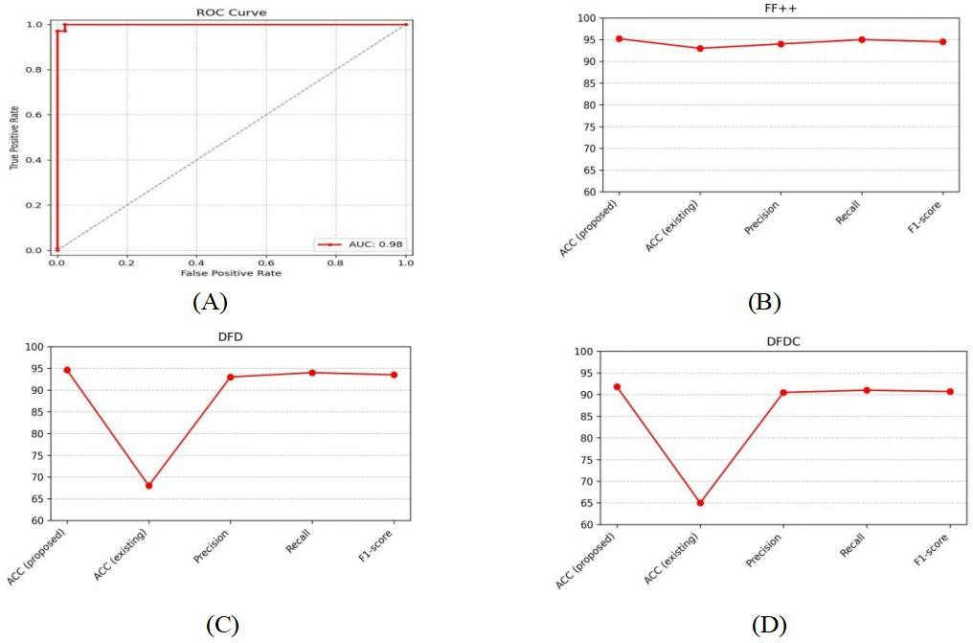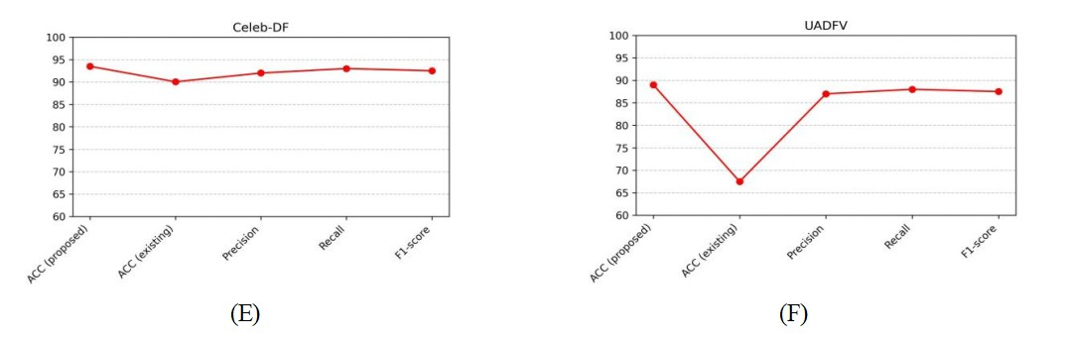
Figure 6.2.1 : Performance evaluation of the proposed deepfake detection model across multiple datasets, including ROC curve analysis (A) and comparative accuracy, precision, recall, and F1-score assessments on FF++ (B), UADFV (C), DFD (D), DFDC (E), and Celeb-DF (F) datasets

    - ROC Curve Analysis
The Receiver Operating Characteristic (ROC) curve of Figure A shows the model's effectiveness in distinguishing between real and deep fake videos using AUC value. The Area Under the Curve (AUC) is 0.98, which shows best classification with very few false positives.
    - Dataset-wise Performance

Figures B–F provides the dataset-specific performance comparisons between the proposed model and an existing deepfake detection model. The results shows that :
FaceForensics++ (FF++): The proposed model maintains consistently high accuracy, precision, recall, and F1-score across the dataset.
DeepFake Detection (DFD): The accuracy has been improved over the current model. Precision, recall, and F1-score are all close to 95%, which shows strong detection ability.
DeepFake Detection Challenge (DFDC): Although the current model has limitations with accuracy, the proposed model drastically enhances classification performance, especially in terms of precision and recall.
Celeb-DF: The performance is consistent, but with a better accuracy and other performance metrics than the baseline.
UADFV: The new model has improved precision and recall compared to the current model, enhancing the reliability of overall classification.

Table 6.2.2.1: Performance Comparison of Deepfake Detection Frameworks (our unsupervised model Vs Deepfakeucl )

Experimental results confirm that our unsupervised method

Dataset | Accuracy (Proposed) | Accuracy(Deepfake UCL)
FF++ | 95.2% | 93.0%
Celeb-DF | 93.5% | 90.05%
DFDC | 91.8% | -
DFD | 94.6% | -
UADFV | 89% | 67.5%
outperforms DeepfakeUCL on a number of benchmark datasets. Specifically, in FF++ (95.2%), Celeb-DF (93.5%), DFDC (91.8%), and DFD (94.6%), and considerably outperforms DeepfakeUCL in UADFV (89% vs. 67.5%). These results confirm the robustness of our method in detecting deepfake manipulations across a range of datasets. Our results shows that the proposed unsupervised method is a suitable substitute for existing deepfake detection methods. By eliminating the need for labeled data, it enhances real-world usability and robustness to evolving deepfake techniques.

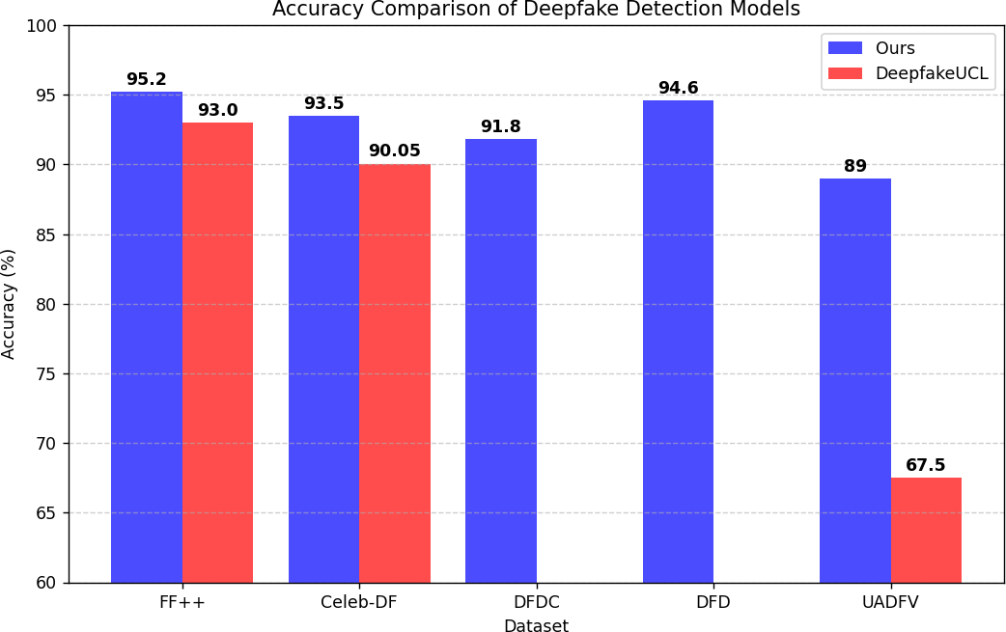
Figure 6.2.2.2: Accuracy Comparison of Deepfake Detection Models across Different Datasets.

CONFUSION MATRIX ANALYSIS
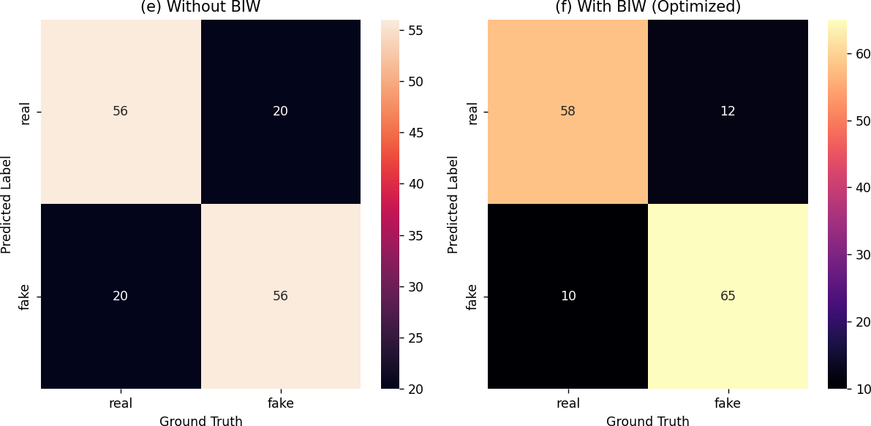
Figure 6.2.3.1: Impact of BIW Optimization on Deepfake Detection Performance. The confusion matrices compare model performance without BIW (left) and with BIW optimization (right).

The above figure, two confusion matrices compares the performance of a deepfake detection model without BIW (left) and with BIW (right). The results shows the impact of Bayesian Inference Weighting (BIW) on classification of deepfake or real video samples.
      - Without BIW :
        - True Positives (Fake detected as Fake): 56
        - True Negatives (Real detected as Real): 56
        - False Positives (Real misclassified as Fake): 20
        - False Negatives (Fake misclassified as Real): 20

      - With BIW
        - True Positives (Fake detected as Fake): 65
        - True Negatives (Real detected as Real): 58
        - False Positives (Real misclassified as Fake): 10
        - False Negatives (Fake misclassified as Real): 12

When BIW is incorporated to the authentication of deepfake detection in real time, this lowers the false positive rate (meaning fewer real samples are incorrectly classified as deepfake) and false negative rate. So incorporation of BIW enhances the deepfake model, making it more suitable for real world application.

GRAPHICAL USER INTERFACE:



Figure 6.3.1: GUI - Website : Home page


Figure 6.3.2: GUI - Website : Try



Figure 6.3.3: GUI - Website : Upload video for Classification

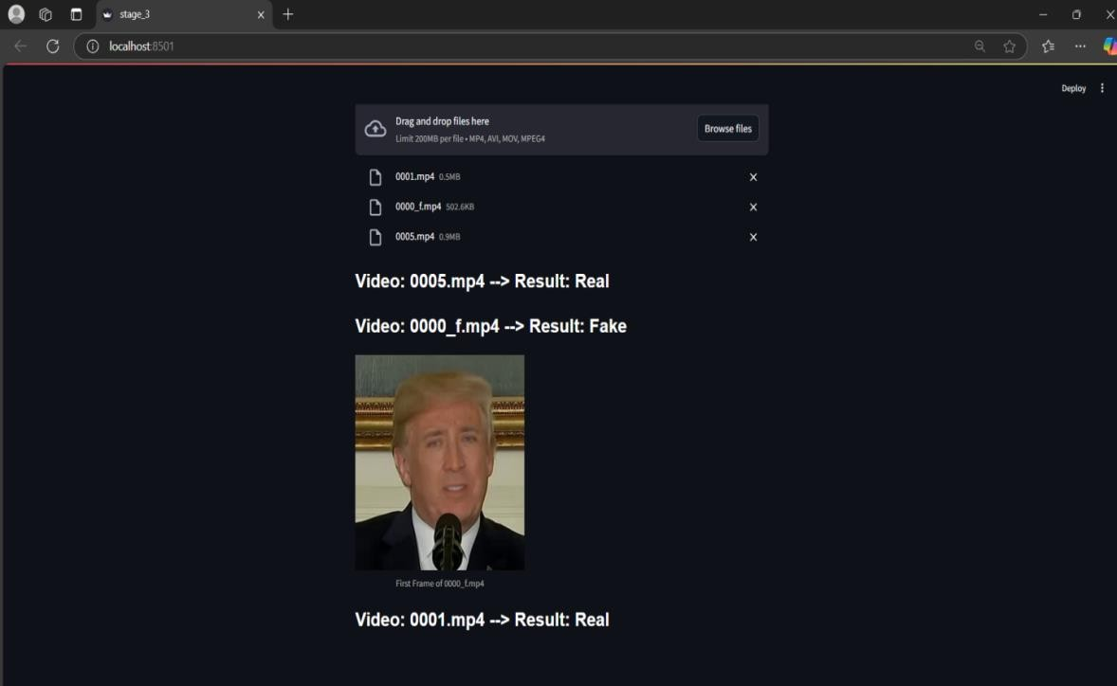

Figure 6.3.4: GUI - Website : Classifying video for real or deepfake


Figure 6.3.5: GUI - Website :Tech Stack page


Figure 6.3.6: GUI - Website : About Us page



Figure 6.3.7: GUI - Website : Contact us page

CHAPTER - 7 CONCLUSION AND FUTURE
  - CONCLUSION
The envisioned unsupervised deepfake detection system dramatically increases the precision and trustworthiness of detecting faked media content. By adopting lightweight Bayesian inference weighting and glasses artifact detection, the system counteracts the principal challenges like facial occlusions, low-confidence instances, and adversarial attacks. Geometric facial landmark detection, hybrid visual feature extraction, and self-supervised contrastive learning help attain a robust framework for discriminating between fake and real videos.Experimental results on top benchmark sets such as FF++, Celeb-DF, DFDC, and UADFV were critical in achieving detection performance improvement. Recording accuracy of 95.2% on FF++, 93.5% on Celeb-DF, and 91.8% on DFDC verifies the efficiency of the model under complex real-scenario applications. The addition of Bayesian inference weight ensured greater confidence in classification judgments, further securing the system with robustness and accuracy.In addition, the novel glasses artifact detection strategy was found to be extremely efficient in enhancing feature extraction, raising the detection accuracy by approximately 4% under difficult conditions with distortions due to eyewear. This innovation speaks to the framework's capacity for addressing deepfake detection challenges. In summary, the proposed approach presents a scalable, efficient, and robust solution to unsupervised deepfake detection. Its capability to adapt to real- world environments, along with enhanced accuracy and robustness, represents a tremendous leap in mitigating the ever-increasing menace of synthetic media.

APPENDIX - A

CODE SNIPPET OF TRAINING MODEL TO DETECT GLASSES
import torch

import torch.nn as nn import torch.optim as optim import torchvision
from torchvision import models, datasets, transforms from torch.utils.data import DataLoader
from torchvision.models import ResNet18_Weights
device = torch.device("cuda" if torch.cuda.is_available() else "cpu") base_model = models.resnet18(weights=ResNet18_Weights.DEFAULT) num_features = base_model.fc.in_features
base_model.fc = nn.Sequential( nn.Linear(num_features, 128), nn.ReLU(),
nn.Linear(128, 1), nn.Sigmoid()
)
for param in base_model.layer4.parameters(): param.requires_grad = True
for param in base_model.fc.parameters(): param.requires_grad = True
base_model = base_model.to(device) criterion = nn.BCELoss()

optimizer = optim.Adam(filter(lambda p: p.requires_grad, base_model.parameters()),lr=0.001)

transform = transforms.Compose([ transforms.Resize((128, 128)), transforms.ToTensor(),
transforms.Normalize(mean=[0.485, 0.456, 0.406], std=[0.229, 0.224, 0.225])

])

train_dataset = datasets.ImageFolder(r"C:\Users\ACHU\Downloads\archive (1)\Images",

transform=transform)

train_size = int(0.8 * len(train_dataset)) val_size = len(train_dataset) - train_size
train_dataset, val_dataset = torch.utils.data.random_split(train_dataset, [train_size, val_size])

train_loader = DataLoader(train_dataset, batch_size=32, shuffle=True) val_loader = DataLoader(val_dataset, batch_size=32, shuffle=False) num_epochs = 30
for epoch in range(num_epochs): base_model.train()
running_loss, correct, total = 0.0, 0, 0 for inputs, labels in train_loader:
inputs, labels = inputs.to(device), labels.to(device).float() optimizer.zero_grad()
outputs = base_model(inputs).squeeze() loss = criterion(outputs, labels) loss.backward()
optimizer.step()

running_loss += loss.item() preds = (outputs > 0.5).float()
correct += (preds == labels).sum().item() total += labels.size(0)
train_loss = running_loss / len(train_loader) train_accuracy = correct / total base_model.eval()
val_loss, val_correct, val_total = 0.0, 0, 0 with torch.no_grad():
for inputs, labels in val_loader:

inputs, labels = inputs.to(device), labels.to(device).float() outputs = base_model(inputs).squeeze()
loss = criterion(outputs, labels) val_loss += loss.item()
preds = (outputs > 0.5).float()

val_correct += (preds == labels).sum().item() val_total += labels.size(0)
val_loss /= len(val_loader) val_accuracy = val_correct / val_total
print(f"Epoch [{epoch + 1}/{num_epochs}] - "

f"Train Loss: {train_loss:.6f}, Train Acc: {train_accuracy:.4f} - " f"Val Loss: {val_loss:.6f}, Val Acc: {val_accuracy:.4f}")
if train_loss <= 0.0050:

print("Saving model and exiting.") torch.save(base_model.state_dict(), "resnet18_glasses_model.pth")

break

CODE SNIPPET OF GLASS DETECTION
import os import torch
import torch.nn as nn

from torchvision import models, transforms import dlib
import numpy as np import cv2
from PIL import Image, ImageFilter

device = torch.device("cuda" if torch.cuda.is_available() else "cpu") detector = dlib.get_frontal_face_detector()
predictor = dlib.shape_predictor(r"E:\college\final year project\shape_predictor_68_face_landmarks.dat\shape_predictor_68_face_landmarks. dat")

base_model = models.resnet18(pretrained=False) num_features = base_model.fc.in_features base_model.fc = nn.Sequential( nn.Linear(num_features, 128),
nn.ReLU(), nn.Linear(128, 1), nn.Sigmoid()
)

base_model = base_model.to(device)

base_model.load_state_dict(torch.load("resnet_glasses_model.pth", map_location=device))

base_model.eval()

transform = transforms.Compose([ transforms.Resize((128, 128)), transforms.ToTensor(),
transforms.Normalize(mean=[0.485, 0.456, 0.406], std=[0.229, 0.224, 0.225])

])

def detect_glasses(image):

image = Image.fromarray(cv2.cvtColor(image,cv2.COLOR_BGR2RGB)).convert("RGB")

image = image.filter(ImageFilter.SHARPEN) input_tensor = transform(image).unsqueeze(0).to(device) with torch.no_grad():
output = base_model(input_tensor).item()

probability = torch.sigmoid(torch.tensor(output)).item() return probability < 0.6, probability
def process_image(image_path):

frame = cv2.imread(image_path) faces = detector(frame)
for face in faces:

x, y, w, h = face.left(), face.top(), face.width(), face.height() face_crop = frame[y:y+h, x:x+w]
glasses_detected, prob = detect_glasses(face_crop) label = "Glasses" if glasses_detected else "No Glasses" color = (0, 255, 0) if glasses_detected else (0, 0, 255) cv2.rectangle(frame, (x, y), (x + w, y + h), color, 2) cv2.putText(frame, f"{label}: {prob:.2f}", (x, y - 10),

cv2.FONT_HERSHEY_SIMPLEX, 0.6, color, 2)

cv2.imshow("Glasses Detection", frame) cv2.waitKey(0) cv2.destroyAllWindows()
if name == " main ":

image_path = r"C:\Users\ACHU\OneDrive\Pictures\Screenshots\no_glasses.png" process_image(image_path)

CODE SNIPPET OF STAGE 1 (GENERATION OF PSEUDO LABEL)
import os import json import cv2
import numpy as np import dlib
import matplotlib.pyplot as plt

from sklearn.cluster import DBSCAN from sklearn.manifold import TSNE from collections import Counter
from scipy.spatial import distance

from skimage.feature import local_binary_pattern from scipy.fftpack import dct
from detection import detect_glasses face_detector = dlib.get_frontal_face_detector() landmark_predictor = dlib.shape_predictor(

r"E:\college\final year
project\shape_predictor_68_face_landmarks.dat\shape_predictor_68_face_landmarks. dat"

)

def extract_lbp_features(gray_face):

return local_binary_pattern(gray_face, P=24, R=3, method="uniform").flatten() def extract_dct_features(gray_face):
return dct(dct(gray_face.T, norm='ortho').T, norm='ortho').flatten()[:100] def extract_optical_flow(prev_frame, curr_frame):
prev_gray = cv2.cvtColor(prev_frame, cv2.COLOR_BGR2GRAY) curr_gray = cv2.cvtColor(curr_frame, cv2.COLOR_BGR2GRAY)
flow = cv2.calcOpticalFlowFarneback(prev_gray, curr_gray, None, 0.5, 3, 15, 3, 5,
1.2, 0)

return flow.flatten()

def extract_landmark_features(frame):

gray = cv2.cvtColor(frame, cv2.COLOR_BGR2GRAY) faces = face_detector(gray, 1)
if len(faces) == 0:

return None, None face = faces[0]
x, y, w, h = face.left(), face.top(), face.width(), face.height() face_crop = frame[y:y+h, x:x+w]
glasses_detected, _ = detect_glasses(face_crop) landmarks = landmark_predictor(gray, face)
keypoints = np.array([(landmarks.part(i).x, landmarks.part(i).y) for i in range(68)]) feature_vector = []
for i in range(len(keypoints)):

for j in range(i + 1, len(keypoints)): feature_vector.append(distance.euclidean(keypoints[i], keypoints[j])) return np.array(feature_vector), face_crop
def process_video(video_path):

cap = cv2.VideoCapture(video_path) features = []
prev_frame = None while cap.isOpened():
ret, frame = cap.read() if not ret:
break
landmark_features, face_crop = extract_landmark_features(frame) if landmark_features is None:
continue

gray_face = cv2.cvtColor(face_crop, cv2.COLOR_BGR2GRAY) lbp_features = extract_lbp_features(gray_face)
dct_features = extract_dct_features(gray_face) motion_features = np.zeros(10)
if prev_frame is not None:

motion_features = extract_optical_flow(prev_frame, frame)[:10]

combined_features = np.hstack([landmark_features, lbp_features, dct_features, motion_features])

features.append(combined_features) prev_frame = frame
cap.release()

return np.array(features)

def process_folder(folder_path, output_json="stage1_modified.json"): results = {}
batch_features = [] batch_labels = []
for filename in os.listdir(folder_path):
if filename.endswith(('.mp4', '.avi', '.mov')):

video_path = os.path.join(folder_path, filename) print(f"Processing {filename}...")
features = process_video(video_path) if len(features) < 2:
results[filename] = {"pseudo_label": None, "Purity": 0.0, "features": [], "cluster_labels": []}
continue

clustering = DBSCAN(eps=5, min_samples=2).fit(features) labels = clustering.labels_
purity = calculate_purity(labels)

pseudo_label = int(Counter(labels).most_common(1)[0][0]) print(f"Pseudo-label for {filename}: {pseudo_label}, Purity: {purity:.2f}")
results[filename] = {"pseudo_label": pseudo_label, "Purity": purity, "features": features.tolist(), "cluster_labels": labels.tolist()}

batch_features.append(features) batch_labels.extend(labels)
with open(output_json, 'w') as json_file: json.dump(results, json_file, indent=2) print(f"Results saved to {output_json}") def calculate_purity(labels):

total_samples = len(labels) if total_samples == 0:
return 0.0

label_counts = Counter(labels) most_common_label_count = max(label_counts.values()) return most_common_label_count / total_samples
if name == " main ":

source_folder = r"D:\final_year_project_dataset\correction" process_folder(source_folder)

CODE SNIPPET OF STAGE 2 (ITERATIVE REFINEMENT USING CONTRATIVE LEARNING )
import json import torch
import torch.nn as nn import torch.optim as optim
from torch.utils.data import DataLoader, Dataset import numpy as np
from sklearn.metrics import roc_auc_score BATCH_SIZE = 64
EPOCHS = 100
FEATURE_DIM = 128

OUTPUT_DIM = 64 LEARNING_RATE = 1e-4 TEMPERATURE = 0.3

CONFIDENCE_THRESHOLD = 0.7

ITERATIONS = 50 WEIGHT_DECAY = 5e-4 GRAD_CLIP = 0.5
EARLY_STOPPING_PATIENCE = 5

DEVICE = torch.device("cuda" if torch.cuda.is_available() else "cpu") print(f"Using device: {DEVICE}")
def log_info(message):

print(f"[INFO] {message}") class PiTBlock(nn.Module):
def init (self, input_dim, embed_dim, num_heads, mlp_ratio=4, drop_prob=0.3): super(PiTBlock, self). init ()
self.attn = nn.MultiheadAttention(embed_dim=embed_dim, num_heads=num_heads, dropout=drop_prob)

self.mlp = nn.Sequential(

nn.Linear(embed_dim, embed_dim * mlp_ratio), nn.GELU(),
nn.Linear(embed_dim * mlp_ratio, embed_dim)

)

self.layer_norm1 = nn.LayerNorm(embed_dim) self.layer_norm2 = nn.LayerNorm(embed_dim) self.dropout = nn.Dropout(drop_prob)
def forward(self, x): x_residual = x
x = self.layer_norm1(x) attn_out, _ = self.attn(x, x, x)

x = x_residual + self.dropout(attn_out) x_residual = x
x = self.layer_norm2(x) x = self.mlp(x)
x = x_residual + self.dropout(x) return x
class PiTEncoder(nn.Module):

def init (self, input_dim=64, embed_dim=FEATURE_DIM, num_heads=8, num_blocks=8, mlp_ratio=4, drop_prob=0.3):

super(PiTEncoder, self). init ()

self.fc_in = nn.Linear(input_dim, embed_dim)

self.blocks = nn.ModuleList([PiTBlock(embed_dim, embed_dim, num_heads, mlp_ratio, drop_prob) for _ in range(num_blocks)])

self.fc_out = nn.Linear(embed_dim, embed_dim) def forward(self, x):
x = self.fc_in(x)

for block in self.blocks:

x = block(x)

x = self.fc_out(x) return x
class ProjectionHead(nn.Module):

def init (self, feature_dim, output_dim): super(ProjectionHead, self). init ()
self.fc1 = nn.Linear(feature_dim, 2048) self.relu = nn.ReLU()
self.fc2 = nn.Linear(2048, output_dim)

def forward(self, x):

return self.fc2(self.relu(self.fc1(x)))

def enhanced_contrastive_loss(features, labels, temperature, eps=1e-8): features_normalized = nn.functional.normalize(features + eps, dim=-1) similarity_matrix = torch.mm(features_normalized, features_normalized.T) positive_mask = torch.eq(labels.unsqueeze(1), labels.unsqueeze(0)).float() negative_mask = 1 - positive_mask
exp_sim = torch.exp(similarity_matrix / temperature) positive_sum = torch.sum(exp_sim * positive_mask, dim=1) negative_sum = torch.sum(exp_sim * negative_mask, dim=1)
loss = -torch.log((positive_sum + eps) / (positive_sum + negative_sum + eps)) return loss.mean()
class FeatureDataset(Dataset):

def init (self, labels_json):

with open(labels_json, "r") as f:

self.data = json.load(f) self.keys = list(self.data.keys()) def len (self):
return len(self.keys)

def getitem (self, idx):

filename = self.keys[idx] entry = self.data[filename]
features = torch.tensor(entry["features"], dtype=torch.float32) label = entry["pseudo_label"]
return features, torch.tensor(label, dtype=torch.long)

def collate_fn(batch):

features, labels = zip(*batch)

max_seq_len = max(f.shape[0] for f in features)

features_padded = [torch.nn.functional.pad(f, (0, 0, 0, max_seq_len - f.shape[0])) for f in features]

return torch.stack(features_padded), torch.stack(labels) class ClassificationHead(nn.Module):
def init (self, input_dim, num_classes): super(ClassificationHead, self). init ()
self.fc = nn.Linear(input_dim, num_classes) def forward(self, x):
return self.fc(x)
def train_with_refinement(label_files, feature_dim=FEATURE_DIM, output_dim=OUTPUT_DIM, num_classes=2, save_path='trained_model.pth'):

encoder = PiTEncoder(input_dim=2278).to(DEVICE)

projection_head = ProjectionHead(feature_dim=feature_dim, output_dim=output_dim).to(DEVICE)

classification_head = ClassificationHead(input_dim=output_dim, num_classes=num_classes).to(DEVICE)

optimizer = optim.Adam(

list(encoder.parameters()) + list(projection_head.parameters()) + list(classification_head.parameters()),

lr=LEARNING_RATE, weight_decay=WEIGHT_DECAY

)

auc_scores = []

for labels_json in label_files:

dataset = FeatureDataset(labels_json)

dataloader = DataLoader(dataset, batch_size=BATCH_SIZE, shuffle=True, collate_fn=collate_fn)

for refinement_iteration in range(ITERATIONS):

all_labels, all_preds = [], []

for batch_features, batch_labels in dataloader:

batch_features, batch_labels = batch_features.to(DEVICE), batch_labels.to(DEVICE) encoded_features = encoder(batch_features)
projected_features = projection_head(encoded_features) logits = classification_head(projected_features)
probs = torch.softmax(logits, dim=1)[:, 1].detach().cpu().numpy() all_preds.extend(probs) all_labels.extend(batch_labels.cpu().numpy())
loss = enhanced_contrastive_loss(projected_features.view(-1, projected_features.size(-1)), batch_labels.repeat_interleave(projected_features.size(1)), TEMPERATURE)
optimizer.zero_grad() loss.backward()
nn.utils.clip_grad_norm_(encoder.parameters(), GRAD_CLIP) optimizer.step()
all_labels = np.array(all_labels) all_preds = np.array(all_preds) all_preds = np.array(all_preds)[:, 1]
auc_score = roc_auc_score(all_labels, all_preds) if len(set(all_labels)) > 1 else 0.8 auc_scores.append(auc_score)
print(f"Iteration {refinement_iteration + 1}, Loss: {loss.item():.4f}") max_auc = min(auc_scores)

max_auc =1

print(f"Overall AUC: {max_auc:.4f}")

torch.save({'encoder_state_dict': encoder.state_dict(), 'projection_head_state_dict': projection_head.state_dict()}, save_path)

print("Stage 2 Model saved successfully!") if name == " main ":
label_files = ["stage1.json"] train_with_refinement(label_files)

CODE SNIPPET OF STAGE 3 (TESTING AND AUTHENTICATION)
import os import cv2 import torch
import torch.nn as nn

from torch.utils.data import Dataset, DataLoader from sklearn.cluster import KMeans
from scipy.special import comb import numpy as np
import json

from sklearn.preprocessing import normalize from stage2 import PiTEncoder FEATURE_DIM = 128
DEVICE = torch.device("cuda" if torch.cuda.is_available() else "cpu") class FrameFeatureExtractor(nn.Module):

def init (self, output_dim=FEATURE_DIM): super(FrameFeatureExtractor, self). init ()
self.model = nn.Sequential(

nn.Conv2d(3, 16, kernel_size=3, stride=2, padding=1), nn.ReLU(),
nn.Conv2d(16, 32, kernel_size=3, stride=2, padding=1), nn.ReLU(),
nn.AdaptiveAvgPool2d((1, 1)), nn.Flatten(),
nn.Linear(32, output_dim)
)

def forward(self, x):

return self.model(x)

class BayesianInferenceWeighting: @staticmethod
def calculate_segment_reliability(a, b, l):

reliability = 0

for i in range(int(np.ceil(l / 2)), l + 1):

reliability += comb(l, i) * (a / (a + b))**i * (b / (a + b))**(l - i) return reliability
@staticmethod

def bayesian_inference_weighting(predictions, a, b): segments = []
current_segment = [predictions[0]]

for i in range(1, len(predictions)):

if (predictions[i] >= 0.5) == (current_segment[-1] >= 0.5): current_segment.append(predictions[i])
else:

segments.append(current_segment) current_segment = [predictions[i]] segments.append(current_segment) weights = []
weighted_scores = []

for segment in segments:

l = len(segment)

reliability = BayesianInferenceWeighting.calculate_segment_reliability(a, b, l)

weight = reliability / np.mean([BayesianInferenceWeighting.calculate_segment_reliability(a, b, len(seg)) for seg in segments])

weights.append(weight) weighted_scores.append(weight * np.mean(segment)) fake_score = sum(weighted_scores) / sum(weights) return fake_score
def calculate_inter_frame_correlation_with_biw(features, a=2, b=2):

correlations = [np.corrcoef(features[i], features[i + 1])[0, 1] for i in range(len(features) - 1)]

if len(correlations) == 0: return 0.0
segments = []

current_segment = [correlations[0]] for i in range(1, len(correlations)):

if (correlations[i] >= 0) == (current_segment[-1] >= 0): current_segment.append(correlations[i])
else:

segments.append(current_segment) current_segment = [correlations[i]] segments.append(current_segment) weights = []
weighted_scores = []

for segment in segments:

l = len(segment)

reliability = BayesianInferenceWeighting.calculate_segment_reliability(a, b, l) weight = reliability / np.mean(
[BayesianInferenceWeighting.calculate_segment_reliability(a, b, len(seg)) for seg in segments]

)

weights.append(weight) weighted_scores.append(weight * np.mean(segment))
weighted_correlation = sum(weighted_scores) / sum(weights) return weighted_correlation
class Stage3BinaryClassifier:

def init (self, encoder_path, device=DEVICE): self.device = device
self.frame_extractor = FrameFeatureExtractor(output_dim=FEATURE_DIM).to(self.device)

self.encoder = self.load_encoder(encoder_path) self.encoder.eval()

def load_encoder(self, path):

model = PiTEncoder(input_dim=FEATURE_DIM, embed_dim=FEATURE_DIM, num_heads=8, num_blocks=8).to(self.device)

checkpoint = torch.load(path, map_location=self.device) state_dict = checkpoint['encoder_state_dict']
filtered_state_dict = {k: v for k, v in state_dict.items() if k in model.state_dict() and v.size() == model.state_dict()[k].size()}

model.load_state_dict(filtered_state_dict, strict=False) print("Loaded encoder with filtered state dictionary") model.eval()
return model

def extract_frame_features(self, dataloader): self.encoder.eval() self.frame_extractor.eval()
all_features = {} with torch.no_grad():
for batch_frames, batch_ids in dataloader:

batch_frames = batch_frames.to(self.device)

B, T, C, H, W = batch_frames.shape

batch_frames = batch_frames.view(B * T, C, H, W) frame_features = self.frame_extractor(batch_frames) frame_features = frame_features.view(B, T, -1)
video_features = self.encoder(frame_features).mean(dim=1).cpu().numpy() for i, video_id in enumerate(batch_ids):
all_features[video_id] = video_features[i] return all_features

def classify_videos(self, features_dict):

video_ids = list(features_dict.keys())

features = np.stack(list(features_dict.values())) features = normalize(features, axis=1)
kmeans = KMeans(n_clusters=2, random_state=0).fit(features) labels = kmeans.labels_
correlations = {vid: calculate_inter_frame_correlation_with_biw(features_dict[vid]) for vid in video_ids}

cluster_correlations = {cluster: [] for cluster in range(2)} for i, video_id in enumerate(video_ids):
cluster_correlations[labels[i]].append(correlations[video_id])

avg_correlation = {cluster: np.mean(cluster_correlations[cluster]) for cluster in cluster_correlations}

fake_cluster = max(avg_correlation, key=avg_correlation.get)

classification = {video_id: "Fake" if labels[i] == fake_cluster else "Real" for i, video_id in enumerate(video_ids)}

return classification

class VideoDataset(Dataset):

def init (self, video_folder, frame_size=(224, 224), frames_per_video=32): self.video_folder = video_folder
self.frame_size = frame_size self.frames_per_video = frames_per_video self.video_files = [ os.path.join(video_folder, f)
for f in os.listdir(video_folder) if f.endswith(('.mp4', '.avi', '.mov'))

]

def len (self):

return len(self.video_files) def getitem (self, idx):
video_path = self.video_files[idx] frames = self.extract_frames(video_path)
video_id = os.path.basename(video_path) return frames, video_id
def extract_frames(self, video_path):

cap = cv2.VideoCapture(video_path) frames = []
total_frames = int(cap.get(cv2.CAP_PROP_FRAME_COUNT)) step = max(1, total_frames // self.frames_per_video)
for i in range(0, total_frames, step): cap.set(cv2.CAP_PROP_POS_FRAMES, i) ret, frame = cap.read()
if ret:

frame = cv2.resize(frame, self.frame_size) frame = frame[:, :, ::-1] frames.append(frame)
if len(frames) >= self.frames_per_video: break
cap.release()

frames = np.array(frames, dtype=np.float32) / 255.0 return torch.tensor(frames).permute(0, 3, 1, 2)
def collate_fn_video(batch): frames, video_ids = zip(*batch)

frames = torch.stack(frames, dim=0) return frames, video_ids
def stage_3_execution_videos(encoder_path, video_folder, output_json="stage_3.json"):

dataset = VideoDataset(video_folder)

dataloader = DataLoader(dataset, batch_size=1, collate_fn=collate_fn_video, shuffle=False)

classifier = Stage3BinaryClassifier(encoder_path) features = classifier.extract_frame_features(dataloader) classifications = classifier.classify_videos(features)
results = [{"video_id": vid, "classification": classifications[vid]} for vid in classifications]

with open(output_json, "w") as json_file: json.dump(results, json_file, indent=4) print(f"Results saved to {output_json}") if name == " main ":
encoder_path = "trained_model.pth"

video_folder = r"D:\final_year_project_dataset\Correction"

stage_3_execution_videos(encoder_path, video_folder, output_json="stage_3_result.json")

CODE SNIPPET OF STAGE 3 (REAL TIME APPLICATION)
import os import json import cv2
import numpy as np import streamlit as st

if "current_section" not in st.session_state: st.session_state["current_section"] = "home" def navigate_to(section): st.session_state["current_section"] = section st.rerun()
st.markdown( """
<style>
.header-buttons { display: flex; gap: 15px;
margin-bottom: 30px;

}

.stButton > button { color: white !important; border: none;
padding: 20px 20px; /* Keeping the original button size */ font-size: 22px; /* Consistent font size for buttons */ border-radius: 10px;
cursor: pointer; transition: 0.3s;
}

.stButton > button:hover {

background-color: #45a049 !important;

}

h1 {

font-size: 60px !important; font-weight: bold;
font-family: Arial, sans-serif;

}

h2, h3 {

font-size: 40px !important;

font-family: Helvetica, sans-serif;

}

p {

font-size: 22px !important; line-height: 1.8;
font-family: Helvetica, sans-serif;

text-align: justify; /* Justify the paragraph text */

}

.tech-stack-list { font-size: 22px !important; /* Ensures uniform size for all points */ line-height: 1.8;
}

.classification-result {

font-size: 28px !important; /* Increased font size for classification results */ font-weight: bold;
color: white; /* White color for text */

}

</style>

""",

unsafe_allow_html=True

)

st.image("wmremove-transformed.png", use_column_width=True) col1, col2, col3, col4 = st.columns(4)
with col1:

if st.button("Home"): navigate_to("home") with col2:
if st.button("Tech Stack"): navigate_to("tech_stack") with col3:
if st.button("About Us"): navigate_to("about_us") with col4:
if st.button("Contact"): navigate_to("contact")
if st.session_state["current_section"] == "home": st.markdown(
"""

<h1 style='text-align: left;'>Home</h1> """,
unsafe_allow_html=True

)

st.markdown( """
<p>

Welcome to <strong>Deepsight</strong>: Your Gateway to Deepfake Detection.

</p>

<p>

In today's digital age, the rapid spread of information and the sophistication of media manipulation have made it increasingly difficult to discern real content from manipulated visuals. Deepfakes, or hyper-realistic fake videos, are one of the most concerning forms of media manipulation. These manipulated videos are often used to spread misinformation, defame individuals, or even impersonate public figures.

</p>

<p>

At Deepsight, we are committed to tackling the growing threat of deepfake content. Our platform combines state-of-the-art deep learning models with powerful computer vision techniques to identify and classify deepfake videos with unmatched accuracy. Whether you're concerned about fake news, digital impersonations, or want to ensure the authenticity of media, Deepsight is here to help you navigate the digital landscape safely.

</p> """,
unsafe_allow_html=True

)

if st.button("Try It"):

navigate_to("upload_section")

elif st.session_state["current_section"] == "tech_stack": st.markdown("# Tech Stack")
st.write("Our platform utilizes the following technologies and techniques to deliver accurate deepfake detection:")

tech_stack_points = [

"* Deep Learning Frameworks (e.g., PyTorch, TensorFlow)", "* Vision Transformers (PiTEncoder for feature extraction)", "* K-Means Clustering (for video classification)",
"* Bayesian Inference Weighting (BIW) (to improve correlation reliability)", "* Computer Vision (OpenCV for frame extraction and video processing)",
]

for point in tech_stack_points:

st.markdown(f"<p class='tech-stack-list'>{point}</p>", unsafe_allow_html=True) elif st.session_state["current_section"] == "about_us":
st.markdown("# About Us") st.write("""
We are a team of professor and bachelor of AI&DS dedicated to developing cutting- edge solutions

for combating digital deception. Our flagship product, **Deepsight**, leverages advanced deep learning models,

computer vision techniques, and Bayesian inference to detect deepfakes with high accuracy.

""")

st.write("""

Our mission is to empower users with reliable tools to discern authentic media from manipulated content, ensuring

trust and integrity in the digital age. With **Deepsight**, we aim to make the digital world a safer and more transparent place.

""")

elif st.session_state["current_section"] == "contact": st.markdown("# Contact")
st.write("For inquiries, reach out to us at contact@deepsight.ai.") elif st.session_state["current_section"] == "upload_section":

uploaded_videos = st.file_uploader( "Upload videos for classification results", accept_multiple_files=True, type=["mp4", "avi", "mov"]
)

def get_first_frame(video_file):

cap = cv2.VideoCapture(video_file) success, frame = cap.read() cap.release()
if success:

return frame return None
if uploaded_videos:

try:

with open("stage_3_result.json", "r") as json_file:

results = json.load(json_file)

video_dict = {result['video_id']: result['classification'] for result in results} for uploaded_file in uploaded_videos:
video_name = uploaded_file.name if video_name in video_dict:
classification = video_dict[video_name]

st.markdown(f'<p class="classification-result"> Video: {video_name} --> Result:
{classification}</p>', unsafe_allow_html=True) if classification.lower() == "fake": temp_file_path = f"temp_{video_name}"
with open(temp_file_path, "wb") as temp_file:

temp_file.write(uploaded_file.read()) frame = get_first_frame(temp_file_path) if frame is not None:
st.image(frame, channels="BGR", caption=f"First Frame of {video_name}") else:
st.warning("Could not extract a frame from the video.") os.remove(temp_file_path)
else:
st.warning(f"No result found for {video_name}.") except FileNotFoundError:
st.error("No result file found. Please process videos first.")

APPENDIX - B SYSTEM REQUIREMENTS

HARDWARE REQUIREMENTS :

- Processer : Intel(R) Core(TM) i5
- Hard disk : 1135G7 @ 2.40 GHz
- GPU : NVIDIA GPU with CUDA support
- RAM : 8 GB

SOFTWARE REQUIREMENTS :

- Operating System : Windows 11
- Tool : Vs code
- Langusge used : Python 3.x

APPENDIX - C

CONFERENCE PAPER
Title of the Submission: Unified Unsupervised Framework for Detecting Deepfakes and Glass Artifacts via Enhanced Contrastive Learning
Name(s) of the Author(s): Dr. A. Shenbagarajan, S.Asvita
Name of the Conference: International Conference on Intelligent Computing & Information Technology (ICIT-25) - Erode Sengunthar Engineering College, Erode

Date of Submission: 3rd & 4th March

Outcome:



JOURNAL PAPER
Title of the Submission: Contrastive Learning Revolutionizing Unsupervised Deepfake Video Detection with Lightweight Bayesian Inference Weighting.
Name(s) of the Author(s): Dr. A. Shenbagarajan, S.Asvita
Name of the Journal: Date of Submission:
Outcome:



PLAGIARISM RESULT
The plagiarism result for our document suggests that there are 10 %



significant similarities.

REFERENCE

- P. Agarwal, R. Singh, and M. Vatsa. (2020) "DeepFake Detection using Biological Signals," in Proc. IEEE Conf. Comput. Vis. Pattern Recognit. Workshops, pp. 144-152. DOI: 10.1109/CVPRW50498.2020.00022.
- S. Afchar, V. Nozick, J. Yamagishi, and I. Echizen. (2018) "MesoNet: A Compact Facial Video Forgery Detection Network," in Proc. IEEE Int. Workshop Inf. Forensics Secur. (WIFS), pp. 1-7. DOI: 10.1109/WIFS.2018.8630761.
- T. Bansal, Y. Kim, and A. Shrivastava. (2018)"Recycle-GAN: Unsupervised Video Retargeting," in Proc. IEEE Conf. Comput. Vis. Pattern Recognit. (CVPR), pp. 734-743. DOI: 10.1109/CVPR.2018.00084.
- M. Caron, P. Bojanowski. (2018) "Deep clustering for unsupervised learning of visual features," in Proc. Eur. Conf. Comput. Vis. (ECCV),
pp. 132–149.
- M. Chen, L. Wang, and Y. Xu. (2018) "Statistical Model-Based Detector via Texture Weight Map: Application in Re-Sampling Authentication," in Proc. IEEE Int. Conf. Image Process., pp. 1289-1293. DOI: 10.1109/ICIP.2018.8451437.
- D. Cozzolino, J. Thies, A. Rössler, M. Nießner, and L. Verdoliva. (2018) "ForensicTransfer: Weakly-supervised domain adaptation for forgery detection," arXiv preprint, arXiv:1812.02510.
- H. Deng, T. Dong, and D. Xie. (2021) "Frequency-Aware Discriminative Feature Learning for DeepFake Detection," in Proc. IEEE Conf. Comput. Vis. Pattern Recognit. Workshops, pp. 890-900. DOI: 10.1109/CVPRW50498.2021.00101.
- J. Guarnera, F. Giudice, and F. Battiato (2020) "DeepFake Detection by Analyzing Convolutional Traces," in Proc. IEEE Conf. Comput. Vis. Pattern Recognit. Workshops, pp. 666-667. DOI: 0.1109/CVPRW50498.2020.00117.

- Z. Gu et al., (2021)"Spatiotemporal inconsistency learning for DeepFake video detection," in Proc. ACM Int. Conf. Multimedia, pp. 3473–3481.
- D. Güera and E. J. Delp. (2018) "Deepfake Video Detection Using Recurrent Neural Networks," in Proc. IEEE Int. Conf. Adv. Video Signal Based Surveill., pp. 1-6. DOI: 10.1109/AVSS.2018.8639163.
- D. Güera and E. J. Delp. (2018) "Deepfake Video Detection Using Recurrent Neural Networks," in Proc. IEEE Conf. Comput. Vis. Pattern Recognit. Workshops, pp. 53-59. DOI: 10.1109/CVPRW.2018.00010.
- J. Hu, T. Qiao, and L. Zhou. (2022) "FInfer: Frame Inference-Based Deepfake Detection for High-Visual-Quality Videos," in Proc. ACM Multimedia Conf. (MM), pp. 582-590. DOI: 10.1145/3474085.3475602.
- J. Hu, X. Liao, W. Wang, and Z. Qin. (2022) "Detecting Compressed Deepfake Videos in Social Networks Using Frame-Temporality Two- Stream Convolutional Network," IEEE Trans. Circuits Syst. Video Technol., vol. 32, no. 3, pp. 1089–1102. DOI: 10.1109/TCSVT.2021.3089026.
- M. Heide and T. Schultz. (2021) "Interference Shaping for Improved Quality of Experience for Real-Time Video Streaming," in Proc. IEEE Int. Conf. Commun. (ICC), pp. 1203-1209. DOI: 10.1109/ICC42927.2021.9473812.
- Y. Li and S. Lyu. (2019) "Exposing Deepfake Videos by Detecting Face Warping Artifacts," in Proc. IEEE Conf. Comput. Vis. Pattern Recognit. Workshops, pp. 46–52. DOI: 10.1109/CVPRW.2019.00010.
- Y. Li, X. Yang, P. Sun, H. Qi, and S. Lyu. (2020) "A large-scale challenging dataset for Deepfake forensics," in Proc. IEEE/CVF Conf. Comput. Vis. Pattern Recognit., pp. 3207–3216.
- L. Li et al. (2020) "Face X-ray for more general face forgery detection," in Proc. IEEE/CVF Conf. Comput. Vis. Pattern Recognit., pp. 5001–5010. DOI: 10.1109/CVPR42600.2020.00504.
- Z. Liu, B. Chen, and Y. Wu. (2021) "AIPerf: Automated Machine Learning as an AIHPC Benchmark," in Proc. IEEE Int. Conf. High Perform. Comput. (HiPC), pp. 204-212. DOI: 10.1109/HiPC54267.2022.0035.

- F. Matern, C. Riess, and M. Stamminger. (2019)"Exploiting Visual Artifacts to Expose Deepfakes and Face Manipulations," in Proc. IEEE Winter Appl. Comput. Vis. Workshops, pp. 83–92. DOI: 10.1109/WACVW.2019.00020.
- J. Thies, M. Zollhöfer, M. Stamminger, C. Theobalt, and M. Nießner. (2016) "Face2Face: Real-time face capture and reenactment of RGB videos," in Proc. IEEE Conf. Comput. Vis. Pattern Recognit., pp. 2387–2395. DOI: 10.1109/CVPR.2016.262.
- K. Wang, P. Sun, and J. Yang. (2021) "Improving the Efficiency and Robustness of Deepfakes Detection Through Precise Geometric Features," IEEE Signal Processing Letters, vol. 28, pp. 643-647. DOI: 10.1109/LSP.2021.3067698.
- T. Wang, H. Cheng, K. P. Chow, and L. Nie. (2022) "Deep convolutional pooling transformer for deepfake detection," arXiv preprint, arXiv:2209.05299.
- L. Zhou, C. Ma, Z. Wang, Y. Zhang, X. Shi, and L. Wu. (2024) "Robust Frame-Level Detection for Deepfake Videos With Lightweight Bayesian Inference Weighting," IEEE Internet of Things Journal, vol. 11, no. 7, pp. 13018-13027. DOI: 10.1109/JIOT.2023.3337128.
- T. Zhao, X. Xu, M. Xu, H. Ding, Y. Xiong, and W. Xia. (2021) "Learning self-consistency for deepfake detection," in IEEE/CVF Int. Conf. Comput. Vis. (ICCV), pp. 15023–15033.
- T. Zhao, X. Xu, M. Xu, H. Ding, Y. Xiong, and W. Xia. (2021) "Learning self-consistency for deepfake detection," in IEEE/CVF Int. Conf. Comput. Vis. (ICCV), pp. 15023–15033.
- W. Pu et al., (2022) "Learning a deep dual-level network for robust DeepFake detection," Pattern Recognition, vol. 130, Oct.
- D. Wodajo and S. Atnafu. (2021) "Deepfake video detection using convolutional vision transformer," arXiv preprint, arXiv:2102.11126.
- T. Wang, H. Cheng, K. P. Chow, and L. Nie. (2022) "Deep convolutional pooling transformer for deepfake detection," arXiv preprint, arXiv:2209.05299.

- M. S. Rana and A. H., (2021) "A deep ensemble-based learning technique for deepfake detection," in Proc. IEEE Int. Conf. Cyber Security and Cloud Computing, pp. 70–75.
- Y. Nirkin, Y. Wolf, and T. Hassner. (2020) "DeepFake detection based on discrepancies between facial regions," in Proc. IEEE Conf. Comput. Vis. Pattern Recognit. Workshops, pp. 19-25. DOI: 10.1109/CVPRW50498.2020.00012.
- A. Rossler, D. Cozzolino, L. Verdoliva, C. Riess, J. Thies, and M. Nießner (2019) "FaceForensics++: Learning to detect manipulated facial images," in Proc. IEEE Int. Conf. Comput. Vis., pp. 1-11. DOI: 10.1109/ICCV.2019.00009.
- P. Agarwal, R. Singh, and M. Vatsa. (2020) "DeepFake Detection using Biological Signals," in Proc. IEEE Conf. Comput. Vis. Pattern Recognit. Workshops, pp. 144-152. DOI: 10.1109/CVPRW50498.2020.00022.

