**Requirements**

**Introduction**

* Over 1.30 lakhs deaths happening every year from street mishaps, with further of around 35 to 750 lakhs individuals experiencing mellow wounds because of street mishaps. In a review directed by the World Health Organization on street mishaps dependent on to pay status of nation, shown as low and centre pay and other option is non-industrial nations to have the most elevated many of street mishap-related deaths.
* Non-industrial nations have street mishaps passing a pace of about 26.5 per 110,000 populaces, which is a lot higher when contrasted with the 13.3 per 100,000 popular for major league salary or created nations.
* Convolutional Neural Networks (CNN) extract spatial features and Long Short-Term Memory (LSTM) networks learn the sequences. The street mishaps lead to loss of human life and crippling.
* The street mishaps lead to loss of human life and crippling. It was noted, with profound worry that majority of deaths happen because of late reaction by crisis benefits particularly for mishap happening in distant territories or around evening time.
* This project seeks to know whether there is any mishap done or no mishap. The classification, using an CNN-LSTM model achieves an accuracy of 95%.

**Research**

* They have attempted to contrast our work and other mishap location procedures.
* The greater part of the examinations in this field spin around the upgrade of unmistakable foundation as opposed to on Intelligent Transportation Frameworks (ITS) which incorporate gridlock location, mishap location, identifying the event of an occasion, and so on Indeed, even the couple of existing examinations in the area need usage subtleties and are territory explicit for example there are imperatives both in the geological just as segment viewpoints.
* SoSmart SpA thought about a mobile phone application called SOSmart which gave free assistance to the overcomer of the incident at the hour of the occasion, The workplace was definitely not hard to use and you could benefit help at the snap of a catch. In any case, the obvious flaw it is a manual uncovering system.

**Cost and Features**

**Cost**

* Since the system uses only open source software, it is free of cost.

**Features**

* This model takes user input videos. The input videos are fed to the model and the model analyses the whether the accident occurred or no accident. If the Accident occurs it sounds like an alarm. The process will continue until the user closes the program.

## Product Perspective

* This model is an accident detection which shows whether accident or no accident, which can be seen by the operator in the control room.
* The model identifies the anomaly and detects an accident or no accident If the accident occurs it sounds the alarm.

## Operating Environment

* This project runs on any platform with adequate memory and supports Python 3 and libraries, for example, Tensor stream and Kera's. More insights concerning Hardware and Software stages on which undertaking was created is given in section Convolutional Neural Network.

**Simple Design**

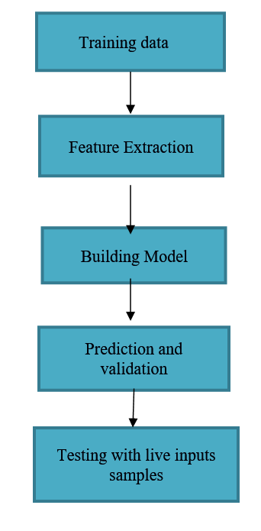

**SWOT ANALYSIS**

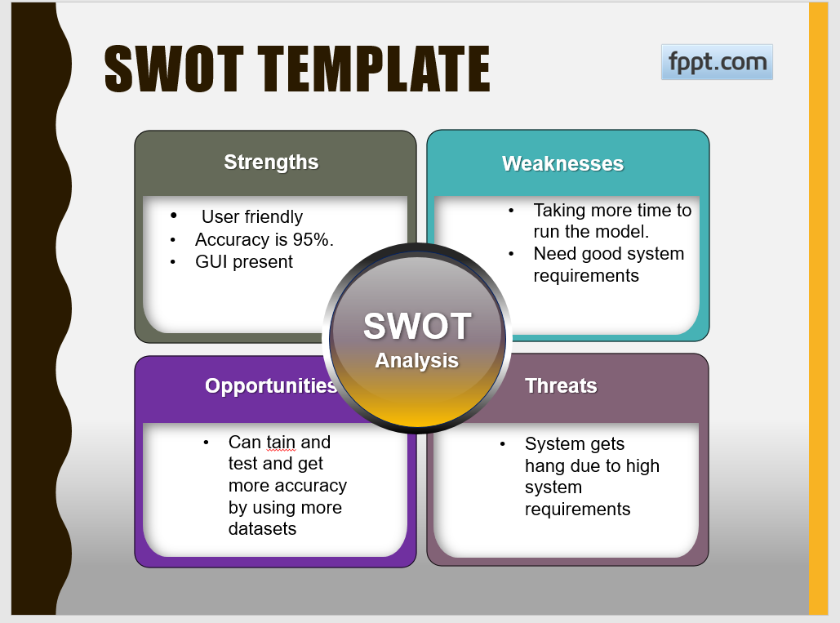

**4W's and 1'H**

**Who:**

* It will help to the person who met with an accident and not able to contact emergency crises.

**What:**

* After the person met with accident, it seconds alarm in control room who is using this software.

**When:**

* When person not in condition to contact emergency services, this software will help at that point of time.

**Where:**

* This software needs to be in control room, where all the cctv surveillance are present.

**How:**

* This project seeks to know whether there is any mishap done or no mishap, if accident is done it sounds alarm. So the person in control room who is there is control room can immediately call to emergency services.

**Detail requirements:**

It describes the environment in which the project was executed.

The model as to handle a huge amount, of videos at least for the purpose of training and this requires a good amount of processor speed along with better RAM than what could handle the normal computational work. As an alternative, cloud labs could be made use of for better processing and faster training.

|  |  |
| --- | --- |
| Processors | Intel quad core i5 processor |
| CPU | 8250K CPU @ 2.1GHz |
| RAM | 8 GB |
| System category | 64 bit OS, x64-type processor |
| Storage | 1 TB |

**High level Software requirements**

|  |  |  |
| --- | --- | --- |
| Platforms | Features | Reasons |
| Google Colab | Runtime environment having both CPU and GPU | Open source platform, Fast execution in GPU environment, installing packages are easy, can load any large amount of data without any hassle |
| JupyterNotebook | Runtime environment | Open source Platform, Loading dataset and using it in our code is easy. |
| Coding Language | Python3.0 | Coding of Neural Networks is easy, huge collection of packages are available |
| Main Packages | Keras and Tensor flow | To build the neural network |

**Low level requirements:**

