

**ONLINE EXAMINATION PORTAL USER GUIDE**

**Team ID: 03**

**Team Members**

1. **Kartik Gupta (170101030)**
2. **Anubhav Tyagi (170101009)**
3. **Rutvik Ghughal (170101057)**
4. **Shubham Kumar (170101064)**
5. **Ch. Rohith Ravi Prabhu Teja (170101017)**
6. **Aranya Aryaman (170101011)**
7. **Chandra Prakash Meena (160101023)**
8. **Tushar Bhutada(170101073)**
9. **Mayank Baranwal (170101084)**
10. **Avneet Singh (170101015)**
11. **Nakka Sriharsha (170101040)**
12. **Sparsh Sinha (170101085)**
13. **Rythum Singla (170101058)**
14. **Pranay Garg (170101047)**
15. **Aviral Gupta (170101014)**
16. **Aviral Gupta (170101014)**

**CONTENTS**

1. Introduction
2. Home Page
   1. Signup
   2. login
3. Student Dashboard
4. Professor Dashboard
5. Admin Dashboard
6. Exam Window
7. Test Evaluation & Analysis

**1****. INTRODUCTION**

This software provides an examination environment and handles all related tasks.

This project includes:

* Login system secured by password
* Admin panel
* Making questions pool and generating random questions while taking test
* Switching to different questions as well as sections while attempting test
* Saving answers given by the candidate along with question
* Test evaluation and grade calculation
* Normalizing scores and generation of certificate
* And more…

**2. HOME PAGE**

This is the screen you land up on opening the application, where you will be choosing to

# Signup (For New Users)

Select whether you are a student or a professor.

* If you are a professor, Fill/Mark the following fields
  + **Username** (Remember this for future) - If username already exists, you won’t be allowed to make a profile with that username as it is unique.
  + **Password**- Choose the password for your account. (Remember this to login later)
  + **Confirm Password**- Re-Enter your Password to confirm it. It must be same as earlier.
  + **Full Name** - Your Name and Surname with a space in between
  + **IITG Check Box**- If you are a member of IITG, check the box adjacent to it.
  + **Branch** - Select the Branch from the list of branches available.
  + **Email**- Your Email ID from a verified Email Provider
  + **Phone No.** - Your personal contact number you want us to display (must be 10 digits)

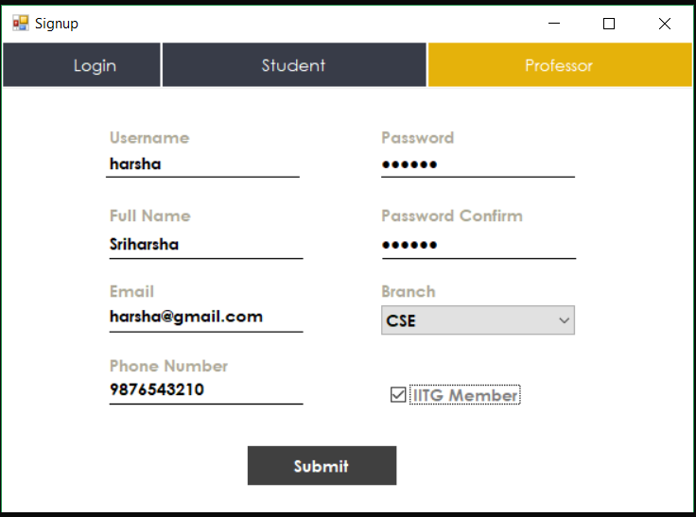

* If you are a student, you need to provide **Roll No.** along with the above details.

# Login (For Existing Users)

Under Login Form, we have two text fields, username & password.

* If you are already a member, Enter your credentials. If the user is a professor, he is directed to the prof’s profile page and similarly students will be directed to the student’s profile page.

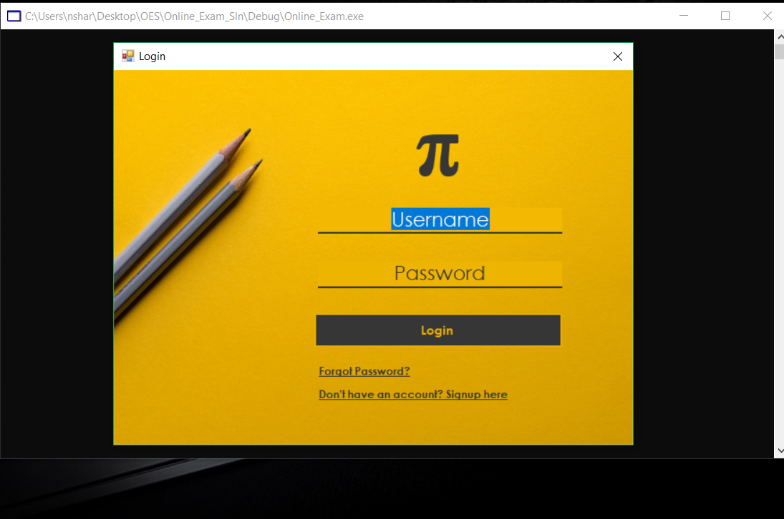

* If you are not a member, Click the hyperlink “Don’t have an account?”. After this click, you will be redirected to Signup Page.

**3.STUDENT DASHBOARD**

It also contains some buttons on left panel which helps him to configure his profile and examinations that are conducted and that he thinks to be conducted. The buttons are:

## My Profile

Here one can view their details like Username, Full name, Email ID, Phone Number, Department.

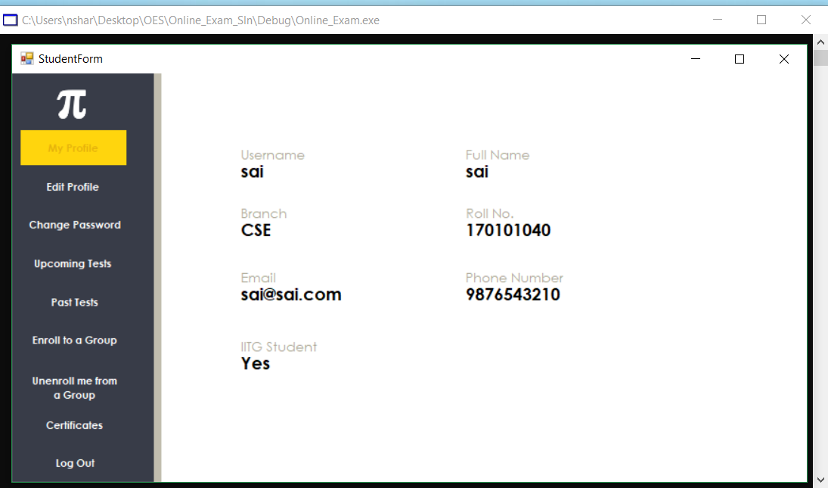

## Edit Profile

By clicking this button one can edit their details (except Username, Branch, IITG-Checkbox, Roll Number (if student)) that are displayed in their profile.

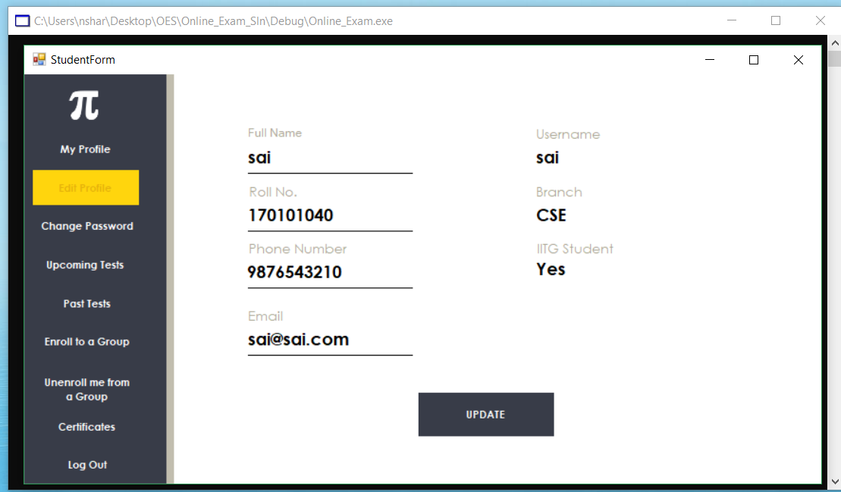

## Past Tests

This displays the tests given by them in the past along with some basic information about the exam.

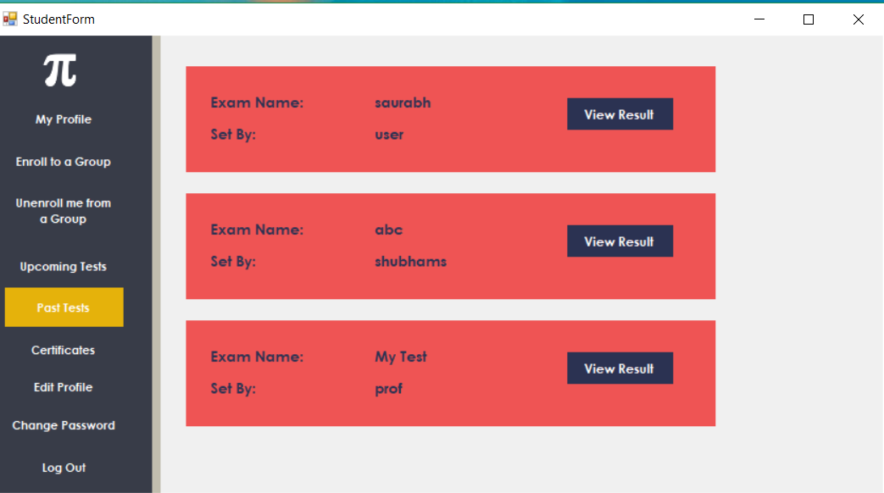

He can also view result of a particular exam.

(Refer 8.Test Analysis for its preview.)

## Upcoming tests

Student can view the exams that he can appear in future, created by professors for groups he is enrolled in.

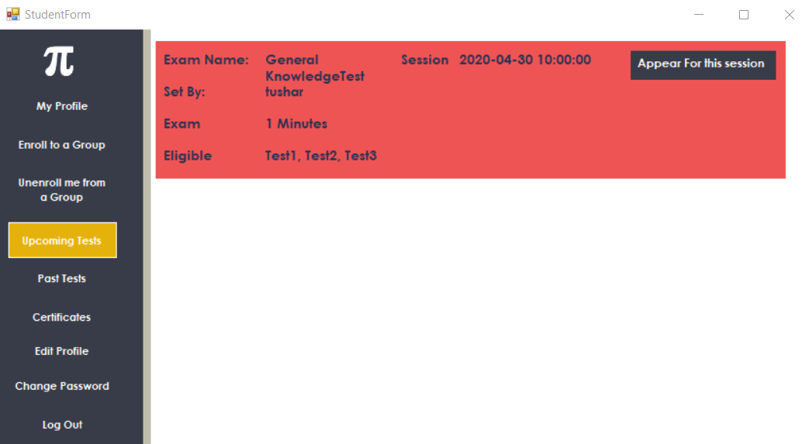

## Enroll to a group

Through this button student can join a group created by professor. Some groups don’t require an enrollment key while some demands one. If one is required student need to enter one.

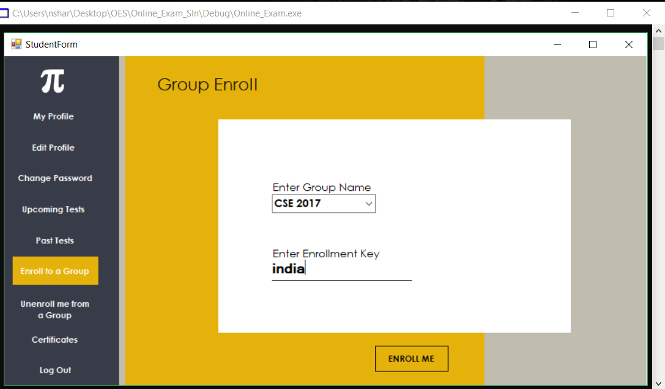

## Un-enroll from a group

By this student can leave any of the groups he is enrolled in.

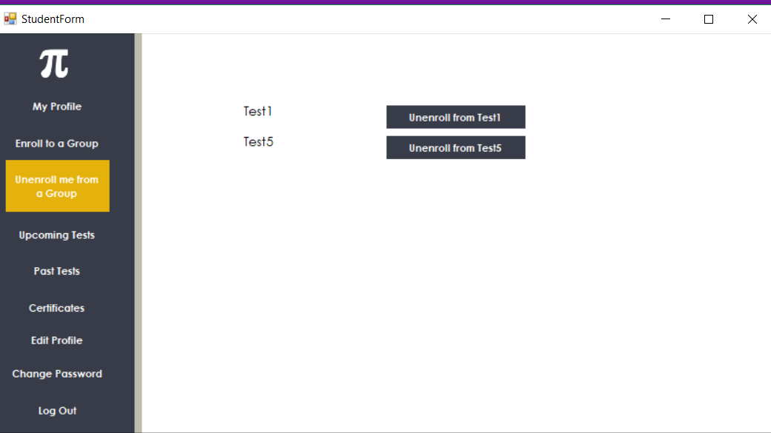

## Certificates

Student can view and print the certificates of the exams he/she has passed.



## Logout

This logs out them out of their current session.

**4.PROFESSOR DASHBOARD**

It also contains some buttons on left panel which helps him to configure his profile and examinations that are conducted and that he thinks to be conducted. The buttons are:

## My Profile

Here one can view their details like Username, Full name, Email ID, Phone Number, Department.

## Edit Profile

By clicking this button one can edit their details that are displayed in their profile



## Create a Group

This button enables one to create a group of users if he wants to be particular on the students who will be able to write the tests created. He can provide students an enrolment key which has to be entered while joining the group which will be cross-checked with the one given by professor.

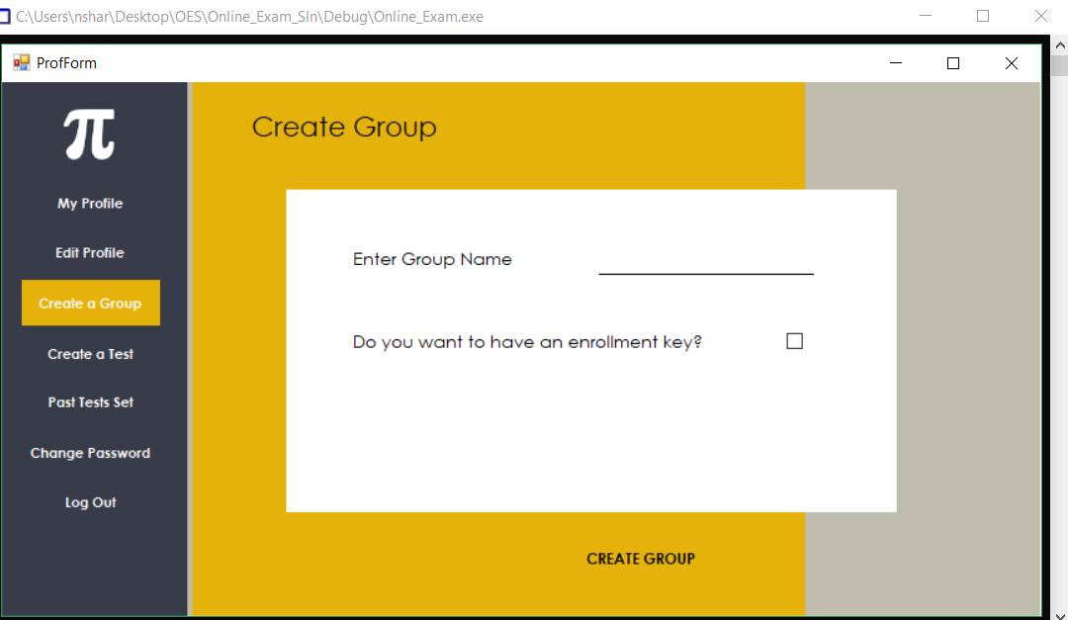

## Create a test

Through this one can create a new test. Details required to create one are:

* Test name
* Number of sections in the examination
* Weightage of marks for each section
* Number of questions in each section
* Pass percentage of the exam
* Groups that can appear for the examination
* Time slots in which the students can appear for the exam

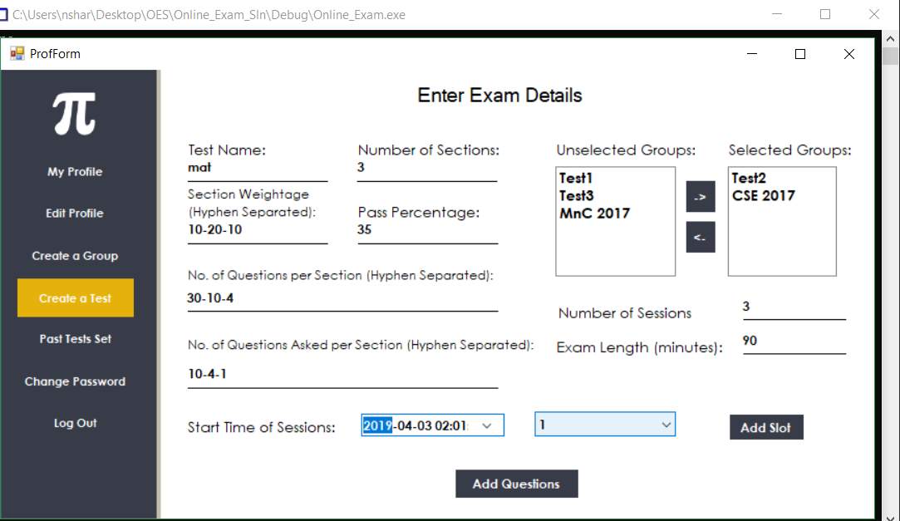

* Add Questions: While adding questions select the section, question number, type the question and choose the type of question (Multiple Choice Question / True-False / One Word) give correct answer and wrong options (for MCQ) then click Save and then Next. After adding all questions click Done.

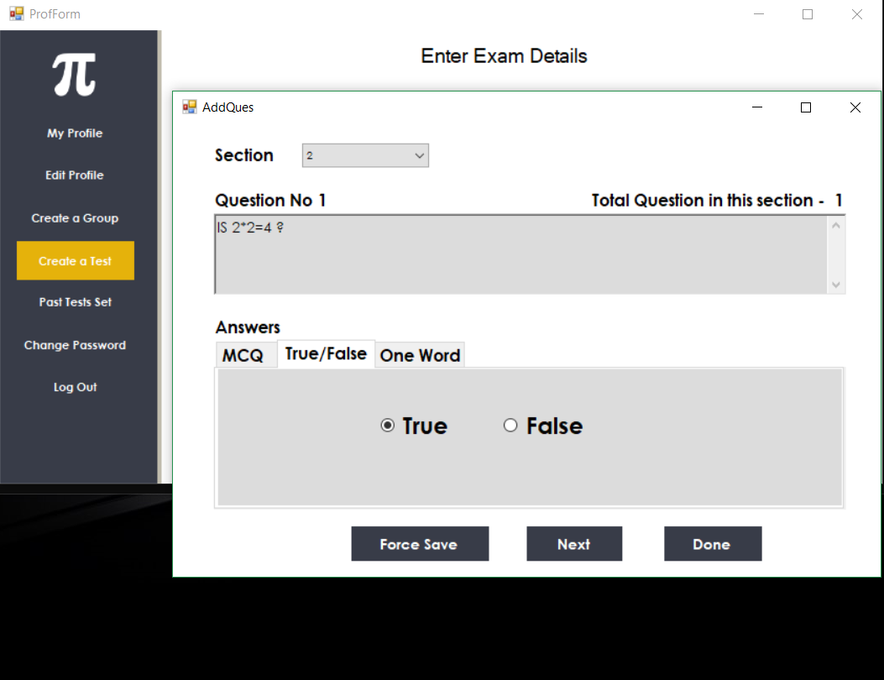

## Past Test Sets

This displays the tests created by them in the past along with some basic information about the exam like groups that were eligible to write it. They can also view the standings of students in it.

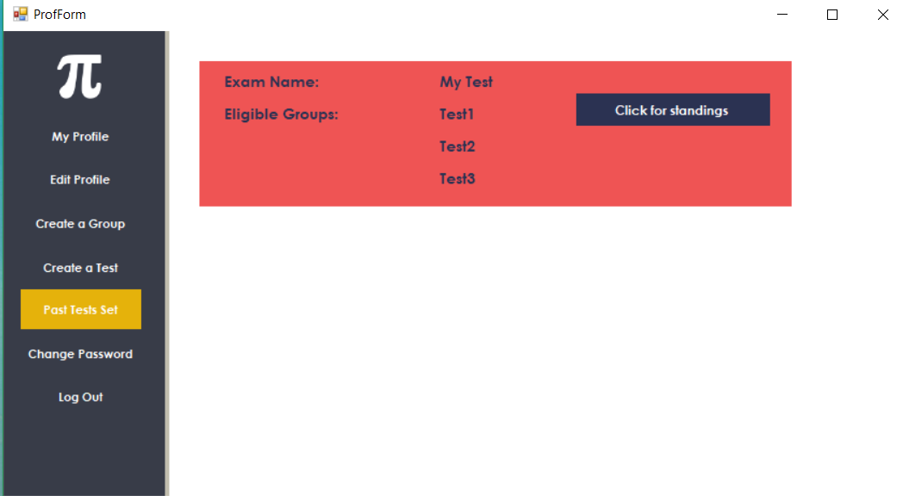

## Logout

This logs out them out of their current session.

**5.ADMIN DASHBOARD**

Admin is most privileged when it comes to managing the system.

Admin can:

## Approve Professors

When a professor signs up his details are sent to Admin, who cross checks details provided and approves him/her.

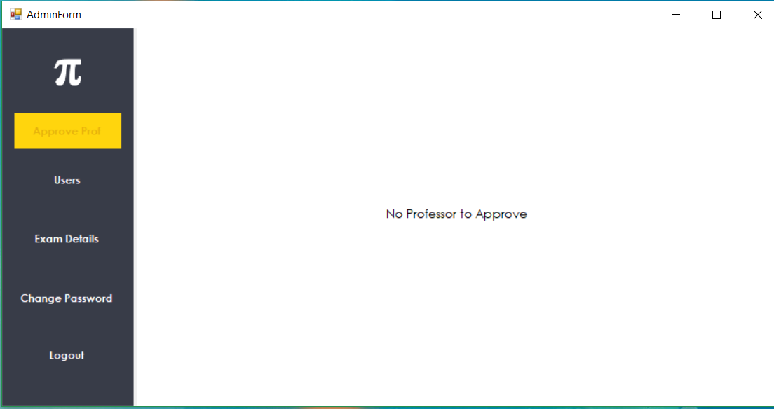

## View all Users

Admin can view details of the students and professors.

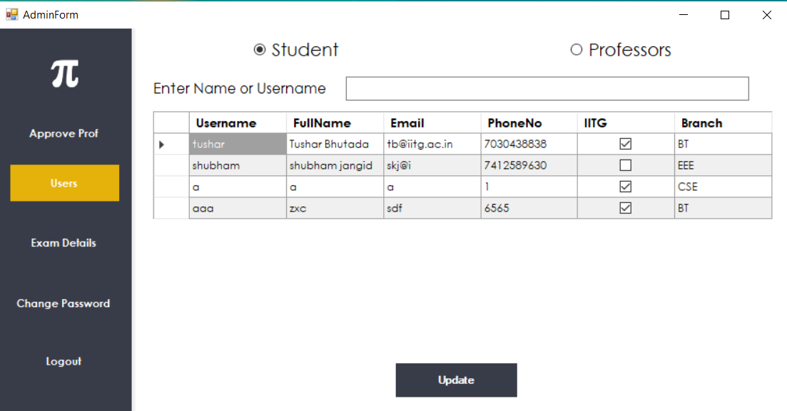

## View Past Exams

Admin can view all the tests conducted in the past along with the exams that are going to be conducted.

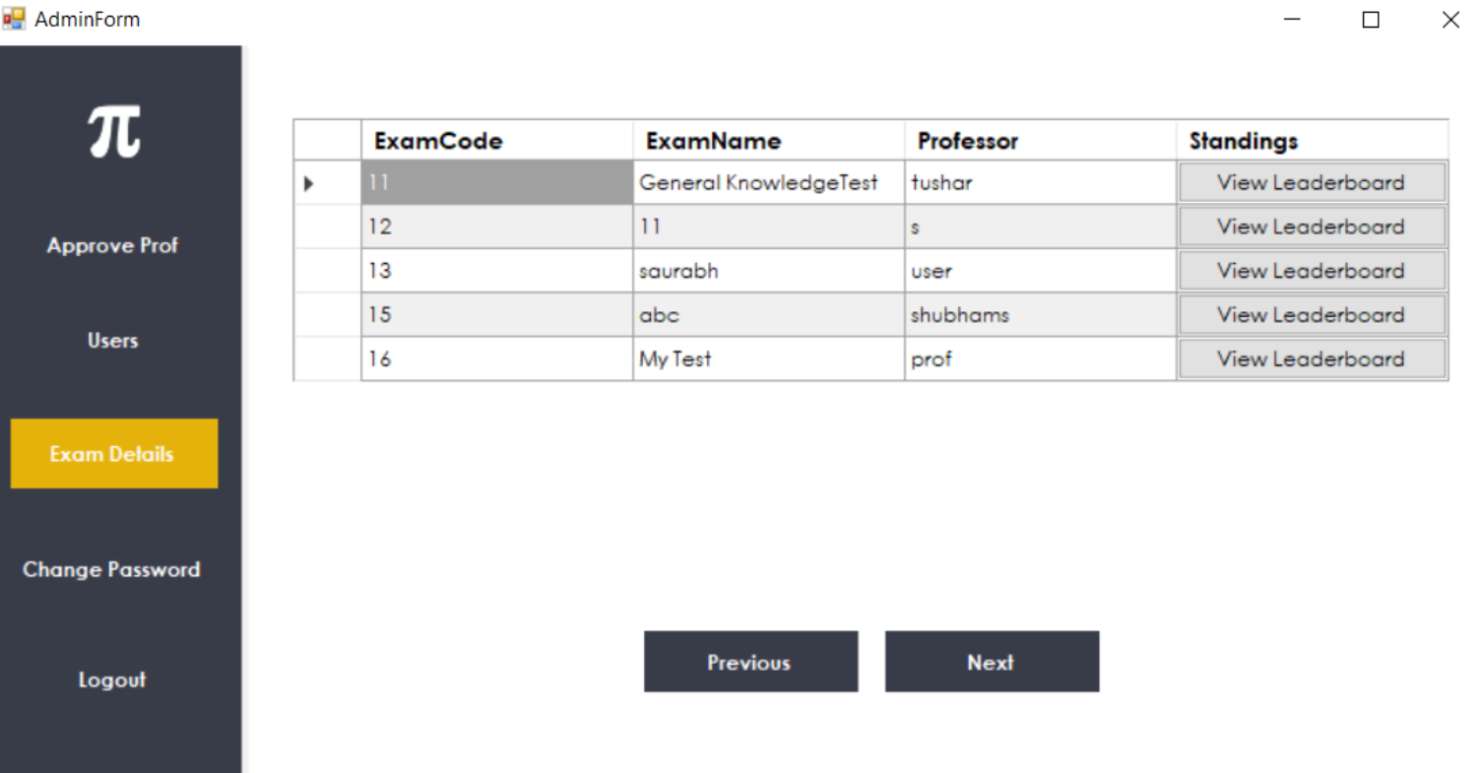

He/she can also view the statistics of past exams.

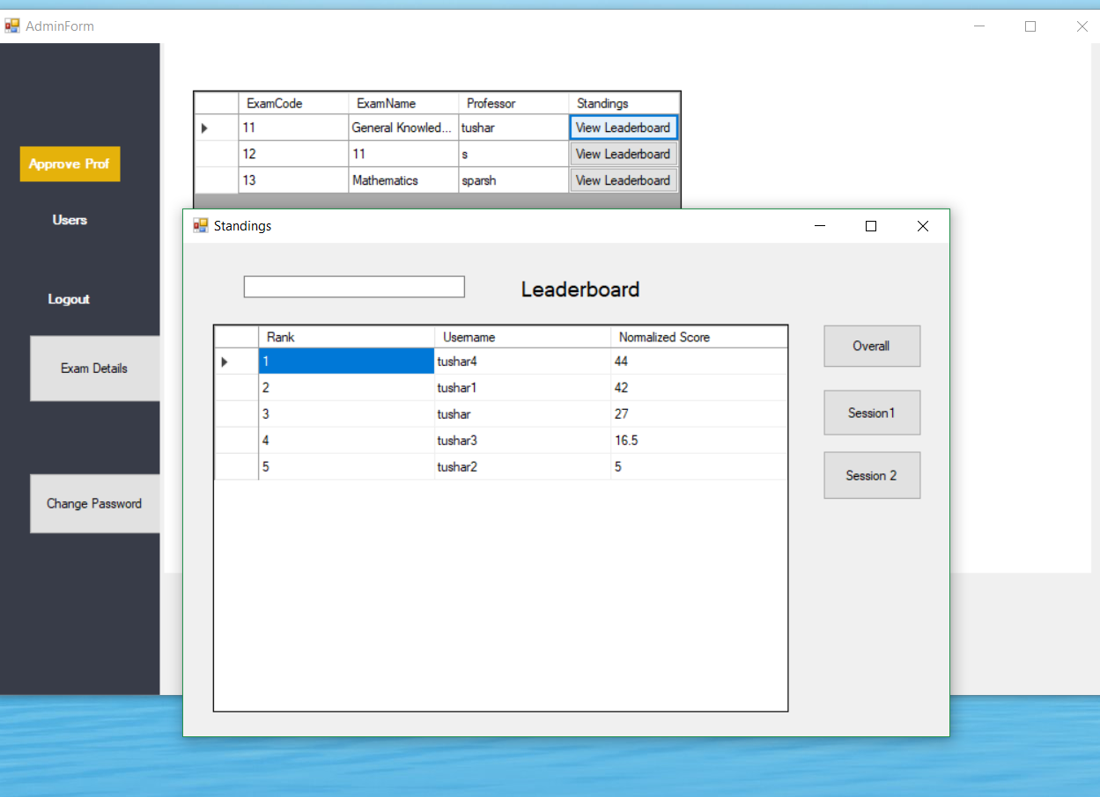

## Generate certificates for past tests

Admin can generate certificate for any exam that is/will be conducted.

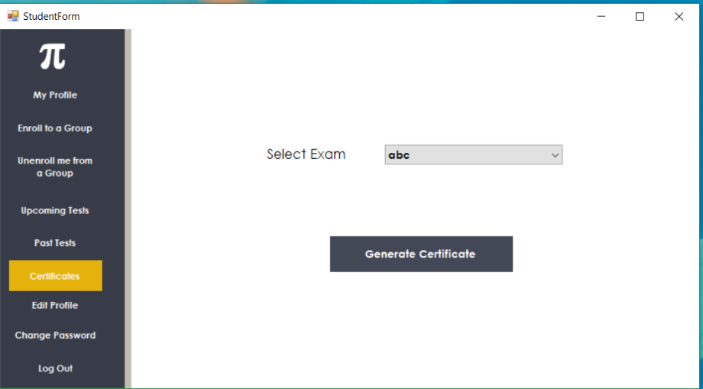

**6.EXAM WINDOW**

It is embedded with following components

## Exam details

Here name of the exam, Number of questions you have attempted and Maximum marks of the exam are displayed

## Timer

Time remaining is shown here

## Legend

It specifies what each colour of a question number in the Index Panel indicates.

## Index Panel

It displays the numbers of the current section and current state of each.

## Control Buttons

Located at bottom of the page, using which we can

* + Go to previous question
  + Navigate to next question
  + Mark current question for review
  + Save Response: **After marking the answer one needs to press save response before proceeding to another question.**
  + Clear Response marked for current question.
  + End test.

## Marking Scheme

All sections with the weightage of each question is displayed here.

## Sections Panel

Sections present in the exam are displayed in a ribbon. On clicking on a section, one can navigate to corresponding section

## Answers Panel

Place where you will select the answer

## Question Panel

Area where Question is displayed.

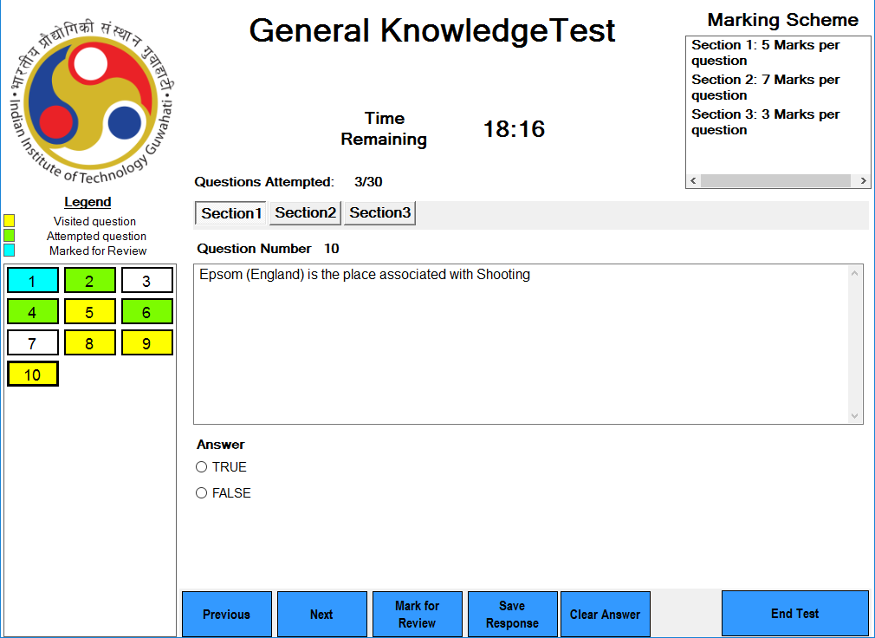

**7. TEST EVALUATION & ANALYSIS**

## Section Wise Analysis

Here, bar graphs showing your section wise performance are drawn your score is plotted along with Maximum, Minimum and Average marks.

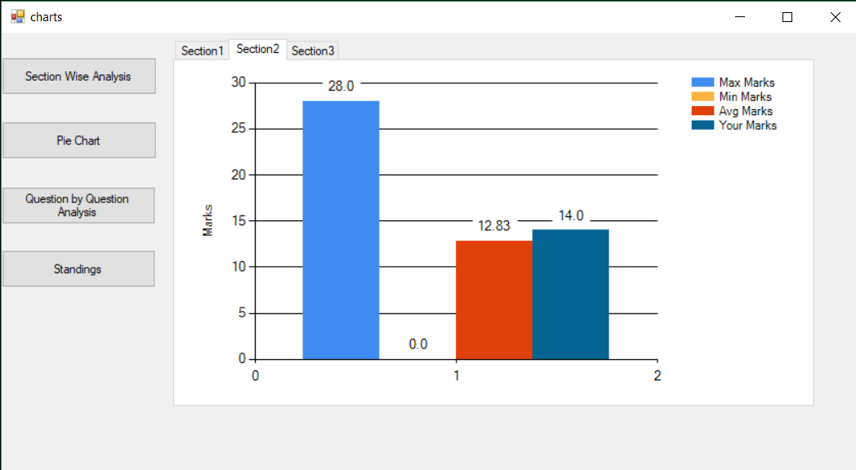

## Pie Charts

Here pie charts depicting Questions that are Correct, Incorrect and Unattempted are plotted for each section.

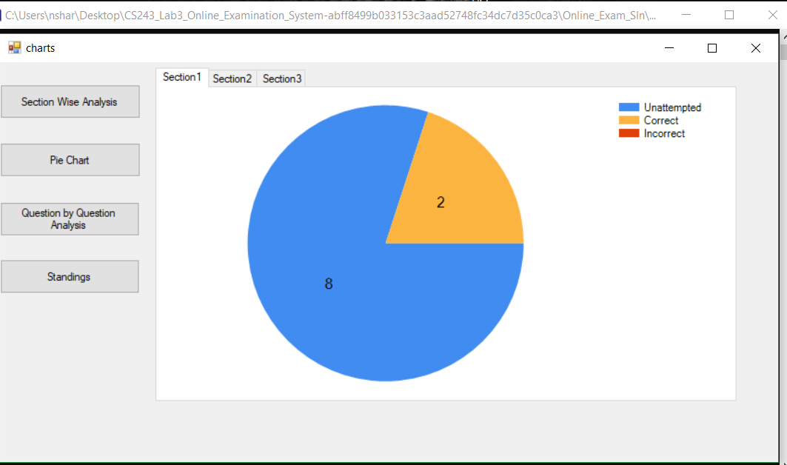

## Question-wise Analysis

In this, Length of the exam (in minutes), Total score secured, Normalized score o

