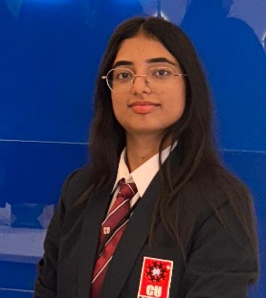
SUMMARY
Avya Juneja
Moga, Punjab |
junejav@gmail.com
| +91 9056376052
https://www.linkedin.com/in/avya-juneja-8a6454323 | https://github.com/Avya0507
B.E AIML Student
An innovative Computer Science (AIML) student at Chandigarh University, passionate about coding, problem solving, and technology. Proficient in C++, C, and Python, I excel at applying theoretical concepts to real world applications. Skilled in responsive web design and software development. With a collaborative mindset, I contribute innovative solutions that enhance project efficiency and effectiveness while continuously expanding my knowledge and embracing new challenges.
TECHNICAL SKILLS
Programming & Framework: C++, Python, C, Java, SQL, HTML, CSS, Javascript.
Development Tools: Visual Studio code, Github.
Database: MySQL, MongoDB, Oracle.
Projects
- Mini Shopping Website (E-commerce Web Development Project)
• Designed a responsive shopping website using HTML, CSS, and JavaScript
• Implemented product listing, filtering, and add-to-cart functionality
- Smart plant watering system (IOT)
Built an IoT-based smart plant watering system using Arduino, soil moisture sensors, and relay modules.
The system automates irrigation by analysing moisture levels and triggering water flow when required.
- Project Link: https://github.com/avyajuneja/mini-shopping-website
EDUCATION
Bachelor of Engineering in Computer Science with Artificial Intelligence and Machine learning.
Chandigarh University, Mohali (2024)
- Coursework: Programming in Python: A Hands-On Introduction (Coursera)
- Coursework: Design Thinking and Creativity for Innovation (LinkedIn Learning)
- Coursework: Foundation of Ai and Machine Learning (Coursera)
- Coursework: Software Foundation Course- C++ (IBM)
- Coursework: Ethical Hacking (ACP)
Senior Secondary (Non-Medical-12 Grade)
Dr Kitchlu Public Senior Secondary School, Moga, Punjab|2023|82%
Secondary (10 Grade)
R.K.S International Public School, Janer, Moga, Punjab|2021|86.4%
ADDITIONAL INFORMATION
- Languages: English, Hindi, Punjab
- Participated in Coding Competitions & Hackathons
SOFT SKILLS

- Team Management • Team Work

