Power System Analysis
EE2600
Quiz 4
Date: 17-04-2021
Answer all the questions. If required, make suitable assumptions and state those.
Time: 3 hours Full marks: 15

Q1. 3
Four solid conductors are running parallelly through the vacuum. The sum of those conductor currents is zero. Over any cross-sectional plane, the centers of conductors are sequentially positioned at the vertices of a square. The information of the radius of each conductor and the length of a side of the above square are provided. Find out the flux linkage with each conductor for every km when Conductors 1, 2 and 3 carry 5 kA, 10 kA and -7 kA, respectively, with respect to the same positive direction. Please return only the absolute values (i.e., eliminate minus signs) of flux linkages.

Q2. 3
Consider a 3-phase untransposed overhead transmission line. Each phase of the transmission line comprises a single solid conductor. All the conductors have the same radius. Over a cross-sectional plane, the centers of the conductors are arranged across a straight line that makes 45⁰ angle with the ground surface. The information about the radius and heights of different conductors are provided. Determine all the phase-to-ground and phase-to-phase capacitance values per km.

Q3. 3
A 3-phase transmission line is made up of bundled conductors as is show below. All the bundles are identical and have solid sub-conductors. The centers of all the bundles are arranged over a straight line. The distance between two sub-conductors within a bundle and that between two successive bundles are given. The radius of each sub-conductor is also mentioned. If it is a transposed transmission line, find out the full-stretch GMD between two bundles along with the GMR of each bundle. The GMR here is related to the inductance calculation.
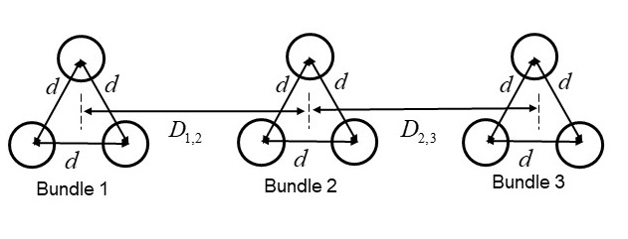

Q4. 3
Consider a 500 km long, 3-phase, 50 Hz distributed parameter, balanced transmission line. The information about the series resistance, series inductance, shunt conductance and shunt capacitance for the positive sequence network of the transmission line are provided. The line-to-line voltage phasor magnitude at the sending end is 400 kV. Find out the 3-phase active power and reactive power supplied to the load at the receiving end if the transmission line is loaded with its characteristic impedance.

Q5. 3
Consider the same transmission line as in Q4, but ignore the series resistance and shunt conductance. The magnitudes and angles of the sending end and receiving end line-to-line voltage phasors are provided. Find out the magnitude and angle of the line-to-line voltage phasor (between the same phases) at the mid-point of the transmission line.

-End-

