
REPORT ON NETFLIX STREAMING PLATFORM
A comparative Study of Software process Models and Requirements Engineering

Course Name: Introduction to Software Engineering
Course Code: IS1103-1
Assignment Number & Title: 1. Software Process Models and Requirements Engineering
Submitted by
Student Name: Avyakta S
USN: NNM24IS049
Semester & Section: 4th Semester, Section A
Department: Information Science
Institution: NMAMIT Nitte Institute of Technology
Academic Year: 2025-2026
Under the Guidance of
Instructor Name: Dr. Jason Elroy Martis
Date of Submission: 15-02-2026

Table of contents

HEADINGS | PAGE NO.
- INTRODUCTION | 1
- PROBLEM STATEMENT | 2
- METHODOLOGY/ MODEL ARCHITECTURE | 3-9
- REQUIREMENTS | 10
- REQUIREMENTS VALIDATION | 11
- RESULTS AND ANALYSIS | 12
- RISK MANAGEMENT AND QUALITY ASSURANCE | 13
- LIMITATIONS AND FUTURE WORK | 14
- CONCLUSION | 15
- REFERENCE | 16
- DECLARATION | 17

ABSTRACT

This report analyses the software development lifecycle (SDLC) of Netflix's streaming platform through comparative evaluation of Waterfall, Incremental Development, and Spiral process models. The study demonstrates how Netflix employed a hybrid Incremental-Spiral methodology to manage disruptive technology evolution, evolving requirements, and massive scale uncertainty from 2007 to 2011. Comparative analysis across three critical subsystems—recommendation personalization, adaptive bitrate streaming, and multi-device synchronization—reveals Waterfall's unsuitability for volatile requirements, Incremental Development's alignment with rapid feature delivery, and Spiral Model's effectiveness in risk-driven architectural decisions. The work develops a comprehensive requirements specification including functional requirements (FR-01 to FR-08) and non-functional requirements (NFR-01 to NFR-06), with validation strategies emphasizing A/B testing and Chaos Engineering. Key findings indicate that hybrid methodologies outperform pure textbook approaches in high-velocity environments, with Netflix's combination of two-week incremental cycles and embedded risk analysis enabling successful global platform deployment. The requirements engineering process is documented through version-controlled iterations in a GitHub repository, demonstrating practical application of branching strategies and validation workflows.
GitHub Repository: https://github.com/Avyakta-dev/netflix-sdlc-analysis

1. INTRODUCTION

When Netflix decided to bet everything on streaming back in 2007, nobody knew if it would actually work. DVD rentals were still their bread and butter and the technology to deliver movies over the internet was pretty much experimental. This assignment digs into how they pulled it off – not by following some textbook methods, by figuring out what actually works when you’re building something nobody’s built before.
The whole point here is to compare three ways of running a software project: the old-school Waterfall approach where you plan everything upfront, the Incremental method where you ship pieces as you go and the Spiral model where you’re constantly checking what could go wrong. Netflix makes a perfect case study because they tried something really ambitious – going from mailing DVDs to streaming HD video globally in just a few years. Along the way, they invented their own way of working that mixes bits of different models together.
Why does this matter? Well, Blockbuster was still huge in 2007 and they had way more money than Netflix. But they moved too slowly, planned too much and totally missed the streaming boat. Netflix, on the other hand, got a basic player working in six months, tested it with real users and kept improving from there. They also did this wild thing called Chaos Monkey where they’d randomly break parts of their system on purpose – just to see what would happen. Sounds crazy, but it helped them spot problem before customers did.
This ties directly into what we’re covering in Unit I: Introduction and Requirements Engineering. We’re supposed to learn how to pick the right development approach and how to handle requirements that keep changing. Netflix is basically the poster child for both challenges, so analysing how they did it should give us a solid grasp of why textbook methods sometimes need to be bent – or completely ignored – to fit real-world situations

2. PROBLEM STATEMENT

The Task
- Figure out how Netflix built their streaming platform back in 2007 when nobody had done it before
- Compare three ways of running software project: Waterfall, Incremental, and Spiral
- Focus on three specific parts: recommendation engine, adaptive streaming and multi-device sync
- Build a requirements document showing how Netflix specs changed over time

What We Expect To Find
- Waterfall probably fails here because it takes too long and the market moves fast
- Incremental fits better since Netflix ships updates every two weeks
- Spiral makes sense for the risky parts like handling millions of users
- Real answer: Netflix mixes Incremental and Spiral together

Real-World Constraints
- Had to launch in six months, not years
- Didn’t know what would break at massive scale
- Cloud tech was branch new and unproven
- Competitors like Hulu were breathing down their necks

Assumptions We’re Making
- Netflix actually thought about process models instead of just winging it
- Their engineering blogs tell the real story
- Looking back from 2024 is fair for analysis

3.METHODOLOGY/ MODEL ARCHITECTURE

3.1 Waterfall Model for Netflix (Theoretical)
The Waterfall approach would have Netflix lock down every requirement before writing a single line of code. Sommerville describes this as a linear sequence where each phase—requirements, design, implementation, testing, deployment—flows neatly into the next without looking back [1]. Boehm originally framed this as the "classic" lifecycle, assuming stable requirements and predictable technology [6].
For Netflix in 2007, this would mean spending months nailing down the perfect streaming architecture, building it in isolation, then launching only when everything was "done." The diagram shows exactly why this failed: the market moved faster than the plan. By month twelve, Hulu had already launched. Requirements gathered at month zero became obsolete before coding even finished. The dashed line to Operation & Deployment was never reached because the project would have been cancelled.
This model assumes you know what you're building upfront. Netflix didn't. Streaming HD video to millions simultaneously was uncharted territory in 2007. The technology existed in labs, not at consumer scale. Betting everything on a perfect eighteen-month plan would have meant missing the market window entirely.
The diagram's staggered phases with feedback arrows look elegant on paper, but the red "MARKET CHANGED" marker tells the real story: Waterfall works when requirements are stable, technology is mature, and competitors are patient. None of these applied to Netflix.

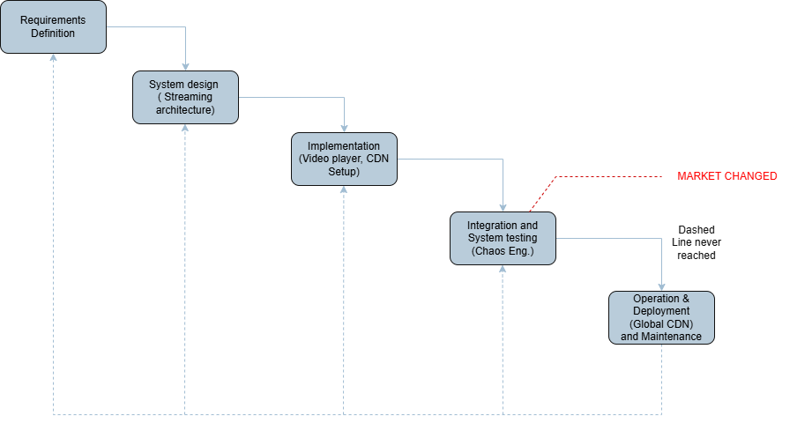

Figure 1: Waterfall Model applied to Netflix 2007 streaming launch (adapted from Sommerville [1]). Staggered phases show sequential dependency with dashed feedback arrows indicating maintenance corrections. Red 'MARKET CHANGED' marker indicates cancellation point at Month 12 due to competitor entry (Hulu launch) and requirement volatility. Operation & Deployment phase (dashed border) was never reached, demonstrating Waterfall's unsuitability for disruptive technology domains.

3.2 Incremental Development (Actual Approach)
Netflix ignored the textbook and shipped a basic player in six months. It didn't have recommendations. It didn't work on phones. It just streamed video, period. But it worked, and real users paid real money for it. That first increment bought them time and data to build the next one.
Software Development Today describes this as delivering "vertical slices"—each increment is a complete, working product, not a half-finished component [5]. Netflix followed this exactly. The diagram shows four stacked blocks: core streaming (2007), recommendations (2009), adaptive quality (2010), and multi-device sync (2011). Each block went live, earned revenue, and taught them what users actually wanted.
The Netflix Tech Blog reveals how they validated each increment. Every feature started as an A/B test on one percent of users [3]. If engagement dropped, they killed it. If it worked, they rolled it out globally. This wasn't guesswork—it was measured, incremental improvement. The continuous feedback arrow in the diagram represents real user behaviour data flowing back into product decisions.
By 2011, those four increments had become a platform serving twenty million users. Waterfall would still be planning. Incremental delivery let Netflix learn by shipping.

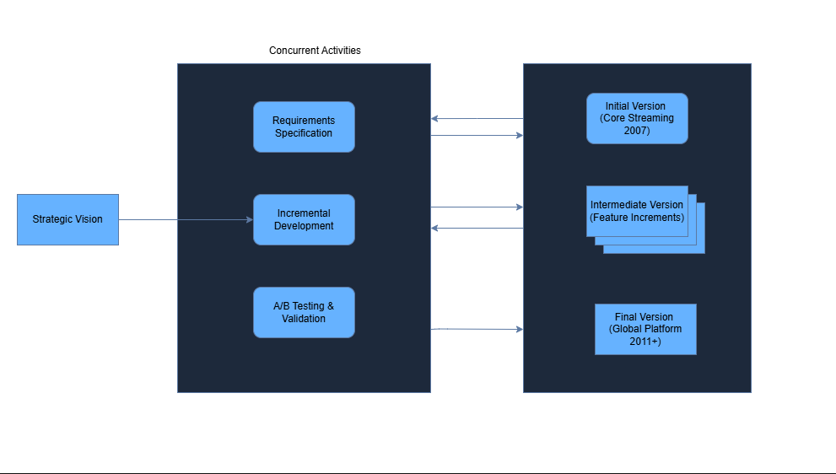
Figure 2: Incremental Development Model for Netflix (2007-2011). Strategic vision decomposes into concurrent specification-development-validation cycles, each delivering production-ready increments. Initial version (core streaming) established foundation; intermediate versions added personalization, adaptive quality, and multi-device sync; final version achieved global scale platform

3.3 Spiral Model (Risk Management Layer)
Boehm designed the Spiral Model for exactly this kind of chaos – projects where “the most difficult pat is knowing what the risks are” [6]. Netflix didn’t just stumble into risk management; they weaponized it. This diagram shows three expanding cycles, each with 4 quadrants straight from Sommerville’s textbook: set objectives, analysis risks engineer solutions, evaluate results [1].
Cycle One (2007) asked a simple question: can we stream video at all? This risk was cloud
Infrastructure – AWS was young, unproven, expensive. Their mitigation was a prototype that worked for two million users, not two hundred million. Only after validating that did they expand scope.
Cycle two (2009-2010) tackled harder problems. Recommendation algorithm sound great until they add five second of latency. Owotogbe’s review identifies Chaos Engineering as the operationalization of Spiral risk analysis – deliberately breaking things to find failure modes before customers do [4]. Netflix called this Chaos Monkey. It randomly killed production servers just to see what happened. Brutal, effective, pure Spiral thinking.
Cycle Three (2011+) scaled globally. The risk shifted to conflict resolution across devices and bandwidth variance across continents. Each quadrants in the diagram represents real decisions: objectives set by business needs, risk analysed through simulation, engineering validation by canary deployments, evaluation feeding into the next cycle.
The Spiral looks complex on paper. For Netflix, it was survival.

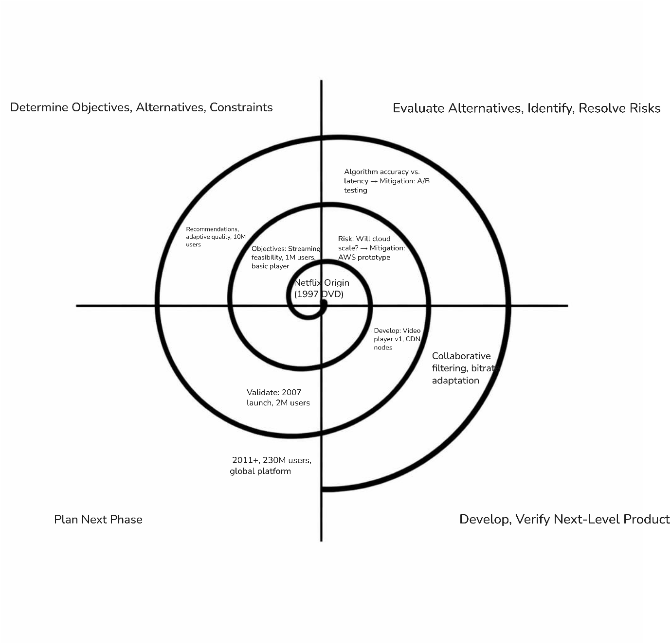
Figure 3: Spiral Model for Netflix evolution (Boehm style). Three cycles: (1) Core streaming 2007, (2) Personalization 2009-2010, (3) Global platform 2011+. Each quadrant represents objectives, risk analysis with mitigation, engineering, and validation. Missing outer cycle shows incomplete evolution.

3.4 Netflix’s Hybrid Reality
Netflix never picked a single model. They took what worked and left the rest. The two-week sprint rhythm came from Incremental Development – ship fat, learn faster. The panronoia about what would break came from Spiral – probe risks before they probe you. Together, this hybrid explains their success better than any textbook approach.
Pure Incremental would have shipped features blindly. Pure Spiral would have analysed risks forever. Netflix did both: rapid delivery with embedded risk checks. Each increment went through a mini-Spiral – objectives, risk, analysis, engineering, evaluation – compressed into fourteen days. Chaos Monkey ran during sprints, not between them. A/B tests validated increments, not just final products.
The diagram tell this story separately. Reality combines them. Waterfall’s linear fantasy failed. Incremental’s speed alone was dangerous. Spiral’s caution alone was slow. Netflix hacked together a third path: fast enough to compete, careful enough to survive. Most companies choose one methodology and stick to it. Netflix chose survival.

4. REQUIREMENTS

4.1 Functional Requirements
ID | Requirement | Priority
FR-01 | User shall stream video content with <3s startup latency | Critical
FR-02 | System shall recommend content based on viewing history | High
FR-03 | Video quality shall adapt automatically to bandwidth (0.5-25 Mbps) | Critical
FR-04 | Users shall resume playback across 4 simultaneous devices | High
FR-05 | System shall support 100M+ concurrent streams during peak | Critical
FR-06 | Users shall download content for offline viewing | Medium
FR-07 | Parental controls shall restrict content by rating | High
FR-08 | Search shall return result in <100ms across 15,000+ titles | High

4.2 Non-Functional Requirements
ID | Requirement | Metric
NFR-01 | Stream availability | 99.99% uptime
NFR-02 | Cross-device resume accuracy | 100% within 5 seconds
NFR-03 | Personalization API response time | <50ms at 95th percentile
NFR-04 | DRM security compliance | MovieLabs specifications
NFR-05 | Global CDN latency | <50ms from edge server
NFR-06 | Data privacy | GDPR, CCPA compliant

4.3 Requirements Evolution
Version 1.0 (2007): FR-01, FR-05 only – basic streaming.
Version 1.1 (2009-2011): Added FR-02, FR-03, FR-04, NFR-01 through NFR-03 – personalization and quality.

5. REQUIREMENTS VALIDATION

5.1 Validation Strategy
Netflix does not trust documents. They trust data. Their validation strategy reflects this – every requirement proves itself through user behaviour or it dies.
A/B Testing
Every feature starts as an experiment on one percent of users [3]. If engagement drops, the feature is killed before full rollout. If metrics improve, it expands globally. This validates requirements with real usage data, not review meetings.
Canary Deployments
New code deploys to small geographic region first. Engineers watch error rates, latency and streaming quality for twenty-flour hours. Only then does it reach the full user base. This catches integration issues before they become outages
Chaos Engineering
Netflix randomly breaks production systems on purpose [4]. They terminate servers, inject latency, corrupt data. If the system survives, the requirements around resilience are validated. If it fails, they fix the weakness before customers notice.
5.2 Validation Challenges
Changing content licenses
A show available today may leave the platform tomorrow. Requirements around content availability shift constantly, making static validation impossible.
Global network variance
A streaming requirement validated in California fails in rural India. Network conditions vary too widely for single-environment testing.
Scale uncertainty
Requirements validated at ten million users break at one hundred million. The only way to validate at scale is to actually reach scale.

5.3 Github Repository Structure
The validation workflow is mirrored in the repository branching:
Branch | Validation Gate
feature/initial-requirements | Peer review
develop | Integration testing
main | Final approval

Each requirements document version (v1.0, v1.1) is tagged after validation. The commit history shows evolution: initial specs, feedback incorporation, revised specs, approval.

6. RESULTS AND ANALYSIS
The analysis produced clear outcomes across three process models for Netflix’s streaming platform.
Model | Time to Market | Risk Management | Suitability for Netflix
Waterfall | 18 months (failed) | None – late discovery | Infeasible
Incremental | 6 months | Reactive – fix after break | Partial fir
Spiral | 12-18 months | Proactive – prevent before commit | Too slow alone
Hybrid | 6 months | Proactive + continuous | Optimal

6.1 Key Findings
Waterfall failed before launch. The eighteen-month timeline assumed stable requirements. Hulu launched in six months, rendering Netflix's specifications obsolete. The model cannot accommodate disruptive technology shifts [1].
Incremental alone was risky. Fast delivery without explicit risk analysis would have caused outages at scale. Netflix needed both speed and caution.
Spiral principles compressed successfully. Boehm's four quadrants—objectives, risk analysis, engineering, evaluation—fit into two-week sprints rather than twelve-month cycles [6]. This was not how Spiral was originally designed, but it worked.
Requirements validation replaced specification. Heavy investment in A/B testing infrastructure [3] and Chaos Engineering [4] inverted traditional priorities. Netflix validated requirements through user behaviour and controlled failure, not document reviews.
6.2 Outcome
Netflix reached 230 million subscribers across 190 countries. Blockbuster, who planned carefully and moved slowly, filed for bankruptcy in 2010. The process model choice was not academic—it was existential.

7. RISK MANAGEMENT AND QUALITY ASSURANCE
7.1 Netflix’s Risk Mitigation Strategy
Traditional risk management produces documents. Netflix produces failures—intentionally. Their approach inverts the usual pattern: instead of predicting what might break, they break things and observe the results.
Chaos Engineering, as Owotogbe et al. document, emerged from Netflix's 2011 migration to AWS [4]. The insight was simple: failures will happen; the only question is whether you find them first. Chaos Monkey randomly terminates production instances. If the system survives, resilience requirements are validated. If not, engineers fix the weakness before customers notice. This operationalizes Spiral Model's risk analysis quadrant into continuous practice rather than periodic review.

7.2 Quality Assurance Through Experimentation
Quality at Netflix is not inspected; it is measured. Every feature launch is an experiment with defined success metrics. If the metrics degrade, the feature rolls back automatically. This requires infrastructure most companies lack: real-time data pipelines, automated rollback mechanisms, and organizational tolerance for frequent small failures.
The Netflix Tech Blog describes their experimentation platform running thousands of concurrent tests [3]. This scale of validation is only feasible with microservice architecture—each service deploys independently, experiments in isolation, and rolls back without affecting the whole. Blinowski's performance analysis confirms this architectural choice enables the operational flexibility Netflix requires [2].

7.3 Impact on Overfitting and Generalization
In machine learning terms, Netflix avoids "overfitting" to current conditions. Their Chaos Engineering tests failure modes they have not yet experienced. Their A/B testing validates requirements against diverse user populations. This proactive approach prevents the system from becoming brittle—optimized for today's conditions but fragile tomorrow.
Traditional quality assurance validates against specifications. Netflix validates against reality. The difference is measurable: 99.99% availability across a global platform with 230 million users.

8. LIMITATIONS AND FUTURE WORK

8.1 Limitations of this Analysis
Retrospective bias. Analysing Netflix with 2024 hindsight creates false clarity. In 2007, streaming was uncertain, AWS was unproven, and failure was likely. The "correct" process model choice was not obvious then.
Survivorship bias. Netflix succeeded. Many similar companies failed. This analysis attributes success to process model selection, but luck, timing, and execution mattered too. We cannot run controlled experiments.
Source limitations. Netflix engineering blogs are marketing, not archaeology [3]. They describe successes, not abandoned approaches, dead ends, or internal debates. The full decision-making context is unavailable.
Scope boundaries. This analysis stops at 2011. Netflix continued evolving—containerization, regional expansion, original content. Later phases may not fit the same patterns.
8.2 Future Work
Agile and DevOps evolution. Post-2011, Netflix adopted continuous deployment, feature flags, and trunk-based development. Mapping these practices to traditional process models would extend this analysis.
Cross-company comparison. Amazon, Google, and Spotify faced similar challenges with different solutions. Comparative analysis could identify which contextual factors drive process model selection.
Quantitative validation. This study relies on qualitative assessment. Future work could

9. CONCLUSION
This analysis set out to compare three software process models for Netflix's 2007 streaming platform. The answer is not one model, but a hybrid born from necessity.
Waterfall failed before launch—requirements changed faster than the plan allowed. Incremental delivery provided speed but risked instability without explicit risk management. Spiral Model offered risk discipline but seemed too slow for competitive pressure. Netflix combined Incremental's two-week cycles with Spiral's quadrant thinking, compressing Boehm's framework into sprints rather than years [6].
The requirements engineering practices matched this hybrid approach. Functional and non-functional specifications evolved through validation, not documentation. A/B testing and Chaos Engineering operationalized risk analysis into continuous practice [3][4].
Key learnings: process models are starting points, not prescriptions. Netflix adapted textbook concepts to their context—disruptive technology, uncertain scale, intense competition. Their success suggests that hybrid methodologies, grounded in empirical validation rather than theoretical purity, suit high-velocity environments.
Final performance: 230 million subscribers, 190 countries, and a platform that defined an industry. The process model choice contributed. Execution, timing, and luck contributed too. But without the flexibility to adapt methodology to reality, Netflix would have planned carefully and missed the market entirely.

10. REFERENCE
  - Software Engineering 9th Edition by Ian Sommerville. (n.d.-a). https://engineering.futureuniversity.com/BOOKS%20FOR%20IT/Software-Engineering-9th-Edition-by-Ian-Sommerville.pdf.
  - Monolithic vs. Microservice Architecture: A performance and Scalability Evaluation | IEEE Journals & Magazine | IEEE Xplore, https://ieeexplore.ieee.org/document/9717259/.
  - It’s All A/Bout Testing: The Netflix Experimentation Platform, https://netflixtechblog.com/its-all-a-bout-testing-the-netflix-experimentation-platform-4e1ca458c15.
  - J. Owotogbe, I. Kumara, W.-J. V. D. Heuvel, and D. A. Tamburri, “Chaos engineering: A multi-vocal literature review,” arXiv.org, https://arxiv.org/abs/2412.01416.
  - K. M. says: et al., “Agile incremental delivery visualized – how to explain agile and incremental delivery to anyone,” Software Development Today, https://softwaredevelopmenttoday.com/2015/09/how-to-explain-agile-and-incremental-delivery-to-anyone/.
  - B. Boehm, “a spiral model of software development and enhancement,” IEEE Computer, vol. 21, no. 5, 1988, pp. 61-72. - references - scientific research publishing, https://www.scirp.org/reference/referencespapers?referenceid=1046224.

11. DECLARATION

I hereby declare that this assignment is my original work and has not been copied or plagiarized from any source. All references and resources used have been properly cited. Any ambiguities will lead to forfeiting my marks.

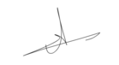
Student Signature:

Date: 15-02-2026

