WEB PROGRAMMING

ASSIGNMENT-11
(JavaScript)

Student Name: Avyakth Shriram
Register Number: 24BCE5461
Course Slot: TG1
Professor: Dr. Kanniga Devi

LAB 11 – TASK 1 - HTML:

<!DOCTYPE html>
<html>
<head>
<title>Bank loan approval system</title>
<style>
body{
background-color:blanchedalmond;
}
.container{
height: 60vh;
width: 40vw;
margin:auto;
padding-top:20px;
background-color:skyblue;
border-radius: 1.5rem;
}
.formm{
display: flex;
flex-direction: column;
gap:10px;
margin: 20px;
}
#error{
color:red;
}
</style>
</head>
<body>
<div class="container">
<h1 style="text-align:center;margin:auto;height:50px;width:60%;background-color:yellowgreen;border-radius:1rem;">Check Your Loan Eligibility</h1>
<div>
<form class="formm">
AGE: <input type="text" id="age" class="num"/>
SALARY: <input type="text" id ="salary" class="num"/>
Credit-Score: <input type="text" id ="credit-score" class="num"/>
</form>
<div style="text-align:center;gap:20px;">
<input type="button" onclick="submitted()" value="submit" style="background-color:yellowgreen;border:none;height:30px;width:70px;border-radius:2rem;"/>
<p id="error"></p>
</div>
</div>
</div>
<script type="text/javaScript" src="Task1.js"></script>
</body>
</html>

LAB 11 – TASK 1 - JavaScript:

function submitted(){
var age = Number(document.getElementById("age").value);
var salary = Number(document.getElementById("salary").value);
var Cred = Number(document.getElementById("credit-score").value);
var inputs = document.querySelectorAll(".num");
if(age < 21 || age>60){
document.getElementById("error").innerHTML = "The age must be between 21 and 60";
return;
}
else if(salary<50000){
document.getElementById("error").innerHTML = "The salary must be greater than 50,000";
return;
}
else if (Cred<700 && salary<100000){
document.getElementById("error").innerHTML = "Either the salary must be greater than 100000 or the Credit score of the customer must be greater than 700";
return;
}else{
document.getElementById("error").innerHTML = "Document submitted Successfully!";
}
for(let input of inputs){
if(isNaN(input.value)){
document.getElementById("error").innerHTML =`${input.id} must be a number`;
return;
}
}
}

LAB 11 – TASK 1 - Screenshots:

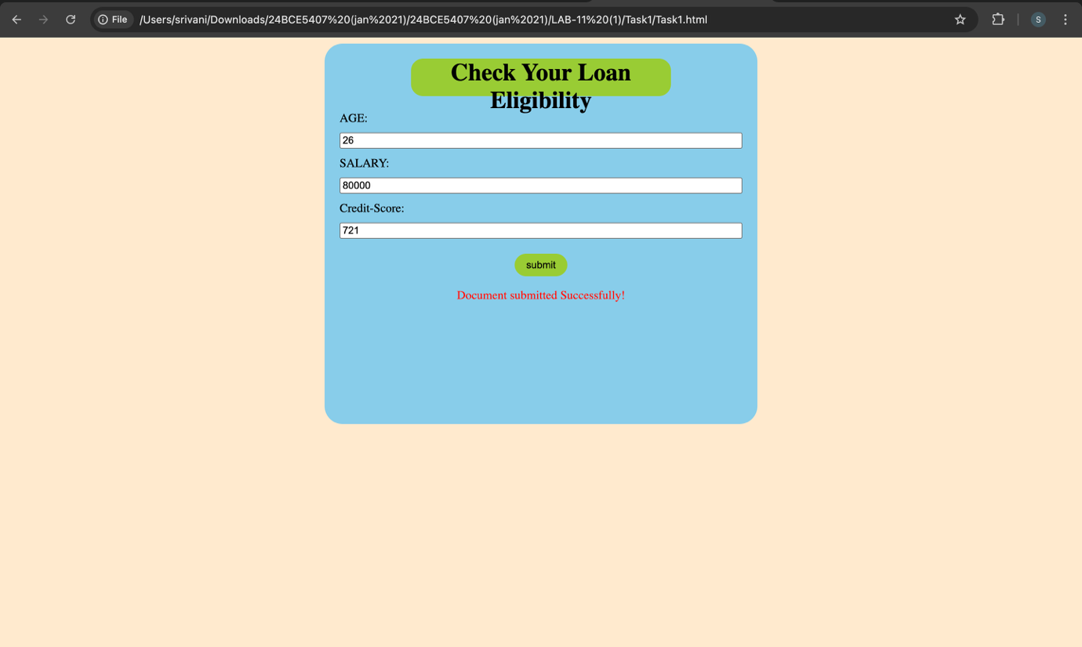

LAB 11 – TASK 2 – HTML:

<!DOCTYPE html>
<html>
<head>
<title>SMART TRAFFIC LIGHT SYSTEM</title>
<link rel="stylesheet" type="text/css" href="Task2.css"/>
</head>
<body>
<div class="container">
<h1>Smart traffic light system</h1>
<div class="inner-container">
<form>
Time(24hr-format): <input type="text" id="time" />
Count(vehicles): <input type="text" id="count" />
</form>
<input value="submit" type="button" id="submit-btn" onclick="findTime()"/>
<p id="output">Green Light is On for the next:<span id="req"></span></p>
</div>
</div>
<script type="text/javaScript" src="Task2.js"></script>
</body>
</html>

LAB 11 – TASK 2 – JavaScript:

function findTime(){
var time = Number(document.getElementById("time").value);
var count = document.getElementById("count").value;
if((time>=7 && time<=10) || (time>=17 && time <=20)){
if(count<50){
document.getElementById("req").innerHTML = "60";
}else{
document.getElementById("req").innerHTML = "80";
}
}else if((time>24 || time<1)){
document.getElementById("output").innerHTML = "Invalid time input!";
return;
}else{
if(count<50){
document.getElementById("req").innerHTML = "30";
}else{
document.getElementById("req").innerHTML = "50";
}
}
}

LAB 11 – TASK 2 – CSS:

* {
margin: 0;
padding: 0;
box-sizing: border-box;
font-family: roboto;
}

body {
background-color: #1a1a2e;
display: flex;
justify-content: center;
align-items: center;
height: 100vh;
color: #ffffff;
}

.container {
background: #16213e;
padding: 2rem;
border-radius: 15px;
box-shadow: 0 10px 30px rgba(0, 0, 0, 0.5);
text-align: center;
width: 350px;
border: 1px solid #0f3460;
}

h1 {
font-size: 1.5rem;
margin-bottom: 1.5rem;
color: #4ecca3;
text-transform: uppercase;
letter-spacing: 1px;
}

.inner-container form {
display: flex;
flex-direction: column;
gap: 15px;
margin-bottom: 20px;
}

input {
padding: 10px;
border-radius: 5px;
border: none;
background: #0f3460;
color: white;
font-size: 1rem;
outline: none;
transition: 0.3s;
}

#submit-btn {
width: 100%;
padding: 12px;
background-color: #4ecca3;
color: #1a1a2e;
border: none;
border-radius: 5px;
font-weight: bold;
cursor: pointer;
font-size: 1rem;
transition: transform 0.2s, background-color 0.3s;
}

#submit-btn:hover {
background-color: #45b291;
}

.output {
margin-top: 20px;
font-size: 1.1rem;
color: #95a5a6;
}

#req {
display: block;
font-size: 2.5rem;
font-weight: bold;
color: #4ecca3;
margin-top: 10px;
text-shadow: 0 0 10px rgba(78, 204, 163, 0.5);
}

#req:not(:empty)::after {
content: "s";
font-size: 1rem;
margin-left: 5px;
}

LAB 11 – TASK 2 – Screenshots:

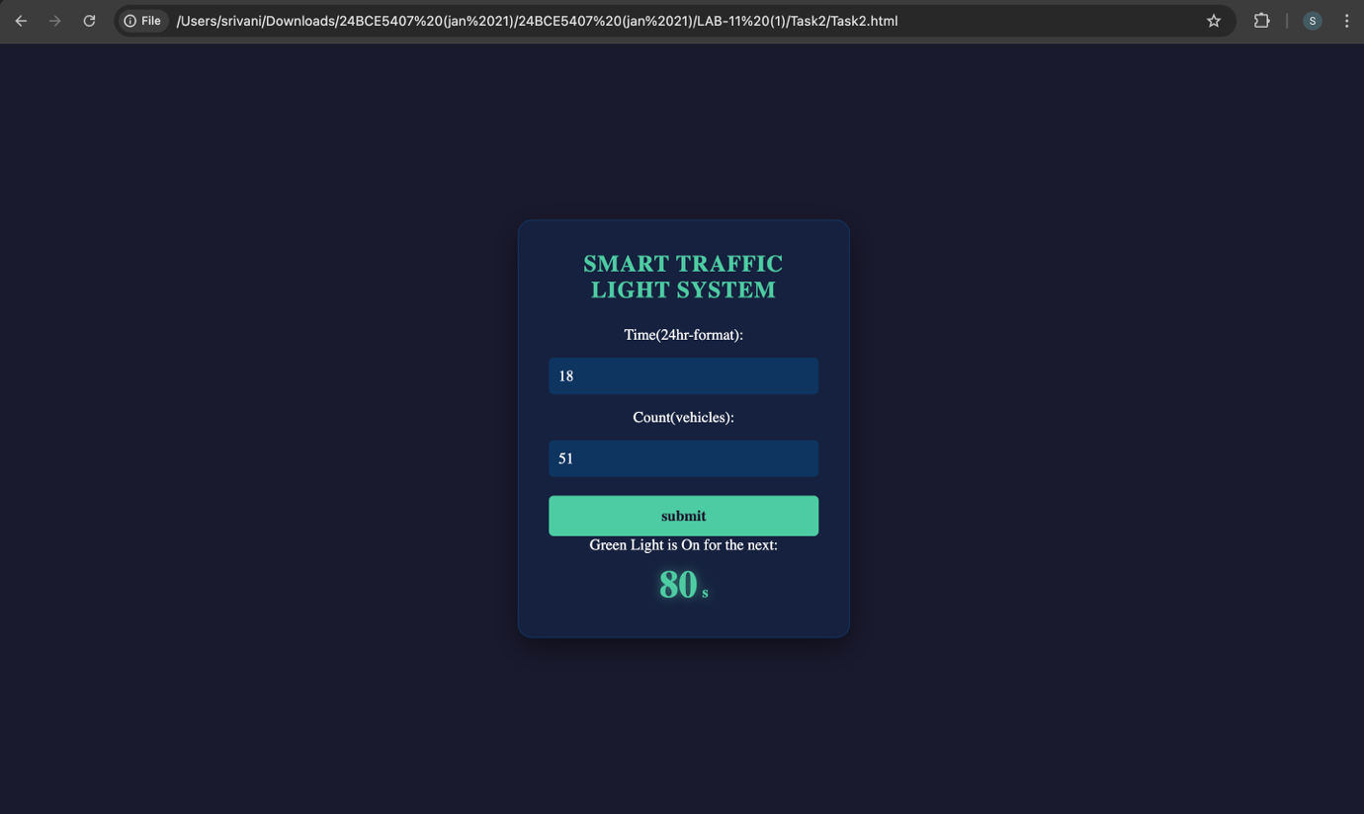

LAB 11 - TASK3 – HTML:

<!DOCTYPE html>
<head>
<title>Hotel Room Pricing System</title>
<link rel="stylesheet" type="text/css" href="Task3.css"/>
</head>
<body>
<div class="container">
<h1>Hotel Room Pricing System</h1>
<h3>Select the month:</h3>
<form>
<input type="radio" name = "month" value="january">January
<input type="radio" name = "month" value="february">February
<input type="radio" name = "month" value="march">March
<br/>
<input type="radio" name = "month" value="april">April
<input type="radio" name = "month" value="may">May
<input type="radio" name = "month" value="june">June
<br/>
<input type="radio" name = "month" value="july">July
<input type="radio" name = "month" value="august">August
<input type="radio" name = "month" value="september">September
<br/>
<input type="radio" name = "month" value="october">October
<input type="radio" name = "month" value="november">November
<input type="radio" name = "month" value="december">December
<br>
</form>
<h3>Select the room type:</h3>
<form>
<input type="radio" name = "room" value="standard">Standard
<input type="radio" name = "room" value="deluxe">Deluxe
<input type="radio" name = "room" value="suite">Suite
</form>
<input value="submit" type="button" id="submit-btn" onclick="findPrice()"/>
<p id="output"></p>
</div>
<script type="text/javaScript" src="Task3.js"></script>
</body>

LAB 11 – TASK 3 – JavaScript:

function findPrice() {
const month = document.querySelector('input[name="month"]:checked')?.value;
const room = document.querySelector('input[name="room"]:checked')?.value;
const output = document.getElementById("output");
if (!month || !room) {
output.innerHTML = "Please select both a month and a room type.";
return;
}

let price = 0;
if (month === "june" || month === "july" || month === "august" || month === "december") {

if (room === "standard") {
price = 5000;
} else if (room === "deluxe") {
price = 8000;
} else {
price = 12000;
}

}
else {

if (room === "standard") {
price = 3000;
} else if (room === "deluxe") {
price = 5000;
} else {
price = 8000;
}

}
output.innerHTML = `The room price per day is: ${price}`;
}

LAB 11 – TASK 3 – CSS:

body{
background-color:gray;
}
.container{
background-color: #1a252f;
width: 400px;
padding: 20px;
border-radius: 10px;
box-shadow: 0 5px 15px rgba(0,0,0,0.3);
color: white;
font-family: Arial, sans-serif;
margin: 100px auto;
}
form{
margin-bottom: 20px;
text-align: left;
}

LAB 11 – TASK 3 – Screenshots:
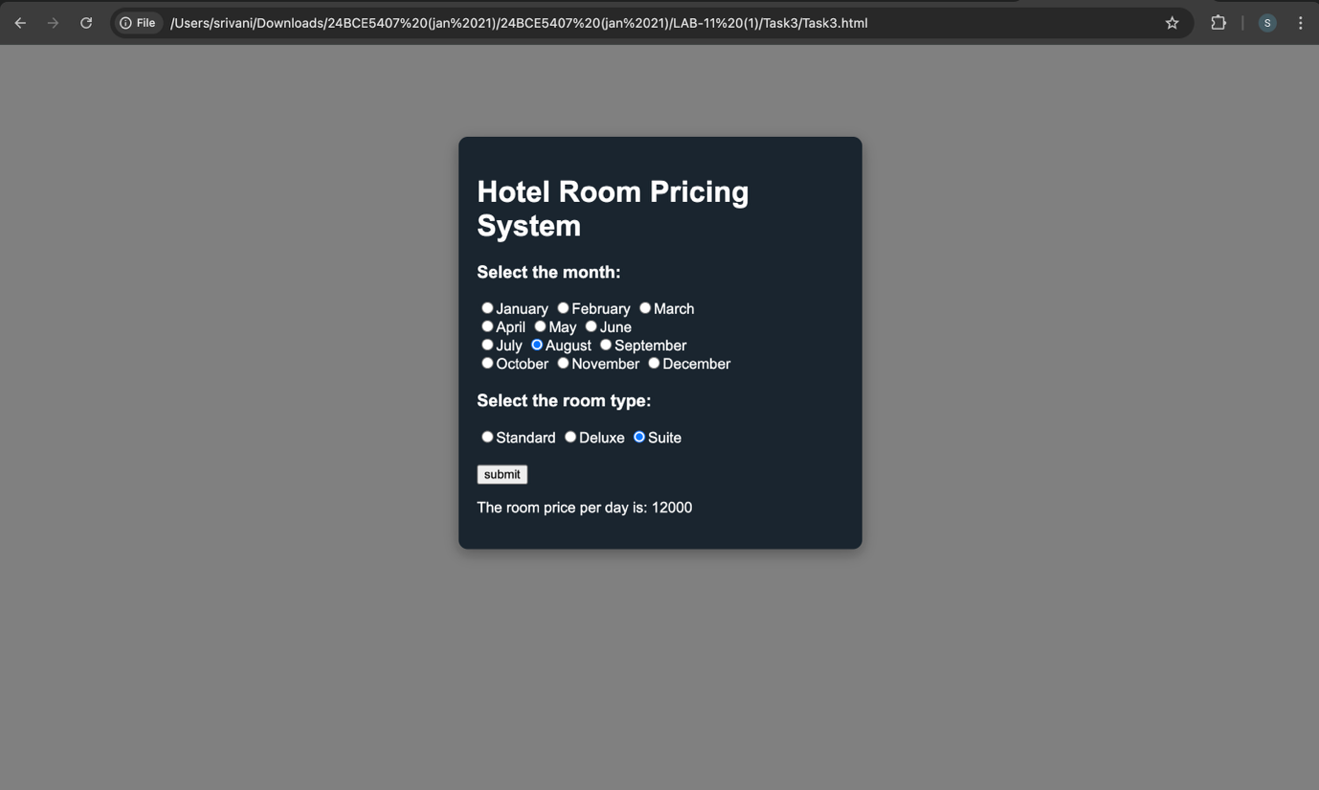

LAB 11 – TASK 4 – HTML:

<!DOCTYPE html>
<html lang="en">
<head>
<meta charset="UTF-8">
<title>Movie Ticket Calculator</title>
<link rel="stylesheet" href="Task4.css">
</head>
<body>
<div class="container">
<h2>Movie Ticket Price</h2>
<label for="age">Enter Age:</label>
<input type="number" id="age" placeholder="e.g. 25">
<label for="time">Show Time (24hr format):</label>
<input type="number" id="time" placeholder="e.g. 14 for 2 PM" min="0" max="23">
<button onclick="calculatePrice()">Calculate Price</button>
<div id="result" class="result"></div>
</div>
<script src="Task4.js"></script>
</body>
</html>

LAB 11 – TASK 4 – JavaScript:

function calculatePrice() {
const age = parseInt(document.getElementById('age').value);
const time = parseInt(document.getElementById('time').value);
const resultDiv = document.getElementById('result');
let price = 0;
if (age < 12) {
price = 100;
} else if (age >= 60) {
price = 120;
} else {
price = 200;
}
if (time < 17) {
price = price * 0.5;
}
if (isNaN(age) || isNaN(time)) {
resultDiv.innerText = "Please enter valid numbers.";
} else {
resultDiv.innerText = `Final Ticket Price: ₹${price}`;
}
}

LAB 11 – TASK 4 – CSS:

body {
font-family: Arial, sans-serif;
display: flex;
justify-content: center;
align-items: center;
height: 100vh;
background-color: #f4f4f9;
}

.container {
background: white;
padding: 2rem;
border-radius: 8px;
box-shadow: 0 4px 6px rgba(0,0,0,0.1);
width: 300px;
}

input, button {
width: 100%;
padding: 10px;
margin: 10px 0;
box-sizing: border-box;
}

button {
background-color: #007bff;
color: white;
border: none;
cursor: pointer;
}

.result {
margin-top: 15px;
font-weight: bold;
text-align: center;
color: #333;
}

LAB 11 – TASK 4 – Screenshots:
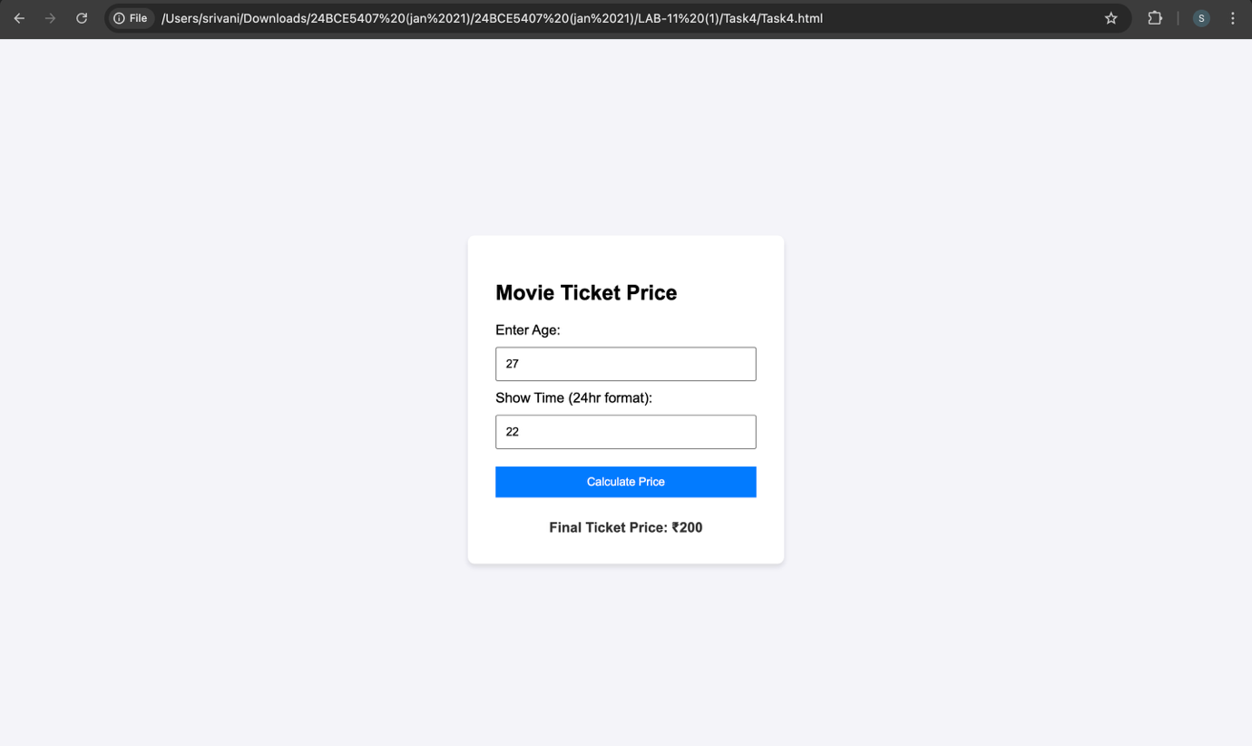

LAB 11 – TASK 5 – HTML:

<!DOCTYPE html>
<html>
<head>
<title>Number Pyramid Generator</title>
<link rel="stylesheet" href="Task5.css">
</head>
<body>
<div class="container">
<div class="card">
<h3>Number Pyramid Generator</h3>
<input type="number" id="levels" placeholder="Enter n (e.g., 5)">
<button onclick="generatePyramid()">Generate</button>
<p id="pyramidResult"></p>
</div>
</div>
<script type="text/javaScript" src="Task5.js"></script>
</body>
</html>

LAB 11 – TASK 5 – JavaScript:

function generatePyramid() {
const n = parseInt(document.getElementById('levels').value);
let currentNumber = 1;
let output = "";
for (let i = 1; i <= n; i++) {
for (let j = 1; j <= i; j++) {
output += currentNumber + " ";
currentNumber++;
}
output += "\n";
}

document.getElementById('pyramidResult').innerText = output;
}

LAB 11 – TASK 5 – CSS:

body { font-family: sans-serif; background-color: #f0f2f5; padding: 20px; }
.card {
background: white;
padding: 20px;
border-radius: 8px;
box-shadow: 0 2px 4px rgba(0,0,0,0.1);
max-width: 400px;
}
input, button {
display: block;
width: 100%;
margin: 10px 0;
padding: 8px;
}
button {
background: #007bff;
color: white;
border: none;
cursor: pointer;

}
pre {
background: #eee;
padding: 10px;
border-radius: 4px;
}
.container{
display:flex;
flex-direction: column;
justify-content: center;
align-items: center;
}

LAB 11 – TASK 5 – Screenshots:

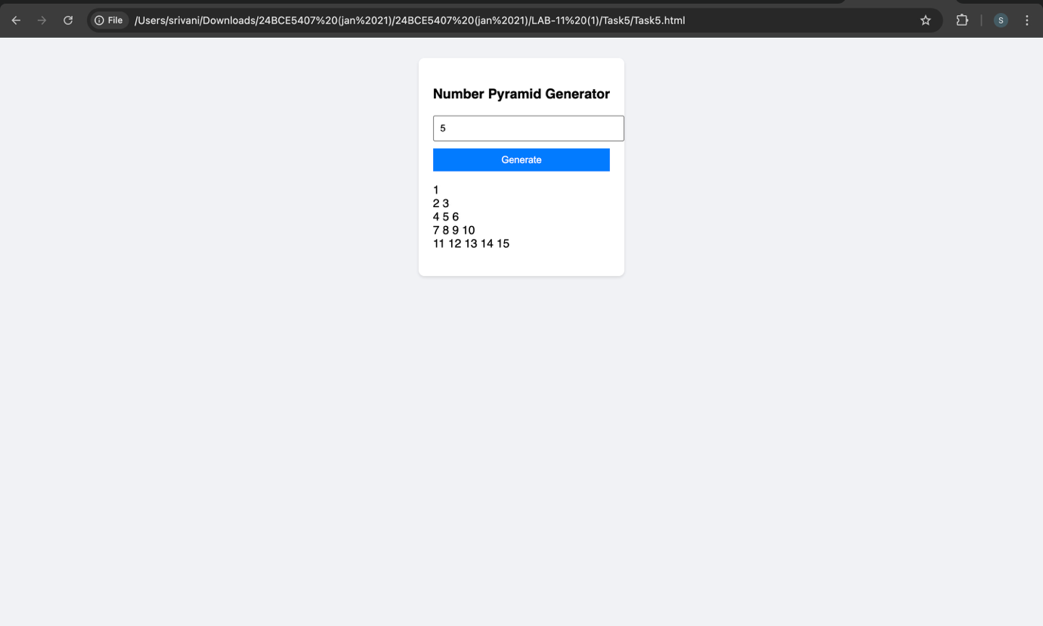

LAB 11 – TASK 6 – HTML:

<!DOCTYPE html>
<html>
<head>
<title>Toll Tax System</title>
<link rel="stylesheet" href="Task6.css">
</head>
<body>
<div class="box">
<h2>Toll System</h2>

<div id="setupStep">
<label>How many vehicles?</label>
<input type="number" id="totalVehicles" value="1">
<button onclick="startCollection()">Start</button>
</div>

<div id="inputStep" class="hidden">
<p id="currentVehicleLabel">Vehicle 1 of 5</p>
<label>Type:</label>
<select id="vType">
<option value="car">Car (₹50)</option>
<option value="truck">Truck (₹100)</option>
<option value="bike">Bike (₹30)</option>
</select>
<br><br>
<label><input type="checkbox" id="isVIP"> VIP Pass?</label>
<br><br>
<button onclick="processNext()">Next Vehicle</button>
</div>

<pre id="resultDisplay"></pre>
</div>
<script src="Task6.js"></script>
</body>
</html>

LAB 11 - TASK 6 – JavaScript:

let currentCount = 1;
let maxVehicles = 0;
let totalTax = 0;
let log = "Log:\n";

function startCollection() {
maxVehicles = parseInt(document.getElementById('totalVehicles').value);
if (maxVehicles > 0) {
document.getElementById('setupStep').classList.add('hidden');
document.getElementById('inputStep').classList.remove('hidden');
updateLabel();
}
}

function updateLabel() {
document.getElementById('currentVehicleLabel').innerText = "Vehicle " + currentCount + " of " + maxVehicles;
}

function processNext() {
const type = document.getElementById('vType').value;
const isVIP = document.getElementById('isVIP').checked;
let fee = 0;

if (!isVIP) {
if (type === "car") fee = 50;
else if (type === "truck") fee = 100;
else if (type === "bike") fee = 30;
}

totalTax += fee;
log += "Vehicle " + currentCount + " (" + type + "): ₹" + fee + (isVIP ? " [VIP]" : "") + "\n";

if (currentCount < maxVehicles) {
currentCount++;
updateLabel();
document.getElementById('isVIP').checked = false; // Reset checkbox for next
} else {
finishCollection();
}
}

function finishCollection() {
document.getElementById('inputStep').classList.add('hidden');
log += "----------------\nTotal Collected: ₹" + totalTax;
document.getElementById('resultDisplay').innerText = log;
}

LAB 11 – TASK 6 – CSS:

body {
font-family: sans-serif;
display: flex;
justify-content: center;
padding-top: 50px;
background-color: gray;
}

.box {
background-color:rgb(210, 78, 100);
padding: 25px;
border-radius: 8px;
width: 320px;
text-align: center;
box-shadow: 0 4px 6px rgba(0,0,0,0.1);
}

.hidden { display: none; }

#resultDisplay {
text-align: left;
background: #eee;
padding: 10px;
margin-top: 15px;
white-space: pre-wrap;
}

button {
padding: 8px 16px;
cursor: pointer;
}

LAB 11 – TASK 6 – Screenshots:

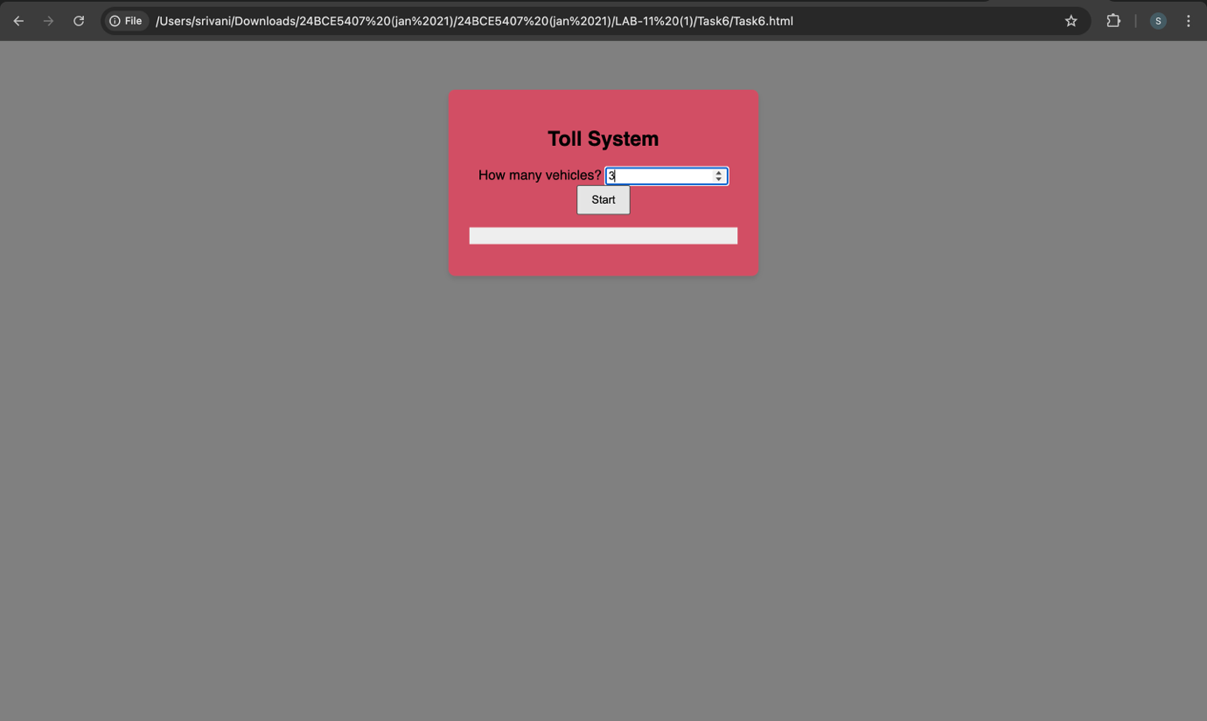
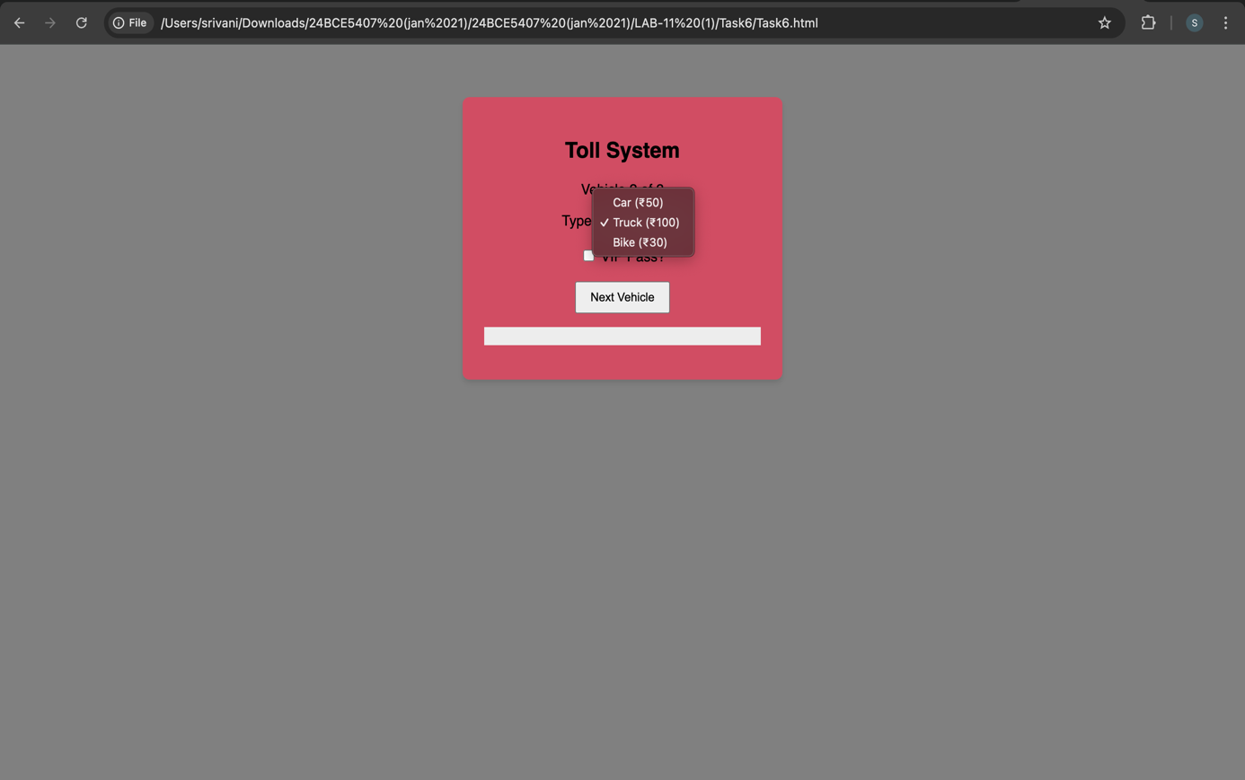
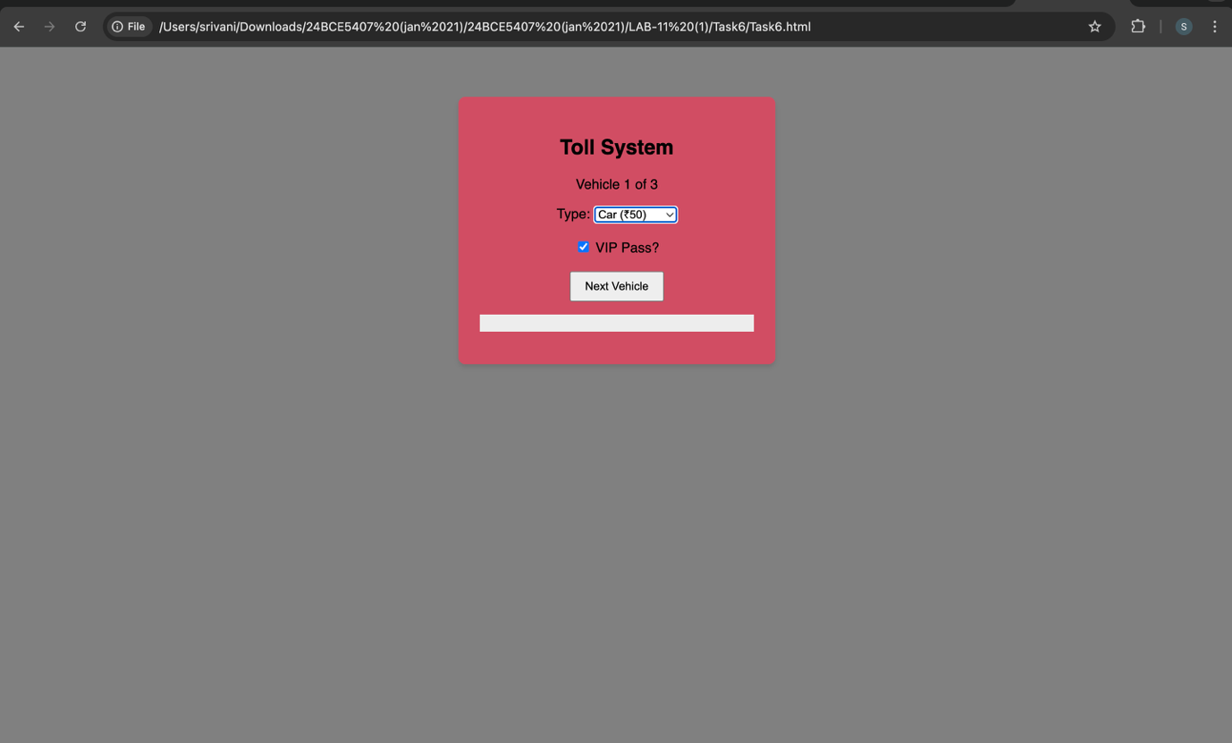
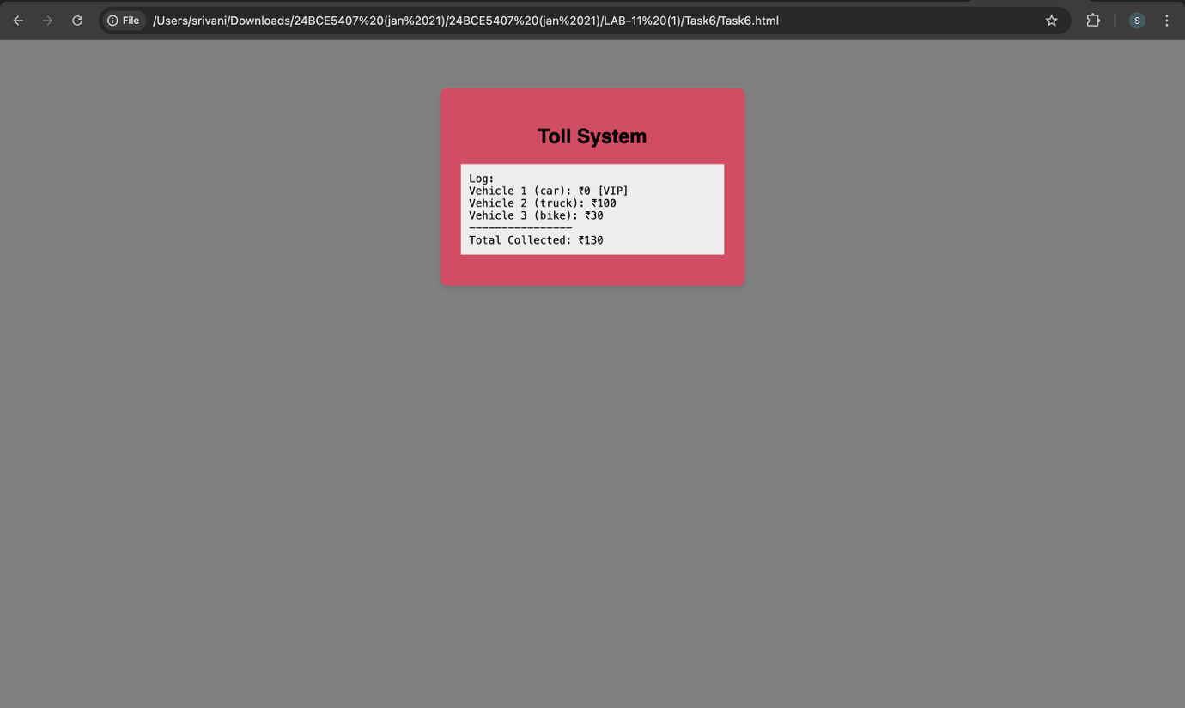

LAB 11 – TASK 7 – HTML:

<!DOCTYPE html>
<html lang="en">
<head>
<meta charset="UTF-8">
<title>Smart Hospital Emergency System</title>
<link rel="stylesheet" href="Task7.css">
</head>
<body>
<div class="container">
<h2>Smart Emergency Terminal</h2>

<div id="setupStep">
<label>Number of Patients to Process:</label>
<input type="number" id="patientTotal" value="1" min="1">
<button class="btn btn-primary" onclick="initializeSystem()">Initialize System</button>
</div>

<div id="inputStep" class="hidden">
<div class="badge" id="patientCounter">Patient 1 of N</div>

<div class="form-grid">
<input type="number" id="age" placeholder="Age">
<input type="number" id="temp" placeholder="Temp (°C)" step="0.1">
<input type="number" id="heartRate" placeholder="Heart Rate (BPM)">
<input type="number" id="oxygen" placeholder="Oxygen Level (%)">

<select id="injuryType">
<option value="accident">Accident</option>
<option value="burn">Burn</option>
<option value="fracture">Fracture</option>
<option value="fever">Fever</option>
<option value="other">Other</option>
</select>

<select id="consciousness">
<option value="conscious">Conscious</option>
<option value="unconscious">Unconscious</option>
</select>
</div>

<button class="btn btn-success" onclick="processPatient()">Classify & Next</button>
</div>

<div id="reportStep" class="hidden">
<pre id="resultDisplay"></pre>
<div id="emergencyAlert" class="alert hidden">EMERGENCY ALERT: Critical Threshold Exceeded!</div>
<button class="btn btn-gray" onclick="location.reload()">New Session</button>
</div>
</div>
<script src="Task7.js"></script>
</body>
</html>

LAB 11 – TASK 7 – JavaScript:

let currentPatient = 1;
let totalToProcess = 0;
let criticalCount = 0;
let report = "--- HOSPITAL EMERGENCY REPORT ---\n\n";

function initializeSystem() {
totalToProcess = parseInt(document.getElementById('patientTotal').value);
if (totalToProcess > 0) {
document.getElementById('setupStep').classList.add('hidden');
document.getElementById('inputStep').classList.remove('hidden');
updateCounter();
}
}

function updateCounter() {
document.getElementById('patientCounter').innerText = "PATIENT " + currentPatient + " OF " + totalToProcess;
}

function processPatient() {
const age = parseInt(document.getElementById('age').value);
const oxygen = parseInt(document.getElementById('oxygen').value);
const conscious = document.getElementById('consciousness').value;
const injury = document.getElementById('injuryType').value;

let priority = "Low";
let dept = "General Medicine";
let wait = "2 Hours";

if (oxygen < 90 || conscious === "unconscious") {
priority = "Critical";
dept = "ICU";
wait = "Immediate";
criticalCount++;
} else if (injury === "accident" || injury === "burn") {
priority = "High";
dept = "Emergency Trauma";
wait = "15 Mins";
} else if (injury === "fracture") {
priority = "Moderate";
dept = "Orthopedics";
wait = "45 Mins";
}

if ((age > 65 || age < 5) && priority !== "Critical") {
priority = "High (Upgraded)";
wait = "10 Mins";
}

report += `Patient ${currentPatient}: [${priority}] -> ${dept} (Wait: ${wait})\n`;

if (currentPatient < totalToProcess) {
currentPatient++;
updateCounter();
clearForm();
} else {
showFinalReport();
}
}

function clearForm() {
document.getElementById('age').value = "";
document.getElementById('oxygen').value = "";
}

function showFinalReport() {
document.getElementById('inputStep').classList.add('hidden');
document.getElementById('reportStep').classList.remove('hidden');

let criticalPercent = (criticalCount / totalToProcess) * 100;
report += `\nStatistics: ${criticalPercent.toFixed(1)}% Critical cases.`;

document.getElementById('resultDisplay').innerText = report;

if (criticalPercent >= 30) {
document.getElementById('emergencyAlert').classList.remove('hidden');
}
}

LAB 11 – TASK 7 – CSS:

body {
background-color: #f5f5dc;
font-family: 'Segoe UI', sans-serif;
display: flex;
justify-content: center;
padding-top: 40px;
}

.container {
background: white;
width: 450px;
padding: 30px;
border-radius: 12px;
box-shadow: 0 10px 30px rgba(0,0,0,0.1);
text-align: center;
}

.form-grid {
display: grid;
grid-template-columns: 1fr 1fr;
gap: 15px;
margin: 20px 0;
}

input, select {
padding: 10px;
border: 2px solid #e0e0e0;
border-radius: 6px;
}

.btn {
width: 100%;
padding: 12px;
border: none;
border-radius: 6px;
font-weight: bold;
cursor: pointer;
margin-top: 10px;
}

.btn-primary { background: #7f8c8d; color: white; }
.btn-success { background: #2d5a27; color: white; }
.btn-gray { background: #bdc3c7; color: #333; }

.badge {
background: #f5f5dc;
color: #7f8c8d;
padding: 5px 15px;
border-radius: 20px;
font-weight: bold;
}

#resultDisplay {
text-align: left;
background: #2c3e50;
color: #ecf0f1;
padding: 15px;
border-radius: 6px;
white-space: pre-wrap;
}

.alert {
background: #e74c3c;
color: white;
padding: 10px;
margin-top: 10px;
border-radius: 6px;
animation: blink 1s infinite;
}

.hidden {
display: none;
}

LAB 11 – TASK 7 – Screenshots:

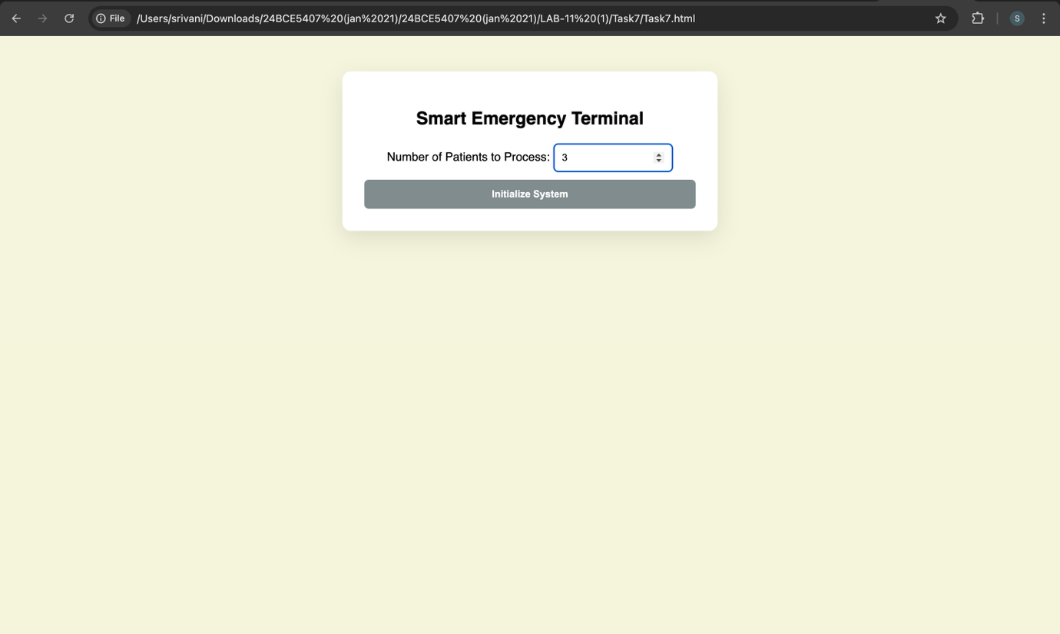
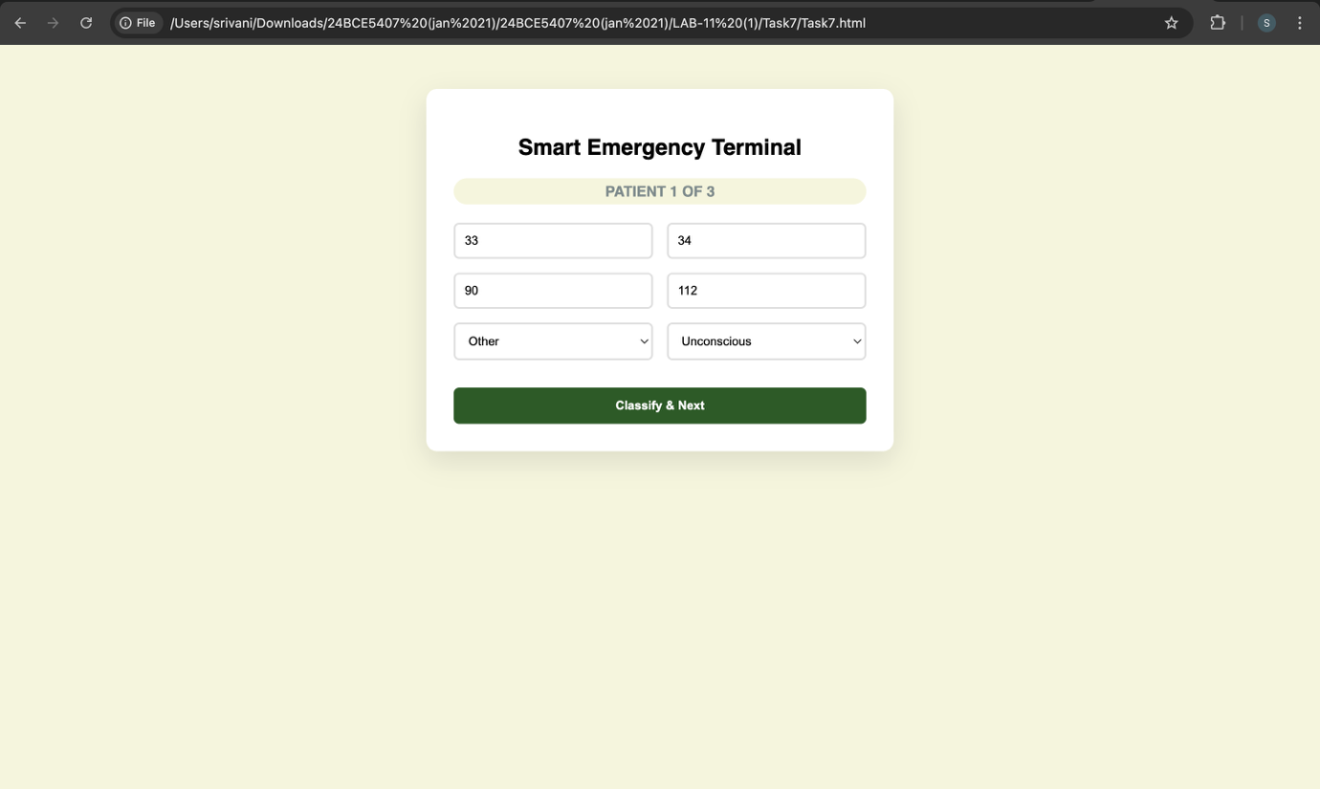
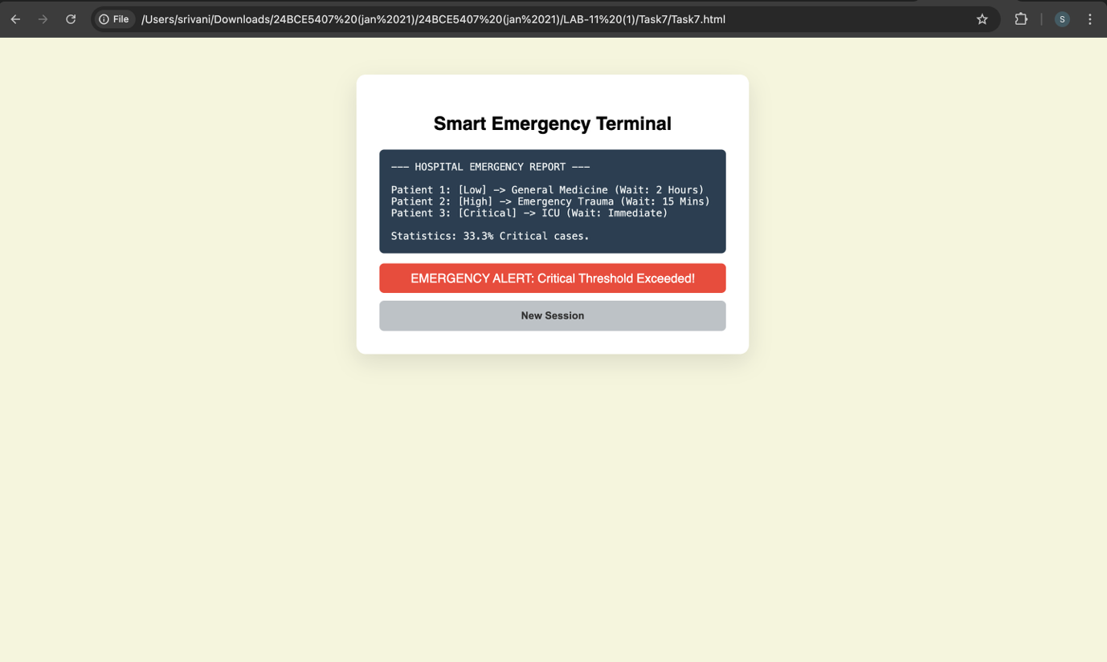

THE END

