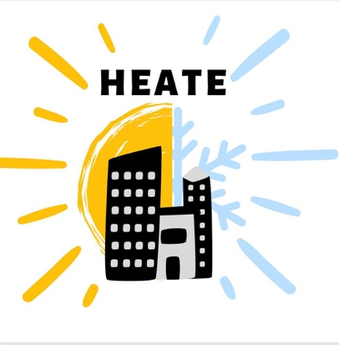**The HEATE (Heat Exposure And Temperature Equity) Project** is made up of a small team of student and faculty researchers at the Columbia University Mailman School of Public Health.

**WHAT** we are interested in studying**:** There is a gap for understanding the impacts of extreme weather in New York City on indoor residential temperatures. We want to know how cold apartments get in the winter and how hot apartments get in the summer in

NYC, relative to outdoor temperatures.

**WHY** we are interested in this: Throughout NYC, people are exposed to extreme temperatures in their homes—this directly impacts quality of life. While HEATE is not a quick fix to this problem, collecting data to support related policy agendas is the first step toward addressing this challenge.

**HOW** we are conducting our study: We are installing two temperature monitors in apartments throughout Northern Manhattan and the South Bronx which will collect data on temperature and relative humidity throughout the coming year.

**GET INVOLVED:** Scan the QR code on the right to fill out a brief form, and we will coordinate sensor installation with you. All households participating in this study will receive $50 in the form of two Visa gift cards given at sensor installation and pick up.

Questions? Email robbie.parks@columbia.edu

**Some NYC Heat Facts:**

* People of color, on average, live in areas 2 °F warmer than their white counterparts largely due to limited greenspace and canopy cover.
* While there is a minimal legal residential temperature in New York City, there is no law established for maximal temperatures in apartments.
* Those with existing health conditions such as heart disease, diabetes, certain psychiatric disorders, and asthma are more vulnerable to extreme temperatures—especially heat!