Fingerprint Voting System

One of the major factors to be taken care of in a voting process is authentication and authorization of voters. Many conditions need to be checked to ensure these factors. Major conditions include:
1. Check authenticity of voter
2. Authorize legitimate voters to vote
3. Avoid double vote casting by any individual
Checking if all these conditions manually is a very complicated and exhausting task with many chances of human error. To avoid this we here propose a fingerprint based voting system project. We use a fingerprint module interfaced with microcontroller and an LCD screen in this system. The fingerprint module is used to sense fingerprints and provide to microcontroller for further processing. The system has list of eligible voters in it, the voting system tallies the recognized finger print against the ones stored in database. If match is found that person is allowed to vote. Once a vote is casted by that person his id is rolled out for that voting process. This avoids double vote casting. Thus our system provides for a fully automated voting system with finger print based authentication.

Block Diagram:

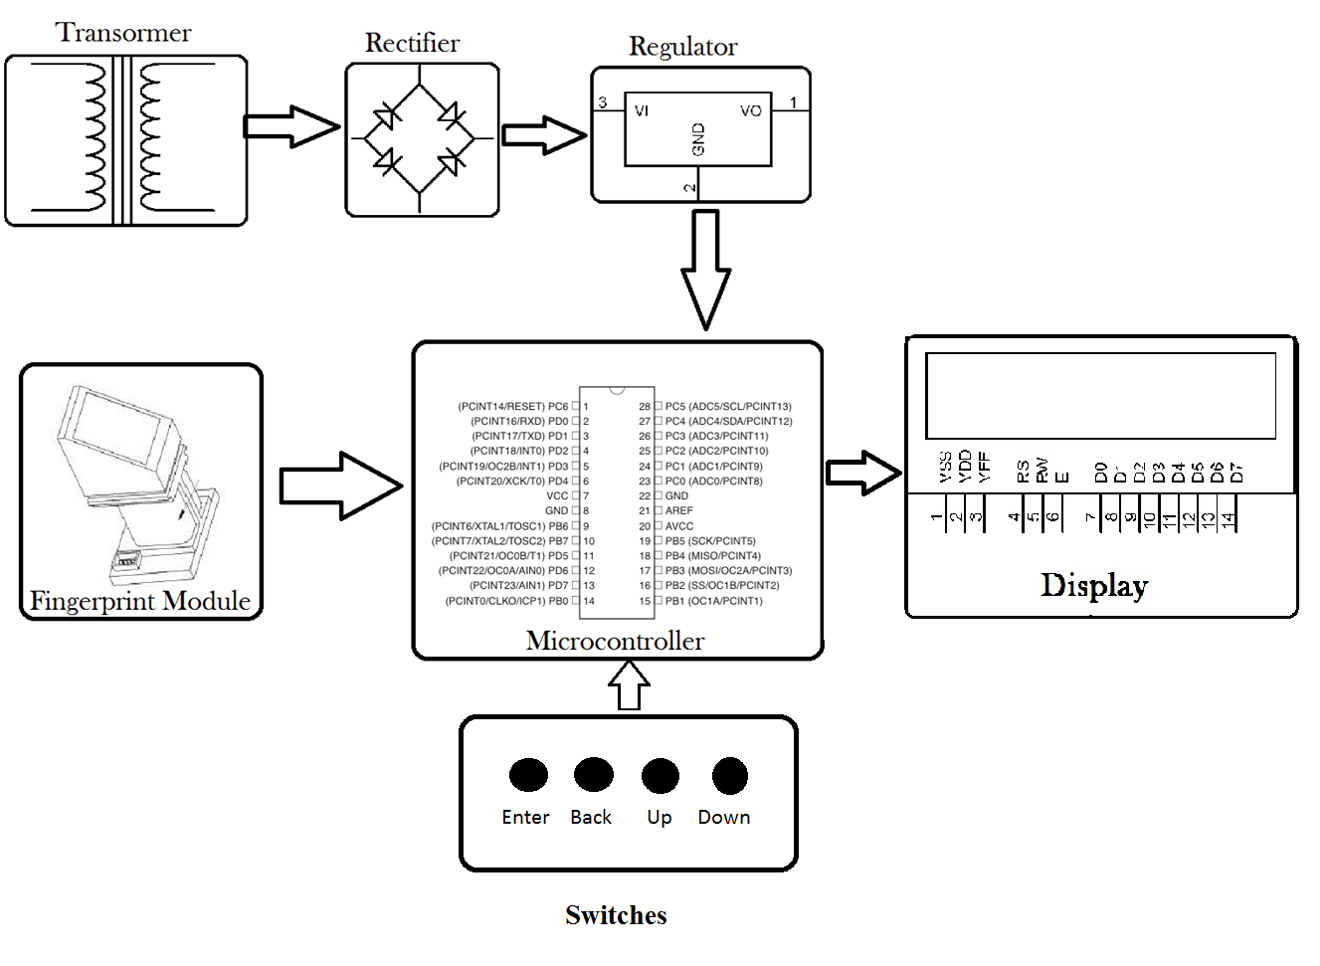

Hardware Specification:
- Finger Print Module
- Microcontroller (Atmega 328)
- Voltage regulator
- Micro switches
- Transformer
- Resistors
- Capacitors
- Diodes

Software Specifications
- Arduino compiler
- MC Programming Language: Embedded C

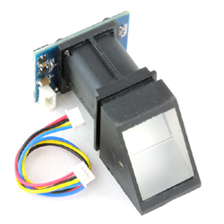

Reference
- http://ieeexplore.ieee.org/xpl/articleDetails.jsp?arnumber=7073090&queryText=fingerprint%20voting&newsearch=true

- http://ieeexplore.ieee.org/xpl/articleDetails.jsp?arnumber=7226054&queryText=fingerprint%20voting&newsearch=true

