Plainpage

Product System Design

STATUS  Activation pending |  | OWNER  Plainpage |  | LAST UPDATED  21 October 2026

Authors | Muhammad Awais Abdullah
Reviewers | Not yet assigned
Related docs | docs/operations.md and the product-tier migration
Scope | Safe collaboration and a review workflow for briefs and handoffs

1. Abstract
Plainpage adds safe document saving, recovery, verified invitations and revision-bound reviews to its existing Supabase workspace. The design keeps document content in the editor while exposing review, history and export through compact controls.
Implementation is prepared in source and tested locally. Database migration, provider credentials, production email delivery and recovery drills remain activation gates. Collaborative editing uses revision checks rather than live cursor merging.

2. Goals and Non-Goals
Goals | Non-goals
Reject stale saves without data loss | Real-time cursor collaboration
Restore documents and earlier revisions | Automated conflict merging
Bind invitations to verified accounts | Public anonymous document links
Approve the exact revision reviewed | Legal signatures or certified approvals

3. Background and Problem Statement
The existing app has real Supabase authentication, rich-text editing, import and sharing. Blind saves, hard deletion and profile-only invitations left gaps in recovery and identity binding. Review workflows also need approvals tied to the exact content reviewed.
The browser edits documents; authenticated Next.js routes enforce access; service-role PostgreSQL functions perform atomic transitions. External email and AI calls remain separate from document writes. A stale revision must never overwrite current content.

4. Proposed Architecture

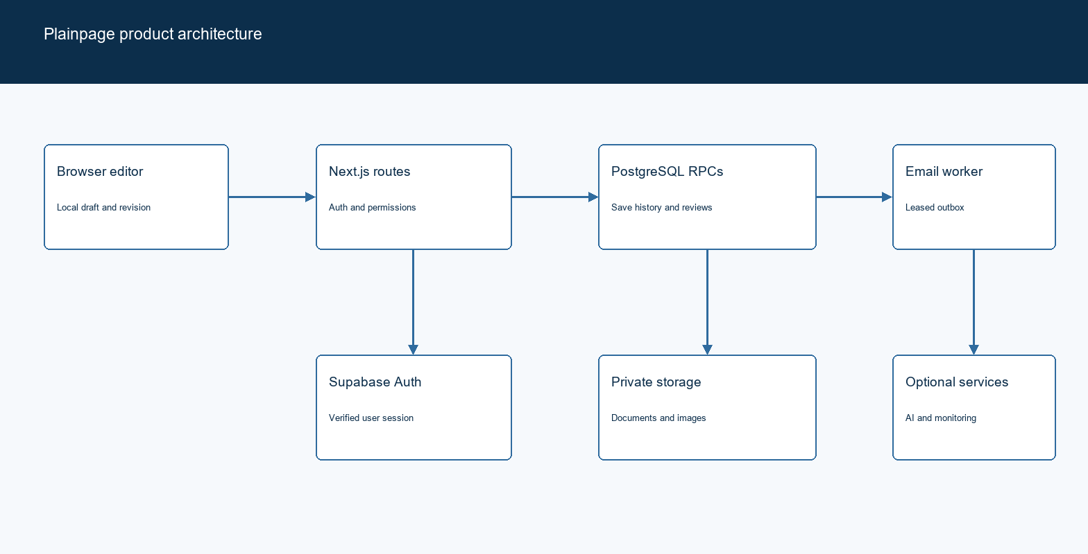
Figure 1. Plainpage application boundaries and durable workflows.

Core components

Component | Responsibility | Primary storage | Failure behavior
Editor and workflow UI | Drafts, review controls, history, exports | Browser state and APIs | Preserve draft and show errors
Auth and access routes | Verify user and permission for each action | Supabase Auth and profiles | Deny unavailable or invalid access
Transactional document functions | Revision checks, history and review transitions | Supabase PostgreSQL | Roll back invalid or stale writes
Notification worker | Lease outbox entries and deliver emails | Outbox and configured sender | Bounded retries and idempotency
Clarity and operations | Local checks, limited AI, filtered telemetry | Optional configured providers | Keep core editing available

5. Request Lifecycle
- A signed-in user submits a document ID, expected revision and requested change.
- The route validates input, verifies the Supabase session and checks document permissions.
- The server checks the product-tier flag and loads current document and sharing state.
- A PostgreSQL function locks the document and compares its revision before updating.
- The transaction stores history and invalidates prior review approvals before returning.
- Notification workers lease durable outbox items and retry with provider idempotency keys.
- The browser advances its revision or preserves local work after a conflict. Optional telemetry excludes document content.

6. API and Data Contracts

Primary data contract

Field | Type | Required | Description
document_id | UUID | Yes | Document identity and permission boundary
revision | Integer | For writes | Expected saved revision; stale values return 409
content | JSON | For edits | Tiptap document content or imported HTML
review_round | UUID | For review | Binds responses to one document revision
reviewers | UUID array | For requests | Existing collaborators; up to 20 reviewers
invitation | Email and role | For invite | Accepted only by the matching verified identity
quota | User and UTC day | For AI | Atomic cap of 20 attempted suggestions

Contract guarantees

- Document and history writes commit together; failed revision checks leave both unchanged.
- Document revision numbers order saves. Outbox UUIDs identify email delivery attempts.
- Review rounds capture document revision, reviewers, due date and per-reviewer decisions.
- The database is the source of saved content. Browser drafts remain unsaved until acknowledged.
The migration and operational contract are published in the repository.
See supabase/migrations/20261021_product_tiers.sql and docs/operations.md.

7. Consistency, Idempotency, and Replay

Client title and content saves share one revision queue. Stale writes return 409 and retain local drafts. Restore creates a new revision. Invitations are accepted under a verified Auth identity; repeated acceptance does not duplicate access. Email retries are independent of document saves.
Scenario | Expected behavior | Reasoning
Repeated save or invitation | Stale saves conflict; accepted invites do not duplicate access | Revision and unique share constraints
Database write fails | No partial save/history update commits | One PostgreSQL transaction
Email or AI times out | Queue retry for mail; explicit AI error | Core content remains durable
Content changes during review | Close prior round and return to Draft | Old approvals cannot finalize a new revision

8. Security and Privacy Considerations

- Supabase verifies sessions. Server routes check owner, editor and viewer permissions. New RPCs are executable only by the service role; browser roles receive no direct table policies.
- Monitoring strips request data, account identity, breadcrumbs and error messages. Analytics count only named actions by day. Local clarity checks do not call an AI service.
- Service-role, AI, sender and scheduler credentials remain server-only. Public Supabase and optional browser monitoring keys are configuration values, not administrative secrets.
- The product-tier flag remains off until migration. Backup tools require explicit connection configuration and a destination. Test restoration in staging before rollout.
- The operator is Muhammad Awais Abdullah. Privacy support is awaisabdullahm79@gmail.com. Account deletion removes active owned data; backup and provider retention require separate configuration and review.

9. Operational Readiness
Signal | SLO or alert | Owner | Launch gate
Auth and reset flow | Live registration, recovery and logout pass | Operator | Required
Save integrity | Two-editor conflict and restore tests pass | Operator | Required
Email delivery | Queued, retried and delivered in staging | Operator | Required
Migration state | Flag enabled only after schema verification | Operator | Required
Recovery drill | Restore database, Auth and Storage copies | Operator | Required
Rollout requires a staged migration, verified backups, real email tests and a reversible application release.

10. Alternatives Considered

Alternative | Why it was considered | Why it was not selected
Blind last-write-wins | Simple autosave | Can silently discard another edit
Live collaborative merging | Simultaneous editing and presence | More complexity than the initial review workflow needs
AI-first product direction | Convenient rewriting and summaries | Review loops better match current briefs and handoffs
Admin provisioning on invite | Immediate profile creation | Does not prove ownership of an email address

11. Open Questions
- Which verified domain and sender will deliver document and review notifications?
- What backup retention and recovery targets will the operator commit to?
- Which enabled AI model and provider spending limits will be used?
- When will staging migration, live Auth tests and desktop/mobile visual checks be completed?

12. Decision and Next Steps
Activate the tested foundations first, then invitations and the review loop, followed by optional Clarity suggestions. Do not enable collaborative beta access until migration, recovery and real-email tests pass. The current implementation is not a claim of production activation.
Milestone | Deliverable | Exit criteria
M1 | Safe save, history, trash and account controls | Migration and recovery tests pass
M2 | Verified invitations and queued notifications | New-user and existing-user flows pass live
M3 | Revision-bound review workflow | Approval, edit invalidation and reminders pass
M4 | Optional AI and operational rollout | Provider configuration and launch gates completed

Product-tier activation requires staging validation; local tests do not establish live service readiness.

