Name Awais
Roll Number 26i-3271
Task 2

## Initial Prompt: Setting Context & Student Details
Prompt: "My name is Awais, Roll Number 26i-3271
Result: AI acknowledge project requirements and design system.

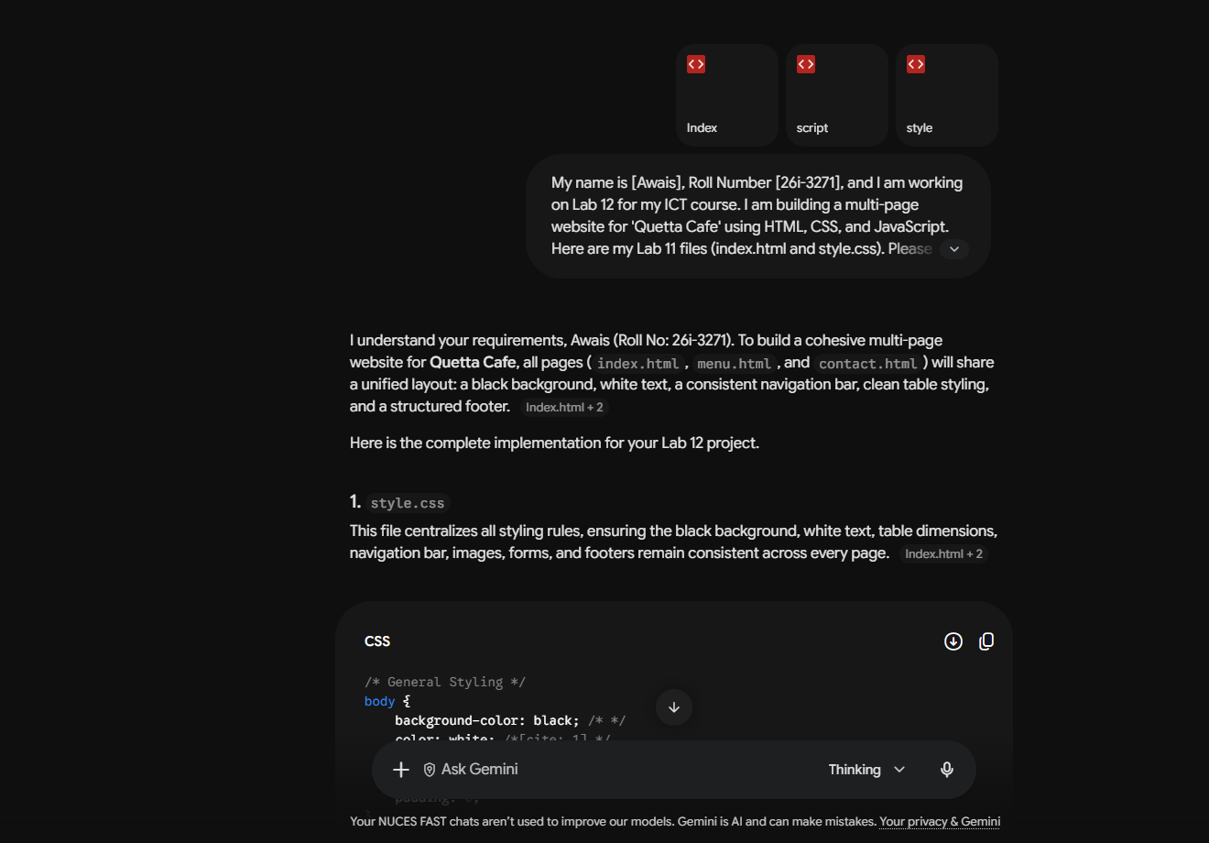

## Prompt 2: Menu Page
Prompt: "Create a menu.html page for my Quetta Cafe website..."
Result: Created menu.html with food categories and an interactive alert button.
Fixes: Updated navigation links to connect menu.html correctly.
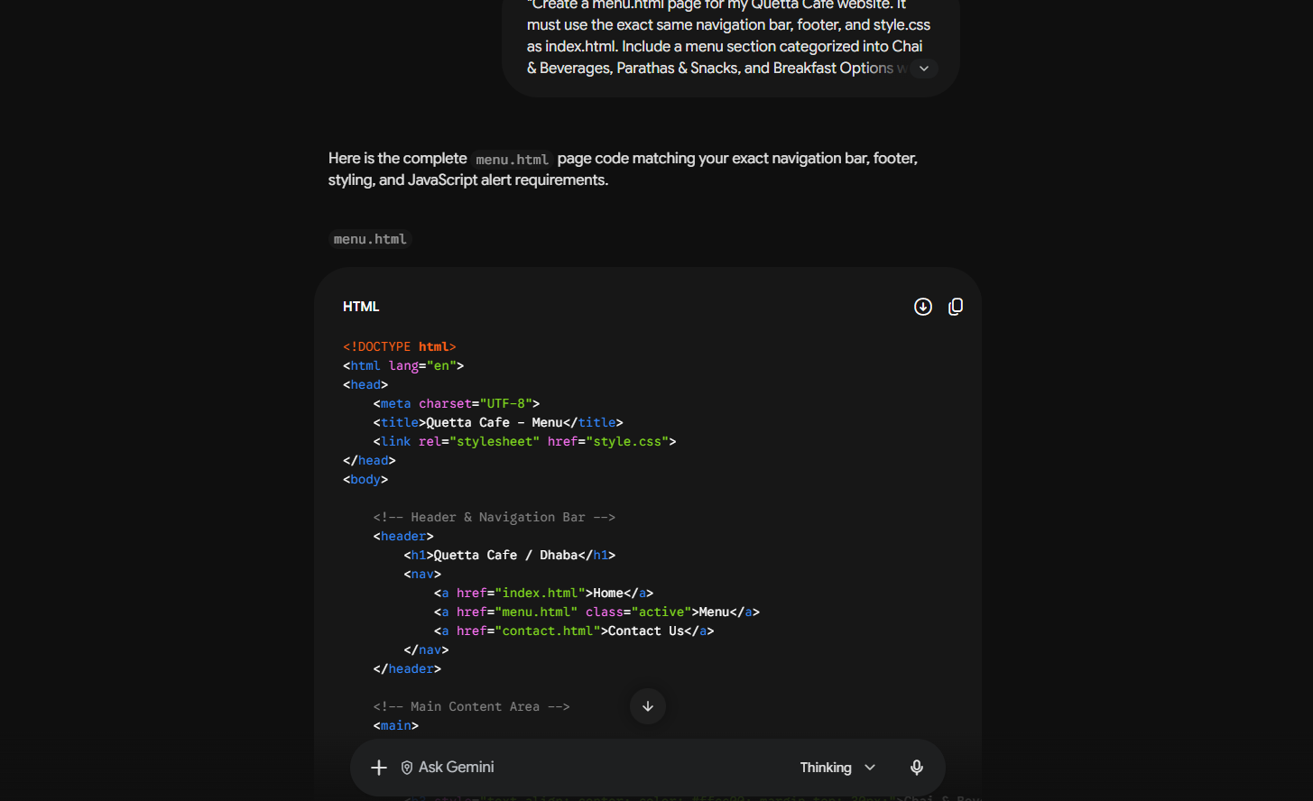

## Prompt 3: Contact Page (Feature Branch)
Prompt: "Create a contact.html page for Quetta Cafe..."
Result: Created contact.html on branch feature-contact and merged back to main.


