Assignment # 3

CS322 - SC - Software Construction

Case study-04

**Group no. 08**

**Team Members:**

1. Ghulam Anwar (Team Lead) - 04072013029
2. Awais Ali -04072212008
3. Hania Naeem- 04072113009

**Submission Date:** 18-03-2024 09:00 AM

**Submitted to:** Dr. Onaiza Maqbool

Domain Model:

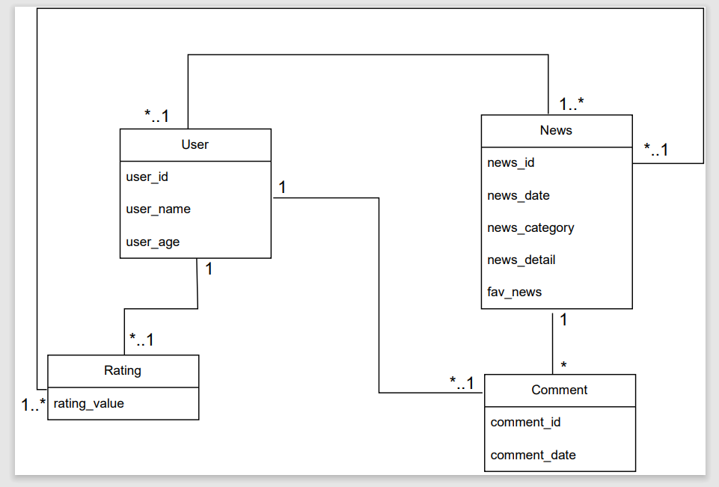

System Sequence Diagrams:

**Hania Naeem’s Part:**

**(SSD for Comments on news post)**

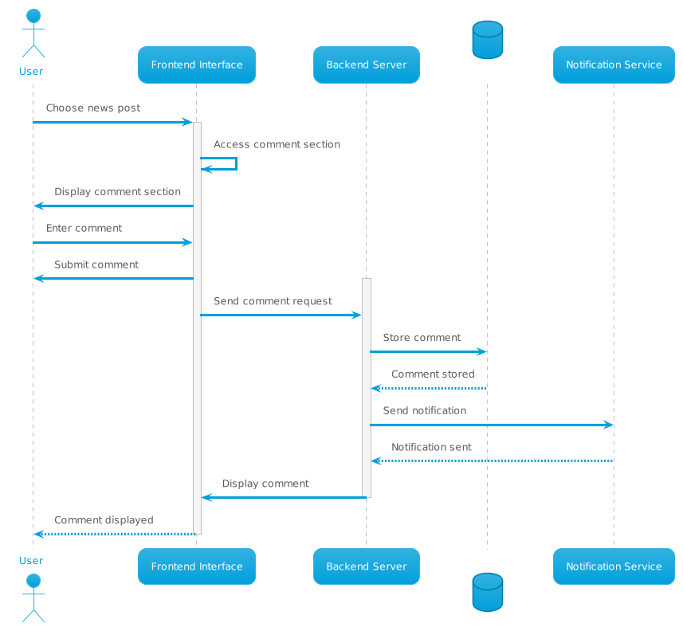

**Ghulam Anwar’s Part:**

**(SSD for Authentication and Authorization)**

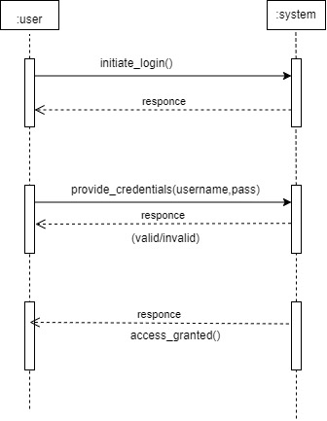

**Awais Ali’s Part:**

**(SSD for User Ratings)**

