Assignment # 5

CS322 - SC - Software Construction

Case study-04

**Group no. 08**

**Team Members:**

1. Ghulam Anwar (Team Lead) - 04072013029
2. Awais Ali -04072212008
3. Hania Naeem- 04072113009

**Submission Date:** 01-04-2024

**Submitted to:** Dr. Onaiza Maqbool

**Ghulam Anwar and Awais Farooq’s Part:**

**(3-tiered architectural design)**

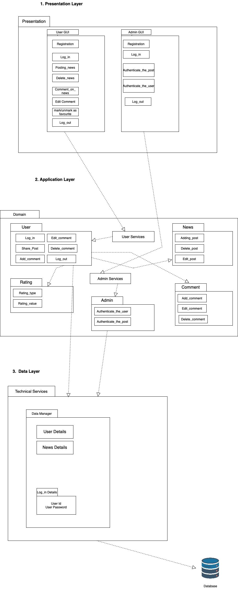

**Hania Naeem’s Part:**

**(description of 3-tiered architectural design)**

# **Three-tier Architecture**

# Description Of the three-tier architecture

Here’s a description to the three-tier architecture diagram given, illustrating the three layers of the system; presentation layer, application layer, and data layer.

## 1. Presentation Layer:

* Includes User GUI, Admin GUI, Registration, Log in/out functionalities.
* Involves actions like Posting news, Commenting on news, Editing comments, Marking/unmarking as favorite.

## 2. Application Layer:

* Consists of Domain, User, News entities with various services like User Services and Admin Services.
* Functions such as Editing comments, Adding/deleting posts or comments, User authentication is also performed in this layer.

## 3. Data Layer:

* Contains Technical Services like Data Manager managing User Details, News Details, Log-in Details in the Database.
* Elements like User Id, User Password are stored and managed here.

The diagram shows a structured system design with clear segregation of responsibilities in each layer for efficient functioning.