AWAIS ALI

04072212008

SC_ ASSIGNMENT. 6&7

._._._._._._._._._._._._._._._._._._._._._.

Sequence Diagram(News Vine)

>SD_1: Posting News

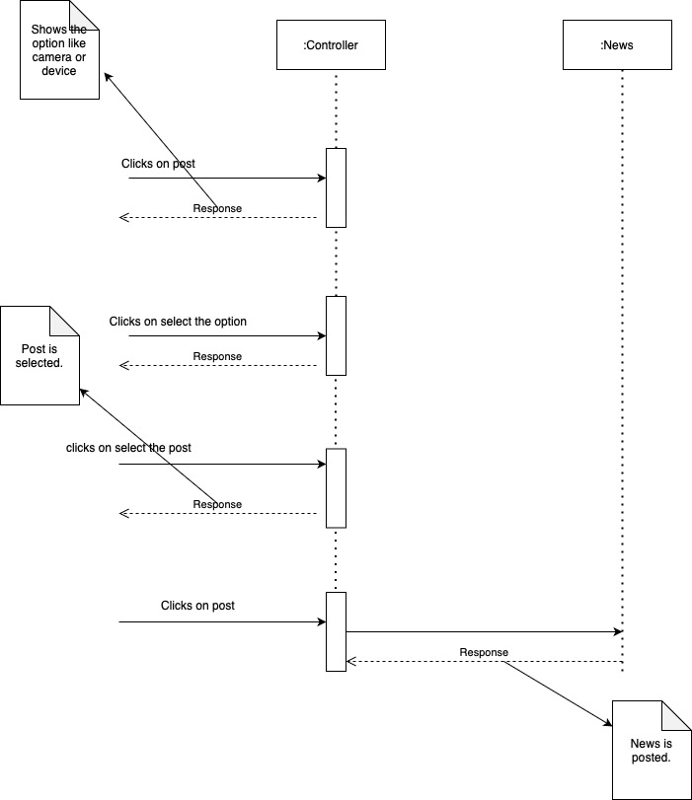

>SD_2 : Edit News

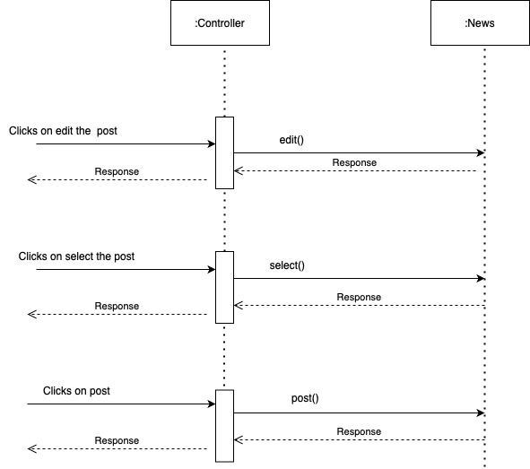

>SD_3 : Delete News

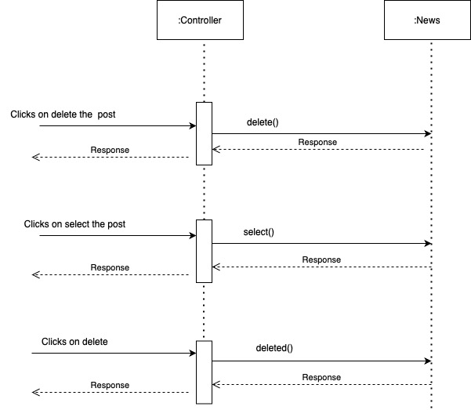

>SD_4: Edit Comments

