|  |  |  |  |  |
| --- | --- | --- | --- | --- |
| MTBC Logo for Letter Head | **Topic: Job Description** | | | Page 1 of 1 |
| **Department**  HR | **Effective Date**  Nov 23, 2009 | **Code**  6.2-F-5/7.1.1-F-1 | **Version**  2.0 |

**Name :**Muhammad Awais Malik

**Designation :**Software Engineer

**Responsibilities:**

* Design, develop and maintain Software’s using state of the art tools and techniques.
* Follow instructions and pre-established guidelines to perform the functions of the job.
* Writes documentation to describe program development, logic. Coding and corrections following the framework dictated Team Lead/Manager IT.
* Perform Unit testing and debugging.
* Any other work delegated by the Team Lead.
* Reportable to his Team Lead/Manager IT.
* Implement and act in accordance with MTBC’s information security and privacy policies.
* Ensure compliance with information security responsibilities specific to your job role.
* Protect assets from unauthorized access, disclosure, modification, destruction or interference.
* Implement and act in accordance with MTBC’s information security and privacy policies.
* Ensure compliance with information security responsibilities specific to your job role.
* Protect assets from unauthorized access, disclosure, modification, destruction or interference.
* Any other task assigned by supervisor.

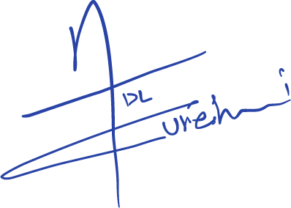

Adil Qureshi

*Manager HR*

